Case-mix, care pathways, and outcomes in patients with traumatic brain injury in CENTER-TBI:
a European prospective, multicentre, longitudinal, cohort study

Ewout W. Steyerberg ^{1,2}, Eveline Wiegers^{1 *}, Charlie Sewalt^{1 *}, Andras Buki³, Giuseppe Citerio^{4,5}, Véronique De Keyser⁶, Ari Ercole⁷, Kevin Kunzmann⁸, Linda Lanyon⁹, Fiona Lecky¹⁰, Hester Lingsma¹, Geoffrey Manley¹¹, David Nelson¹², Wilco Peul¹³, Nino Stocchetti¹⁴, Nicole von Steinbüchel¹⁵, Thijs Vande Vyvere^{16,17}, Jan Verheyden¹⁷, Lindsay Wilson¹⁸, Andrew I.R. Maas^{6,19 *}, David K. Menon^{7 *} and the CENTER-TBI Participants and Investigators**

¹ Department of Public Health, Erasmus MC-University Medical Center Rotterdam, Rotterdam, The Netherlands; Prof. E.W. Steyerberg PhD; E. Wiegers MSc; C. Sewalt MSc; H. Lingsma PhD;
² Department of Biomedical Data Sciences, Leiden University Medical Center, Leiden, The Netherlands; Prof. E.W. Steyerberg PhD
³ Department of Neurosurgery, Medical School, University of Pécs, Hungary and Neurotrauma Research Group, János Szentágothai Research Centre, University of Pécs, Hungary; Prof. A. Buki, MD;
⁴ NeuroIntensive Care, ASST di Monza, Monza, Italy; Prof. G. Citerio MD;
⁵ School of Medicine and Surgery, Università Milano Bicocca, Milano, Italy; Prof. G. Citerio MD;
⁶ Department of Neurosurgery, Antwerp University Hospital, Edegem, Belgium; V. De Keyser M.A.; Prof. A.I.R. Maas MD
⁷ Division of Anaesthesia, University of Cambridge, Addenbrooke’s Hospital, Cambridge, UK; A.Ercole MD;
⁸ MRC Biostatistics Unit, University of Cambridge, UK; K. Kunzmann PhD
⁹ International Neuroinformatics Coordinating Facility, Karolinska Institute, Stockholm, Sweden; L. Lanyon PhD;
¹⁰ Centre for Urgent and emergency care Research (CURE) , Health Services Research Section, School of Health and Related Research (ScHARR), University of Sheffield, Sheffield, UK; Prof. F. Lecky MD;
¹¹ Department of Neurological Surgery, University of California, San Francisco, California, USA; Prof. G. Manley MD;
¹² Dept. of Physiology and Pharmacology, Section of Perioperative Medicine and Intensive Care, Karolinska Institutet, Stockholm, Sweden; D. Nelson MD;
¹³ University Neurosurgical Center Holland (UNCH), LUMC & HMC, The Hague/Leiden The Netherlands; Prof. W. Peul MD;
¹⁴ Department of Pathophysiology and Transplantation, Milan University, and Neuroscience ICU, Fondazione IRCCS Cà Granda Ospedale Maggiore Policlinico, Milano, Italy; Prof. N. Stocchetti MD;
¹⁵ Institute of Medical Psychology and Medical Sociology, Universitätsmedizin Göttingen, Göttingen, Germany; Prof. N. von Steinbüchel PhD;
¹⁶ Dept. of Radiology, Antwerp University Hospital, Edegem, Belgium; Th. Vande Vyvere MSc;
¹⁷ Icometrix, Leuven, Belgium; J. Verheyden MSc; Th. Vande Vyvere MSc;
¹⁸ Division of Psychology, University of Stirling, Stirling, UK; Prof. L. Wilson PhD
¹⁹ University of Antwerp, Edegem, Belgium; Prof. A.I.R. Maas MD

* Equal contribution
** Listed at end of manuscript
Corresponding author: Andrew Maas

Research in Context
Evidence before this study
In November 2017, the Lancet Neurology Commission on Traumatic Brain Injury (TBI) highlighted existing deficiencies in epidemiology, patient characterization, identifying best practice, outcome assessment, and evidence generation. The Commission concluded that “Concerted efforts are urgently needed to address deficiencies in prevention, care and research”, and made a recommendation for large collaborative studies which could provide the framework for precision medicine and comparative effectiveness research (CER).
Added value of this study
The CENTER-TBI Registry and Core Study provide detailed insights into the contemporary landscape of TBI in Europe and constitute a unique resource for improving characterization, developing precision medicine approaches and identification of best practices. The epidemiology of TBI presenting to European centres is changing: patients are older, have most commonly been injured by a fall, and many have comorbidities. Advanced neuroimaging and blood biomarkers can improve characterisation of injury type and severity. Differentiation of patients by care pathways provided novel insights. Around 95% of patients discharged from the Emergency Room or admitted to the ward, and a third of those primarily admitted to the ICU, have suffered a so-called “mild TBI”. However, nearly one third of those discharged from the ER and over half of those admitted to hospital ward did not attain full recovery. There are substantial national and regional variations in care pathways and clinical management.
Implications of all the available evidence:
TBI should no longer be considered predominantly a disease of otherwise healthy young adult males. Falls are the most common cause of TBI and motivate an increased focus for prevention. Mild TBI not only poses the greatest societal burden to health care, but also impacts functional recovery and quality of life in individuals more than commonly thought. Better disease characterisation can contribute to precision medicine approaches through the development of multidimensional classifications of initial injury severity and outcome. Variations in care offer an opportunity for CER to identify best practice.

Abstract
Background
Traumatic Brain Injury (TBI) poses a large public health and societal problem, but the contemporary landscape in Europe is poorly defined. We aimed to characterize patient case-mix, care pathways, and outcome of TBI.

Methods
CENTER-TBI is a Europe-based observational cohort study, consisting of a Core study (Inclusion criteria: clinical diagnosis of TBI, presentation <24 hours post-injury and indication for computed tomography) and a Registry. Patients were differentiated by care pathway: ER stratum (discharged from emergency room), Admission stratum (hospital ward), and ICU stratum (admission to the intensive care unit). Neuro-images and biospecimens were stored in repositories and outcome assessed 6 months post-injury.

Findings
Data of 4509 patients from 18 countries were analysed in the Core study and 22,782 in the Registry. In the Core study, 848 (19%), 1523 (34%), and 2138 (47%), were in ER, Admission, and ICU strata, respectively. In the ICU stratum, 36% of patients had mild TBI (Glasgow Coma Score 13-15). Compared to the Core cohort, the Registry had more patients in ER (43%) and Admission (38%) strata, with >95% classified as mild TBI. Patients in the Core cohort were older than past studies (median age 50 [IQR: 30-66] years, 28% >65 years), 11% had serious comorbidities, 18% were taking anticoagulant or antiplatelet medication, and alcohol was contributory in 25%. Magnetic resonance imaging (MRI) and blood biomarker measurement enhanced characterisation of injury severity and type. Substantial inter-country differences existed in care pathways and practice. Incomplete recovery (Glasgow Outcome Scale Extended [GOSE] <8) was found in 30%, 53%, and 84% of patients in the ER, Admission and ICU strata respectively. In ICU patients with moderate to severe TBI, the rate of unfavourable outcome (GOSE<5) was 55%, similar to that predicted by the IMPACT prognostic model (O/E ratio 1·06 [95% CI 0·97-1·14]), but mortality was lower than expected (O/E ratio 0·70 [95% CI 0·62-0·76]).

Interpretation
Patients with TBI currently presenting to European centres are older and often have comorbidities. Overall, most patients present with mild TBI. The incomplete recovery experienced by many motivate precision medicine research and identification of best practices to improve these outcomes.

Funding: European Union 7th Framework program (EC grant 602150) with additional support from the Hannelore Kohl Stiftung (Germany), from OneMind (USA) and from Integra LifeSciences Corporation (USA).

Key Words: Traumatic Brain Injury, biomarkers, comparative effectiveness research, epidemiology, neuro-imaging, outcome, precision medicine, prospective observational study

Introduction
Traumatic Brain Injury (TBI) is widely recognized as a large public health and societal problem. TBI results in 1·5 million hospital admissions and 57,000 deaths in the EU each year,¹ but the current landscape of TBI in European hospitals is poorly characterized. In 2017, a Lancet Neurology Commission on TBI highlighted the burden posed by TBI to patients, relatives, and society, and provided recommendations to improve patient outcomes through better prevention, clinical care, and research.² One recommendation was for large collaborative observational studies to collect longitudinal data, which could inform improved patient characterization to allow better targeting of therapies, and identify best practices through comparative effectiveness research (CER).
The CENTER-TBI project (Collaborative European NeuroTrauma Effectiveness Research: www.center-tbi.eu) is a collaborative European study, conducted within the InTBIR Initiative (https://intbir.nih.gov/),³ that was designed to address these needs.⁴ It includes a multicentre, longitudinal, prospective, observational cohort study (Core study) with highly granular data collection and a Registry, collecting basic administrative data. The main aims are to 1) better characterize Traumatic Brain Injury (TBI) as a disease and describe it in a European context, and 2) identify the most effective clinical interventions for managing TBI. Provider Profiles of participating centres were established to characterize structures and processes of care in preparation for comparative effectiveness research.⁵⁻¹⁰ We here aim to describe the contemporary landscape of TBI in Europe, with a focus on the patient case-mix, care pathways, and outcome in the Core study, and to explore generalizability by comparison to the Registry.

Methods
Study design
CENTER-TBI includes a Core study (clinicaltrials.gov NCT02210221) and a Registry (RRID: SCR_015582).⁴ A total of 65 centres initiated patient enrolment (Figure 1). The Core study is a prospective observational longitudinal cohort study on patients of all severities of TBI, presenting between December 19, 2014 and December 17, 2017, to centres across Europe and Israel. Inclusion criteria were a clinical diagnosis of TBI, indication for CT scanning, presentation to study centre within 24 hours of injury, and informed consent obtained according to local and national requirements.⁴ The only exclusion criterion for the Core study was severe pre-existing neurological disorder that could confound outcome assessments. Patients were differentiated by care pathway into three strata:
- ER stratum (patients evaluated in the emergency room (ER) and discharged);
- Admission stratum (admitted to hospital ward);
- ICU stratum (primary admission to the intensive care unit).
The assignment to a stratum was prospective in the Core study, and retrospective in the Registry. Generalizability of the Core study was assessed through comparison with the Registry, which collected administrative data not requiring consent, and covered a site-specific, convenience-based, time window during the recruitment period of the Core study. Outcome assessments were performed at 6 months post-injury. The primary outcome measures were global function and health-related quality of life: GOSE¹¹ (overall impact of injury, including extracranial injuries), Qolibri-OS¹² and SF-12v2.¹³ Details of data, imaging and biosamples collection and banking, data handling, and analysis are provided in the Supplementary material.

Data collection
Clinical data were collected using a web-based electronic case report form (eCRF), with stratum-specific work flows (QuesGen Systems Incorporated, Burlingame, CA, USA). Variables were coded in accordance with the Common Data Elements (CDE) scheme established by NIH-NINDS (https://commondataelements.ninds.nih.gov/). Blood was banked for DNA extraction and assayed for protein biomarkers (Neuron Specific Enolase (NSE), S-100B, Neurofilament light (NFL), total tau, glial fibrillary acidic protein (GFAP), and ubiquitin carboxyl-terminal hydrolase L1 (UCHL1)). Patients underwent X-ray computed tomography (CT) at admission (repeated if clinically indicated) and magnetic resonance imaging was obtained in a subset of patients. We provide data on all admission CT examinations, biomarker data on the first 961 patients, and MRI data on the 504 patients who underwent an initial MRI within 3 weeks of injury.

Data handling and storage
Data were de-identified and stored on a secure database, hosted by the International Neuroinformatics Coordinating Facility (INCF; www.incf.org) in Stockholm, Sweden. Source data verification of major characteristics was undertaken on a quasi-random sample of 1298 patients (28%) by a designated Contract Research Organization (ICON, Ltd, Paris). Detailed curation was performed by a multidisciplinary data curation task force.

Data analysis
Data were accessed using a bespoke data management tool, ‘Neurobot’ (http://neurobot.incf.org; RRID: SCR_01700), vs 2.0 (data freeze: May 2019). We report completeness of data, median and interquartile ranges (IQR) for continuous or ordinal variables, and numbers and percentages for categorical variables. All analyses were differentiated by stratum and performed in R statistical software (3.5.1) and RStudio (1.0.136). Analysis of variance (ANOVA) was used for comparison of continuous variables across strata. The chi-square test was used for comparison of categorical variables. No corrections for multiple comparisons were performed. For comparisons of characteristics between strata, we present p-values in Tables 1-3 to assess compatibility with the Null hypothesis of no differences between strata. Kappa statistics were used to express the agreement between central and local radiological evaluation of admission CT scans and for CT versus MR scans. We analysed complete outcome data for the primary outcome measures. Analysis of secondary outcome measures (summarized in appendix) is ongoing and will be presented elsewhere. For 988 patients (22%) with GOSE scores outside the prespecified 5-8 month window, we used a multistate model to impute the 180-day GOSE (msm package¹⁴). We classified Qolibri-OS scores <52 and SF-12v2 summary scores < 40 as impaired.¹⁵ For cases where SF-12v2 summary scores were lacking, we derived scores using SF-36v2 items when available.

We used the IMPACT Core model for the expected mortality and proportion with unfavourable GOSE outcome among patients with moderate or severe TBI (Glasgow Coma Score <= 12).¹⁶ Observed mortality and unfavourable GOSE outcomes were compared to expected outcomes and expressed as a ratio with 95% confidence intervals estimated according to a Poisson distribution.

Role of funding source:
The funders had no role in the collection, analysis and interpretation of data, nor in the writing of the report or in publication decisions. The authors had full access to study data and the senior authors had final responsibility for the decision to publish.

Results
Data collection
The Core study enrolled 4,559 patients and the Registry 22,849 from 65 sites in 19 countries. Of these, data from 4509 patients in the Core study and 22782 in the Registry were analysed (Figure 1). The median enrolment by centre in the Core Study was 50 patients (IQR: 21-107), with widely different distributions across strata (Figures S1 and S2). In the Core study, 848 (19%), 1523 (34%), and 2138 (47%), were in ER, admission and ICU strata respectively. Compared to the Core study, the Registry enrolled more patients in the ER (9839, 43%) and Admission strata (8571, 38%) (Figure 1).
Baseline and Injury characteristics of Core cohort (Table 1)
Overall, the median age was 50 (IQR: 30–66) years, with 28% (n=1254) >65 years of age. Patients in the Admission stratum were older (53 years (IQR: 32-69), 32% (n=493) >65), compared to those in the ER and ICU strata. Male patients were overrepresented in every stratum, most notably in the ICU stratum (n= 1562, 73%). At higher age, however, the proportion of females was higher in the ER and Admission strata (Figure S3). Severe systemic disease was reported in 11% (n=462).
Differences were noted in patient characteristics between the three strata with respect to socio-economic characteristics (education, marital and employment status), medical history (especially frequency of having had a previous TBI), cause of injury and clinical severity (Tables 1, S1 to S4). An incidental fall was the most common cause of injury in the ER (n=424; 51%) and Admission strata (n=761; 51%). A clear association with age was noted, with high rates of falls occurring in those < 10 years of age and in the elderly (>65 years, Figure S4). Road traffic incidents were more common in the ICU stratum (n=926, 45%). Alcohol use was reported in 64% (n=144) of all violence-related TBI, in 28% (n=533) of incidental falls and in 17% (n=262) of road traffic incidents (Figure S5). Recreational and prescription drug use were reported in 6% (n=203) of patients.
Clinical severity varied by stratum: In the ER and Admission strata, the median baseline Glasgow Coma Score (GCS) was 15 (IQR: 15-15), and 99% (n=826) and 95% (n=1409) respectively were classified as mild TBI (GCS 13-15) (Table 1, Figure S6). In the ICU stratum, the median GCS was 9 (IQR: 4-14) and 36% (n=720) of patients had a GCS>12. Major extracranial injuries (AIS>=3) were reported in 28% (n=422) of patients in the Admission stratum and in 55% (n=1174) of those in the ICU stratum. The body region most commonly injured was thorax/chest (n=742, 35%), whilst concomitant serious spinal injuries occurred in 18% (n=374) (Table S4).
Comparisons with Registry
The differential recruitment to individual strata in the Core study and the Registry (Figure 1), and the exclusion of patients with pre-existing neurological disease from the Core cohort, precluded direct overall comparisons between the two cohorts. When differentiated by stratum, patients in the Core study broadly resembled those in the Registry (Table S5): Similar proportions had serious extracranial injuries (n=422 (28%) and n=2410 (28%) in the admission cohorts, and 55% (n=1174) vs 53% (n=2312) in the ICU cohorts respectively), and similar proportions of patients in the ICU stratum arrived intubated at the ER (44%; n=929 in Core and 41%; n=1776 in Registry). In the ICU stratum, the frequency of emergency surgical procedures was similar (e.g. craniotomy for haematoma/contusion 14% (n=297) vs 16% (n=700), respectively. In-hospital mortality was similar across strata (e.g. 15% (n=318) and 19% (n=773) for the ICU stratum in Core and Registry, respectively). Some differences existed in other baseline and injury characteristics (Table S5): Patients in the Core ER stratum were more frequently injured in road traffic incidents (n=266; 32% vs n=2191; 24%) and had more intracranial abnormalities on CT scanning (n=103; 13% vs n=498; 5·1%) than their Registry counterparts. Patients in the Core admission stratum were younger (53 vs 64 years), more often male (n=988, 65% vs n=5133, 60%), more frequently injured in road traffic incidents (n=490; 33% vs n=2077; 25%) and had more intracranial abnormalities on CT scanning (n=681; 49% vs n=3032; 36%). The Core ICU stratum enrolled patients with a lower baseline GCS (median 9, IQR: 4-14 vs 12, IQR: 5-15; Table S5).
CENTER-TBI Neuro-imaging repository and biobank
Early CT scans showed traumatic intracranial abnormalities in 2434 of 4037 (60%) at central review: 13%, 49%, and 89% in the ER (n=103), admission (n=681) and ICU (n=1627) strata, respectively (Table 1, Table S6). The most frequently reported abnormalities were traumatic subarachnoid haemorrhage (1812, 45%) contusion (1301, 32%) and an acute subdural hematoma (1218, 30%; Table S6). Comparisons between central review scores and investigator scores showed good agreement for 3922 initial CT scans (kappa 0·79 for any abnormality, Table S7). Relatively low kappa values were found for traumatic axonal injury (0·35) and cisternal compression (0·54). An early MRI (<3 weeks) showed traumatic intracranial abnormalities in 312 of 504 patients (62%; Table 1). Abnormalities on MR were noted in 60/202 (30%) with a normal admission CT scan (Table S8). Conversely, MR imaging was normal in 32/182 (18%) patients with traumatic abnormalities on the CT scan obtained at presentation. MRI showed more contusions (121; 32% vs 84 22%) and traumatic axonal injuries (135; 35% vs 5%), but CT detected more subarachnoid hemorrhage (122; 32% vs 23%) and epidural hematoma (34; 9% vs 6%, Table S8).
The CENTER-TBI biobank included serum samples from 3833 subjects, whole blood samples from 3649 patients and plasma samples for haemostasis analyses from 604 subjects. Values for S100B, NSE, GFAP, NFL, Total Tau, and UCHL1 were all highest in the ICU stratum (Table 1). Levels of biomarkers were significantly associated with the presence of intracranial injuries at CT scans (Figure S7) and scaled inversely with the GCS (Figure S8). The levels of different biomarkers showed close correlations (Figure S9).
Care pathways
In total, 731 patients (16%) were transferred from another hospital to the study centre, with substantial variations in secondary referral rates across countries (Table 2; Figure 2); most secondary transfers (n=503; 24%) occurred in the ICU stratum (Table 2). Secondary referral was associated with longer time required to reach definitive treatment at the study centre 5 times (median 65 minutes vs. 297 minutes; p<0·001). Overall, 591 (62%) patients with a GCS <9 received an ICP monitor (Table 2), but there were substantial variations across countries (Figure 2). Intracranial surgery was performed in 885 (24%), and extracranial surgery in 735 patients (20%, Tables 2 and S9). An acute subdural hematoma was the most frequent indication for intracranial surgery (n=323; 25% of all intracranial procedures), and an extremity fracture for extracranial surgery (n=457; 35% of all extracranial procedures). Decompressive craniectomy was performed in 195 patients (Table S9).
Of patients initially enrolled in the ER stratum, only 37 (5%) were admitted to hospital (Figure 3). The vast majority of patients in the ER stratum (n=803; 99%) could be discharged home (Table 2). From the Admission stratum, most patients went home (n=1246; 85%) after a median hospital stay of 2·0 days, and 59 (4%) were discharged directly to a rehabilitation centre. For the ICU stratum, ICU mortality was 13% (n=272), and most patients were initially discharged to the ward (n=1131; 60%), with a median ICU length of stay of 5·9 (IQR: 1·8-15) days, and a total inpatient length of stay of 11 (IQR: 3·4–26) days. A total of 518 (27%) were subsequently transferred to another hospital, some were further treated at a rehabilitation centre (n=422, 22%), few went to a nursing home (n=46, 2%) (Table 2, Figure 3).
Outcome
Few patients in the ER and Admission strata died (3, 0·3% and 42, 2·8%, respectively). The in-hospital and 6-month mortality in the ICU stratum was much higher (n=318; 15% and n=394; 21%, Table 3). A 6-month GOSE score was available for 3804 patients (84%, Table 3, Figure 4). Death or severe disability occurred in 43% (n=795) of patients in the ICU stratum. A GOSE < 8 was observed in 84% (n=1547) of patients in the ICU stratum, in 53% (n=665) of the Admission stratum, and in 30% (n=207) of the ER stratum (Table 3). This failure to achieve a complete functional recovery was also reflected in quality of life scores: rates of Qolibri-OS of <52 in survivors were 26% (n=227), 18% (n=160), and 19% (n=91) in the ICU, Admission and ER strata, respectively. SF-12v2 scores showed similar results (Table 3). Patients with missing outcome were generally younger, less educated, and less severely injured (Table S10).

In 1132 patients >14 years with moderate or severe TBI (GCS <=12), all covariates for the IMPACT core model and GOSE were available (84% of eligible patients). The observed 6-month mortality was 347 (30%), while 504 (43%) deaths were expected (O/E ratio 0·70, 95% CI 0·62-0·76). An unfavourable outcome (dichotomised at GOSE<5) was noted in 55% (n=623), which was not better than expected (O/E ratio 1·07, 95% CI 0·97-1·14).

Discussion
This integrated analysis of CENTER-TBI describes the landscape of TBI as currently seen in European hospitals, which differs substantially from previous observational studies¹⁷⁻¹⁸: Patients are nowadays older, have more co-morbidities, and injuries are most frequently caused by falls. The stratification of patients by care pathway demonstrates clear discordances with GCS-based classification of TBI severity. It reflects care provided and sets a context for comparative effectiveness research (CER). CENTER-TBI highlights the substantial burden and poor outcome of TBI, particularly for “mild” TBI. A quarter of patients in the Core ER stratum and half in the Core Admission stratum were not fully recovered at 6 months.

TBI epidemiology: A changing landscape
Our study confirms that TBI should no longer be considered predominantly a disease of healthy young males.¹⁹ Overall, 28% of the population was >65 years of age compared to ~10% in past series.²⁰ The most common cause of injury was incidental falls, which increased with age, from around 50% in the age group 50-60 to over 75% in patients over age 80 years. These findings motivate an increased focus on fall prevention in the elderly. They also make a strong case for targeting health care provision and research for TBI in this population, who have been underserved in the past²¹ Clinical trials generally impose age limits (e.g. 65), and elderly patients are consequently disenfranchised from research to improve their outcome. Including elderly patients in clinical trials, however, produces additional challenges due to co-morbidities, age-related neurocognitive changes and limited neuropsychiatric metrics.²²

Co-morbidities were present in 43% of the population, and anticoagulants or platelet aggregation inhibitors taken by 18%. The highest incidence of prior anticoagulant or antiplatelet therapy was in the admission stratum (21%) and may have predicated the need for a period of observation, and driven hospital admission in a substantial subset of patients. Better prediction of the risks of late lesion development or progression in these patients might avoid unnecessary admission with health-economic benefits.

Alcohol was thought to be a contributory factor in a quarter of cases; recreational and prescription drug use were contributory factors in 6%, broadly in keeping with recent reports.²³⁻²⁵ Alcohol was highly prominent in violence-related TBI and involved about twice as often in incidental falls compared to road traffic incidents (RTI). In public health terms, these findings speak to the need for continued efforts to reduce the role of alcohol in injury causation (with an increased focus on fall prevention), while being vigilant about the impact of recreational and prescription drugs.

Towards precision medicine approaches
Conventional characterization of patients with TBI has relied on the GCS and broad categorisation of structural damage.²⁶ Our data go beyond these approaches to advance precision medicine in TBI, through detailed structured reporting of CT imaging, the inclusion of MRI, and measurement of blood biomarkers. The CDE-based structured CT reporting used may be too detailed for routine clinical practice, but could be modified for wider clinical use, for example by implementing automated pipelines.²⁷ We showed that MR imaging in a multicentre international study can be achieved by use of phantoms and healthy controls.²⁸ MRI detected abnormalities in 30% of CT-negative patients (typically traumatic axonal injury or contusions), and frequently uncovered more extensive damage in patients who did show CT abnormalities, in keeping with past reports.^{29, 30} However, MR abnormalities were absent in 18% of CT-positive patients, most often with tSAH or epidural haematoma. Determining whether this discordance is due to resolution of abnormalities on later (~2 week) MRI studies, or due to inherent greater sensitivity of CT for such lesions is critical, since it will inform whether MRI can be safely used as a sole imaging modality in the hyperacute stage after TBI.

We found that biomarker levels scaled with the presence of intracranial abnormalities, TBI severity (as defined by GCS), and management pathway (defined by stratum). Our data are concordant with recent reports^{31,32, 33} and motivate further research on the role of biomarkers in identifying the need for CT in the patients with least severe injury, selecting CT negative patients for MRI, and prognostication in all severities of TBI.

Care pathways and country/centre differences
We found substantial discordances between conventional stratification of TBI severity (mild, moderate, severe) and care pathways. Patients with “mild” TBI (GCS >12) constituted a third of patients in the ICU stratum. Plausible explanations for these ICU admissions include advanced age, frailty, comorbidities, increased risks of lesion progression due to anticoagulants and antiplatelet agents, and the need for (extracranial) surgery.³⁴

We noted significant differences between countries in prehospital care and treatment policies, which confirm the findings of the provider profiling questionnaires.⁵⁻¹⁰ These analyses were adjusted for baseline characteristics and stratum, and may reflect true differences in policy. Secondary referrals were associated with substantial delays in access to definitive care, which could potentially drive differences in outcomes between countries.³⁵ These differences, and the substantial between-country differences we demonstrate in use of ICP monitoring, cranial and extracranial surgery, and ICU and hospital length of stay, represent opportunities to use CER to identify best practices.

Outcome
Though patients with moderate to severe TBI in the ICU stratum showed a greater survival than expected, nearly half experienced unfavourable outcome and their functional outcome was no better than expected by established prognostic schemes. In the ER stratum, 25% of patients had a GOSE <8, and hence had not returned to their pre-TBI baseline functioning by 6 months. These functional deficits are also reflected in quality of life measures, and impaired Qolibri-OS and SF-12v2 summary scores were seen in 21% (Qolibri-OS), 23% (MCS) and 28% (PCS) respectively of survivors.¹⁴ These data are sobering, and underline the substantial burden of morbidity for subjects who are being discharged from Emergency Rooms, often without follow up, and with no current therapeutic options.³⁶ At the more severe end of the spectrum of TBI severity, the lower than expected mortality in combination with unchanged risk of unfavourable outcome implies that the number of people living with severe disability from TBI has increased.

Generalizability
Despite broad similarities, we observed some significant differences in terms of case-mix between the Core study and Registry. Some of these were expected, since recruitment to the Core study excluded patients with pre-existing neurological disorders, which could have confounded outcome assessment. The most notable difference was the lower percentage of patients in the ER stratum in the Core study (19%) compared to the Registry (43%). This difference likely reflects research interests of participating centres, which are more focussed on more severe injuries, and on the logistic challenges for obtaining informed consent in an environment conditioned towards a high turn-over rate. Overall analyses of the Core data can be misleading due to the non–representative distribution over strata. Moreover, some differences were noted within strata, e.g. with respect to age, injury characteristics, and clinical characteristics at presentation (Table S5). Caution is therefore appropriate when interpreting generalizability of the Core study results. We also note that the stratum-specific results from the Core study can only be generalized to patients without pre-existing major cognitive dysfunction.

Strengths and limitations
Particular strengths of CENTER-TBI are the complementary nature of the Core study and the Registry, the broad pan-European perspective, the inclusion of all TBI severities and age groups, the focus on care pathways, the detailed clinical characterization of patients, and establishment of large neuro-imaging and biospecimen repositories. Collaboration within the InTBIR initiative will facilitate comparisons to contemporary cohorts and enable meta-analyses for research questions that require larger numbers (e.g. genomics). We note that appropriate interpretation of the findings from CENTER requires an accurate understanding of the data and their context. Several limitations should be acknowledged. We focused only on patients presenting to study hospitals and did not include pre-hospital deaths or patients not seen in the hospital setting. Second, recruitment to the Core study was not consecutive and determined by site logistics and research interests; selection bias is possible. Third, participating institutions were mainly referral centres for neurotrauma, and results may not be generalizable to other hospital settings. Fourth, in some countries only one centre participated and consequently, potential intra-country health and health care disparities (e.g. north-south gradients) cannot be evaluated. Fifth, we recognize that the paediatric population was under-represented, as participating centres mainly focused on care for adults. Sixth, not all data elements were complete. In many of the ongoing analyses, multiple imputation will be performed for efficient statistical analyses.³⁷ Similarly, follow-up in the current analysis cohort was not complete, although the availability of GOSE outcomes for 84% of the enrolled patients compares favourably to other observational studies.

Conclusions
CENTER-TBI provides detailed insights into the contemporary landscape of TBI in Europe. TBI should no longer be considered predominantly a disease of otherwise healthy young adult males. Mild TBI not only poses a great societal burden to health care, but also impacts functional recovery and quality of life in individuals more than commonly thought. Substantial geographic differences in care pathways and treatment approaches exist, which provide a basis for comparative effectiveness research to determine best practices. The detailed characterization of patients in the Core study, in combination with the neuro-imaging repository and CENTER biobank, will contribute to the development of multidimensional classifications of initial injury severity and outcome, and to precision medicine approaches. These insights could also provide a basis for re-engaging industry for developing new diagnostics and therapeutic interventions for TBI.

Acknowledgements
CENTER-TBI was supported by the European Union 7th Framework program (EC grant 602150). Additional funding was obtained from the Hannelore Kohl Stiftung (Germany), from OneMind (USA) and from Integra LifeSciences Corporation (USA). We gratefully acknowledge interactions and support from the InTBIR funders and investigators. We are grateful to our patients with TBI for helping us in our efforts to improve care and outcome for TBI.

Declaration of interest statement
All authors declare support to the CENTER-TBI project by funding bodies and other organizations as listed in the acknowledgement section.
DKM reports grants from National Institute for Health Research (NIHR; UK), during the conduct of the study; grants, personal fees and non-financial support from GlaxoSmithKline, personal fees from Neurotrauma Sciences, personal fees from Lantmaanen AB, personal fees from Pressura, personal fees from Pfizer, outside the submitted work. AIRM declares consulting fees from PresSura Neuro, Integra Life Sciences and NeuroTrauma Sciences. GM reports grants from U.S. National Institute of Neurological Disorders and Stroke and from U.S. Department of Defense during the conduct of the study. WP reports grants from the Netherlands Brain Foundation, ES reports personal fees from Springer during the conduct of the study; NvS reports grants from the European Community during the conduct of the study; HEALTH.2013.2.2.1-1.
EWS, CS, AB, GC, VDK, AE, KK, LL, FL, HL, DN, NS, THvdV and LW declare no competing interests.

Contributors’ statement
All persons who meet authorship criteria are listed as authors, and all authors certify that they have participated in the concept, design, analysis, writing, or revision of the manuscript. All authors participated in the reported analyses and interpretation of results relevant to their domain of interest. EWS, AIRM and DKM prepared the draft manuscript and coordinated its finalization. EW and CS performed the data extraction, statistical analyses and drafting of tables and figures. VDK supervised data extraction and drafted Figure 1. ThvdV and JV performed the structured reporting and analyses of neuro-images. All authors approved the final manuscript.

Ethics statement
The CENTER-TBI study (EC grant 602150) has been conducted in accordance with all relevant laws of the EU if directly applicable or of direct effect and all relevant laws of the country where the Recruiting sites were located, including but not limited to, the relevant privacy and data protection laws and regulations (the “Privacy Law”), the relevant laws and regulations on the use of human materials, and all relevant guidance relating to clinical studies from time to time in force including, but not limited to, the ICH Harmonised Tripartite Guideline for Good Clinical Practice (CPMP/ICH/135/95) (“ICH GCP”) and the World Medical Association Declaration of Helsinki entitled “Ethical Principles for Medical Research Involving Human Subjects”. Informed Consent by the patients and/or the legal representative/next of kin was obtained, accordingly to the local legislations, for all patients recruited in the Core Dataset of CENTER-TBI and documented in the e-CRF.
Ethical approval was obtained for each recruiting sites. The list of sites, Ethical Committees, approval numbers and approval dates can be found on https://www.center-tbi.eu/project/ethical-approval
Data sharing statement:
Will individual participant data be available? ` Yes, including data dictionary

What other documents will be available? Study protocol, analytic code and analysis scripts

When will data be available? Immediately following publication, conditional to approved study proposal; no end date.

With whom? Researchers who provide a methodologically sound study proposal that is approved by the management committee.

For what type of analyses? To achieve the aims in the approved proposal

By what mechanism will data be made available? Proposals may be submitted online https://www.center-tbi.eu/data.
A Data Access Agreement is required, and all access must comply with regulatory restrictions imposed on the original study.

Table 1: Characteristics of 4509 patients enrolled in the CENTER-TBI Core study
Variable | N complete | N (%) | ER (N, %) | Admission (N, %) | ICU (N, %) | p-value *
Total number of patients |  | 4509 | 848 | 1523 | 2138
Demographic characteristics  Age (median (IQR)) | 4509 | 50 (30-66) | 48 (29-64) | 53 (32-69) | 49 (29-65) | 0·001
- >65 years |  | 1254 (28%) | 209 (25%) | 493 (32%) | 552 (26%)
Male sex | 4509 | 3023 (67%) | 473 (56%) | 988 (65%) | 1562 (73%) | <0·001
Caucasian | 4300 | 4158 (97%) | 810 (97%) | 1452 (96%) | 1896 (97%) | 0·33
Socio-economic characteristics
Years of education (median (IQR)) | 3212 | 13 (10 – 16) | 13 (11 – 16) | 13 (11 – 16) | 12 (10 – 15) | <0·001
Highest level of education | 3566 |  |  |  |  | <0·001
- College / University |  | 850 (24%) | 236 (30%) | 334 (26%) | 280 (19%)
Married/living together | 4075 | 2070 (51%) | 385 (48%) | 717 (50%) | 968 (52%) | 0·15
Employment status before injury | 3980 |  |  |  |  | 0·05
- Working |  | 1946 (49%) | 427 (52%) | 638 (45%) | 881 (50%)
Pre-injury health status and medical history
Pre-injury ASA-PS classification | 4373 |  |  |  |  | 0·56
- A patient with mild systemic disease |  | 1410 (32%) | 268 (32%) | 507 (34%) | 635 (31%)
- A patient with severe systemic disease |  | 462 (11%) | 93 (11%) | 159 (11%) | 210 (10%)
Previous TBI | 4158 | 402 (9·7%) | 120 (15%) | 149 (10%) | 133 (7·0%) | <0·001
Anticoagulants | 4345 | 298 (6··9%) | 46 (5·5%) | 133 (8·8 %) | 119 (6·0%) | <0·001
Platelet aggregation inhibitors | 4345 | 474 (11%) | 85 (10%) | 178 (12%) | 211 (11%) | 0·38
Cause of injury and influence of alcohol
Cause of injury | 4388 |  |  |  |  | <0·001
- Road traffic incident |  | 1682 (38%) | 266 (32%) | 490 (33%) | 926 (45%)
- Incidental fall |  | 2024 (46%) | 424 (51%) | 761 (51%) | 839 (41%)
Alcohol involved in the injury (yes or suspected) | 4163 | 1054 (25%) | 137 (17%) | 384 (27%) | 533 (28%) | <0·001
- Road traffic incident |  | 262 (26%) | 25 (19%) | 76 (21%) | 161 (33%) | <0·001
- Incidental Fall |  | 533 (54%) | 72 (55%) | 209 (57%) | 252 (51%) | <0·001
Clinical presentation  GCS (median (IQR))  Mild (13-15)  Moderate (9-12)  Severe (3-8) | 4330 | 15 (10-15)  2955 (68%)  389 (9·0%)  986 (23%) | 15 (15-15)  826 (99%)  2 (0·2%)  4 (0·5%) | 15 (14-15)  1409 (95%)  59 (4·0%)  21 (1·4%) | 9 (4-14)  720 (36%)  328 (16%)  961 (48%) | <0·001
Pupillary reactivity  - One pupil unreactive  - Two pupils unreactive | 4247 | 164 (3·9%)  281 (6·6%) | 3 (0·4%)  16 (2·0%) | 27 (1·9%)  19 (1·3%) | 134 (6·6%)  246 (12%) | <0·001
Hypoxia (prehospital/ER phase) | 4256 | 299 (7·0%) | 3 (0·4%) | 30 (2·1%) | 266 (13%) | <0·001
Hypotension (prehospital/ER phase) | 4296 | 297 (6·9%) | 4 (0·5%) | 26 (1·8%) | 267 (13%) | <0·001
Any major extracranial injury (AIS >=3) | 4509 | 1642 (36%) | 46 (5·4%) | 422 (28%) | 1174 (55%) | <0·001
CT characteristics
Any intracranial abnormality at local reading | 3924 | 2268 (58%) | 53 (6·9%) | 632 (48%) | 1583 (87%) | <0·001
Any intracranial abnormality at central reading | 4037 | 2434 (60%) | 103 (13%) | 681 (49%) | 1650 (89%) | <0·001
MR characteristics  Any intracranial abnormality at central reading  Biomarkers# | 504 | 312 (62%) | 32 (26%) | 101 (56%) | 179 (91%) | <0·001
NSE (median (IQR), ng/ml) | 961 | 18 (13-27) | 13 (11-16·8) | 14 (11-18) | 23 (15-34) | <0·001
S100B (median (IQR), µg/L) | 960 | 0·18 (0·09-0·42) | 0·07 (0·05-0·12) | 0·11 (0·06-0·19) | 0·30 (0·15-0·59) | <0·001
GFAP (median (IQR), ng/mL) | 1010 | 4·4 (0·8 – 17) | 0·3 (0·1 – 1·0) | 1·7 (0·6 – 5·1) | 11 (3·4 – 31) | <0·001
NFL (median (IQR), pg/mL) | 1010 | 23 (10 – 60) | 8·3 (5·1 – 15) | 16 (8 – 30) | 40 (18 – 95) | <0·001
t-Tau (median (IQR), pg/mL) | 1010 | 4 (1·7 – 11) | 1·2 (0·8 – 2·0) | 2·3 (1·3 – 4·5) | 7·9 (3·3 – 17) | <0·001
UCHL1 (median (IQR), pg/mL | 1009 | 127 (48 – 381) | 35 (20 – 64) | 68 (34 – 122) | 275 (109 – 597) | <0·001
Laboratory measurements  Hemoglobin (median (IQR), g/dL) | 3846 | 14 (12 – 15) | 14 (13 – 15) | 14 (13 – 15) | 13 (12 – 14) | <0·001
Glucose (median (IQR), mmol/L) | 3492 | 6·9 (5·9 – 8·3) | 6 (5·3 – 7·1) | 6·5 (5·7 – 7·8) | 7·3 (6·3 – 8·9) | <0·001
ASA-PS = The American Society of Anesthesiologists (ASA) physical status classification system, GCS = Glasgow Coma Scale; S100B = S100 calcium-binding protein B, NSE = Neuron-Specific Enolase, NFL = Neurofilament Light, GFAP = Glial Fibrillary Acidic Protein, t-Tau = total Tau, UCHL1 = Ubiquitin Carboxy-Terminal Hydrolase L1; # NSE and S-100B were measured on the e602 module of a Cobas 8000 analyzer (Roche Diagnostics International Ltd· Rotkreuz, Switzerland) in Pecs, Hungary and NFL, total Tau, GFAP, and UCHL1 on the Quanterix SIMOA Neurology 4-plex kit (Quanterix, Lexington, MA, USA), at the University of Florida, USA.
* p-values from ANOVA and chi-square statistics for continuous and categorical characteristics respectively, comparing strata
Table 2: Care pathways of 4509 patients enrolled in the CENTER-TBI Core study
 | Variable |  | N complete |  | N (%) |  | ER (N, %) |  | Admission (N, %) |  | ICU (N, %) |  | p-value*
 | Total number of patients |  |  |  | 4509 |  | 848 |  | 1523 |  | 2138
 | Referral
 | Primary referral |  | 4492 |  | 3761 (84%) |  | 818 (97%) |  | 1323 (87%) |  | 1620 (76%) |  | <0·001
 | - Time to study center (median (IQR)) – mins |  | 4491 |  | 65 (45-100) |  | 62 (42-105) |  | 60 (41-96) |  | 72 (50-101)
 | Secondary referral |  | 4492 |  | 731 (16%) |  | 29 (3·4%) |  | 199 (13%) |  | 503 (24%) |  | <0·001
 | - Time to study center (median (IQR)) – mins |  | 4491 |  | 297 (211-440) |  | 257 (151-316) |  | 295 (205-428) |  | 301 (218-445)
 | Diagnostic and surgical interventions
 | Time from injury to first CT (median (IQR)) – minutes |  | 3924 |  | 118 (81-199) |  | 153 (103-273) |  | 112 (75-190) |  | 110 (80-165) |  | <0·001
 | ICP monitor placed |  | 2159 |  | 924 (43%) |  | 0 (0) |  | 3 (7%) |  | 921 (44%) |  | <0·001
 | GCS <= 8 |  | 958 |  | 591 (62%) |  | 0 (0) |  | 0 (0) |  | 591 (62%) |  | <0·001
 | Intracranial surgery |  | 3686 |  | 885 (24%) |  | 1 (2·4%) |  | 64 (4·2%) |  | 820 (39%) |  | <0·001
 | Extracranial surgery |  | 3685 |  | 735 (20%) |  | 1 (2·4%) |  | 128 (8·4%) |  | 606 (29%) |  | <0·001
Length of stay (days), median (IQR) |  | 4392 |  | 2·8 (1·0 – 12) |  | 0·22 (0·14 – 0·60) |  | 2·0 (0·77 – 5·0) |  | 11 (3·4 – 26) |  | <0·001
Length of stay (days) for patients who survived to hospital discharge, median (IQR) |  | 4018 |  | 2·8 (1·0 – 12) |  | 0·22 (0·14 – 0·60) |  | 2·0 (1·0 – 5·0) |  | 13 (5·0 – 29) |  | <0·001
 | Hospital Discharge Destination |  | 4191 |  |  |  |  |  |  |  |  |  | <0·001
 | Home |  |  |  | 2646 (63%) |  | 803 (99%) |  | 1246 (85%) |  | 597 (31%)
 | Rehab Unit |  |  |  | 480 (11%) |  | 0 (0·0%) |  | 58 (4·0%) |  | 422 (22%)
 | Other Hospital |  |  |  | 636 (15%) |  | 0 (0·0%) |  | 118 (8·0%) |  | 518 (27%)
 | Nursing Home |  |  |  | 49 (1·2%) |  | 1 (0·1%) |  | 2 (0·1%) |  | 46 (2·4%)
 | Other |  |  |  | 17 (0·4%) |  | 0 (0·0%) |  | 0 (0%) |  | 17 (0·9%)
 | In-hospital mortality |  |  |  | 363 (8·7%) |  | 3 (0·4%) |  | 42 (2·9%) |  | 318 (15%)
ICP = Intracranial Pressure, GCS = Glasgow Coma Scale

* p-values from ANOVA and chi-square statistics for continuous and categorical characteristics respectively, comparing strata
Table 3: Outcomes of 4509 patients enrolled in the CENTER-TBI Core study
 | N complete | All (N, %) | ER (N, %) | Admission (N, %) | ICU (N, %) | p-value*
Total number of patients |  | 4509 | 848 | 1523 | 2138
In-hospital mortality | 4471 | 363 (8·1%) | 3 (0·4%) | 42 (2·8%) | 318 (15%) | <0·001
6 months mortality | 3804 | 473 (12%) | 9 (1·3%) | 70 (5·5%) | 394 (21%) | <0·001
6 months GOSE – N completed | 3804 | 3804 (84%) | 694 (82%) | 1264 (83%) | 1846 (86%)
6 months GOSE < 8 | 3804 | 2419 (64%) | 207 (30%) | 665 (53%) | 1547 (84%) | <0·001
6 months Unfavourable outcome (GOSE < 5) | 3804 | 966 (25%) | 31 (4·5%) | 140 (11%) | 795 (43%) | <0·001
6 months SF-12v2 Mental Component Summary (median (IQR)) | 2300 | 50 (41 – 57) | 51 (43 – 57) | 51 (42 – 57) | 48 (39 –55) | <0·001
6 months SF-12v2 Physical Component Summary (median (IQR)) | 2300 | 48 (39 – 55) | 51 (41 – 56) | 50 (40 – 56) | 46 (36 - 53) | <0·001
6 months Qolibri-OS (median (IQR)) | 2323 | 71 (54 - 83) | 75 (58- 91) | 75 (58-83) | 67 (50-83) | <0·001
6 months SF-12v2 Mental Component Summary <40 (impaired)  6 months SF-12v2 Physical Component Summary <40 (impaired)  6 months Qolibri-OS < 52 (impaired) | 2300  2300  2323 | 551 (24%)  661 (29%)  511 (22%) | 101 (21%)  112 (23%)  91 (19%) | 184 (21%)  207 (24%)  160 (18%) | 266 (28%)  342 (36%)  260 (26%) | 0.002  <0·001  <0·001
GOSE = Glasgow Outcome Scale Extended, SF-12v2 = Short-Form 12v2, Qolibri-OS = Qolibri-Overall Scale
* p-values from ANOVA and chi-square statistics for continuous and categorical characteristics respectively

Figure 1: Centre participation and recruitment to CENTER-TBI Study. The accrual to ER, Admission, and ICU strata was defined prospectively in the Core study, and retrospectively in the Registry.
Figure 2: Between-country differences in processes of care for TBI in Europe. [1] performing intracranial surgery, [2] performing extracranial surgery, [3] the frequency of secondary referral, [4] frequency of placement of an ICP monitor in GCS<=8. These analyses were adjusted for baseline characteristics and stratum, and may reflect true differences in policy.

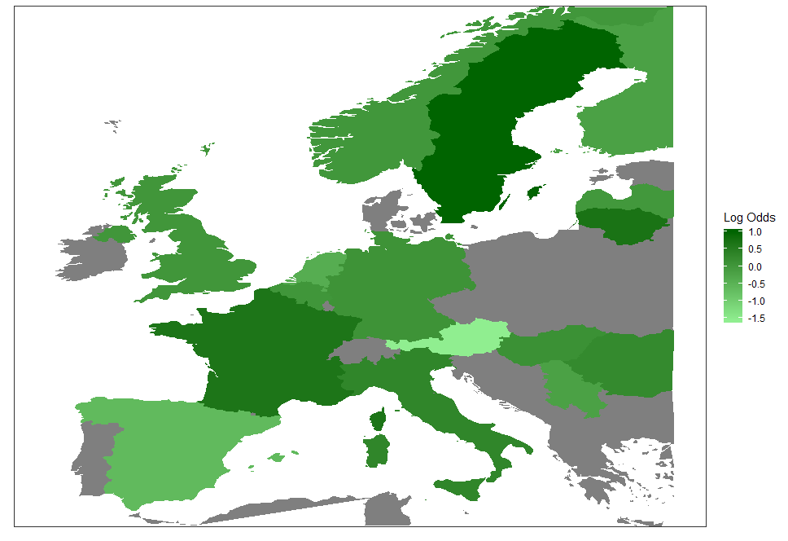 | 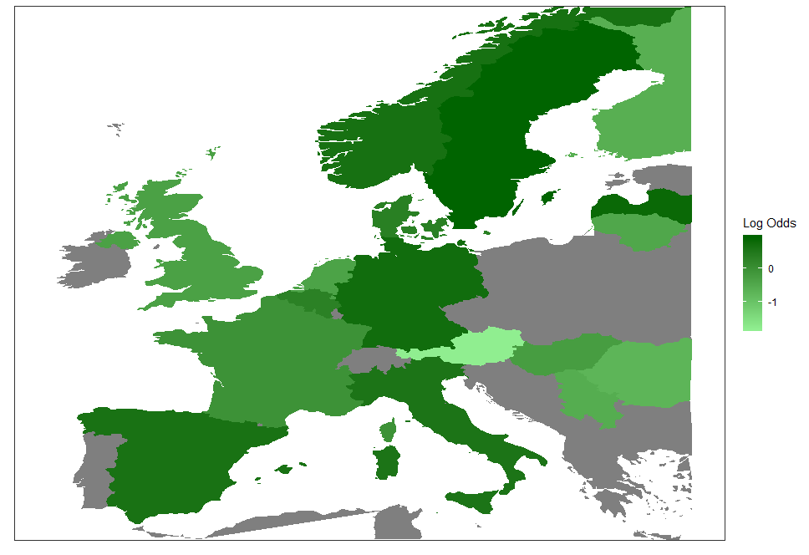
Log odds ratio of intracranial surgery, representing the log odds of intracranial surgery per contry compared to the overall average, adjusted for IMPACT CT model and stratum | Log odds ratio of extracrianal surgery, representing the log odds of extracranial surgery per contry compared to the overall average, adjusted for any major extracranial injury and stratum

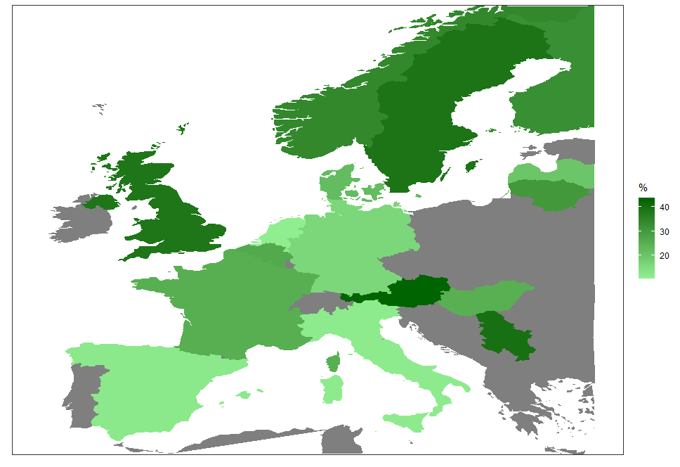 | 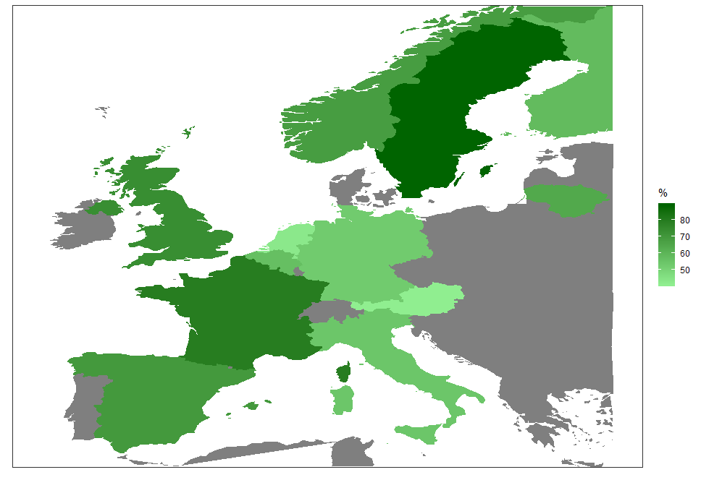
Percentage of patients in the ICU stratum (n = 2138) referred from another hospital per country | Percentage of patients with severe TBI (n= 958) with ICP monitor per country

Figure 3: Care pathway by stratum in the CENTER-TBI Core study (n=4509 patients). Vertical lines represent the first, second and third transition of care. For example, the majority of patients from the ER are discharged home while from the ICU most patients go to the ward. Abbreviations: ICU: Intensive Care Unit; ED: Emergency department. HCU: High Care Unit; OR: Operation Room; RU: Rehabilitation Unit; NH: Nursing Home.
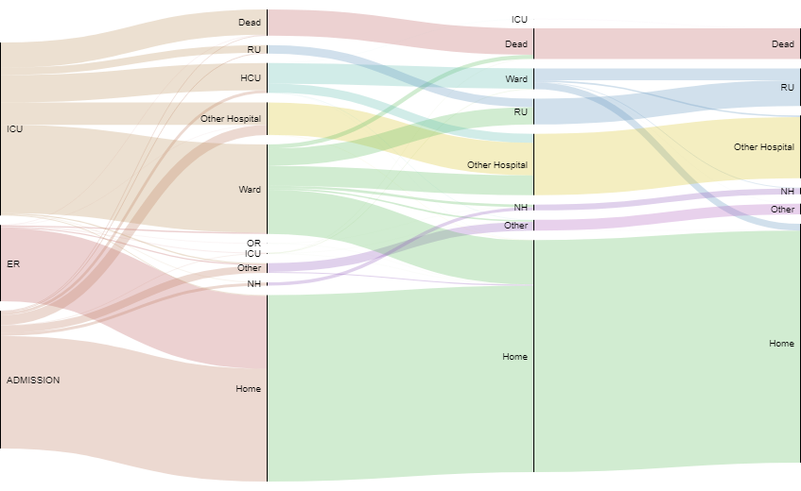
Figure 4: GOSE at 6 months by stratum in the Center-TBI Core study (ER n=694; Admission n=1264; ICU n=1846).
GOSE 1 = dead; GOSE 8 = Upper Good recovery; GOSE categories 2 (Vegetative) and 3 (Lower Severe Disability) are combined as differentiation is not possible for assessments performed by postal questionnaire.

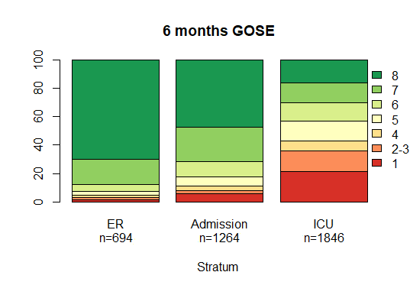

References

1. Majdan M, Plancikova D, Brazinova A, et al. Epidemiology of traumatic brain injuries in Europe: a cross-sectional analysis. Lancet Public Health 2016; 1(2): e76-e83.
2. Maas AIR, Menon DK, Adelson PD, et al. Traumatic brain injury: integrated approaches to improve prevention, clinical care, and research. Lancet Neurol 2017; 16(12): 987-1048.
3. Tosetti P, Hicks RR, Theriault E, et al. Toward an international initiative for traumatic brain injury research. J Neurotrauma 2013; 30(14): 1211-22.
4. Maas AI, Menon DK, Steyerberg EW, et al. Collaborative European NeuroTrauma Effectiveness Research in Traumatic Brain Injury (CENTER-TBI): a prospective longitudinal observational study. Neurosurgery 2015; 76(1): 67-80.
5. Volovici V, Ercole A, Citerio G, et al. Intensive care admission criteria for traumatic brain injury patients across Europe. J Crit Care 2019; 49: 158-61.
6. Huijben JA, Volovici V, Cnossen MC, et al. Variation in general supportive and preventive intensive care management of traumatic brain injury: a survey in 66 neurotrauma centers participating in the Collaborative European NeuroTrauma Effectiveness Research in Traumatic Brain Injury (CENTER-TBI) study. Crit Care 2018; 22(1): 90.
7. Huijben JA, van der Jagt M, Cnossen MC, et al. Variation in Blood Transfusion and Coagulation Management in Traumatic Brain Injury at the Intensive Care Unit: A Survey in 66 Neurotrauma Centers Participating in the Collaborative European NeuroTrauma Effectiveness Research in Traumatic Brain Injury Study. J Neurotrauma 2017.
8. Cnossen MC, Polinder S, Lingsma HF, et al. Variation in Structure and Process of Care in Traumatic Brain Injury: Provider Profiles of European Neurotrauma Centers Participating in the CENTER-TBI Study. PLoS One 2016; 11(8): e0161367.
9. Cnossen MC, Huijben JA, van der Jagt M, et al. Variation in monitoring and treatment policies for intracranial hypertension in traumatic brain injury: a survey in 66 neurotrauma centers participating in the CENTER-TBI study. Crit Care 2017; 21(1): 233.
10. Foks KA, Cnossen MC, Dippel DWJ, et al. Management of mild traumatic brain injury at the emergency department and hospital admission in Europe: A survey of 71 neurotrauma centers participating in the CENTER-TBI study. J Neurotrauma 2017.
11. Wilson JT, Pettigrew LE, Teasdale GM. Structured interviews for the Glasgow Outcome Scale and the extended Glasgow Outcome Scale: guidelines for their use. J Neurotrauma 1998; 15(8): 573-85.
12. von Steinbuechel N, Wilson L, Gibbons H, et al. QOLIBRI overall scale: a brief index of health-related quality of life after traumatic brain injury. J Neurol Neurosurg Psychiatry 2012; 83(11): 1041-7.
13. Ware JE. User's manual for the SF-12v2 health survey (with a supplement documenting SF-12 health survey). Lincoln, R.I.: QualityMetric Inc.; 2002.
14. Jackson C. Multi-State Models for Panel Data: The msm Package for R. 2011 2011; 38(8): 28.
15. Wilson L, Marsden-Loftus I, Koskinen S, et al. Interpreting Quality of Life after Brain Injury Scores: Cross-Walk with the Short Form-36. J Neurotrauma 2017; 34(1): 59-65.
16. Steyerberg EW, Mushkudiani N, Perel P, et al. Predicting outcome after traumatic brain injury: development and international validation of prognostic scores based on admission characteristics. PLoS Med 2008; 5(8): e165; discussion e.
17. Teasdale GM, Murray GD, Miller DJ, Pickard JD, Shaw MDM. Head injuries in four British neurosurgical centres AU - MURRAY, L. S. British Journal of Neurosurgery 1999; 13(6): 564-9.
18. Murray GD, Teasdale GM, Braakman R, et al. The European Brain Injury Consortium Survey of Head Injuries. Acta Neurochirurgica 1999; 141(3): 223-36.
19. Kehoe A, Smith JE, Edwards A, Yates D, Lecky F. The changing face of major trauma in the UK. Emerg Med J 2015; 32(12): 911-5.
20. Flaada JT, Leibson CL, Mandrekar JN, et al. Relative risk of mortality after traumatic brain injury: a population-based study of the role of age and injury severity. J Neurotrauma 2007; 24(3): 435-45.
21. Kirkman MA, Jenks T, Bouamra O, Edwards A, Yates D, Wilson MH. Increased mortality associated with cerebral contusions following trauma in the elderly: bad patients or bad management? J Neurotrauma 2013; 30(16): 1385-90.
22. Lamm AG, Goldstein R, Giacino J, Niewczyk P, Schneider JC, Zafonte RD. Changes in Patient Demographics and Outcomes in the Inpatient Rehabilitation Facility Traumatic Brain Injury Population from 2002 to 2016: Implications for Patient Care & Clinical Trials. J Neurotrauma 2019.
23. Yue JK, Ngwenya LB, Upadhyayula PS, et al. Emergency department blood alcohol level associates with injury factors and six-month outcome after uncomplicated mild traumatic brain injury. J Clin Neurosci 2017; 45: 293-8.
24. Martin JL, Gadegbeku B, Wu D, Viallon V, Laumon B. Cannabis, alcohol and fatal road accidents. PLoS One 2017; 12(11): e0187320.
25. Legrand SA, Houwing S, Hagenzieker M, Verstraete AG. Prevalence of alcohol and other psychoactive substances in injured drivers: comparison between Belgium and The Netherlands. Forensic Sci Int 2012; 220(1-3): 224-31.
26. Marshall LF,L Bowers SM, Melville RK, et al. A new classification of head injury based on computerized tomography. 1991; 75 (Supplement): S14.
27. Jain S, Vyvere TV, Terzopoulos V, et al. Automatic Quantification of Computed Tomography Features in Acute Traumatic Brain Injury. J Neurotrauma 2019.
28. Timmermans C, Smeets D, Verheyden J, et al. Potential of a statistical approach for the standardization of multicenter diffusion tensor data: A phantom study. J Magn Reson Imaging 2019.
29. Yuh EL, Mukherjee P, Lingsma HF, et al. Magnetic resonance imaging improves 3-month outcome prediction in mild traumatic brain injury. Ann Neurol 2013; 73(2): 224-35.
30. Lee H, Wintermark M, Gean AD, Ghajar J, Manley GT, Mukherjee P. Focal lesions in acute mild traumatic brain injury and neurocognitive outcome: CT versus 3T MRI. J Neurotrauma 2008; 25(9): 1049-56.
31. Posti JP, Takala RS, Runtti H, et al. The Levels of Glial Fibrillary Acidic Protein and Ubiquitin C-Terminal Hydrolase-L1 During the First Week After a Traumatic Brain Injury: Correlations With Clinical and Imaging Findings. Neurosurgery 2016; 79(3): 456-64.
32. Papa L, Brophy GM, Welch RD, et al. Time Course and Diagnostic Accuracy of Glial and Neuronal Blood Biomarkers GFAP and UCH-L1 in a Large Cohort of Trauma Patients With and Without Mild Traumatic Brain Injury. JAMA Neurol 2016; 73(5): 551-60.
33. Bazarian JJ, Biberthaler P, Welch RD, et al. Serum GFAP and UCH1-L1 in prediction of absence of intracranial injuries on head CT (ALERT-TBI): a multicenter observational study. Lancet Neurol 2018; published online July 24. http://dx.doi.org/10.1016/S1474-4422(18)30231-X.
34 Ratcliff JJ, Adeoye O, Lindsell CJ, et al. ED disposition of the Glasgow Coma Scale 13 to 15 traumatic brain injury patient: analysis of the Transforming Research and Clinical Knowledge in TBI study. Am J Emerg Med 2014; 32(8): 844-50.
35. Matsushima K, Inaba K, Siboni S, et al. Emergent operation for isolated severe traumatic brain injury: Does time matter? J Trauma Acute Care Surg 2015; 79(5): 838-42.
36. Seabury SA, Gaudette E, Goldman DP, et al. Assessment of Follow-up Care After Emergency Department Presentation for Mild Traumatic Brain Injury and Concussion: Results From the TRACK-TBI Study. JAMA Netw Open 2018; 1(1): e180210.
37. van Buuren S. Flexible Imputation of Missing Data. New York: Chapman & Hall/CRC; 2012.

**The CENTER-TBI participants and investigators:
Cecilia Åkerlund¹, Krisztina Amrein², Nada Andelic³, Lasse Andreassen⁴, Audny Anke⁵, Anna Antoni⁶, Gérard Audibert⁷, Kaspars Auslands⁸, Philippe Azouvi⁹, Maria Luisa Azzolini¹⁰, Rafael Badenes¹¹, Ronald Bartels¹², Pál Barzó¹³, Romuald Beauvais¹⁴, Ronny Beer¹⁵, Bo-Michael Bellander¹⁶, Antonio Belli¹⁷, Habib Benali ¹⁸, Maurizio Berardino¹⁹, Luigi Beretta¹⁰, Morten Blaabjerg²⁰, Peter Bragge²¹, Alexandra Brazinova²², Vibeke Brinck²³, Joanne Brooker²⁴, Camilla Brorsson²⁵, Andras Buki²⁶, Monika Bullinger²⁷, Manuel Cabeleira²⁸, Alessio Caccioppola²⁹, Emiliana Calappi²⁹, Maria Rosa Calvi¹⁰, Peter Cameron³⁰, Lozano Guillermo Carbayo³¹, Marco Carbonara²⁹, Ana M. Castaño-León³², Giorgio Chevallard³³, Arturo Chieregato³³, Maryse Cnossen³⁴, Mark Coburn³⁵, Jonathan Coles³⁶, Jamie D. Cooper³⁷, Marta Correia³⁸, Amra Covic³⁹, Nicola Curry⁴⁰, Endre Czeiter²⁶, Marek Czosnyka²⁸, Claire Dahyot-Fizelier⁴¹, Helen Dawes⁴², Vincent Degos¹⁸, Francesco Della Corte⁴³, Hugo den Boogert¹², Bart Depreitere ⁴⁴, Simone Dijkland³⁴, Dula Dilvesi⁴⁵, Abhishek Dixit⁴⁶, Emma Donoghue²⁴, Jens Dreier⁴⁷, Guy-Loup Dulière⁴⁸, Ari Ercole⁴⁶, Patrick Esser⁴², Erzsébet Ezer⁴⁹, Martin Fabricius⁵⁰, Valery L. Feigin⁵¹, Kelly Foks⁵², Shirin Frisvold⁵³, Alex Furmanov⁵⁴, Pablo Gagliardo⁵⁵, Damien Galanaud¹⁸, Dashiell Gantner³⁰, Guoyi Gao⁵⁶, Pradeep George⁵⁷, Alexandre Ghuysen⁵⁸, Lelde Giga⁵⁹, Ben Glocker⁶⁰, Jagos Golubovic⁴⁵, Pedro A. Gomez³², Johannes Gratz⁶¹, Benjamin Gravesteijn³⁴, Francesca Grossi⁴³, Russell L. Gruen⁶², Deepak Gupta⁶³, Juanita A. Haagsma³⁴, Iain Haitsma⁶⁴, Raimund Helbok¹⁵, Eirik Helseth⁶⁵, Lindsay Horton⁶⁶, Jilske Huijben³⁴, Peter J. Hutchinson⁶⁷, Bram Jacobs⁶⁸, Stefan Jankowski⁶⁹, Mike Jarrett²³, Ji-yao Jiang⁵⁶, Kelly Jones⁵¹, Mladen Karan⁴⁵, Angelos G. Kolias⁶⁷, Erwin Kompanje⁷⁰, Daniel Kondziella⁵⁰, Evgenios Koraropoulos⁴⁶, Lars-Owe Koskinen²⁵, Noémi Kovács⁷¹, Alfonso Lagares³², Steven Laureys⁷², Rolf Lefering⁷³, Valerie Legrand⁷⁴, Aurélie Lejeune⁷⁵, Leon Levi⁷⁶, Roger Lightfoot⁷⁷, Angels Lozano¹¹, Marc Maegele⁷⁸, Marek Majdan²², Alex Manara⁷⁹, Costanza Martino⁸⁰, Hugues Maréchal ⁴⁸, Julia Mattern ⁸¹, Catherine McMahon⁸², Béla Melegh⁸³, Tomas Menovsky⁸⁴, Davide Mulazzi²⁹, Visakh Muraleedharan⁵⁷, Lynnette Murray³⁰, Nandesh Nair⁸³ , Ancuta Negru⁸⁵, Virginia Newcombe⁴⁶, Daan Nieboer³⁴, Quentin Noirhomme⁷², József Nyirádi³, Mauro Oddo⁸⁶, Otesile Olubukola⁸⁷, Matej Oresic⁸⁸, Fabrizio Ortolano²⁹, Aarno Palotie^{89, 90, 91}, Paul M. Parizel⁹², Jean-François Payen⁹³, Natascha Perera¹⁴, Vincent Perlbarg¹⁸, Paolo Person ⁹⁴, Anna Piippo-Karjalainen⁹⁵, Sébastien Pili Floury⁹⁶, Matti Pirinen⁸⁹, Horia Ples⁸⁵, Suzanne Polinder³⁴, Inigo Pomposo³¹, Jussi P. Posti⁹⁷, Louis Puybasset⁹⁸, Andreea Radoi⁹⁹, Arminas Ragauskas¹⁰⁰, Rahul Raj⁹⁵, Malinka Rambadagalla¹⁰¹, Ruben Real³⁹, Jonathan Rhodes¹⁰², Sylvia Richardson¹⁰³, Sophie Richter⁴⁶, Samuli Ripatti⁸⁹, Saulius Rocka¹⁰⁰, Cecilie Roe¹⁰⁴, Olav Roise¹⁰⁵, Jonathan Rosand¹⁰⁶, Jeffrey V. Rosenfeld¹⁰⁷, Christina Rosenlund¹⁰⁸, Guy Rosenthal⁵⁴, Rolf Rossaint³⁵, Sandra Rossi⁹⁴, Daniel Rueckert ⁶⁰, Martin Rusnák ¹⁰⁹, Juan Sahuquillo ⁹⁹, Oliver Sakowitz^{81, 110}, Renan Sanchez-Porras¹¹⁰, Janos Sandor¹¹¹, Nadine Schäfer⁷³, Silke Schmidt¹¹², Herbert Schoechl¹¹³, Guus Schoonman¹¹⁴, Rico Frederik Schou¹¹⁵, Elisabeth Schwendenwein⁶ ,Toril Skandsen^{116, 117} , Peter Smielewski²⁸, Abayomi Sorinola¹¹⁸, Emmanuel Stamatakis⁴⁶, Simon Stanworth⁴⁰, Ana Stevanovic³⁵, Robert Stevens¹¹⁹, William Stewart¹²⁰, Nina Sundström²⁵, Anneliese Synnot^{24, 121}, Riikka Takala¹²², Viktória Tamás¹¹⁸, Tomas Tamosuitis¹²³, Mark Steven Taylor²², Braden Te Ao⁵¹, Olli Tenovuo⁹⁷, Alice Theadom⁵¹, Matt Thomas⁷⁹, Dick Tibboel¹²⁴, Marjolein Timmers⁷⁰, Christos Tolias¹²⁵, Tony Trapani³⁰, Cristina Maria Tudora⁸⁵, Peter Vajkoczy¹²⁶, Shirley Vallance³⁰, Egils Valeinis⁵⁸, Zoltán Vámos⁴⁹, Gregory van der Steen⁸⁴, Joukje van der Naalt⁶⁸, Jeroen T.J.M. van Dijck¹²⁷, Thomas A. van Essen ¹²⁷, Wim van Hecke¹²⁸, Caroline van Heugten¹²⁹, Dominique van Praag¹³⁰, Thijs vande Vyvere¹²⁸, Audrey Vanhaudenhuyse^{18, 72}, Roel P. J. van Wijk¹²⁷, Alessia Vargiolu¹³¹, Emmanuel Vega⁷⁵, Kimberley Velt³⁴, Jan Verheyden¹²⁸, Paul M. Vespa¹³², Anne Vik^{114, 133}, Rimantas Vilcinis ¹²³, Victor Volovici ⁶⁴, Daphne Voormolen³⁴, Petar Vulekovic⁴⁵, Kevin K.W. Wang¹³⁴, Guy Williams⁴⁶, Lindsay Wilson⁶⁶, Stefan Winzeck⁴⁶, Stefan Wolf¹³⁵, Zhihui Yang¹³⁴, Peter Ylén¹³⁶, Alexander Younsi⁸¹, Frederik A. Zeiler^{46, 137}, Veronika Zelinkova²², Agate Ziverte⁵⁹ , Tommaso Zoerle²⁹
¹ Department of Physiology and Pharmacology, Section of Perioperative Medicine and Intensive Care, Karolinska Institutet, Stockholm, Sweden
² János Szentágothai Research Centre, University of Pécs, Pécs, Hungary
³ Division of Surgery and Clinical Neuroscience, Department of Physical Medicine and Rehabilitation, Oslo University Hospital and University of Oslo, Oslo, Norway
⁴ Department of Neurosurgery, University Hospital Northern Norway, Tromso, Norway
⁵ Department of Physical Medicine and Rehabilitation, University Hospital Northern Norway, Tromso, Norway
⁶ Trauma Surgery, Medical University Vienna, Vienna, Austria
⁷ Department of Anesthesiology & Intensive Care, University Hospital Nancy, Nancy, France
⁸ Riga Eastern Clinical University Hospital, Riga, Latvia
⁹ Raymond Poincare hospital, Assistance Publique – Hopitaux de Paris, Paris, France
¹⁰ Department of Anesthesiology & Intensive Care, S Raffaele University Hospital, Milan, Italy
¹¹ Department Anesthesiology and Surgical-Trauma Intensive Care, Hospital Clinic Universitari de Valencia, Spain
¹² Department of Neurosurgery, Radboud University Medical Center, Nijmegen, The Netherlands
¹³ Department of Neurosurgery, University of Szeged, Szeged, Hungary
¹⁴ International Projects Management, ARTTIC, Munchen, Germany
¹⁵ Department of Neurology, Neurological Intensive Care Unit, Medical University of Innsbruck, Innsbruck, Austria
¹⁶ Department of Neurosurgery & Anesthesia & intensive care medicine, Karolinska University Hospital, Stockholm, Sweden
¹⁷ NIHR Surgical Reconstruction and Microbiology Research Centre, Birmingham, UK
¹⁸ Anesthesie-Réanimation, Assistance Publique – Hopitaux de Paris, Paris, France
¹⁹ Department of Anesthesia & ICU, AOU Città della Salute e della Scienza di Torino - Orthopedic and Trauma Center, Torino, Italy
²⁰ Department of Neurology, Odense University Hospital, Odense, Denmark
²¹ BehaviourWorks Australia, Monash Sustainability Institute, Monash University, Victoria, Australia
²² Department of Public Health, Faculty of Health Sciences and Social Work, Trnava University, Trnava, Slovakia
²³ Quesgen Systems Inc., Burlingame, California, USA
²⁴ Australian & New Zealand Intensive Care Research Centre, Department of Epidemiology and Preventive Medicine, School of Public Health and Preventive Medicine, Monash University, Melbourne, Australia
²⁵ Department of Clinical Neuroscience, Neurosurgery, Umea University, Umea, Sweden
²⁶ Department of Neurosurgery, Medical School, University of Pécs, Hungary and Neurotrauma Research Group, János Szentágothai Research Centre, University of Pécs, Hungary
²⁷ Department of Medical Psychology, Universitätsklinikum Hamburg-Eppendorf, Hamburg, Germany
²⁸ Brain Physics Lab, Division of Neurosurgery, Dept of Clinical Neurosciences, University of Cambridge, Addenbrooke’s Hospital, Cambridge, UK
²⁹ Neuro ICU, Fondazione IRCCS Cà Granda Ospedale Maggiore Policlinico, Milan, Italy
³⁰ ANZIC Research Centre, Monash University, Department of Epidemiology and Preventive Medicine, Melbourne, Victoria, Australia
³¹ Department of Neurosurgery, Hospital of Cruces, Bilbao, Spain
³² Department of Neurosurgery, Hospital Universitario 12 de Octubre, Madrid, Spain
³³ NeuroIntensive Care, Niguarda Hospital, Milan, Italy
³⁴ Department of Public Health, Erasmus Medical Center-University Medical Center, Rotterdam, The Netherlands
³⁵ Department of Anaesthesiology, University Hospital of Aachen, Aachen, Germany
³⁶ Department of Anesthesia & Neurointensive Care, Cambridge University Hospital NHS Foundation Trust, Cambridge, UK
³⁷ School of Public Health & PM, Monash University and The Alfred Hospital, Melbourne, Victoria, Australia
³⁸ Radiology/MRI department, MRC Cognition and Brain Sciences Unit, Cambridge, UK
³⁹ Institute of Medical Psychology and Medical Sociology, Universitätsmedizin Göttingen, Göttingen, Germany
⁴⁰ Oxford University Hospitals NHS Trust, Oxford, UK
⁴¹ Intensive Care Unit, CHU Poitiers, Potiers, France
⁴² Movement Science Group, Faculty of Health and Life Sciences, Oxford Brookes University, Oxford, UK
⁴³ Department of Anesthesia & Intensive Care, Maggiore Della Carità Hospital, Novara, Italy
⁴⁴ Department of Neurosurgery, University Hospitals Leuven, Leuven, Belgium
⁴⁵ Department of Neurosurgery, Clinical centre of Vojvodina, Faculty of Medicine, University of Novi Sad, Novi Sad, Serbia
⁴⁶ Division of Anaesthesia, University of Cambridge, Addenbrooke’s Hospital, Cambridge, UK
⁴⁷ Center for Stroke Research Berlin, Charité – Universitätsmedizin Berlin, corporate member of Freie Universität Berlin, Humboldt-Universität zu Berlin, and Berlin Institute of Health, Berlin, Germany
⁴⁸ Intensive Care Unit, CHR Citadelle, Liège, Belgium
⁴⁹ Department of Anaesthesiology and Intensive Therapy, University of Pécs, Pécs, Hungary
⁵⁰ Departments of Neurology, Clinical Neurophysiology and Neuroanesthesiology, Region Hovedstaden Rigshospitalet, Copenhagen, Denmark
⁵¹ National Institute for Stroke and Applied Neurosciences, Faculty of Health and Environmental Studies, Auckland University of Technology, Auckland, New Zealand
⁵² Department of Neurology, Erasmus MC, Rotterdam, the Netherlands
⁵³ Department of Anesthesiology and Intensive care, University Hospital Northern Norway, Tromso, Norway
⁵⁴ Department of Neurosurgery, Hadassah-hebrew University Medical center, Jerusalem, Israel
⁵⁵ Fundación Instituto Valenciano de Neurorrehabilitación (FIVAN), Valencia, Spain
⁵⁶ Department of Neurosurgery, Shanghai Renji hospital, Shanghai Jiaotong University/school of medicine, Shanghai, China
⁵⁷ Karolinska Institutet, INCF International Neuroinformatics Coordinating Facility, Stockholm, Sweden
⁵⁸ Emergency Department, CHU, Liège, Belgium
⁵⁹ Neurosurgery clinic, Pauls Stradins Clinical University Hospital, Riga, Latvia
⁶⁰ Department of Computing, Imperial College London, London, UK
⁶¹ Department of Anesthesia, Critical Care and Pain Medicine, Medical University of Vienna, Austria
⁶² College of Health and Medicine, Australian National University, Canberra, Australia
⁶³ Department of Neurosurgery, Neurosciences Centre & JPN Apex trauma centre, All India Institute of Medical Sciences, New Delhi-110029, India
⁶⁴ Department of Neurosurgery, Erasmus MC, Rotterdam, the Netherlands
⁶⁵ Department of Neurosurgery, Oslo University Hospital, Oslo, Norway
⁶⁶ Division of Psychology, University of Stirling, Stirling, UK
⁶⁷ Division of Neurosurgery, Department of Clinical Neurosciences, Addenbrooke’s Hospital & University of Cambridge, Cambridge, UK
⁶⁸ Department of Neurology, University Of Groningen, University Medical Center Groningen, Groningen, Netherlands
⁶⁹ Neurointensive Care, Sheffield Teaching Hospitals NHS Foundation Trust, Sheffield, UK
⁷⁰ Department of Intensive Care and Department of Ethics and Philosophy of Medicine, Erasmus Medical Center, Rotterdam, The Netherlands
⁷¹ Hungarian Brain Research Program - Grant No. KTIA_13_NAP-A-II/8, University of Pécs, Pécs, Hungary
⁷² Cyclotron Research Center , University of Liège, Liège, Belgium
⁷³ Institute of Research in Operative Medicine (IFOM), Witten/Herdecke University, Cologne, Germany
⁷⁴ VP Global Project Management CNS, ICON, Paris, France
⁷⁵ Department of Anesthesiology-Intensive Care, Lille University Hospital, Lille, France
⁷⁶ Department of Neurosurgery, Rambam Medical Center, Haifa, Israel
⁷⁷ Department of Anesthesiology & Intensive Care, University Hospitals Southhampton NHS Trust, Southhampton, UK
⁷⁸ Cologne-Merheim Medical Center (CMMC), Department of Traumatology, Orthopedic Surgery and Sportmedicine, Witten/Herdecke University, Cologne, Germany
⁷⁹ Intensive Care Unit, Southmead Hospital, Bristol, Bristol, UK
⁸⁰ Department of Anesthesia & Intensive Care,M. Bufalini Hospital, Cesena, Italy
⁸¹ Department of Neurosurgery, University Hospital Heidelberg, Heidelberg, Germany
⁸² Department of Neurosurgery, The Walton centre NHS Foundation Trust, Liverpool, UK
⁸³ Department of Medical Genetics, University of Pécs, Pécs, Hungary
⁸⁴ Department of Neurosurgery, Antwerp University Hospital and University of Antwerp, Edegem, Belgium
⁸⁵ Department of Neurosurgery, Emergency County Hospital Timisoara , Timisoara, Romania
⁸⁶ Department of Intensive Care Medicine, Centre Hospitalier Universitaire Vaudois, Lausanne, Switzerland
⁸⁷ Emergency Medicine Research in Sheffield, Health Services Research Section, School of Health and Related Research (ScHARR), University of Sheffield, Sheffield, UK
⁸⁸ School of Medical Sciences, Örebro University, Örebro, Sweden
⁸⁹ Institute for Molecular Medicine Finland, University of Helsinki, Helsinki, Finland
⁹⁰ Analytic and Translational Genetics Unit, Department of Medicine; Psychiatric & Neurodevelopmental Genetics Unit, Department of Psychiatry; Department of Neurology, Massachusetts General Hospital, Boston, MA, USA
⁹¹ Program in Medical and Population Genetics; The Stanley Center for Psychiatric Research, The Broad Institute of MIT and Harvard, Cambridge, MA, USA
⁹² Department of Radiology, Antwerp University Hospital and University of Antwerp, Edegem, Belgium
⁹³ Department of Anesthesiology & Intensive Care, University Hospital of Grenoble, Grenoble, France
⁹⁴ Department of Anesthesia & Intensive Care, Azienda Ospedaliera Università di Padova, Padova, Italy
⁹⁵ Department of Neurosurgery, Helsinki University Central Hospital
⁹⁶ Intensive Care Unit, CHRU de Besançon, Besançon, France
⁹⁷ Division of Clinical Neurosciences, Department of Neurosurgery and Turku Brain Injury Centre, Turku University Hospital and University of Turku, Turku, Finland
⁹⁸ Department of Anesthesiology and Critical Care, Pitié -Salpêtrière Teaching Hospital, Assistance Publique, Hôpitaux de Paris and University Pierre et Marie Curie, Paris, France
⁹⁹ Neurotraumatology and Neurosurgery Research Unit (UNINN), Vall d'Hebron Research Institute, Barcelona, Spain
¹⁰⁰ Department of Neurosurgery, Kaunas University of technology and Vilnius University, Vilnius, Lithuania
¹⁰¹ Department of Neurosurgery, Rezekne Hospital, Latvia
¹⁰² Department of Anaesthesia, Critical Care & Pain Medicine NHS Lothian & University of Edinburg, Edinburgh, UK
¹⁰³ Director, MRC Biostatistics Unit, Cambridge Institute of Public Health, Cambridge, UK
¹⁰⁴ Department of Physical Medicine and Rehabilitation, Oslo University Hospital/University of Oslo, Oslo, Norway
¹⁰⁵ Division of Surgery and Clinical Neuroscience, Oslo University Hospital, Oslo, Norway
¹⁰⁶ Broad Institute, Cambridge MA Harvard Medical School, Boston MA, Massachusetts General Hospital, Boston MA, USA
¹⁰⁷ National Trauma Research Institute, The Alfred Hospital, Monash University, Melbourne, Victoria, Australia
¹⁰⁸ Department of Neurosurgery, Odense University Hospital, Odense, Denmark
¹⁰⁹ International Neurotrauma Research Organisation, Vienna, Austria
¹¹⁰ Klinik für Neurochirurgie, Klinikum Ludwigsburg, Ludwigsburg, Germany
¹¹¹ Division of Biostatistics and Epidemiology, Department of Preventive Medicine, University of Debrecen, Debrecen, Hungary
¹¹² Department Health and Prevention, University Greifswald, Greifswald, Germany
¹¹³ Department of Anaesthesiology and Intensive Care, AUVA Trauma Hospital, Salzburg, Austria
¹¹⁴ Department of Neurology, Elisabeth-TweeSteden Ziekenhuis, Tilburg, the Netherlands
¹¹⁵ Department of Neuroanesthesia and Neurointensive Care, Odense University Hospital, Odense, Denmark
¹¹⁶ Department of Neuromedicine and Movement Science, Norwegian University of Science and Technology, NTNU, Trondheim, Norway
¹¹⁷ Department of Physical Medicine and Rehabilitation, St. Olavs Hospital, Trondheim University Hospital, Norway
¹¹⁸ Department of Neurosurgery, University of Pécs, Pécs, Hungary
¹¹⁹ Division of Neuroscience Critical Care, John Hopkins University School of Medicine, Baltimore, USA
¹²⁰ Department of Neuropathology, Queen Elizabeth University Hospital and University of Glasgow, Glasgow, UK
¹²¹ Cochrane Consumers and Communication Review Group, Centre for Health Communication and Participation, School of Psychology and Public Health, La Trobe University, Melbourne, Australia
¹²² Perioperative Services, Intensive Care Medicine and Pain Management, Turku University Hospital and University of Turku, Turku, Finland
¹²³ Department of Neurosurgery, Kaunas University of Health Sciences, Kaunas, Lithuania
¹²⁴ Intensive Care and Department of Pediatric Surgery, Erasmus Medical Center, Sophia Children’s Hospital, Rotterdam, The Netherlands
¹²⁵ Department of Neurosurgery, Kings college London, London, UK
¹²⁶ Neurologie, Neurochirurgie und Psychiatrie, Charité – Universitätsmedizin Berlin, Berlin, Germany
¹²⁷ Dept. of Neurosurgery, Leiden University Medical Center, Leiden, The Netherlands and Dept. of Neurosurgery, Medical Center Haaglanden, The Hague, The Netherlands
¹²⁸ icoMetrix NV, Leuven, Belgium
¹²⁹ Movement Science Group, Faculty of Health and Life Sciences, Oxford Brookes University, Oxford, UK
¹³⁰ Psychology Department, Antwerp University Hospital, Edegem, Belgium
¹³¹ NeuroIntensive Care, ASST di Monza, Monza, Italy
¹³² Director of Neurocritical Care, University of California, Los Angeles, USA
¹³³ Department of Neurosurgery, St.Olavs Hospital, Trondheim University Hospital, Trondheim, Norway
¹³⁴ Department of Emergency Medicine, University of Florida, Gainesville, Florida, USA
¹³⁵ Department of Neurosurgery, Charité – Universitätsmedizin Berlin, corporate member of Freie Universität Berlin, Humboldt-Universität zu Berlin, and Berlin Institute of Health, Berlin, Germany
¹³⁶ VTT Technical Research Centre, Tampere, Finland
¹³⁷ Section of Neurosurgery, Department of Surgery, Rady Faculty of Health Sciences, University of Manitoba, Winnipeg, MB, Canada

Case-mix, care pathways, and outcomes in patients with traumatic brain injury in CENTER-TBI:
a European prospective, multicentre, longitudinal, cohort study

Ewout W. Steyerberg ^{1,2}, Eveline Wiegers^{1 *}, Charlie Sewalt^{1 *}, Andras Buki³, Giuseppe Citerio^{4,5}, Véronique De Keyser⁶, Ari Ercole⁷, Kevin Kunzmann⁸, Linda Lanyon⁹, Fiona Lecky¹⁰, Hester Lingsma¹, Geoffrey Manley¹¹, David Nelson¹², Wilco Peul¹³, Nino Stocchetti¹⁴, Nicole von Steinbüchel¹⁵, Thijs Vande Vyvere^{16,17}, Jan Verheyden¹⁷, Lindsay Wilson¹⁸, Andrew I.R. Maas^{6,19 *}, David K. Menon^{7 *} and the CENTER-TBI Participants and Investigators**

Supplementary material

Index of Supplementary Material

1. Supplementary methods

2. Supplementary Tables:
Table S1: Socioeconomic characteristics
Table S2: Pre-injury health status and medical history
Table S3: Cause of injury and intoxications
Table S4: Baseline clinical characteristics
Table S5: Characteristics of patients enrolled in the Center-TBI Registry vs.Center-TBI Core study.
Table S6: CT characteristics from central review
Table S7: Agreement between central and local radiological evaluation of admission CT scans.
Table S8: CT and MR agreement for MR early (<3 weeks) scans
Table S9: Diagnostic and Surgical interventions
Table S10: Glasgow Outcome Scale – Extended (GOSE) assessed at follow-up: known vs. unknown

3. Supplementary Figures
Figure S1: Participation per study centre & country in the Center-TBI Core study
Figure S2: Enrolment in strata by centre.
Figure S3: Age by sex distribution by stratum
Figure S4: Cause of Injury by Age Group, CENTER-TBI Core
Figure S5 Alcohol use and Cause of Injury, CENTER-TBI Core
Figure S6: GCS distribution by stratum
Figure S7: Biomarkers versus CT Abnormalities by stratum
Figure S8: Biomarkers by GCS levels in the CENTER-TBI Core study
Figure S9: Correlation between glucose, hemoglobin, and six biomarkers
4. References

Supplementary methods
Informed Consent and data de-identification
Consent procedures adhered to local and national requirements. Informed consent was preferred, but seldom possible as most patients were rendered mentally incapacitated by their TBI. Efforts were made to identify a legally acceptable representative (e.g. consultee/proxy). Other options included deferred consent and waiver of consent. We specifically sought consent for blood sampling, DNA analyses, and sharing data with other researchers (both within and outside of Europe). Subjects were free to withdraw, or to be withdrawn by their consultee/proxy: options included complete withdrawal (deletion of all data and destruction of biosamples) and partial withdrawal (cessation of new data accrual, but permission to use data and biosamples already collected). Locally collected data were de-identified and patients allocated a randomly generated GUPI (Global Unique Patient Identifier). All date and time entries were zeroed to the Unix epoch, thus permitting analysis of time intervals while preserving de-identification. Potential patient identifiers were removed from free text, both manually and by automated procedures. Images were defaced upon upload.

Biobank
The CENTER-TBI biobank (Pecs, Hungary) stored samples of whole blood, serum and plasma for genetic, biomarker and haemostasis analyses, respectively, for both the current study and legacy research.¹ Biomarker analysis was staged: we report on admission samples from 961 patients to explore the potential utility of candidate biomarkers, which included Neuron Specific Enolase (NSE), S-100B , Neurofilament light (NFL), total tau, glial fibrillary acidic protein (GFAP), and ubiquitin carboxyl-terminal hydrolase L1 (UCHL1). NSE and S-100B were measured on the e602 module of a Cobas 8000 analyzer (Roche Diagnostics International Ltd. Rotkreuz, Switzerland) in Pecs, Hungary. Neurofilament light (NFL), total tau, glial fibrillary acidic protein (GFAP), and ubiquitin carboxyl-terminal hydrolase L1 (UCHL1) were measured using the Quanterix SIMOA Neurology 4-plex kit (Quanterix, Lexington, MA, USA), at the University of Florida, USA.

Neuro-imaging repository
CT scans were obtained in all patients upon presentation. Follow up CT scans were acquired as clinically indicated or by local protocol. ¹ MR scans were obtained in a subset of participating centres, and results are provided on analysis of the first 504 early (<3 weeks) studies. Images were scored locally, details captured in the e-CRF, and subsequently uploaded into a central repository coordinated and maintained by Icometrix (https://icometrix.com/). All uploaded images were read centrally using NINDS CDE-based structured qualitative reporting
(https://www.commondataelements.ninds.nih.gov/Doc/SharedForms/F0328_Imaging.docx).

Outcome data
Outcome assessments included disease-specific and health-related quality of life, psychosocial and symptom questionnaires and neuropsychological tests. Outcome assessors underwent face-to face training. Questionnaires were translated into national languages and linguistically validated.¹ Telephone or postal interviews were permitted in addition to face-to-face assessments. Cross-sectional outcome assessments across all strata were performed at 6 months post-injury. We report on the three primary outcome measures as defined on registration of the study (global function and health-related quality of life: GOSE² (overall impact of injury, including extracranial injuries), Qolibri-OS³ and SF-12v2⁴), and on mortality at 6 months after injury. We classified Qolibri-OS scores <52 and SF-12v2 summary scores < 40 as impaired.⁵ Secondary outcome instruments used in the study are given in the tables below.

Secondary outcome Instruments CENTER-TBI
Questionnaire Follow-up* (Telephone interview or postal questionnaire/personal interview)
- Participant Questionnaire Part A
- QOLIBRI
- Post-traumatic Stress Disorder (PCL-5)
- GAD-7
- Rivermead Post Concussion Questionnaire (RPQ)
- SF36v2
- PHQ-9

Neuropsychology Follow-up* (Neuropsychological testing face to face visit)
- Participant Questionnaire Part B
- GOAT
- RAVLT
- TMT
- CANTAB
- 10 meter walk and timed up and go
- JFK Coma Recovery Scale –Revised

Data curation
Data were stored on a secure relational database, hosted by the International Neuroinformatics Coordinating Facility (INCF; www.incf.org) in Stockholm, Sweden. Source data verification of major characteristics was undertaken on a quasi-random sample of 1298 patients (28%) by a designated Contract Research Organization (ICON, Ltd, Paris). A multidisciplinary data curation task force addressed data missingness and plausibility, tested for multivariate consistency by cross-checking variables, and calculated derived variables to aid analyses. The cleaned and fully de-identified database was accompanied by a data dictionary with detailed descriptions of data manipulation or transformation applied, and an explicit record of non-resolvable curation issues. A data management tool, ‘Neurobot’ (http://neurobot.incf.org) was developed by INCF (RRID: SCR_01700). This facilitated data extractions, with the script storable as a unified resource locator for subsequent reuse, reference, or sharing. Separate repositories were used to store Imaging files (https://icometrix.com/) and high-resolution data (in hdf5 format⁶).

Data analysis
Patients without any GOSE assessment were excluded from analysis (n=705; 16%). The 6-month GOSE scores were available within the 5-8 month protocol window for 2186 (62%) patients. For 988 patients (22%) with scores outside the 5-8 month window, we used a multistate model to estimate the 180-day GOSE. We used the IMPACT Core model for the expected mortality and proportion with unfavourable GOSE outcome among patients with moderate or severe TBI (Glasgow Coma Score <= 12). ⁷ Observed mortality and unfavourable GOSE outcomes were compared to expected outcomes and expressed as a ratio with 95% confidence intervals estimated according to a Poisson distribution.
For calculating SF-12v2 summary scores, we used the SF-12v2 questionnaires where complete, supplemented by derived scores using SF-36v2 items when available.

Table S1: Socio-economic characteristics
Variable | N complete | N (%) | ER (N, %) | Admission (N, %) | ICU (N, %) | p-value*
 |  | 4509 | 848 (19%) | 1523 (34%) | 2138 (47%)
Years of education (median, IQR) | 3212 | 13 (10 – 16) | 13 (11 – 16) | 13 (11 – 16) | 12 (10 – 15) | <0·001
Highest level of education | 3566 |  |  |  |  | <0·001
- None or primary school |  | 641 (18%) | 141 (18%) | 224 (17%) | 276 (19%)
- Currently in or with diploma/degree oriented program |  | 814 (23%) | 152 (19%) | 324 (25%) | 338 (23%)
- Secondary school |  | 1261 (35%) | 258 (33%) | 422 (32%) | 581 (39%)
- College / University |  | 850 (24%) | 236 (30%) | 334 (26%) | 280 (19%)
Marital status | 4075
- Married/living together |  | 2070 (51%) | 385 (48%) | 717 (50%) | 968 (52%) | 0·15
Employment status before injury | 3980 |  |  |  |  | 0·05
- Working |  | 1946 (49%) | 427 (52%) | 638 (45%) | 881 (50%)
- Unable to work/sick leave |  | 127 (3·2%) | 23 (2·8%) | 46 (3·3%) | 58 (3·3%)
- Retired |  | 1112 (28%) | 208 (26%) | 438 (31%) | 466 (27%)
- Looking for work |  | 235 (5·9%) | 48 (5·9%) | 88 (6·2%) | 99 (5·7%)
- Student / schoolgoing |  | 486 (12%) | 92 (11%) | 174 (12%) | 220 (13%)
- Homemaker |  | 74 (1·9%) | 18 (2·2%) | 30 (2·1%) | 26 (1·5%)

* p-values from ANOVA and chi-square statistics for continuous and categorical characteristics respectively

Table S2: Pre-injury health status and medical history
 | N complete | All (N, %) | ER (N, %) | Admission (N, %) | ICU (N, %) | p-value*
 |  | 4509 | 848 (19%) | 1523 (34%) | 2138 (47%)
Pre-injury ASA-PS classification | 4373 |  |  |  |  | 0·56
- A normal healthy patient |  | 2501 (57%) | 482 (57%) | 836 (56%) | 1183 (58%)
- A patient with mild systemic disease |  | 1410 (32%) | 268 (32%) | 507 (34%) | 635 (31%)
- A patient with severe systemic disease |  | 462 (11%) | 93 (11%) | 159 (11%) | 210 (10%)
Medical history |  |  |  |  |  | 0·21
- Any | 4370 | 2089 (48%) | 413 (49%) | 737 (49%) | 939 (46%)
- Cardiovascular disease | 4375 | 1304 (30%) | 235 (28%) | 492 (33%) | 577 (29%)
- Endocrine disease | 4369 | 583 (13%) | 130 (16%) | 206 (14%) | 247 (12%)
Diabetic Mellitus |  | 339 (7·8%) | 70 (8·3%) | 124 (8·1%) | 145 (6·8%)
- Oncologic | 4368 | 285 (6·5%) | 63 (7·5%) | 110 (7·3%) | 112 (5·6%)
- Pulmonary | 4369 | 443 (10%) | 83 (9·9%) | 180 (12%) | 180 (8·9%)
- Psychiatric | 4352 | 601 (14%) | 127 (15%) | 182 (12%) | 292 (15%)
Previous TBI / concussions |  |  |  |  |  | <0·001
- Previous TBI | 4158 | 402 (9·7%) | 120 (15%) | 149 (10%) | 133 (7·0%)
Anticoagulants | 4345 | 298 (6·9%) | 46 (5·5%) | 133 (8·8%) | 119 (6·0%) | 0·001
Platelet aggregation inhibitors | 4345 | 474 (11%) | 85 (10%) | 178 (12%) | 211 (11%) | 0·38
ASA-PS = The American Society of Anesthesiologists (ASA) physical status classification system, Any Medical History = Cardiovascular disease, Endocrine disease, Oncologic disease, Pulmonary disease, Psychiatric disease, TBI = Traumatic Brain Injury.
* p-values from ANOVA and chi-square statistics for continuous and categorical characteristics respectively

Table S3: Cause of injury and intoxications

 | N complete | All (N, %) | ER (N, %) | Admission (N, %) | ICU (N, %) | p-value *
 |  | 4509 | 848 (19%) | 1523 (34%) | 2138 (47%)
Cause of injury | 4388 |  |  |  |  | <0·001
- Road traffic incident |  | 1682 (38%) | 266 (32%) | 490 (33%) | 926 (45%)
- Incidental fall |  | 2024 (46%) | 424 (51%) | 761 (51%) | 839 (41%)
- Violence / assault |  | 245 (5·6%) | 61 (7·3%) | 100 (6·7%) | 84 (4·1%)
- Suicide attempt |  | 48 (1·1%) | 1 (0·1%) | 3 (0·2%) | 44 (2·1%)
- Other |  | 389 (8·9%) | 84 (10%) | 145 (9·7%) | 160 (7·8%)
Alcohol involved in the injury (yes or suspected) | 4163 | 1054 (25%) | 137 (17%) | 384 (27%) | 533 (28%) | <0·001
Recreational drugs involved in the injury (yes or suspected) | 3938 | 130 (3·3%) | 12 (1·5%) | 28 (2·0%) | 90 (5·2%) | <0·001
Sedatives or sleeping pills involved in the injury (yes or suspected) | 3883 | 92 (2·4%) | 10 (1·2%) | 31 (2·2%) | 51 (3·0%) | 0·020
* p-values from ANOVA and chi-square statistics for continuous and categorical characteristics respectively

Table S4: Baseline clinical characteristics
 | N complete | All (N, %) | ER (N, %) | Admission (N, %) | ICU (N, %) | p-value *
 |  | 4509 (100% | 848 (19%) | 1523 (34%) | 2138 (47%)
GCS (median (IQR))  Mild (13-15)  Moderate (9-12)  Severe (3-8) | 4330 | 15 (10-15)  2955 (68%)  389 (9·0%)  986 (23%) | 15 (15-15)  826 (99%)  2 (0·2%)  4 (0·5%) | 15 (14-15)  1409 (95%)  59 (4·0%)  21 (1·4%) | 9 (4-14)  720 (36%)  328 (16%)  961 (48%) | <0·001
GCS motor score | 4397 |  |  |  |  | <0·001
M1-3 |  | 828 (18,9%) | 4 (0·5%) | 20 (1·3%) | 804 (39%)
M4 |  | 158 (3·6%) | 3 (0·4%) | 9 (0·6%) | 146 (7·0%)
M5 |  | 433 (9·8%) | 9 (1·1%) | 45 (3·0%) | 379 (13%)
M6 |  | 2978 (68%) | 819 (98%) | 1417 (95%) | 742 (36%)
Pupillary reactivity  One pupil unreactive  Two pupils unreactive | 4247 | 164 (3·9%)  281 (6·6%) | 3 (0·4%)  16 (2·0%) | 27 (1·9%)  19 (1·3%) | 134 (6·6%)  246 (12%) | <0·001
LOC (yes or suspected) | 3987 | 2634 (66%) | 391 (49%) | 883 (64%) | 1360 (75%) | <0·001
PTA (yes or suspected) | 3092 | 1483 (48%) | 284 (35%) | 681 (50%) | 518 (58%) | <0·001
Hypoxia (prehospital/ER phase) | 4256 | 299 (7·0%) | 3 (0·4%) | 30 (2·1%) | 266 (13%) | <0·001
Hypotension (prehospital/ER phase) | 4296 | 297 (6·9%) | 4 (0·5%) | 26 (1·8%) | 267 (13%) | <0·001
ISS (median (IQR)) | 4453 | 16 (9-29) | 4 (2-8) | 10 (9-17) | 29 (25-41) | <0·001
Major extracranial injury (AIS >=3) |  |  |  |  |  | <0·001
Any | 4509 | 1642 (36%) | 46 (5·4%) | 422 (28%) | 1174 (55%)
Face | 4509 | 650 (14%) | 19 (2·2%) | 160 (11%) | 471 (22%)
Thorax/chest | 4509 | 886 (20%) | 8 (0·9%) | 136 (8·9%) | 742 (35%)
Abdomen/pelvis | 4509 | 422 (9·4%) | 7 (0·8%) | 56 (3·7%) | 359 (17%)
Extremities | 4508 | 513 (11%) | 17 (2·0%) | 124 (8·1%) | 372 (17%)
External | 4509 | 92 (2·0%) | 8 (0·9%) | 21 (1·4%) | 63 (2·9%)
Spine | 4509 | 480 (11%) | 10 (1·2%) | 96 (6·3%) | 374 (18%)
GCS= Glasgow Coma, M = Motor, LOC = Loss of Consciousness, PTA = Post-Traumatic Amnesia, ISS = Injury Severity Score, AIS = Abbreviated Injury Scale (AIS).
* p-values from ANOVA and chi-square statistics for continuous and categorical characteristics respectively
Table S5: Characteristics of patients enrolled in the Center-TBI Registry versus Center-TBI Core study.
 | ER |  | Admission |  | ICU
 | Core | Registry | Core | Registry | Core |  |  | Registry
 | 848 (19%) | 9839 (43%) | 1523 (34%) | 8571 (38%) | 2138 (47%) |  |  | 4372 (19%)
Demographic characteristics
Age (median, (IQR)) | 48 (29 – 64) | 50 (29 - 72) | 53 (32 – 69) | 64 (40 - 81) | 49 (29 – 65) |  |  | 51 (31 - 68)
Male sex | 473 (56%) | 5523 (56%) | 988 (65%) | 5133 (60%) | 1562 (73%) |  |  | 3169 (73%)
Injury characteristics
- Road traffic accident | 266 (32%) | 2191 (24%) | 490 (33%) | 2077 (25%) | 926 (45%) |  |  | 1636 (39%)
- Incidental fall | 424 (51%) | 4851 (52%) | 761 (51%) | 5237 (64%) | 839 (41%) |  |  | 2039 (49%)
- Other | 146 (17%) | 2244 (24%) | 248 (17%) | 910 (11%) | 288 (14%) |  |  | 496 (12%)
Baseline clinical characteristics
GCS (median, (IQR)) | 15 (15 – 15) | 15 (15 – 15) | 15 (14 – 15) | 15 (14 – 15) | 9 (4 – 14) |  |  | 12 (5 – 15)
Mild (13-15) | 826 (99%) | 9276 (98%) | 1409 (95%) | 7735 (94%) | 720 (36%) |  |  | 1466 (49%)
Moderate (9 – 12) | 2 (0·2%) | 96 (10%) | 59 (4·0%) | 369 (4·5%) | 328 (16%) |  |  | 423 (14%)
Severe (3 – 8) | 4 (0·5%) | 55 (0·6%) | 21 (1·4%) | 113 (1·4%) | 961 (48%) |  |  | 1093 (37%)
GCS motor score (median, (IQR)) | 6 (6 – 6) | 6 (6 - 6) | 6 (6 – 6) | 6 (6 - 6) | 5 (1 – 6) |  |  | 5 (1 - 6)
Pupillary reactivity
- One pupil unreactive | 3 (0·4%) | 47 (0·5%) | 27 (1·9%) | 38 (0·5%) | 134 (6·6%) |  |  | 491 (12%)
- Two pupils unreactive | 16 (2%) | 81 (0·9%) | 19 (1·3%) | 126 (1·6%) | 246 (12%) |  |  | 303 (7·3%)
Major extracranial injury (AIS>=3) | 46 (5·4%) | 321 (3·3%) | 422 (28%) | 2410 (28%) | 1174 (55%) |  |  | 2312 (53%)
CT Characteristics
Any intracranial abnormality | 103 (13%) | 498 (5·1%) | 681 (49%) | 3032 (36%) | 1650 (89%) |  |  | 3509 (81%)
Key emergency interventions
Craniotomy for haematoma/contusion | 0 (0%) | 6 (0%) | 19 (1·2%) | 124 (1·5%) | 297 (14%) |  |  | 700 (16%)
Arrived intubated at ED | 2 (0·2%) | 50 (0·5%) | 15 (1·0%) | 53 (0·6%) | 929 (44%) |  |  | 1776 (41%)
Status on discharge
- In-hospital mortality | 3 (0·4%) | 75 (0·8%) | 42 (2·8%) | 209 (2·5%) | 318 (15%) |  |  | 773 (19%)
GCS = Glasgow Coma Scale, ICP = Intracranial pressure

Table S6: CT characteristics from central review
 | N complete | All (N, %) | ER (N, %) | Admission (N, %) | ICU (N, %) | p-value *
Total number of patients |  | 4509 | 848 | 1523 | 2138
Marshall CT classification | 4037 | 4037 | 805 | 1378 | 1854 | <0·001
- Diffuse Injury I (no visible pathology) |  | 1633 (41%) | 716 (89%) | 711 (52%) | 207 (11%)
- Diffuse Injury II |  | 1527 (38%) | 85 (11%) | 556 (40%) | 886 (48%)
- Diffuse Injury III (swelling) |  | 165 (4·1%) | 0 (0·0%) | 13 (0·9%) | 152 (8·2%)
- Diffuse Injury IV (shift) |  | 32 (0·8%) | 0 (0%) | 4 (0·3%) | 28 (1·5%)
- V/VI (Evacuated/Non evacuated mass lesion) |  | 679 (17%) | 4 (0·5%) | 94 (6·8%) | 581 (31%)
Any intracranial abnormality  Basal cistern absent / compressed | 4037  4037 | 2434 (60%)  640 (16%) | 103 (13%)  3 (0·4%) | 681 (49%)  59 (4·3%) | 1650 (89%)  578 (31%) | <0·001  <0·001
Midline shift | 4037 | 464 (12%) | 3 (0·4%) | 58 (4·2%) | 403 (22%) | <0·001
Traumatic subarachnoid haemorrhage (tSAH) | 4037 | 1812 (45%) | 56 (7%) | 424 (31%) | 1332 (73%) | <0·001
Epidural Hematoma | 4037 | 445 (11%) | 1 (0·1%) | 101 (7·4%) | 343 (19%) | <0·001
Acute subdural hematoma | 4037 | 1218 (30%) | 21 (2·6%) | 298 (22%) | 899 (49%) | <0·001
Diffuse Axonal Injury | 4037 | 368 (9·1%) | 18 (2·2%) | 67 (4·8%) | 283 (16%) | <0·001
Contusion | 4037 | 1301 (32%) | 25 (3·1%) | 254 (19%) | 1022 (55%) | <0·001
Any intracranial abnormality: Basal cistern absent / compressed, Midline shift, Traumatic subarachnoid haemorrhage, Epidural Hematoma, Acute subdural hematoma, Subacute/chronic subdural hematoma, Mixed density subdural hematoma, Contusion, Mass lesion, Intraventricular haemorrhage, and Traumatic axonal injury.
* p-values from ANOVA and chi-square statistics for continuous and categorical characteristics respectively

Table S7: Agreement between central and local radiological evaluation of 3,922 admission CT scans.
 | Agreement | Frequencies |  | Concordance |  | Discordance
 | Kappa (95% CI) | Central (N,%) | Site (N,%) | CR+/SR+ | CR-/SR- | CR-/SR+ | CR+/SR- | McNemar (p-value)
CT+ | 0·79 (0·77-0·81) | 2358 (60%) | 2408(61%) | 2184 | NA | 224 | 174 | 0·014
CT- | 0·79 (0·77-0·81) | 1564 (40%) | 1514 (39%) | NA | 1340 | 224 | 174 | 0·014
Epidural hematoma | 0·59 (0·55-0·63) | 465 (12%) | 419 (11%) | 282 | 320 | 137 | 183 | 0·012
Acute subdural hematoma | 0·67 (0·65-0·70) | 1200 (31%) | 1222 (31%) | 936 | 2436 | 286 | 264 | 0·371
tSAH | 0·67 (0·65-0·70) | 1784 (45%) | 1500 (38%) | 1329 | 1967 | 171 | 455 | 0·001
Contusion | 0·63 (0·60-0·65) | 1278 (33%) | 1366 (35%) | 994 | 2272 | 372 | 284 | 0·001
TAI | 0·35 (0·30-0·40) | 359 (9%) | 378 (10%) | 152 | 3337 | 226 | 207 | 0·387
MLS | 0·75 (0·71-0·78) | 456 (12%) | 576(15%) | 402 | 3292 | 174 | 54 | 0·001
Cisternal compression | 0·54 (0·50-0·58) | 627 (16%) | 351 (9%) | 290 | 3234 | 61 | 337 | 0·001
Kappa values for a positive and negative CT scan (CT+, CT-, see methodology section) and 7 different CT characteristics. Frequencies in which CT characteristics were reported by the investigator sites and by the central review are shown, with associated McNemar tests for discordance of paired values. Frequencies of concordance and discordance are also shown· CR = Central Review, SR = Site Review, NA = Not applicable. tSAH = Traumatic Subarachnoid Hemorrhage, TAI = Traumatic Axonal Injury, MLS = Midline Shift, CI = Confidence Interval.

Table S8: CT and MR agreement for 384 MR early (<3 weeks) scans (derived from central review)
 | Agreement | Frequencies |  | Concordance |  | Discordance
 | Kappa (95% CI) | CT (N,%) | MR (N,%) | CT+/MR+ | CT-/MR- | CT+/MR- | CT-/MR+ | McNemar (p-value)
Any intracranial abnormality | 0·52 (0·44-0·61) | 182 (47%) | 210 (55%) | 142 | 150 | 32 | 60 | 0·005
No intracranial abnormality | 0·52 (0·44-0·61) | 202 (53%) | 174 (45%) | 150 | 142 | 60 | 32 | 0·005
Epidural hematoma | 0·64 (0·49-0·79) | 34 (9%) | 23 (6%) | 15 | 346 | 15 | 4 | 0·022
Acute subdural hematoma | 0·47 (0·36-0·58) | 75 (20%) | 81 (21%) | 45 | 273 | 30 | 36 | 0·538
tSAH | 0·48 (0·39-0·58) | 122 (32%) | 90 (23%) | 66 | 238 | 56 | 24 | 0·001
Contusion | 0·65 (0·57-0·74) | 84 (22%) | 121 (32%) | 76 | 255 | 8 | 45 | 0·001
TAI | 0·15 (0·08-0·22) | 21 (5%) | 135 (35%) | 18 | 246 | 3 | 117 | 0·001
MLS | 0·28 (0·05-0·50) | 19 (5%) | 8 (2%) | 4 | 361 | 15 | 4 | 0·022
Cisternal compression | 0·29 (0·05-0·52) | 17 (4%) | 9 (2%) | 4 | 362 | 13 | 5 | 0·099
Kappa values for Any intracranial abnormality and 7 different imaging characteristics. Frequencies in which the imaging characteristics were reported on CT and MR are shown, with associated McNemar tests for discordance of paired values. Frequencies of concordance and discordance are also shown. CT = Computed Tomography, MR = Magnetic Resonance. tSAH = Traumatic Subarachnoid Hemorrhage, TAI = Traumatic Axonal Injury, MLS = Midline Shift, CI = Confidence Interval.

Table S9: Diagnostic and Surgical interventions
 | N completed | N (%) | ER (N, %) | Admission (N, %) | ICU (N, %) | p-value *
Total number of patients |  | 4509 | 848 (19%) | 1523 (34%) | 2138 (47%)
ICP monitor placed | 2340 | 924 (43%) | 0 (0·0%) | 3 (7%) | 921 (44%) | <0·001
Intracranial surgery | 3686 | 885 (24%) | 1 (2·4%) | 64 (4·2%) | 820 (39%) | <0·001
Total number of intracranial surgeries |  | 1290 | 1 | 65 | 1224
- Decompressive craniectomy |  | 204 (16%) | 0 (0·0%) | 2 (3·1%) | 202 (17%)
- Depressed skull fracture |  | 54 (4·2%) | 0 (0·0%) | 9 (14%) | 45 (3·7%)
- Acute subdural hematoma |  | 323 (25%) | 0 (0·0%) | 14 (22%) | 309 (25%)
- Epidural hematoma |  | 134 (10%) | 0 (0·0%) | 19 (29%) | 115 (9·4%)
- Intracerebral hematoma |  | 32 (2·5%) | 0 (0·0%) | 1 (1·5%) | 31 (2·5%)
- Ventriculostomy for CSF drainage |  | 162 (13%) | 0 (0·0%) | 1 (1·5%) | 161 (13%)
- Other |  | 381 (30%) | 1 (100%) | 19 (29%) | 361 (30%)
Extracranial surgery | 3685 | 735 (20%) | 1 (2·4%) | 128 (8·4%) | 606 (29%) | <0·001
Total number of extracranial surgeries |  | 1305 | 2 | 158 | 1145
- Maxillofacial |  | 177 (14%) | 1 (50%) | 36 (23%) | 140 (12%)
- Extremity fracture |  | 457 (35%) | 1 (50%) | 56 (35%) | 400 (35%)
- Laparotomy |  | 65 (5·0%) | 0 (0·0%) | 4 (2·5%) | 61 (5·3%)
- Pelvic fracture |  | 64 (4·9%) | 0 (0·0%) | 5 (3·2%) | 59 (5·2%)
- Spinal stabilization |  | 117 (9·0%) | 0 (0·0%) | 13 (8·2%) | 104 (9·1%)
- Thoracotomy |  | 13 (1·0%) | 0 (0·0%) | 2 (1·3%) | 11 (1·0%)
- Other |  | 412 (32%) | 0 (0·0%) | 42 (27%) | 370 (32%)
CSF = Cerebrospinal Fluid. Percentage for individual types of surgical procedures are in relation to the total number of extracranial and intracranial surgeries performed (as appropriate in each context)
* p-values from ANOVA and chi-square statistics for continuous and categorical characteristics respectively

Table S10: Glasgow Outcome Scale – Extended (GOSE) assessed during follow-up: known (n=3804) versus unknown (n=705)
Variable | GOSE available (N, %) | GOSE unknown (N, %) | p-value *
 | 3804 (84%) | 705 (16%)
Demographic characteristics
Age (median (IQR)) | 51 (30-67) | 46 (29-65) | 0·14
- >=65 years | 1069 (28%) | 185 (26%) | 0·33
Male sex | 2537 (67%) | 486 (69%) | 0·26
Caucasian | 3537 (97%) | 621 (95%) | 0·04
Socio-economic characteristics
Years of education (median (IQR)) | 13 (10-16) | 12 (10-15) | <0·001
Highest level of education
- College / University | 758 (25%) | 92 (18%) | 0·001
Married/living together | 1790 (51%) | 280 (48%) | 0·18
Employment status before injury
- Working | 1669 (49%) | 278 (48%) | 0·006
Pre-injury health status and medical history
Pre-injury ASA-PS classification |  |  | 0·70
- A patient with mild systemic disease | 1204 (33%) | 206 (31%)
- A patient with severe systemic disease | 390 (11%) | 72 (11%)
Previous TBI | 346 (11%) | 56 (8·7%) | 0·40
Anticoagulants | 249 (6·8%) | 49 (7·4%) | 0·57
Platelet aggregation inhibitors | 418 (11%) | 58 (8·5%) | 0·05
Cause of injury and use of medication
Cause of injury |  |  | <0·001
- Road traffic incident | 1454 (39%) | 228 (34%)
- Incidental fall | 1716 (46%) | 308 (45%)
Alcohol involved in the injury (yes or suspected) | 854 (24%) | 200 (32%) | <0·001
Baseline clinical characteristics
GCS baseline (median (IQR)) | 15 (9-15) | 15 (12-15) | <0·001
GCS motor score (median (IQR)) | 6 (5-6) | 6 (6-6) | <0·001
Pupillary reactivity  - One pupil unreactive  - Two pupils unreactive | 141 (3·9%)  256 (7·1%) | 25 (3·8%)  23 (3·5%) | 0·003
Hypoxia (prehospital/ER phase) | 270 (7·5%) | 28 (4·2%) | 0·003
Hypotension (prehospital/ER phase) | 273 (7·5%) | 24 (3·6%) | <0·001
Major extracranial injury (AIS >=3)
Spine | 427 (11%) | 56 (7·9%) | 0·003
ASA-PS = The American Society of Anesthesiologists (ASA) physical status classification system, TBI = Traumatic Brain Injury, GCS = Glasgow Coma Scale, AIS = Abbreviated Injury Scale (AIS).
* p-values from ANOVA and chi-square statistics for continuous and categorical characteristics respectively
Figure S1: Participation per study centre & country in the Center-TBI Core study (n=4509 patients)
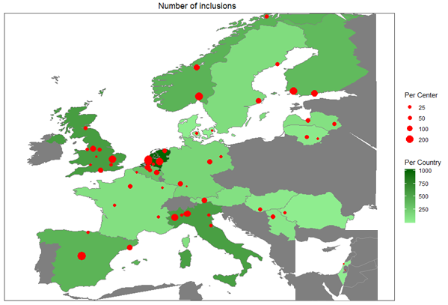
The median enrollment by country was 125 (IQR: 50 – 403) and median by site 50 (IQR: 21 – 107). Four countries accounted for 2563/4509 (57%) of recruited patients (Netherlands: N=7 centres, n=1,006 patients; the UK: N=9 centres, n=578 patients; Italy: N=8 centres, n=560 patients and Norway: N=3 centres, n=419 patients).
Figure S2: Enrolment in strata by centre. The width of the bars indicates the total number of patients per centre. 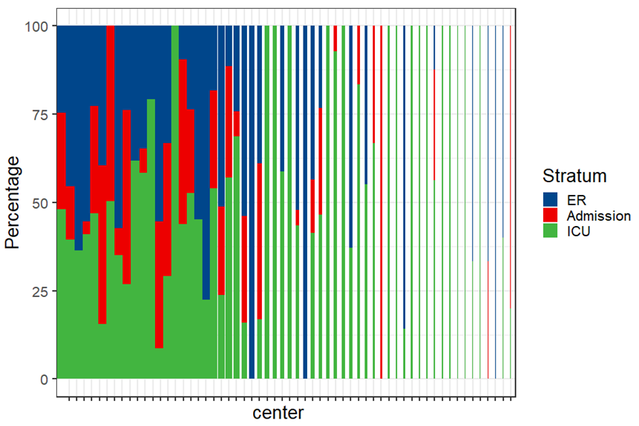

Figure S3: Age by sex distribution by stratum in the Center-TBI Core study (n=4509 patients). The ER stratum included most females and the ratio of females to males increased with older ages in each stratum.
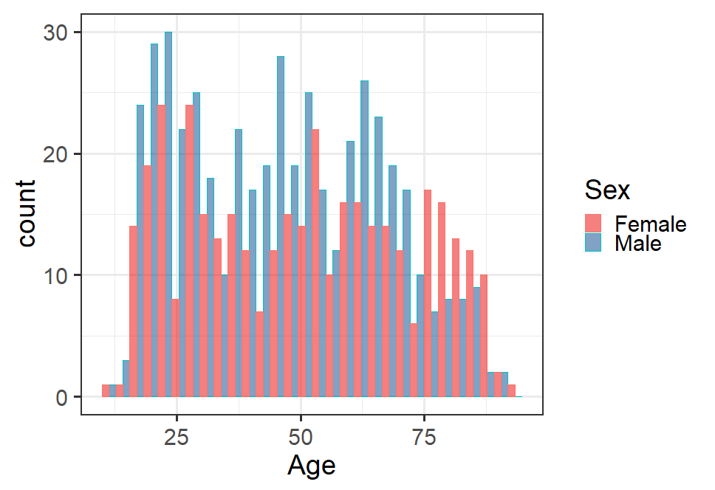 | 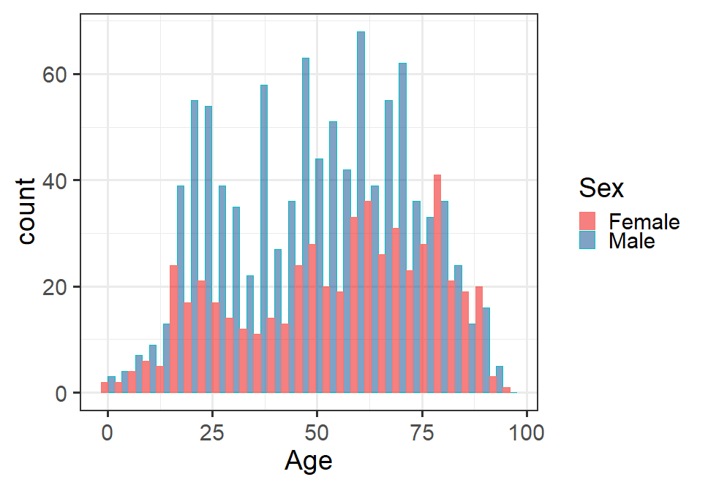 | 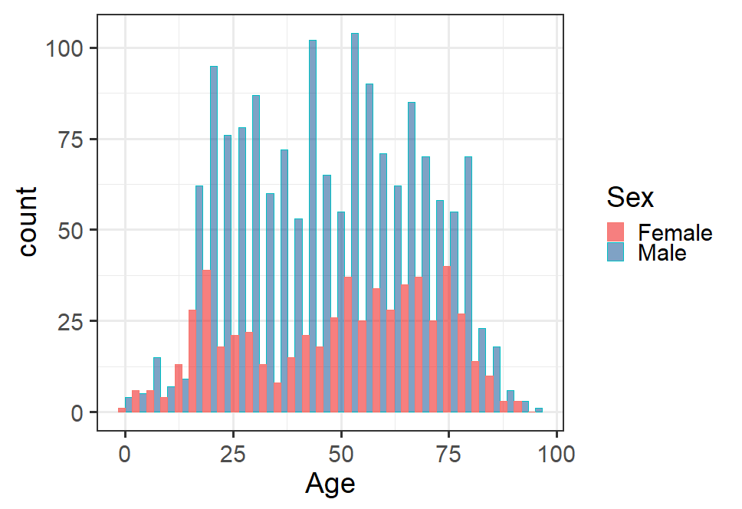
ER (n=848) | Admission (n=1523) | ICU (n=2138)

Figure S4: Cause of Injury by Age Group, CENTER-TBI Core (N=4388)

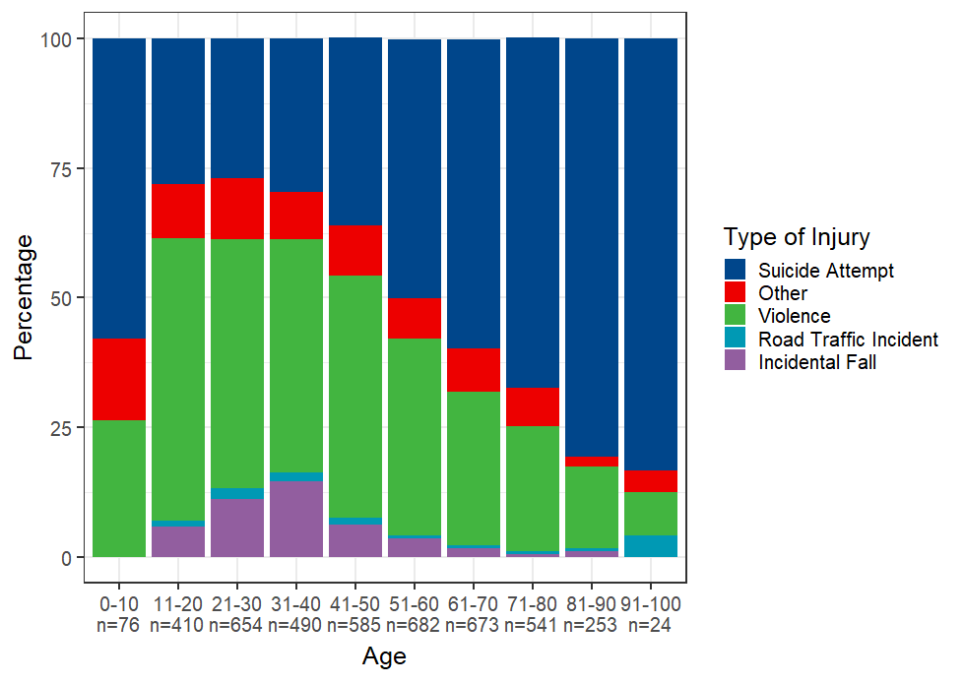

Figure S5 Alcohol use and Cause of Injury, CENTER-TBI Core (N= 4071)

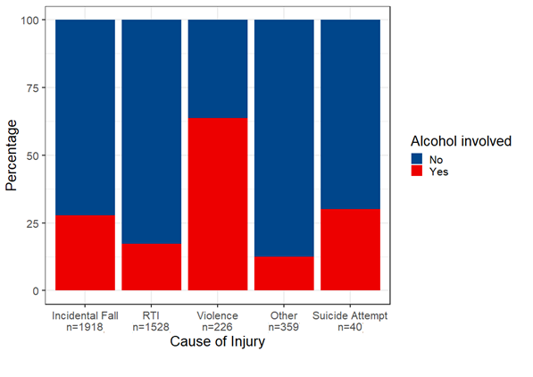
*RTI = Road Traffic Incident.

Figure S6: GCS distribution by stratum, CENTER-TBI- core (n=4,344). GCS baseline reflects the GCS score obtained as close as possible to study admission, and is derived from all available scores from the time period pre-hospital to admission to ward/ICU or discharge from the ER.

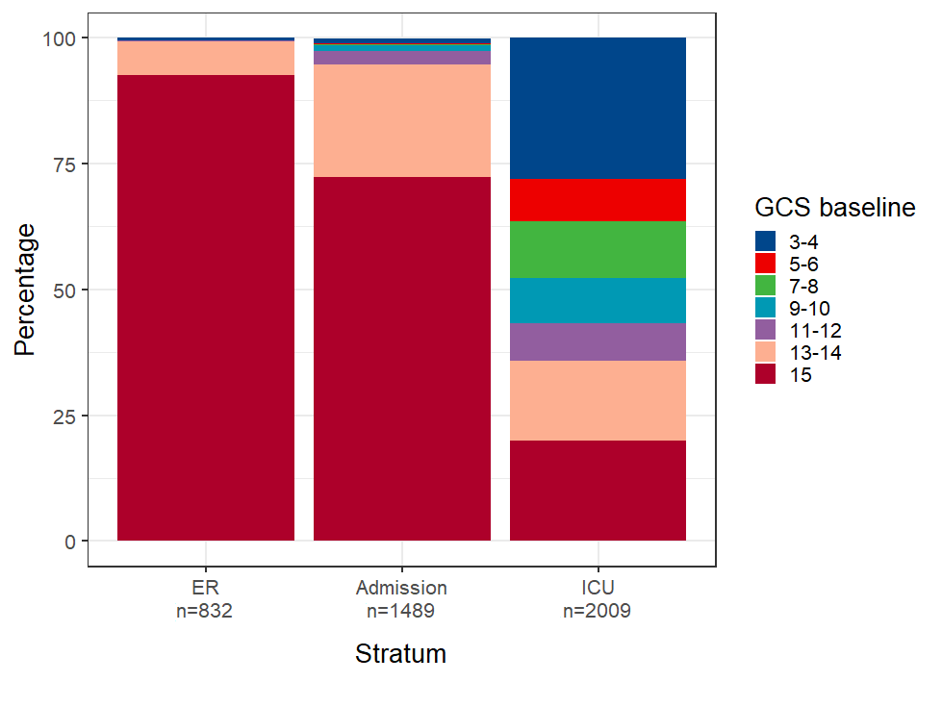

Figure S7: Biomarkers versus CT Abnormalities by stratum (complete case analysis, n=898)

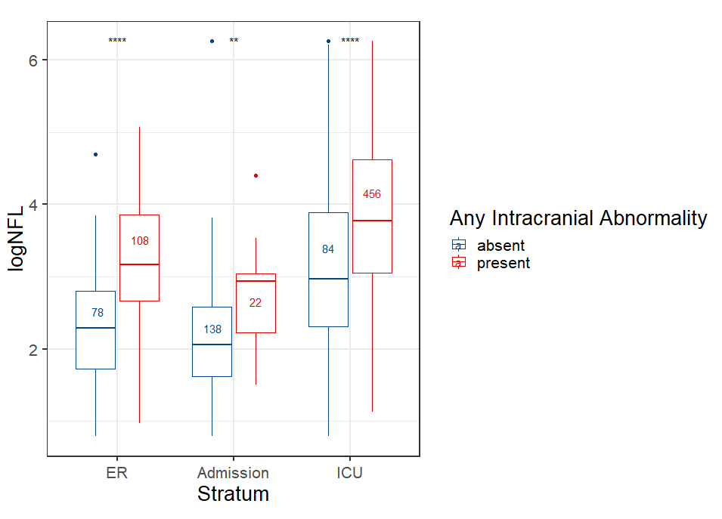 | 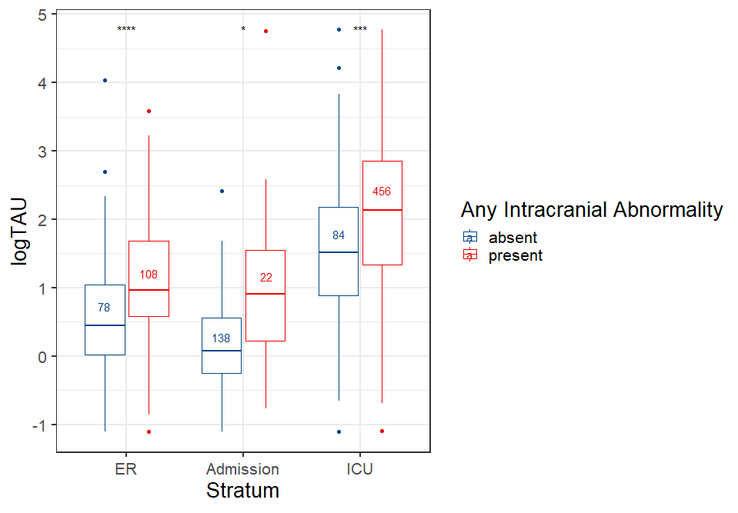 | 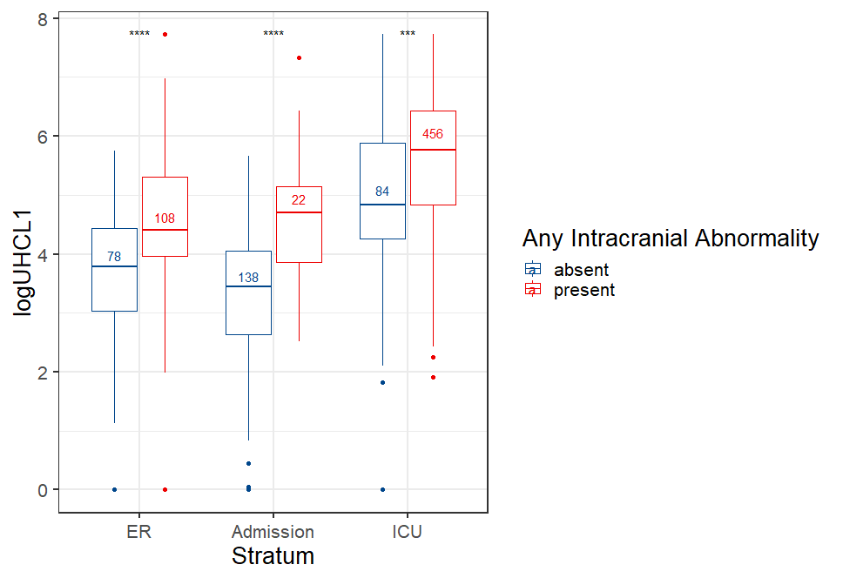
NFL = Neurofilament Light | t-TAU = total TAU | UCHL1 = Ubiquitin Carboxy-Terminal Hydrolase L1
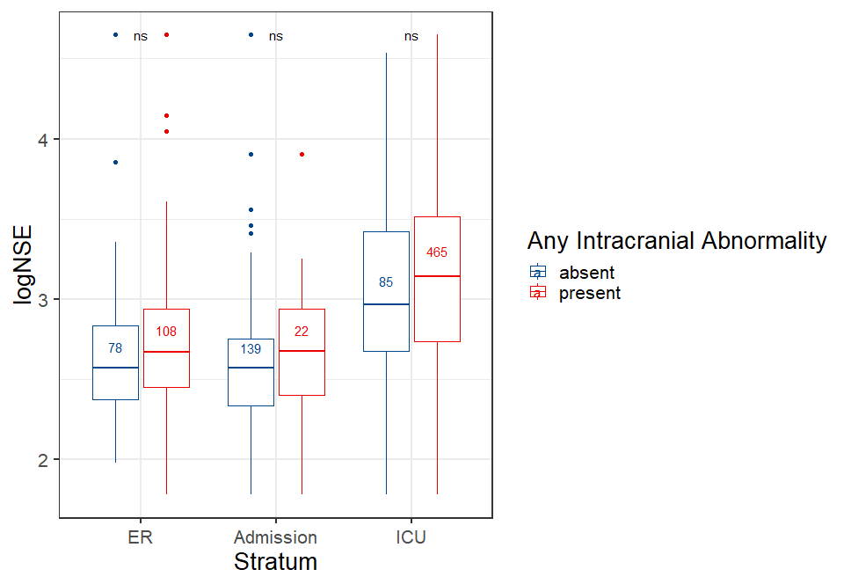 | 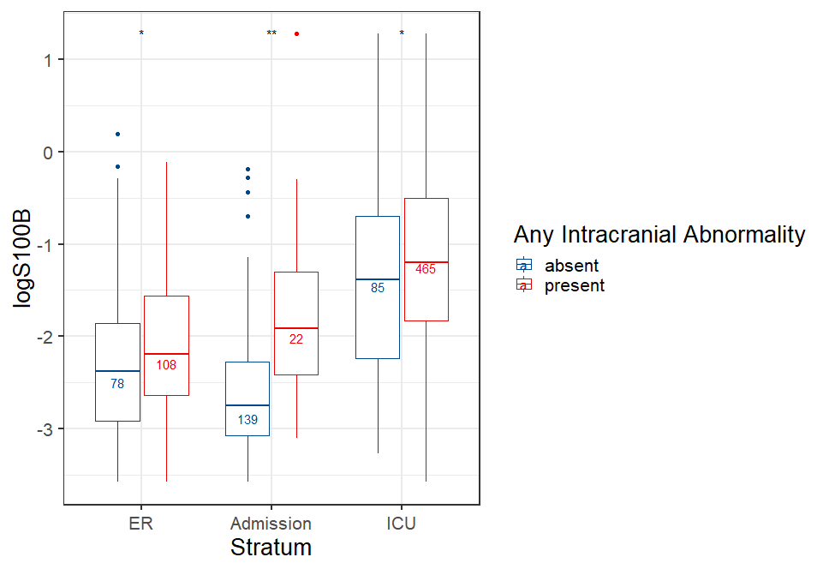 | 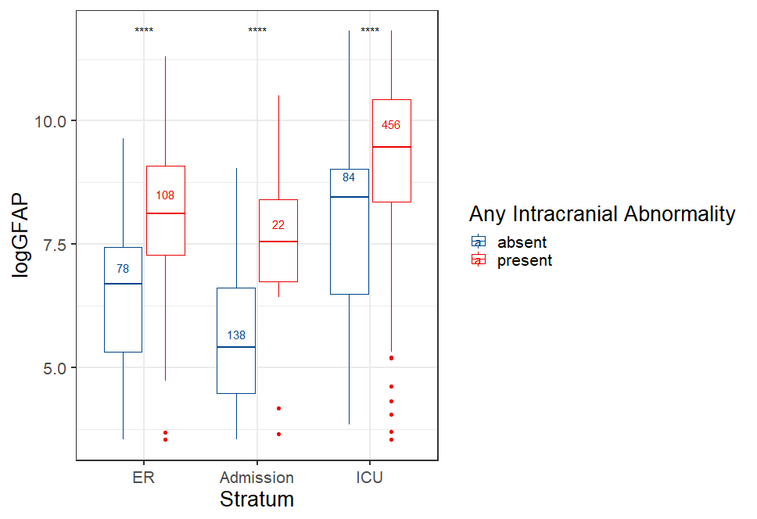
NSE = Neuron-Specific Enolase | S100B = S100 calcium-binding protein B | GFAP = Glial Fibrillary Acidic Protein
# NSE and S-100B were measured on the e602 module of a Cobas 8000 analyzer (Roche Diagnostics International Ltd· Rotkreuz, Switzerland) in Pecs, Hungary and NF-L, total Tau, GFAP, and UCH-L1 on the Quanterix SIMOA Neurology 4-plex kit (Quanterix, Lexington, MA, USA), at the University of Florida, USA. Differences between biomarker values in patients with any intracranial abnormality versus patients without any intracranial abnormality were tested per stratum with a t-test. The stars above the bars indicate significance: ns: p>0·05, *: p<=0·05, **: p<=0·01, ***: p<=0·001, ****: p<=0·0001·.

Figure S8: Biomarkers by GCS levels in the CENTER-TBI Core study (n=898)
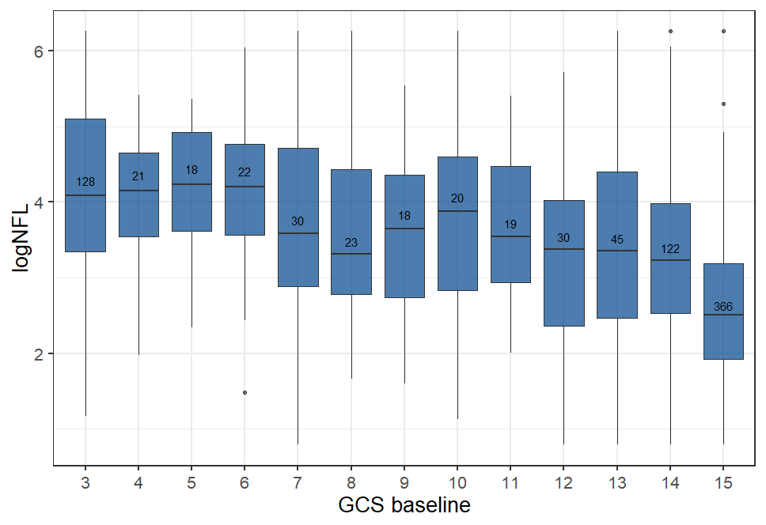 | 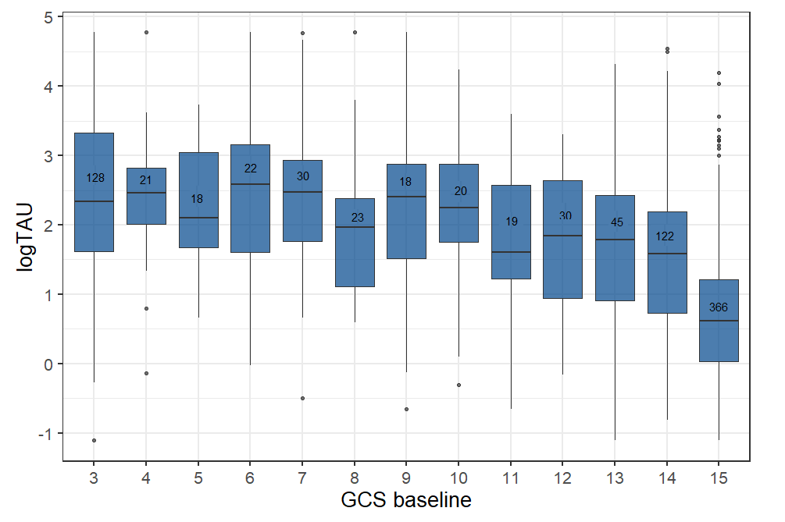
NFL = Neurofilament Light | t-TAU = total TAU
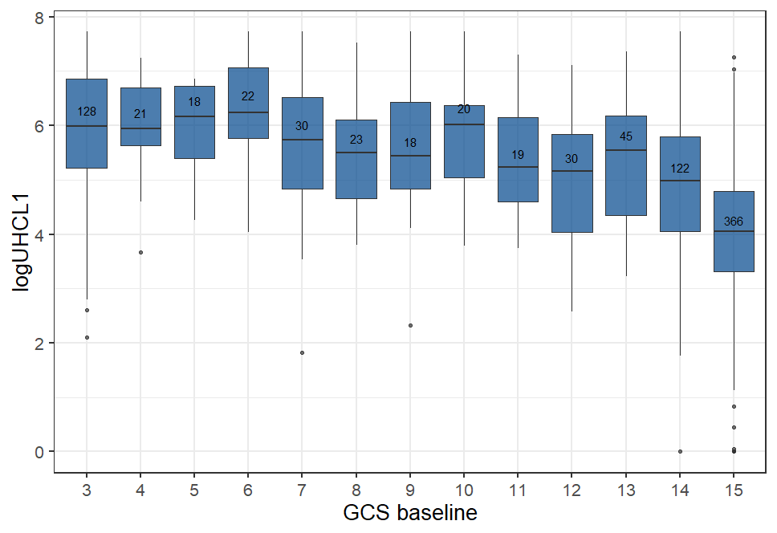 | 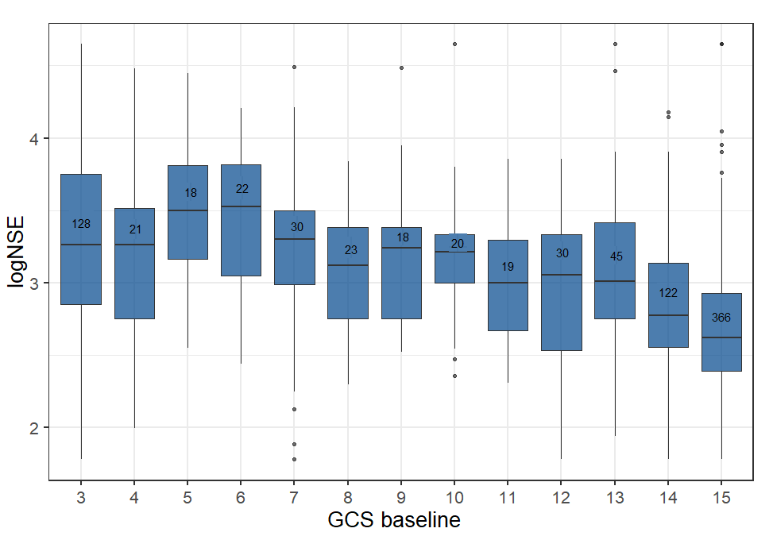
UCHL1 = Ubiquitin Carboxy-Terminal Hydrolase L1 | NSE = Neuron-Specific Enolase

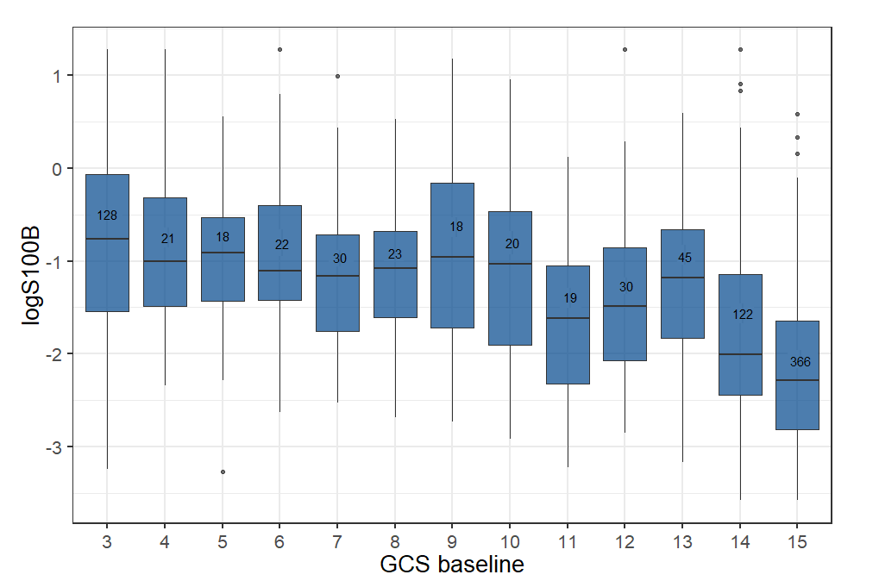 | 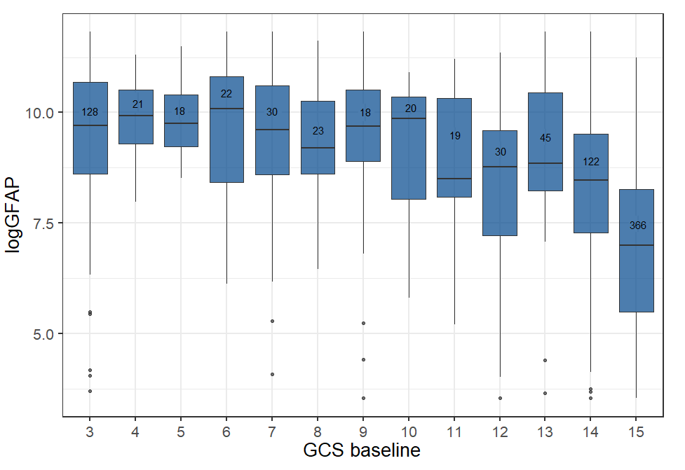
S100B = S100 calcium-binding protein B | GFAP = Glial Fibrillary Acidic Protein

# NSE and S-100B were measured on the e602 module of a Cobas 8000 analyzer (Roche Diagnostics International Ltd· Rotkreuz, Switzerland) in Pecs, Hungary and NF-L, total Tau, GFAP, and UCH-L1 on the Quanterix SIMOA Neurology 4-plex kit (Quanterix, Lexington, MA, USA), at the University of Florida, USA.

Figure S9: Correlation between glucose, hemoglobin, and six biomarkers (GFAP, NFL, NSE, S100B, UHCL1, t-TAU, n=804). Strong correlations were noted, specifically between GFAP, NFL, S100B, UCHL1, and t-TAU (r>0·7). Only weak correlations were noted between biomarkers versus glucose or hemoglobin.
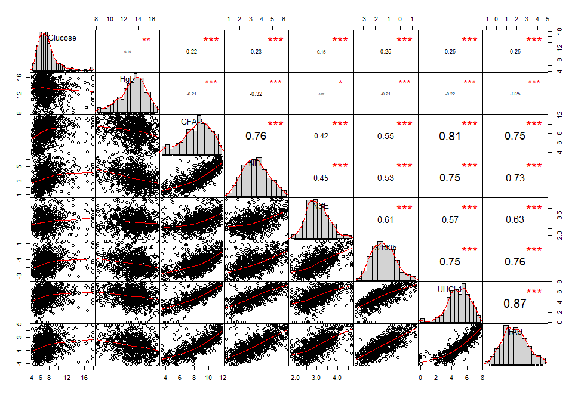
Hgb = Hemoglobin, GFAP = Glial Fibrillary Acidic Protein, NFL = Neurofilament Light, NSE = Neuron-Specific Enolase, S100B = S100 calcium-binding protein B, UCHL1 = Ubiquitin Carboxy-Terminal Hydrolase L1, t-TAU = total TAU· All biomarkers were log transformed.

References

1. Maas AI, Menon DK, Steyerberg EW, et al. Collaborative European NeuroTrauma Effectiveness Research in Traumatic Brain Injury (CENTER-TBI): a prospective longitudinal observational study. Neurosurgery 2015; 76(1): 67-80.

2. Wilson JT, Pettigrew LE, Teasdale GM. Structured interviews for the Glasgow Outcome Scale and the extended Glasgow Outcome Scale: guidelines for their use. J Neurotrauma 1998; 15(8): 573-85.

3. von Steinbuechel N, Wilson L, Gibbons H, et al. QOLIBRI overall scale: a brief index of health-related quality of life after traumatic brain injury. J Neurol Neurosurg Psychiatry 2012; 83(11): 1041-7.

4. Ware JE. User's manual for the SF-12v2 health survey (with a supplement documenting SF-12 health survey). Lincoln, R.I.: QualityMetric Inc.; 2002.

5. Wilson L, Marsden-Loftus I, Koskinen S, et al. Interpreting Quality of Life after Brain Injury Scores: Cross-Walk with the Short Form-36. J Neurotrauma 2017; 34(1): 59-65.

6. Cabeleira M, Ercole A, Smielewski P. HDF5-Based Data Format for Archiving Complex Neuro-monitoring Data in Traumatic Brain Injury Patients. Acta Neurochir Suppl 2018; 126: 121-5.

7. Steyerberg EW, Mushkudiani N, Perel P, et al. Predicting outcome after traumatic brain injury: development and international validation of prognostic scores based on admission characteristics. PLoS Med 2008; 5(8): e165; discussion e.

