Developing a blueprint for a civilian-military collaborative program in trauma training for Northern European countries: A South African experience
Henk van der Wal^{1,8}, Thijs TCF van Dongen^{6,7,8}, Christine FW Vermeulen^{1,2,3}, John L Bruce⁴, Wanda Bekker⁴, Vassil Manchev⁴, Victor Kong^{4,5}, Oscar van Waes^{1,2}, Damian L Clarke^{4,5}, Rigo Hoencamp^{2,6,7,8}
- Institute for Defence and Partner Hospitals, Ministry of Defence, Utrecht, The Netherlands.
- Trauma Research Unit, Department of Surgery, Erasmus MC, University Medical Centre Rotterdam, Rotterdam, The Netherlands.
- Vascular Section, Department of Surgery, Erasmus MC, University Medical Centre Rotterdam, Rotterdam, The Netherlands.
- Pietermaritzburg Metropolitan Trauma Service, Department of Surgery, University of KwaZulu-Natal, Durban, South Africa
- Department of Surgery, University of the Witwatersrand, Johannesburg, South Africa
- Department of Surgery, Alrijne Hospital, Leiderdorp, The Netherlands.
- Division of Surgery, Leiden University Medical Centre, Leiden, The Netherlands.
- Defence Healthcare Organization, Ministry of Defence, Utrecht, The Netherlands.
Corresponding author:
Henk van der Wal
P.O. Box 90004, 3509AA Utrecht, The Netherlands
Phone: +31-6-19304031 | E-mail: h.vd.wal.02@mindef.nl
Keywords: trauma training, trauma surgery, collaboration, mutual benefit, value-based health care, military healthcare

Abstract
Background. Recent terrorist attacks and mass shooting incidents in major European and North American cities have shown the unexpected influx of large volumes of patients with complex multi-system injuries. The rise of subspecialisation and the low violence-related penetrating injuries among European cities, show the reality that most surgical programs are unable to provide sufficient exposure to penetrating and blast injuries. The aim of this study is to describe and create a collaborative program between a major South African trauma service and a NATO country military medical service, with synergistic effect on both partners. This program includes comprehensive cross-disciplinary training & teaching, and scientific research.
Methods. This is a retrospective descriptive study. The Pietermaritzburg hospital and Netherlands military trauma register databases were used for analysing patient data: Pietermaritzburg between September 2015 and August 2016, Iraq between May and July 2018 and Afghanistan from 2006 to 2010. Interviews were held to analyse the mutual benefits of the program.
Results. From the Pietermaritzburg study, mutual benefits focus on social responsibility, exchange of knowledge and experience and further mutual exploration. The comparison showed the numbers of surgical procedures over a one-month period performed in Iraq 12.7, in Afghanistan 68.8 and in Pietermaritzburg 152.
Conclusion. This study has shown a significant volume of penetrating trauma in South Africa that can provide substantial exposure over a relatively short period. This will help to prepare civilian and military surgeons and deployable military medical personnel for casualties with blast – and/or penetrating injuries. The aforementioned findings and the willingness to shape the mutual benefits, create a platform for trauma electives, research, education and training.

Introduction
The current global geo-political situation is characterized by political instability and manifests itself in ongoing military conflicts, which are often described as being asymmetrical in nature. An asymmetrical conflict implies that often the combatants are not members of formal military structures and that the concept of a frontline or combat zone needs to be rethought.¹⁻³ Recent terrorist attacks and mass shooting incidents in major European and North American cities are examples of this new era of asymmetrical warfare. Mass casualty situations occurred unexpectedly in many previously ‘peaceful’ countries and civilian surgeons were suddenly expected to manage an influx of large volumes of patients with complex multi-system injuries.⁴⁻⁶
This change in the nature of conflicts around the world coincides with a number of changes which have profoundly affected the delivery of modern surgical training and practice. The steady rise in sub-specialisation means that surgeons are increasingly focused on operating on specific organs and may not be able to manage and/or feel comfortable dealing with complex multiregional injuries. Furthermore, with the generally low incidence of penetrating and blast trauma, the development of a trauma system approach means that only a limited number of centres will be able to provide comprehensive trauma service and continue to develop and maintain their skills in (visceral) trauma care. In the Netherlands, violence-related penetrating injuries were recorded in only 2,519 emergency department admissions in 2011. There were only 92 deaths recorded secondary to a penetrating injury in the same year. This corresponds to an incidence of penetrating trauma of 16.4/100,000 and penetrating trauma related mortality of 0.6/100,000 per inhabitant.⁷ Penetrating trauma accounts for only 5–10 % of all trauma cases in Europe, compared with 40–50 % in the United States of America (US) and South Africa.⁸⁻¹⁰ The reality is that most European surgical programs are unable to provide trainees with sufficient exposure to penetrating and blast injuries.
One proposed solution to this lack of experience is the emerging concept of military-civilian collaboration to ensure that there is a sufficient pool of trauma skills available to deal with these situations as, and when the need arises.¹¹ One such collaboration is the development of formal trauma electives which allow surgeons from areas with low volumes of penetrating trauma, to work in high volume civilian centres with these types of injuries. An example of a country which has a high burden of penetrating trauma and a well-established trauma training program, is South Africa. Until recently, there has been a paucity of publication on the concept of these collaborative projects. And although they have been in existence for a number of years, they remain unstructured and under-researched. This collaboration of developing formal trauma electives creates a platform to transfer scientific knowledge and trauma experience, and has the potential to create a mutually beneficial synergy for all stakeholders in South Africa and Europe.
The primary aim of this study is to describe the development of a formal collaborative program between a major South African trauma service and the military medical service of a major NATO country, with a synergistic impact on all partners. The secondary aim is to propose a comprehensive cross disciplinary training & teaching program, focusing on trauma surgery, acute care medicine as well as healthcare management and leadership. The final goal is the development of a rich body of cross-disciplinary scientific research and clinical improvement which impacts on multiple fields, which include but are not limited to nursing, anaesthetics, emergency medicine and trauma surgery.

Materials and Methods
Collaborative program:
All participating parties in this collaborative program have as their objective, a sustainable benefit for society in terms of improved outcomes for acutely injured and unwell patients. Central to the program is a robust collaboration with the University of KwaZulu-Natal (UKZN). UKZN has a well-established trauma and emergency group which is known as the Acute Care Consortium. The collaboration with the Netherlands Ministry of Defence (MoD) is an attempt to develop an equal and mutually beneficial program based on clinical electives in trauma surgery, acute care exposure for military medical personnel, healthcare management training & teaching and cross-program scientific research. The mutual-benefit analysis is based on the outcome of a series of interviews regarding a set of predetermined key objectives. These interviews were held by the representatives of the MoD with (1) (clinical) management of UKZN; (2) clinicians and head of departments of Pietermaritzburg Metropolitan Trauma Service (PMTS); and (3) military medical leadership and heads of military clinical professional groups. The collaborative program with the PMTS focuses on providing exposure to penetrating (visceral) trauma to improve or refresh essential lifesaving trauma skills amongst military personnel.
Pietermaritzburg Metropolitan Trauma Service:
The PMTS provides definitive trauma care to the city of Pietermaritzburg, as well as the western third of the province. The PMTS covers a total catchment population of over three million people. It is also one of the largest academic trauma centres within the province of KwaZulu-Natal (KZN). Due to the extremely high incidence of interpersonal violence, gang related and criminal activities throughout the entire province, approximately 3,000 trauma patients are admitted per year, with approximately 50% due to penetrating trauma. The PMTS functions with a trauma team which is headed by a duty full-time professor of trauma surgery. Almost all patients are managed by the trauma team, with the exception of those with isolated orthopaedic trauma. The only patients that require transfer out of the trauma centre are those with traumatic brain injuries requiring surgical intervention. For such cases the neurosurgical unit is located at Inkosi Albert Luthuli Central Hospital (IALCH) in Durban (one hour from PMTS).
Data Analysis:
The caseload of Pietermaritzburg hospital during a twelve-month period (September 2015 - August 2016) was analysed retrospectively and information concerning the method of injury was gathered. Next, a comparison was made between the procedures performed by a military surgeon in a Role 2 hospital during a recent deployment in Iraq (May and July 2018), in a Role 2 hospital during the deployment in Uruzgan, Afghanistan (2006-2010), and at the PMTS in Pietermaritzburg during the recent one-month employment. Data of Iraq and Afghanistan are corrected for one month to be able to compare with the caseload during the one-month employment as part of the collaborative program.
Ethics Approval:
This study was approved by the Dutch Ministry of Defence and the Institutional Review Board and the Biomedical Research Ethics Committee (BREC) of the University of KwaZulu-Natal (BCA221/13, BE 207/09) South Africa.
Statistical Analysis:
Statistical analyses were performed using a computerized software package, SPSS (version 24, IBM Corporation, Armonk, NY, USA). The categorical variables were analysed based on their absolute and relative frequencies in percentages.

Results
Mutual benefits:
To make the benefits of the collaborative program transparent, a division in predetermined key objectives was made. The respective results below are also conditional for creation of the mutual benefits.
The key objectives show a significant overlap in benefits between the three collaboration partners (table 1). The main overlapping benefits are social responsibility, exchange of knowledge and experience and mutual exploration within the overall collaborative program. Common grounds are to be found in the field of the South African perspective, the military medical perspective and healthcare/medical leadership and management.
Trauma case load:
During the PMTS twelve-month cohort, 2,887 patients were admitted by the PMTS. There were 1,244 cases (43%) of penetrating trauma and 1,644 cases (57%) of blunt. The mechanisms of injury for penetrating trauma were as follows: stab wounds (SWs); 955 (77%), gunshot wounds (GSWs); 252 (20%), and other injuries; 37 (3%). The mechanisms of injury for blunt trauma were as follows: assault; 739 (45%), road traffic accidents (RTAs); 669 (41%), fall; 166 (10%), and other injuries; 70 (4%).
Timeframe:
The weekly pattern of patient presentation to the emergency department (ED), did show a predictable pattern. Most patients present at the ED in the weekends, especially on Saturday (24.8%) as can be seen in figure 1. The caseload is at its peak around midnight and after work between 16:00 and 18:00 (figure 2). Also, office holidays do account for a high number of trauma admissions (5.4%) as can be seen in table 2. Christmas [] accounts for 1.8% of all admissions in one year for the last 6 years.
Working routine collaborative program:
To optimize the effectiveness from the collaborative program, the MoD constructed a working routine blueprint (table 3). Within the working routine, safety measures and/or other precautions, and occupational regulations need to be incorporated, based on the local work and security situation. For example, as seen in table 2, the night shifts will start and end within daylight hours, which prevent the need for night-time travel and limited road movement.
Comparison of surgical procedures:
Table 4 shows a comparison of the procedures performed by a military surgeon in a Role 2 hospital during a recent deployment in Iraq, in a Role 2 hospital during a deployment in Uruzgan, Afghanistan between the period 2006-2010, and during the one-month employment at the PMTS in Pietermaritzburg. The total procedures performed during one month in Iraq was 12.7, in Uruzgan 68.8 and in Pietermaritzburg 152. In Iraq the three main procedures were (1) debridement, irrigation and dressing (34%), (2) laparotomy (10%) and (3) chest drain placement (6%). In Uruzgan the main procedures were (1) debridement, irrigation and dressing (50%), (2) laparotomy (7%) and external fixation of an extremity (6%). Finally, for Pietermaritzburg the procedures were (1) chest drain placement (33%), (2) laparotomy (22%) and thoracotomy (7%).

Discussion
This collaborative program provides mutual benefits and synergy for all stakeholders. The volume of trauma treated by the PMTS is sufficient to provide adequate exposure for a military surgeon prior to deployment to a major conflict zone, with the intention of improving the outcome for future casualties. The conflict zone experience of military surgeons has been proven to be an important added value during terrorist attacks in major cities as has been published in papers emanating from the terrorist attacks in Boston, Paris and Brussels.^{5,12-14} The universal stakeholder is the patient, civilian or military, who will benefit from well-trained surgeons and other medical personnel with a broad experience. The collaborative program with the PMTS is expected to enhance the preparedness to provide acute care in the event of terrorist attacks, as acute care providers who have participated will be expected to provide leadership during an acute event, and to impart their knowledge on an ongoing basis amongst fellow, civilian, colleagues in every layer of the medical support chain. In addition to the enhanced preparedness and skills for individual acute care providers, the collaborative program will strengthen ongoing efforts to refine clinical algorithms and protocols for all organizations in the medical support chain, who need to be prepared to deal with mass casualty situations or terrorist attacks.
The mentioned volume of trauma will also be used for other trauma related military medical personnel, such as ED- and ICU-nurses, military first-response nurses, military medical officers, military anaesthesiologists and more. Although the execution of a complete military surgical team, due to South African legislation and local practical issues, is cumbersome [], military medical teams can concurrently be exposed to provide acute care at various stations such as the emergency department, burns unit, operating rooms and intensive care unit and wards. This depends on the qualifications of the team members and their primary military medical function at their military medical unit. Although the military medical personnel will work in different stations, as elements in the medical chain they are in communication with their team members, which benefit while working together during military operations.
- Mutual benefits
The benefits for all parties are based on equality and access. This has been the fundamental basis of the Memorandum of Understanding (MoU) between UKZN and MoD, which was signed on 23 January 2019. All parties involved have taken their social responsibility to improve medicine and (medical) leadership by organizing structural teaching and training programs and embedding scientific research. Ultimately, we will assess casualty outcome, civilian and military, in conjunction with cost effectiveness to be able to provide value-based healthcare.¹⁵
The strength of the collaborative program is to have a platform to make improvements in the acute care and medical leadership domains, where the South African and military medical perspectives are the reinforcing factors.
- Effectiveness and efficiency of the blueprint
A key aspect of this paper is to create a proven effective blueprint in medical/clinical exposure for the (military) surgeon but certainly also for a broader group of (military) medical personnel. In addition, the program has to be efficient from a managerial point of view. This efficiency includes, among others, the following aspects: opportunities to deploy medical personnel according to military operational standards, time and costs (exposure versus minimal period of deployment), safety, minimum numbers of military medical personnel to deploy. Legislation and regulations must be treated in an efficient manner to let their sometimes-inhibiting effect have a minimal impact on the collaborative program.
The demand for an efficient program also relates to the other aspects of the program, such as acute care training, healthcare management training & teaching and scientific research. The further execution of the blueprint shall incorporate researching these aspects. The healthcare management training and teaching can also emphasize on research of aspects of efficiency.
- Future research
The development of the blueprint as described in this paper, needs further research to develop towards a program of structural collaboration, with assessment of the predefined goals. Within the program, research is needed to prove that the clinical electives in trauma surgery will be of added value to both military surgeons to use in combat situations and civilian surgeons in case of terrorist attacks on national ground. Secondly, research is needed whether the exposure to acute care in South Africa is of added value to military medical personnel when deployed in combat situations. In order to effectively arrange the foregoing, investigation is needed on how the collaboration can be fine-tuned to be executed on a continuous basis. This assessment will also include aspects of personal safety in a more basic and austere medical environment (for example exposure to high-risk blood-borne diseases and tuberculosis) and logistical and administrative arrangements (for example registration to practice medicine / nursing and the provision of living quarters). The research can also be used to investigate the field of management and leadership on how improvements can be made that make acute care organizations better prepared for their task of dealing with mass casualty situations and terrorist attacks.^{5,16} Including the improvement for military medical leadership during military operations. The aspects from the results section will therefore be the basis for further development of the blueprint.
- Limitations
The main limitation of this paper is that the program described is a “living document” and future developments might change the initial layout. However, since a “golden standard” of international collaboration programs does not exist, this paper could well serve as explementary blueprint for future (intercontinental) collaboration programs. Also, to compare the outcome of the different trauma systems used in this paper, more detailed registration will be required. As the collaboration between all mentioned partners will continue to develop, so will the sharing of data and eventually the mutual understanding of each others trauma system. This mutual understanding will help to improve the principal trauma management of the casualties described, ultimately improving their outcome.

Conclusion
The change in the nature of conflicts around the world forces assessment of the delivery of modern surgical training and practice. The original idea of developing a collaborative program in trauma care for northern European countries in South Africa, has broadened into a multi-faceted program intended to strengthen systems in both regions. There is a significant volume of penetrating trauma in South Africa to provide substantial exposure over a relatively short period. This can effectively create added value for all military and civilian surgeons. This program is also useful to (re)gain exposure to penetrating trauma for deployable military medical personnel. Driven by their social responsibility, all parties involved have signed a MoU on January 23rd, 2019. This MoU offers a platform to further shape the mutual benefits through trauma electives, research, education and medical exposure. The platform will be the basis to achieve the second aim and final goal.
References

1. Lind WS. Understand Fouth Generation Warfare. Military Review. 2004;84(9):12-16.
2. Lind WS, Nightengale K, Schmitt JF, Sutton JW, Wilson GI. The Changing Face of War: Into the Fourh Generation. Marine Corps Gazette. 1989;73(10):22-26.
3. Hoencamp R. Medical aspects and challenges in an armed conflict. Mil Spect. 2016;185(6):241-250.
4. Gregory TM, Bihel T, Guigui P, et al. Terrorist attacks in Paris: Surgical trauma experience in a referral center. Injury. 2016;47(10):2122-2126.
5. Hirsch M, Carli P, Nizard R, et al. The medical response to multisite terrorist attacks in Paris. Lancet. 2015;386(10012):2535-2538.
6. Tresson P, Touma J, Gaudric J, et al. Management of Vascular Trauma during the Paris Terrorist Attack of November 13, 2015. Ann Vasc Surg. 2017;40:44-49.
7. Hoencamp R, Tan EC, Idenburg F, et al. Challenges in the training of military surgeons: experiences from Dutch combat operations in southern Afghanistan. Eur J Trauma Emerg Surg. 2014;40(4):421-428.
8. Greensmith M, Cho J, Hargest R. Changes in surgical training opportunities in Britain and South Africa. Int J Surg. 2016;25:76-81.
9. Hardcastle TC, Steyn E, Boffard K, et al. Guideline for the assessment of trauma centres for South Africa. S Afr Med J. 2011;101(3):189-194.
10. Uchino H, Kong VY, Bruce JL, et al. Preparing Japanese surgeons for potential mass casualty situations will require innovative and systematic programs. Eur J Trauma Emerg Surg. 2017.
11. Berwick DM, Downey AS, Cornett EA. A National Trauma Care System to Achieve Zero Preventable Deaths After Injury: Recommendations From a National Academies of Sciences, Engineering, and Medicine Report. JAMA. 2016;316(9):927-928.
12. Gates JD, Arabian S, Biddinger P, et al. The initial response to the Boston marathon bombing: lessons learned to prepare for the next disaster. Ann Surg. 2014;260(6):960-966.
13. Goralnick E, Van Trimpont F, Carli P. Preparing for the Next Terrorism Attack: Lessons From Paris, Brussels, and Boston. JAMA Surg. 2017;152(5):419-420.
14. Khorram-Manesh A. Europe on Fire; Medical Management of Terror Attacks - New Era and New considerations. In: Bull Emerg Trauma. Vol 4.2016:183-185.
15. Porter ME. What is value in health care? N Engl J Med. 2010;363(26):2477-2481.
16. Berghout MA, Fabbricotti IN, Buljac-Samardzic M, Hilders C. Medical leaders or masters?-A systematic review of medical leadership in hospital settings. PLoS One. 2017;12(9):e0184522.

Table 1. Key objectives and benefits of the program
Key objectives | UKZN | PMTS | MoD
overall | taking social responsibility
overall | focus on all medical staff integrated in the acute care domain, including civilian, active-duty military and reservists
overall | strengthening and improvement of the position of medical personnel and students | N/A | to be able to contribute to the healthcare in South Africa
clinical electives in trauma surgery | exchange of knowledge and experience in trauma surgery and acute care from a military perspective |  | exchange of knowledge and experience in trauma surgery and acute care from a South African perspective
clinical electives in trauma surgery | N/A | capacity on a continuous based availability | N/A
acute care training for military medical personnel | exposure to experiences of young military physicians and nurses for medical students | additional manpower with exchange of military medical experience on a continuous based availability | retention and pre-deployment training for military medical personnel (from the Institute for Defence and Partner Hospitals and operational medical units)
healthcare management and leadership training & teaching | exchange of knowledge and experience in healthcare management and leadership for healthcare leadership and medical students & nurses | contribution to healthcare management in PMTS | exposure for university students & researchers and military healthcare managers and leaders in South African healthcare
healthcare management and leadership training & teaching | management and (medical) leadership improvement in acute care organizations |  | (medical) leadership improvement during military operations
cross-program scientific research | exchange of knowledge in medical and clinical fields of interest
cross-program scientific research | exploration of innovations within the whole program | N/A | exploration of innovations within the whole program

UKZN indicates University of KwaZulu-Natal, PMTS: Pietermaritzburg Metropolitan Trauma Service, MoD: (Dutch) Ministry of Defence, N/A: not applicable.

Table 2. Trauma admissions on office holidays
Holiday | Frequency | Percentage from total admissions (9,403)
New Year’s Day (Jan. 1) | 60 | 0,6
Human Rights Day (Mar. 21) | 24 | 0,3
Good Friday (Mar. 30) | 30 | 0,3
Family Day (Apr. 2) | 27 | 0,3
Freedom Day (Apr. 27) | 25 | 0,3
Labour Day (May 1) | 36 | 0,4
Youth Day (Jun. 16) | 39 | 0,4
National Women’s Day (Aug. 9) | 24 | 0,3
Heritage Day (Sep. 24) | 30 | 0,3
Day of Reconciliation (Dec. 16) | 42 | 0,4
Christmas - 1st (Dec. 25) | 124 | 1,3
Christmas - 2nd (Dec. 26) | 47 | 0,5
Total | 508 | 5.4

Table 3. Working routine collaborative program Pietermaritzburg
Day | Remarks | Hours
Monday | Out of shift | not applicable
Tuesday | Off | not applicable
Wednesday | Elective surgery | 07.30 - 16.00
Thursday | Elective surgery | 07.30 - 16.00
Friday | Shift Edendale/ Grey’s | 14.00 - 09.00
Saturday | Shift Edendale/ Grey’s | 16.00 - 09.00
Sunday | Shift Edendale/ Grey’s | 16.00 - 09.00

Procedures performed | Iraq | Uruzgan | PMB
Head/ neck | 0.5 | 3.5 | 0
Thoracotomy/ pericard window | 0.2 | 0.5 | 11
Chest drain | 0.8 | 1.3 | 50
Laparotomy | 1.3 | 5 | 34
DEF | 1.2 | 2.4 | 23
DCS | 0.2 | 2.6 | 11
Genitals | 0.8 | 0.6 | 3
Major amputation | 0.5 | 1.7 | 1
Minor amputation | 0 | 0.9 | 0
Vascular intervention | 0.7 | 0.4 | 3
Extremity ORIF | 0.2 | 3.4 | 0
External fixation | 0.5 | 4.3 | 4
MUA | 0.2 | 1.1 | 0
Fasciotomy/ escharotomy | 0.5 | 1.3 | 4
DID | 4.3 | 34.2 | 5
DIS | 0 | 2.2 | 0
Reconstruction/ SSG | 0.5 | 2.4 | 3
Minor (general) surgery | 0.3 | 1.0 | 0
Total procedures | 12.7 | 68.8 | 152
Table 4. Surgical procedures Iraq, Afghanistan, South Africa corrected for 1 month

PMB indicates Pietermaritzburg hospital, m: month, DEF: definitive surgery, DCS: damage control surgery, ORIF: open reduction internal fixation, MUA: manipulation under anesthesia, DID: debridement - irrigation and dressing, DIS: debridement – irrigation and splinting, SSG: split skin graft. * data from studied period corrected for 1 month

List of Figures

Figure 1. Weekly pattern of patient presentation to the emergency department
Figure 2. Average time of patient assessment during 24 hours

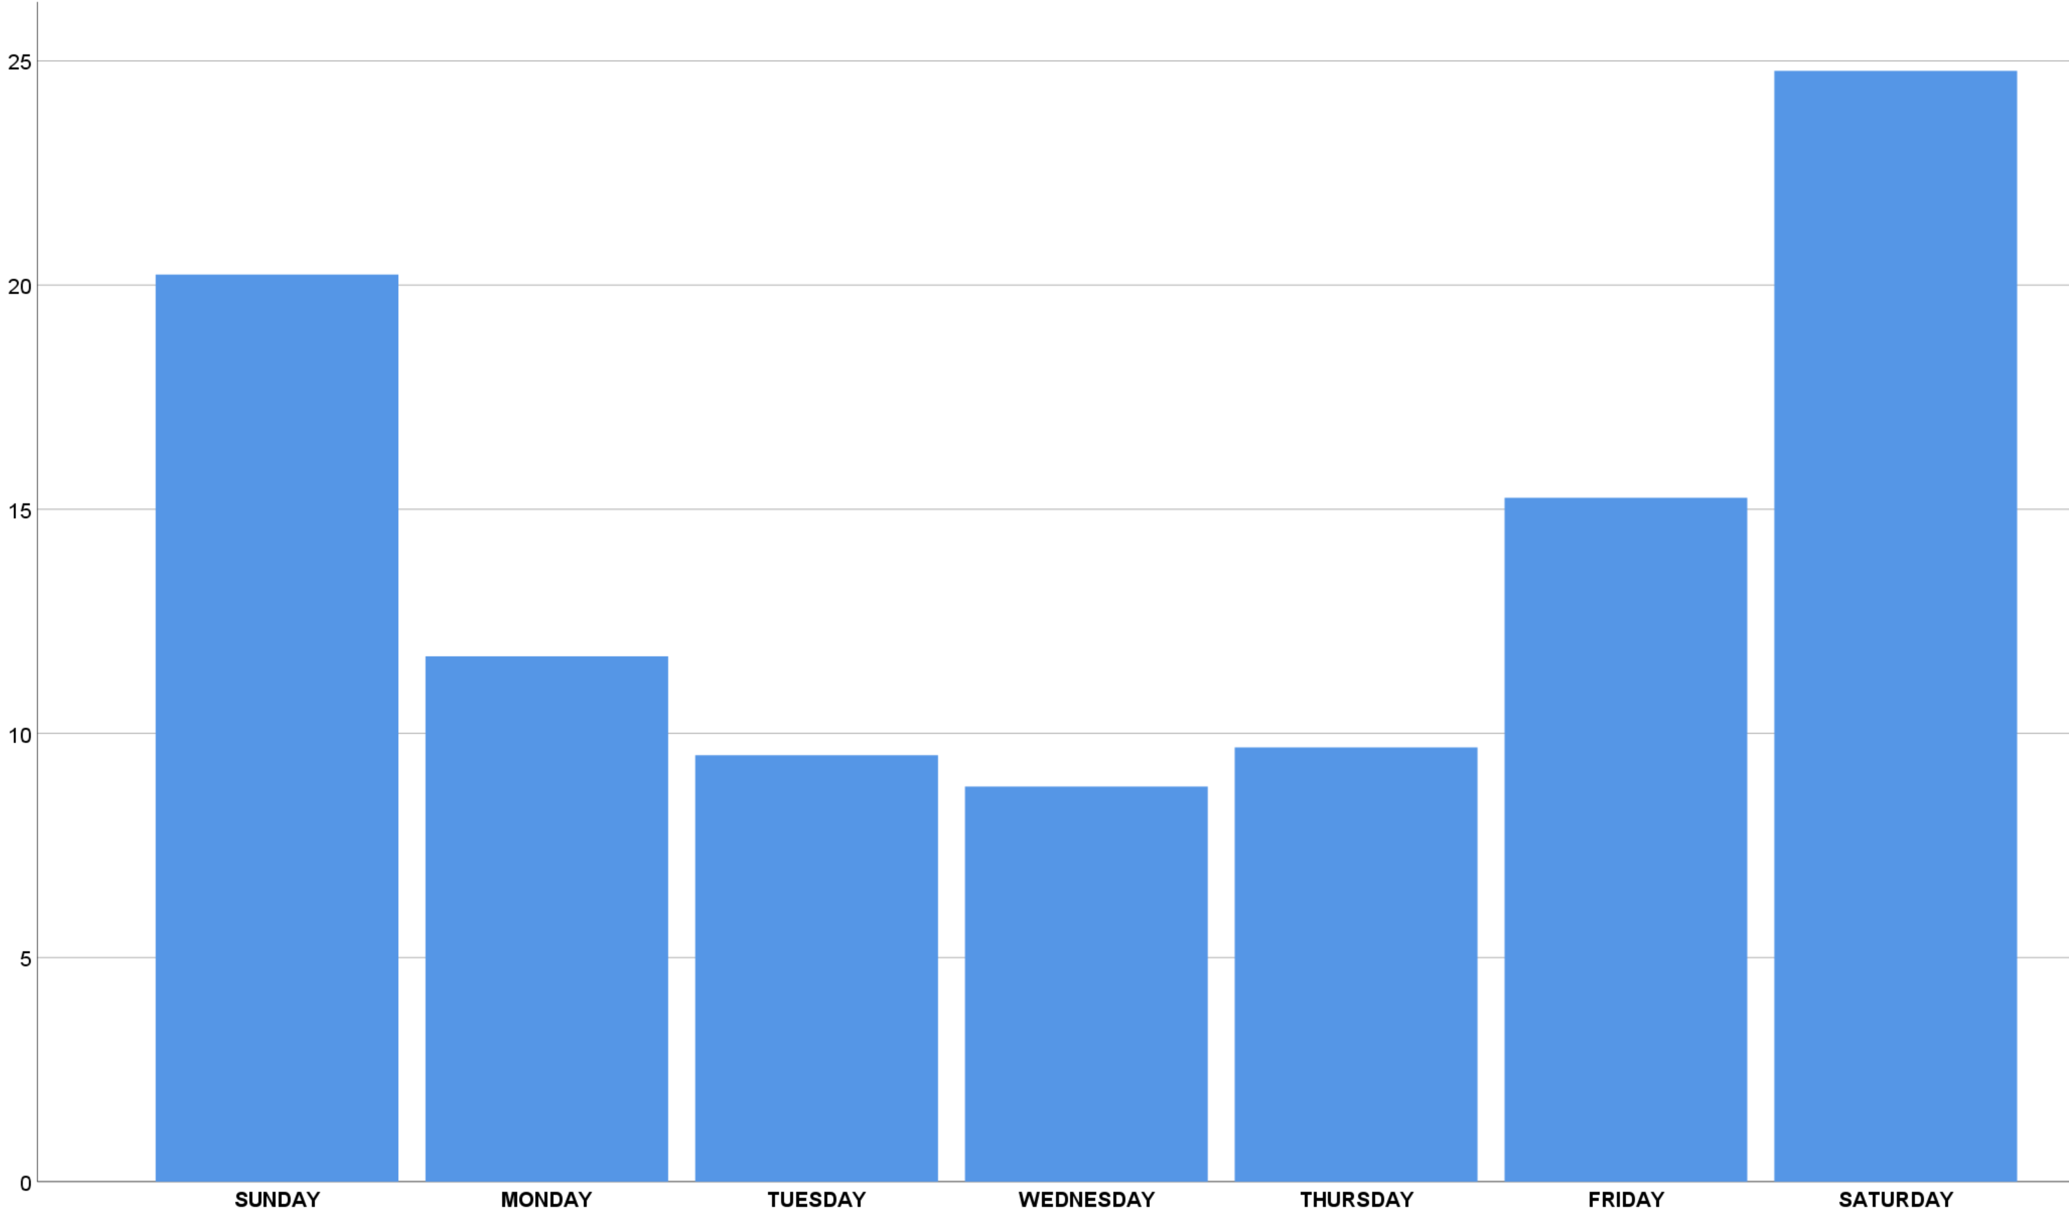
Figure 1. Weekly pattern of patient presentation to the emergency department
Weekday
Percent of admissions

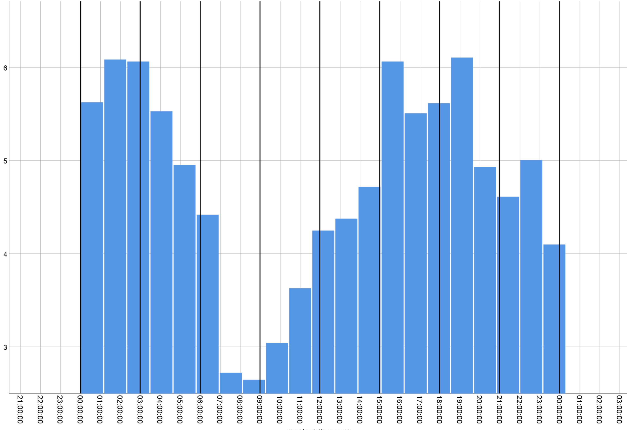
Figure 2. Average time of patient assessment during 24 hours
00:00 03:00 06:00 09:00 12:00 15:00 18:00 21:00 00:00
Time of assessment
Frequency

[] Christmas consists of the 25th and 26th of December, which are both holidays: in the Netherlands the 26th is second Christmas day and in South Africa the Day of Goodwill.
[] In the Netherlands the operating room assistant and assistant-anesthetist primarily have a technician status and therefore cannot be accredited according South African legislation.

