SUPPLEMENTARY MATERIAL
Higher versus Lower Intensity Surveillance for Patients with Colorectal Adenomas: A Cost-Effectiveness Analysis
Meester, Reinier G.S. PhD
Lansdorp-Vogelaar, Iris PhD
Winawer, Sidney J. MD DSc
Zauber, Ann G. PhD
Knudsen, Amy B. PhD
Ladabaum, Uri MD MS

Jul 3rd, 2019.
Stanford, CA, United States.

Table of Contents

Table of Contents 2
1. Microsimulation model 4
1.1 Demography module 4
1.2 Natural history module 4
1.3 Screening module 5
1.4 Module integration 5
Supplementary Figure 1. The stages of disease in MISCAN-Colon 6
Supplementary Figure 2. Integrating MISCAN-Colon modules for two example patients * 7
2. Specific model assumptions for the present study 9
2.1 Screening efficacy 9
2.2 Surveillance intervals 9
2.3 Quality of life 9
2.4 Screening and treatment Costs 9
Supplementary Table 1. Applied sequential surveillance intervals 10
Supplementary Table 2. Cost and QALY losses for colorectal cancer testing and care * 11
Supplementary Table 3. Impact inventory from the 2nd Panel on Cost-Effectiveness in Health and Medicine 12
3. Model validation 13
3.1 Adenoma recurrence 13
3.2 CRC incidence 13
3.3 CRC mortality 14
Supplementary Table 4. Published adenoma detection rates in surveillance 15
Supplementary Figure 3a-b. Observed vs. simulated distal colorectal cancer incidence for the intervention group of the UK Flexible Sigmoidoscopy Trial * 16
Supplementary Figure 4. Observed vs. simulated cancer incidence and mortality reductions for colonoscopy screening, from observational studies in a 2014 systematic review * 17
Supplementary Figure 5. Observed vs. simulated colorectal cancer mortality reductions for biennial FIT screening * 18
Supplementary Figure 6. Simulated vs. observed adenoma detection during surveillance of patients with removed low-risk and high-risk adenomas * 19
Supplementary Figure 7. Observed vs. simulated colorectal cancer incidence for HRA patients in 17 UK Hospitals after baseline polypectomy, first surveillance, and multiple surveillance exams * 20
Supplementary Figure 8. Observed vs. simulated colorectal cancer mortality for adenoma patients in the Norwegian cancer registry, with and without assumed colonoscopy use in the reference population * 22
Supplementary Figure 9. Observed vs. simulated colorectal cancer mortality in the National Polyp Study * 24
4. Outcomes of Surveillance in a Colonoscopy Screening Setting 25
Supplementary Table 5. Prediction cumulative lifetime surveillance benefit for patients with adenoma detected in colonoscopy screening, by age and finding 25
Supplementary Table 6. Health outcomes, costs, and incremental cost-effectiveness ratios of adenoma surveillance strategies for patients with adenomas detected at a screening colonoscopy, by age and finding * 27
Supplementary Table 7. Component-specific impact of surveillance on quality of life and costs for patients with adenomas detected in colonoscopy screening, by age and finding 29
Supplementary Figure 10. Lifetime colorectal cancer incidence in patients with adenoma detected at a screening colonoscopy, by age and finding * 31
Supplementary Figure 11. Sensitivity analysis of incremental cost-effectiveness of surveillance in patients with adenoma at screening colonoscopy * 33
5. Outcomes of Surveillance in a FIT Screening Setting 35
Supplementary Table 8. Prediction cumulative lifetime surveillance benefit for patients with adenoma detected in FIT screening, by age and finding at follow-up colonoscopy 35
Supplementary Table 9. Health outcomes, costs, and incremental cost-effectiveness ratios of surveillance strategies for patients with adenomas detected at FIT screening, by age and finding at follow-up colonoscopy * 37
Supplementary Table 10. Component-specific impact of surveillance on quality of life and costs for patients with adenomas detected in FIT screening, by age and finding at follow-up colonoscopy 39
Supplementary Figure 12. Lifetime colorectal cancer incidence in patients with adenoma detected at FIT screening, by age and finding at follow-up colonoscopy * 41
Supplementary Figure 13. Sensitivity analysis of incremental cost-effectiveness for surveillance in patients with adenoma detected by FIT * 43
6. Supplementary References 45

1. Microsimulation model
MISCAN-Colon is a stochastic, semi-Markov, microsimulation model for colorectal cancer programmed in Delphi (Borland Software Corporation, Scotts Valley, California, United States). It can be used to explain and predict trends in colorectal cancer incidence and mortality and to quantify the effects and costs of primary prevention, screening, and surveillance after polypectomy.
The term ‘microsimulation’ implies that these individuals are moved through the model one at a time, rather than as proportions of a cohort. The term ‘semi-Markov’ implies that MISCAN-Colon, unlike traditional Markov models, does not assume annual state transitions; instead it generates durations in states, allowing future state transitions to depend on past transitions, and thereby increases model flexibility and computational performance. The term ‘stochastic’ implies that the model determines the states and corresponding durations by drawing from probability distributions, rather than using fixed values. Hence, the results of the model are subject to random variation.
MISCAN-Colon consists of three modules: a demography module, natural history module, and screening module.

1.1 Demography module
Using birth- and life-tables representative for the population under consideration, MISCAN-Colon draws a date of birth and a date of non-colorectal cancer related death for each individual simulated.(1) The maximum age an individual can achieve is assumed to be 100 years.

1.2 Natural history module
Transitions
As each simulated person ages, one or more adenomas may develop (Supplementary Figure 1). These adenomas can be either progressive or non-progressive. Both progressive and non-progressive adenomas can grow in size from small (≤5mm), to medium (6-9mm), to large (≥10mm); however, only progressive adenomas can develop into preclinical cancer. A preclinical cancer may progress through stages I to IV without symptoms, or may be diagnosed during each stage because of symptoms. After clinical diagnosis, cancer survival is simulated using age-, stage-, and localization-specific survival estimates for clinically diagnosed colorectal cancer as obtained by Rutter and colleagues.(2) For individuals with synchronous cancer at time of diagnosis, the survival of the most advanced cancer is used. The date of death for individuals with colorectal cancer is set to the earliest simulated death due either to the disease or another cause (‘Demography module’).

Transition rates and durations
An individual’s risk of developing adenomas depends on the individual’s age and a personal Gamma-distributed risk index (non-homogeneous Poisson process). As a result of the latter most individuals develop no adenomas, whilst some develop many. We assumed that the distribution of adenomas over the colon and rectum equals the distribution of cancers as observed in SEER before the introduction of screening.(3) The age-specific onset of adenomas and the dispersion of the personal risk index were calibrated to data on the prevalence and multiplicity distribution of adenomas as observed in autopsy studies.(4-13) The adenoma growth rates were calibrates were calibrated to the size distribution detected with colonoscopy in the COlonoscopy or COlonography for Screening (COCOS) trial.(14) The age-specific probability of adenoma-progressivity and the age- and localization-specific transition probabilities between preclinical cancer stages and between preclinical and clinical cancer stages were simultaneously calibrated to SEER data on the age-, stage-, and localization-specific incidence of CRC as observed before the introduction of screening.(3)
The average durations between the preclinical cancer stages were calibrated to the rates of screen-detected and interval cancers observed in randomized controlled trials evaluating screening using guaiac fecal occult blood tests.(15-17) This exercise has been described extensively elsewhere.(18) The average duration from the emergence of an adenoma until progression into preclinical cancer (i.e. the adenoma dwell-time) was calibrated to the rates of interval cancers (including surveillance detected cancers) observed in a randomized controlled trial evaluating once-only sigmoidoscopy screening. We assumed an equal overall dwell-time for adenomas developing into cancer from a medium size (30% of all cancers) and from a large size (70% of all cancers). All durations in the adenoma and preclinical cancer phase were drawn from Exponential distributions. Durations of the disease stages within the adenoma and preclinical cancer phase, respectively, were assumed to be perfectly correlated (i.e. if a small adenoma grows into a medium-sized adenoma rapidly, it will also grow into a large adenoma or develop into colorectal cancer rapidly). However, durations in the adenoma phase were assumed to be uncorrelated with durations in the preclinical cancer phase (i.e. a rapidly growing adenoma does not necessarily develop into a rapidly progressing cancer). The proportion of medium-size non-progressive adenomas growing large and the average duration in the medium-size non-progressive adenoma state were calibrated to size-specific adenoma detection rates observed in a Dutch randomized controlled trial on colonoscopy screening (not shown).
All calibrations were performed using the Nelder-Mead search algorithm to minimize deviances from observed values based on log-likelihood functions (Poisson likelihood for incidence, Binomial likelihood for adenoma prevalence, and Multinomial likelihood for cancer stages). Resulting assumptions for adenoma prevalence, CRC incidence by stage, and lifetime CRC incidence and mortality are presented in Table 1.

1.3 Screening module
Screening will alter some of the simulated life histories: some cancers will be prevented by the detection and removal of adenomas, while other cancers will be detected in an earlier stage with a more favorable survival. As the stage-specific survival of screen-detected cancer observed in randomized controlled trials on guaiac fecal occult blood testing was substantially more favorable than that of clinically detected cancers, even after correcting for lead-time bias,(19) we assigned those screen-detected cancers that would have been clinically detected in the same stage the survival corresponding to a one stage less progressive cancer. Hence, a cancer screen-detected in stage II, that would also have been clinically diagnosed in stage II, is assigned the survival of a clinically diagnosed stage I cancer. The only exceptions were screen-detected stage IV cancers. These cancers were always assigned the survival of a clinically diagnosed stage IV cancer.
Besides positive health effects of screening, the model also allows for the evaluation of colonoscopy-related complications and over-diagnosis and over-treatment of colorectal cancer (i.e. the detection and treatment of cancers that would not have been diagnosed without screening). The modeled efficacy of a screening or surveillance test depends on its ability to detect pre-cancerous or early cancerous lesions. In case of stool-based screening modalities, follow-up with colonoscopy is required and also determines outcomes.

1.4 Module integration
The demography module generates a date of birth and a date of non-colorectal cancer related death for each individual simulated, creating a life-history without adenomas or colorectal cancer (Life History 1, Supplementary Figure 2). Then, for example patient A, the natural history module generates two adenomas. The second of these adenomas progresses into preclinical cancer, which, in the absence of screening, is diagnosed because of symptoms in stage I and results in cancer death before death from other causes would have occurred (Life History 2, Supplementary Figure 2). In the screening module, a screening and surveillance examination are simulated, indicated by the black arrows, which detects cancer in an early stage. As a result, cancer-related death is prevented. Hence, integrating all 3 modules for example patient A, surveillance prolongs life by the amount indicated by the blue arrow (Life History 3, Supplementary Figure 2). Example patient B is similar, except that the patient develops preclinical cancer that never actually develops into clinical disease. This patient dies with cancer, but not from cancer. Hence, for example patient B, surveillance leads to overdiagnosis and unnecessary treatment.

Supplementary Figure 1. The stages of disease in MISCAN-Colon

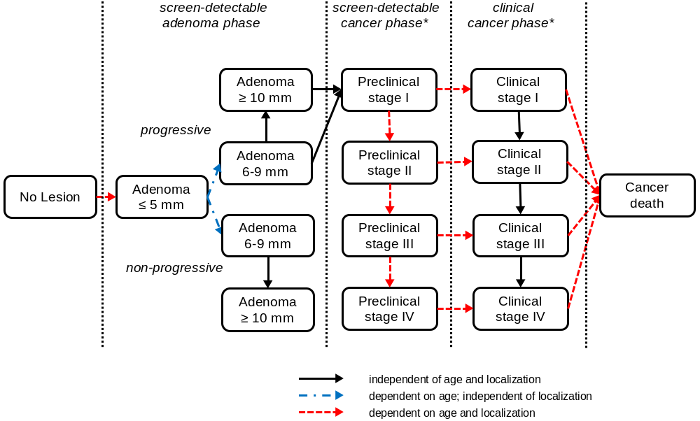
* Cancer stages were based on the 5th edition Cancer Staging Manual from the American Joint Committee on Cancer.(20)

Supplementary Figure 2. Integrating MISCAN-Colon modules for two example patients *

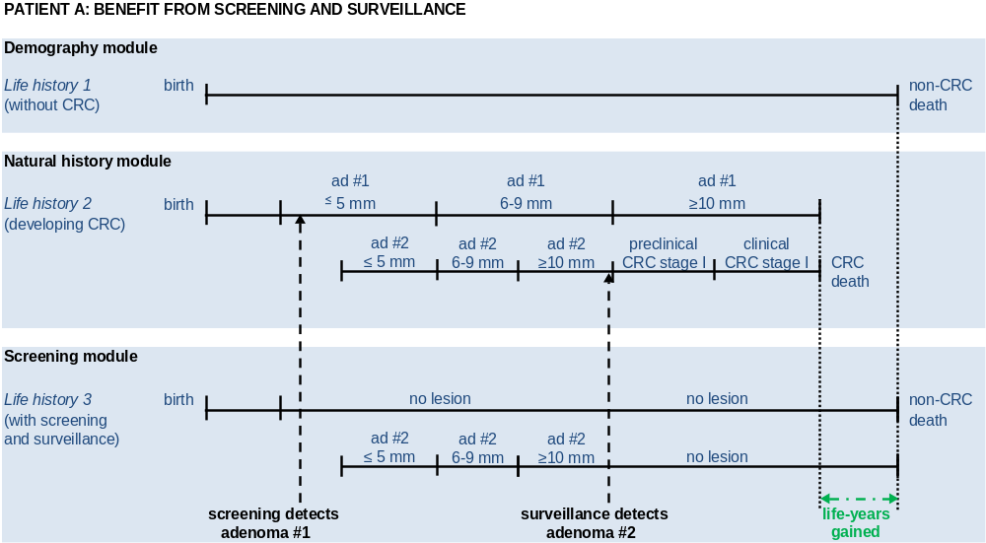
Abbreviations: ad = adenoma; CRC = colorectal cancer.

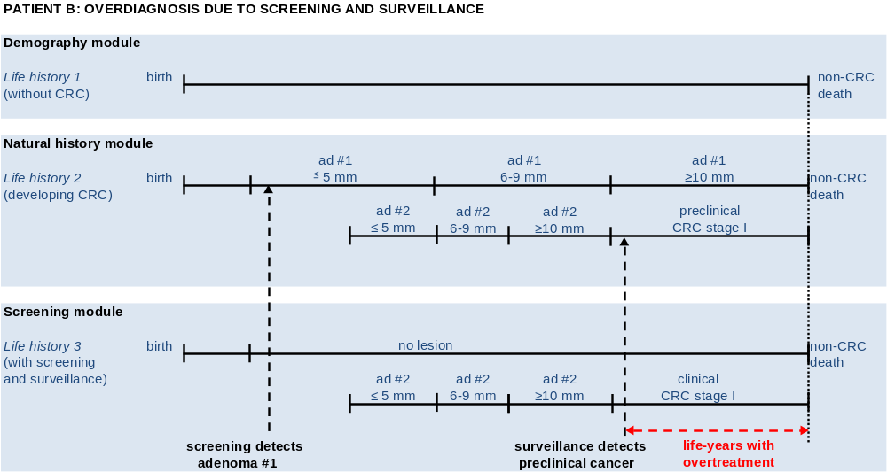
Abbreviation: ad = adenoma; CRC = colorectal cancer.
* For both patient A and B, there is a small risk that colonoscopy results in fatal complications (Table 1), leading to a loss in overall life years due to screening or screening. For Patient B, surveillance will always lead to a loss in quality-adjusted life-years gained (Supplementary Table 2).

2. Specific model assumptions for the present study

2.1 Screening efficacy
The modeled efficacy of a screening or surveillance test depends on its ability to detect pre-cancerous or early cancerous lesions. In case of stool-based screening modalities, follow-up with colonoscopy is required and also determines outcomes. Assumed per-lesion sensitivity for colonoscopy was based on a systematic review of back-to-back colonoscopy studies, and varied from 75% for diminutive adenomas up to 95% for large adenomas and CRC.(21) Person-level sensitivity and specificity of FIT were based on estimates from a recent large population-based study (7.6% for small adenomas; 23.8% for large adenomas; 73.8% for CRC).(22) We assumed that colonoscopy leads to complications such as perforation, bleeding, or even death, in some patients,(23, 24) with overall colonoscopy complication rates increasing exponentially from 4.1 per 1,000 at age 50 years to 85.4 per 1,000 at age 80 years. No complication risk for FIT was assumed.

2.2 Surveillance intervals
Surveillance intervals for low and high-intensity surveillance were varied depending on baseline adenoma characteristics and subsequent findings (Supplementary Table 1). With low-intensity surveillance, patients with baseline HRA findings received surveillance colonoscopy in 5 years, and patients with baseline LRA findings received surveillance colonoscopy in 10 years. If surveillance detected additional adenomas, the subsequent interval was either 5 or 10 years again, depending on the risk characteristics. If no further adenomas were detected, surveillance was deferred for 10 years in patients with previously detected HRA; patients with previously detected LRA would be returned to screening. With high-intensity surveillance, there was no assumed return to screening: patients either received surveillance in either, 3, 5 or 10 years, respectively, depending on the most recent findings (HRA, LRA, or no new adenomas).

2.3 Quality of life
Assumed losses in quality-of-life for the receipt of CRC care were derived from a publication by Ness and colleagues.(25) With limited available data to inform their values,(26) quality-of-life adjustments for receipt of screening were based on assumptions (Supplementary Table 2).

2.4 Screening and treatment Costs
Costs (Supplementary Table 2) of FIT, colonoscopy, colonoscopy complications and treatment were derived similar as in previous studies for the U.S. Centers for Medicare and Medicaid Services (CMS).(27, 28) Costs were computed from a modified societal perspective, including patient time costs, and not including other non-medical costs (see Supplementary Table 3 for all included components). Patients time costs included only the time for the procedure and traveling, not overnight preparation or recovery to routine, both for colonoscopy(29) and treatment. The health-care sector perspective as described by the Second Panel on Cost-Effectiveness in Health and Medicine was considered less relevant, and is expected to result in similar cost-effectiveness estimates given a similar relative patient-time component in screening costs compared with treatment.
FIT, colonoscopy, and colonoscopy complication costs were approximated using 2007 CMS payment and co-insurance rates.(30, 31). Costs were updated to 2015 US dollars using the general consumer price index (CPI).(32) Our assumptions were compared to and similar as recently published estimates based on 2014 CMS data.(33) No recent treatment cost estimates were available for this analysis. Our estimates were based on net cost estimates derived from 1998-2003 CMS data by Yabroff and colleagues,(34) and distinguish phase of care (Supplementary Table 2). Treatment costs were also updated to 2015 US dollars using general CPI. Since 2003 several expensive treatment drugs have been approved by the U.S. Food and Drug Administration, so it is possible that our estimates underestimate true costs. The magnitude of our cost assumptions for the first year of treatment after diagnosis are similar order, however, as net annual expense estimates based on 2007-2011 CMS data.(35)
The included patient time component was 1 hour in FIT, 8 hours in colonoscopy, and 16 hours for complications. Patient time was already incorporated in net cancer therapy cost estimates by Yabroff and colleagues (varying 20-280 hours).(36) Time was valued at median 2015 US wage per hour ($17.40).(32)

Supplementary Table 1. Applied sequential surveillance intervals
Index  Finding * | First  Interval, y † | First  Finding * | Second  Interval, y † | Second  Finding, y * | Third  interval †
HRA | 3 (5) | HRA | 3 (5) | HRA | 3 (5)
 |  |  |  | LRA | 5 (10)
 |  |  |  | NA | 5 (10)
 |  | LRA | 5 (10) | HRA | 3 (5)
 |  |  |  | LRA | 5 (10)
 |  |  |  | NA | 10 (10)
 |  | NA | 5 (10) | HRA | 3 (5)
 |  |  |  | LRA | 5 (10)
 |  |  |  | NA | 10 (10)
LRA | 5 (10) | HRA | 3 (5) | HRA | 3 (5)
 |  |  |  | LRA | 5 (10)
 |  |  |  | NA | 5 (10)
 |  | LRA | 5 (10) | HRA | 3 (5)
 |  |  |  | LRA | 5 (10)
 |  |  |  | NA | 10 (Re-SCR)
 |  | NA | 10 (Re-SCR) | HRA | 3 (5)
 |  |  |  | LRA | 5 (10)
 |  |  |  | NA | 10 (Re-SCR)
Abbreviations: HRA = High-risk adenoma; LRA = low-risk adenoma; Re-SCR = return to screening after 10 years.
* Low-risk adenomas were defined as 1-2 tubular adenomas <10 mm in diameter; high-risk adenomas were defined as ≥3 tubular adenomas <10mm in diameter, and/or ≥1 advanced adenoma (tubular adenoma ≥10 mm in diameter, tubulovillous adenoma, or adenoma with high-grade dysplasia). In the model histology was not simulated, and an advanced adenoma was considered a large adenoma.
† Numbers presented first are for the HI surveillance regimen; number for the low-intensity regimen are in parentheses. Unit is years.

Supplementary Table 2. Cost and QALY losses for colorectal cancer testing and care *
 |  | CRC care, by phase †
Variable | Screening tests  and complications | Initial  care | Continuing  care | Terminal  care, ending in CRC death | Terminal  care, ending in other-cause death
Costs, 2015 US $
Per FIT | 26 | - | - | - | -
Per colonoscopy
without polypectomy | 917 | - | - | - | -
with polypectomy | 1,113 | - | - | - | -
Per complication | 6,245 | - | - | - | -
Per life year with CRC care
Stage I | - | 34,180 | 2,723 | 58,598 | 18,146
Stage II | - | 45,559 | 2,561 | 58,446 | 16,488
Stage III | - | 54,620 | 3,515 | 61,320 | 20,224
Stage IV | - | 70,028 | 10,180 | 80,613 | 46,011
Loss in QALYs
Per FIT | 0.0016 ‡ | - | - | - | -
Per colonoscopy
without polypectomy | 0.0055 § | - | - | - | -
with polypectomy | 0.0055 | - | - | - | -
Per complication | 0.0384 || | - | - | - | -
Per life year with CRC care
Stage I | - | 0.12 | 0.05 | 0.70 | 0.05
Stage II | - | 0.18 | 0.05 | 0.70 | 0.05
Stage III | - | 0.24 | 0.24 | 0.70 | 0.24
Stage IV | - | 0.70 | 0.70 | 0.70 | 0.70
Abbreviations: CRC = colorectal cancer; FIT = fecal immunochemical test; QALY = quality-adjusted life year.
* Costs were obtained from previous studies.(27, 28) More details on cost assumptions are provided in Supplementary Appendix §2.
† The initial phase reflects the 12 months following diagnosis, the terminal phase reflects the last 12 months of life, and the continuous phase reflects the time between the initial phase and the terminal phase, in patients who survive more than 24 months. The terminal phase takes precedence over the initial and continuing phase (if survival ≤12 months, person only experiences the terminal phase). The initial phase takes precedence over the continuing phase (if survival 12-24 months, a person only experiences the initial and terminal phase).
‡ A utility of 0 for one hour per day for two weeks, to account for the psychological burden of testing.
§ A utility of 0 for two days.
|| A utility of 0 for two weeks

Supplementary Table 3. Impact inventory from the 2nd Panel on Cost-Effectiveness in Health and Medicine
Sector | Type of impact | Included in reference  case analysis |  | Notes on source of evidence
Sector | Type of impact | Health Care  Sector * | Societal | Notes on source of evidence
Formal Health Care Sector
Health | Health outcomes (effects)
Health | Longevity effects | Y | Y
Health | Health-related quality-of-life effects | Y | Y
Health | Other health effects | Y | Y
Health | Medical costs
Health | Paid for by third-party payers | Y | Y
Health | Paid for by patients out-of-pocket | Y | Y
Health | Future related medical costs (payers and patients) | Y | Y
Health | Future unrelated medical costs (payers and patients) | X | X
Informal Health Care Sector
Health | Patient-time costs | NA | Y †
Health | Unpaid caregiver costs | NA | X
Health | Transportation costs | NA | X
Non-Health Care Sector
Productivity | Labor market earnings lost | NA | X
Productivity | Cost of unpaid productivity due to illness | NA | X
Productivity | Cost of uncompensated household production | NA | X
Consumption | Future consumption unrelated to health | NA | X | not relevant to this study
Social services | Cost of social services as part of intervention | NA | X
Legal or  Criminal Justice | Number of crimes related to intervention | NA | X | not relevant to this study
Legal or  Criminal Justice | Cost of crimes related to intervention | NA | X | not relevant to this study
Education | Impact of intervention on educational achievement of population | NA | X | not relevant to this study
Housing | Cost of intervention on home improvements | NA | X | not relevant to this study
Environment | Production of toxic waste polution by intervention | NA | X | not relevant to this study
Other (Specify) | Other impacts | NA | X
Abbreviations: Y = Yes; X = No; NA = Not applicable.
A recommendations summary for the Second Panel on Cost-Effectiveness in Health and Medicine was published in JAMA, 2016.(37)
* The health-care sector perspective was considered less relevant and not presented therefore. It is expected to result in similar cost-effectiveness estimates given a relatively similar patient-time component in screening costs compared with treatment.
† See the section “Specific assumptions for the present study” for more details on how this was incorporated.

3. Model validation
The simulated effects of screening were previously validated against CRC incidence data from three randomized clinical trials on fecal occult blood screening,(15-18) against CRC incidence and mortality data from the UK flexible sigmoidoscopy trial (Supplementary Figure 3),(38, 39) and incidence and mortality data from the NORCCAP sigmoidoscopy trial.(40, 41) Although the effects of colonoscopy screening, FIT screening, and adenoma surveillance would ideally also be validated against randomized clinical trial data, no such data were available at the time of this study. The simulated effects of screening on incidence and mortality do seem reasonable in comparison with observational data on colonoscopy (Supplementary Figure 4)(42-47) and FIT screening (Supplementary Figure 5).(48, 49)
For this study, the MISCAN-Colon model was validated to four different sets of evidence related to the risk associated with adenomas and the relative benefit of colonoscopy for surveillance. All analysis were performed using three different model versions. In addition to the base-case model, we explored two alternative versions of natural history. In one model version, we increased recurrence of advanced adenoma and CRC risk approximately three-fold, which was accomplished by decreasing the assumed average time it takes for new adenomas to grow to medium and large size and to progress to CRC by a factor 5. In another model, we increased only the recurrence of advanced adenomas by a factor three by decreasing the time from adenoma onset to medium and large size by a factor 5. However, the time it takes for medium and large adenoma to develop into CRC was increased to keep overall incidence by age in line with the observed data from the Surveillance Epidemiology and End Result program used for model calibration (see §1).

3.1 Adenoma recurrence
First, we validated predicted adenoma recurrence rates during surveillance in patients with removed adenomas against data from a variety of chemoprevention trials and prospective cohort studies, primarily (see Supplementary Table 4 for more details on included studies).(50-56) We simulated the United States population aged 50-69 years undergoing screening with colonoscopy or FIT, respectively. Patients with adenomas detected through screening were simulated to receive colonoscopy surveillance at 0-5 years after baseline examination. We distinguished patients with low-risk adenoma (LRA) and high-risk adenoma (HRA) at the baseline examination, depending on the number, size and histology of adenomas (LRA means 1-2 small tubular adenoma <10mm in diameter; HRA means ≥3 small- or ≥1 large tubular ≥10 mm, tubulovillous, or high-grade dysplastic adenoma).(57) We then assessed both the predicted overall rate of adenoma detection and the rate of advanced adenoma detection during surveillance. Since MISCAN-Colon only simulates polyp size, and not histology or degree of atypia, we defined advanced adenomas as ≥10mm in diameter. Population sizes were chosen such that there were at least one million adults in each simulation. Predicted adenoma detection rates were then compared to the observed rates from literature. Results of the analysis are in Supplementary Figure 6. The base-case model closely reproduced observed adenoma detection rates for LRA patients and HRA patients, but it underestimated advanced adenoma detection for HRA patients. The models with increased adenoma recurrence better matched with the observed data on advanced adenoma detection for HRA patients, but overestimated advanced adenoma detection rates for LRA patients.

3.2 CRC incidence
Second, we compared CRC incidence in adenoma patients over a period of 3-10 years with data from an observational study by Atkin and colleagues.(58) We simulated a United States population cohort that received baseline screening with colonoscopy, and selected patients with detected HRA. The majority of HRA would be classified as intermediate-risk according to UK adenoma surveillance guidelines, i.e. 3-4 tubular adenomas <10mm in diameter or 1-2 tubular adenomas of which at least one was ≥10mm. Selected patients received either no, one, or two surveillance exams over a period of 10 years after baseline colonoscopy examination. Because the distribution of colonoscopy exams over time was unknown from the study description, we assumed that colonoscopy receipt was divided equally over a 10-year period from baseline. The population size was chosen such that there were approximately one million adults in each simulation, and the baseline age composition was matched to the study population. We then calculated cumulative CRC incidences after 3, 5 and 10 years of follow-up from the last colonoscopy received as the complement of the Kaplan-Meier estimate of disease-free survival, and compared these rates with observed unadjusted rates from the study. Results of the analysis are in Supplementary Figure 7. Compared with the findings from Atkin and colleagues, the base-case model underestimated cumulative CRC incidence for patients who received no surveillance examination. However, the predicted CRC incidences for patients receiving 1 or 2 surveillance examinations were within 95% confidence intervals around the observed 10-year rates. Predictions from the alternative models either overestimated or underestimated risk for all patient subgroups.

3.3 CRC mortality
Third, we compared CRC mortality for patients with resected LRA or HRA with data from an observational study by Løberg and colleagues.(59) We simulated a United States population cohort that was assumed to receive screening colonoscopy at baseline, and selected patients with detected LRA or HRA as defined above. Similar to the Norwegian adenoma surveillance guidelines in place throughout the study period,(60) we assumed that LRA adenoma patients received no colonoscopy surveillance throughout the study period, and that HRA patients received surveillance in either 5 or 10 years, depending on adenoma multiplicity. Assumed adherence to surveillance was 85% in concordance with observed rates for other settings.(61) For reference, we also simulated an average-risk reference population, considering scenarios both with and without colonoscopy use, i.e. a baseline colonoscopy for all adults. The simulated population sizes were chosen such that there were at least one million adults in each simulation, and the age composition for both adenoma cohorts and general population were matched to the study population. We assessed cumulative incidence-based CRC mortality for the adenoma cohort and reference population over a period of up to 19 years, with similarly distributed follow-up durations as observed in the study (median 7.7 years). We calculated mortality risks for all adenoma patients, LRA patients, and HRA patients, respectively. Results of the analysis are in Supplementary Figure 8. For the base-case model and the model with increased recurrence of advanced adenomas but no increased risk, predicted risks for each of the adenoma cohorts were substantially below the 95% confidence intervals around the observed levels. However, for the model with increased adenoma recurrence and risk, predicted risks were more similar to Løberg and colleagues.
Fourth, we validated predicted long-term CRC mortality after polypectomy against data from the National Polyp Study (NPS).(62) We simulated a 35-84 year old United States population cohort. The simulated cohort received screening with a custom test designed to reflect the mix of tests used to identify adenoma patients in NPS and to reproduce observed baseline adenoma detection rates. Patients with adenomas detected at baseline were assigned to receive colonoscopy surveillance with intervals of either 1 and 2 years or 3 years initially, then 3 years, and subsequently, after 3 years only if surveillance detected additional adenomas. The assumed adherence rate for colonoscopy surveillance was 80% similar as the observed adherence in the study. Population sizes were chosen such that there were at least one million adults in the simulated adenoma cohort, and the age composition resembled the study population. Cumulative CRC mortality for patients with baseline adenomas was assessed over a 20-year follow-up period as the complement of the Kaplan-Meier survival estimate, and subsequently compared to NPS findings. Results of the analysis are in Supplementary Figure 9. For the base-case model and the model with increased adenoma recurrence without increased CRC risk, the predicted CRC mortality was within 95% confidence intervals around the observed outcomes throughout the entire follow-up period. However, for the model with increased adenoma progression and risk, the predictions were outside of 95% confidence intervals beyond 13 years follow-up.

Supplementary Table 4. Published adenoma detection rates in surveillance
Index *  Finding | Reference | Patients,  n | Age, † years | Interval, ‡  years | ADR, §  % | AADR,||  % | CRC  %
LRA | Lieberman, 2007(55) | 496 | 62.7 | 2+5 or 5 |  | 4.6
 | Laiyemo, 2008(52) | 1050 | 60.7 | 4 | 37.5 | 4.9
 | Pinsky, 2009(56) | 650 | 63 | 4.5 | 30.2 | 6.5
 | Martinez(a), 2009(53) | 4644 | 62.0 | 4 | 34.5 | 6.9 | 0.5
 | Chung, 2011(50) | 671 | 57.8 | <3+5 or 5 | 45.8 | 2.4
 |  | 355 |  | <3 | 28.5 | 1.7
 |  | 316 |  | 3-5 | 53.5 | 2.2
 | Martinez(b), 2012(54) | 1194 | 64 | 0.5-1.5 |  | 3.8
 | Gupta, 2017(51) | 2477 | 62.3 | 3-5 |  | 7.6
HRA | Lieberman, 2007(55) | 249 | 62.7-64.5 | 2+3 or 5 |  | 13.7
 | Laiyemo, 2008(52) | 855 | 61.5 | 4 | 42.1 | 8.7
 | Martinez(a), 2009(53) | 4523 | 62.0 | 4 | 35.3 | 15.5 | 0.8
 | Chung, 2011(50) | 539 | 59.8 | <3+5 | 57.3 | 12.2
 |  | 516 |  | <3 | 36.6 | 10.1
 | Martinez(b), 2012(54) | 2028 | 64 | 0.5-1.5 |  | 11.2
Abbreviations: LRA = low-risk adenoma; HRA = high-risk adenoma; ADR = Adenoma Detection Rate; AADR = Advanced Adenoma Detection Rate; CRC = Colorectal cancer.
* Low-risk adenomas were defined as 1-2 tubular adenomas <10 mm in diameter; high-risk adenomas were defined as ≥3 tubular adenomas <10mm in diameter, and/or ≥1 advanced adenoma (tubular adenoma ≥10 mm in diameter, tubulovillous adenoma, or adenoma with high-grade dysplasia [HGD]). For Lieberman (2007), villous histology or HGD were not included in HRA.
† This represents the mean or median age as reported in respective studies. Lieberman (2007) reported the mean age for patients with small vs. large tubular adenomas, not LRA vs HRA. Martinez (2009, 2012) reported only the median age across all adenoma patients. Pinsky (2009) reported the mean age for the prostate- lung- colorectal- and ovarian screening trial, of which the 2009 study cohort was a subset.
‡ There was within study variation in intervals. Numbers represent either the mean, median, range, or per-protocol duration in years until colonoscopy follow-up as available from the studies, and were rounded to 0.5 precision. Lieberman (2007) only reported the protocol and no actual timing of colonoscopies by LRA and HRA; everyone had at least one exam after 5.5 years. Laiyemo (2008) reported findings at 4 years from baseline, but over 90% received a clearing colonoscopy in year 1. Pinsky (2009) reported the mean interval for all patients with non-advanced adenomas, not LRA-specific numbers. Chung (2011), Martinez (2012) and Gupta (2017) reported ranges.
§ For Martinez (2009), the number represents the % with non-advanced adenoma. From the study description it is unclear whether patients classified as having non-advanced and advanced adenoma patients were mutually exclusive. Chung (2011) separately reports findings overall and for the first exam received in <3 or 3-5 years, respectively; the number of patients receiving a first exam in 3-5 years was not significant for HRA patients.
|| For the calculation of this rate, advanced adenomas were considered tubular adenoma ≥10 mm in diameter, tubulovillous adenomas, adenomas with high-grade dysplasia, and cancer. Chung (2011) separately reports findings overall and for the first exam received in <3 or 3-5 years, respectively; the number of patients receiving a first exam in 3-5 years was not significant for HRA patients.

Supplementary Figure 3a-b. Observed vs. simulated distal colorectal cancer incidence for the intervention group of the UK Flexible Sigmoidoscopy Trial *
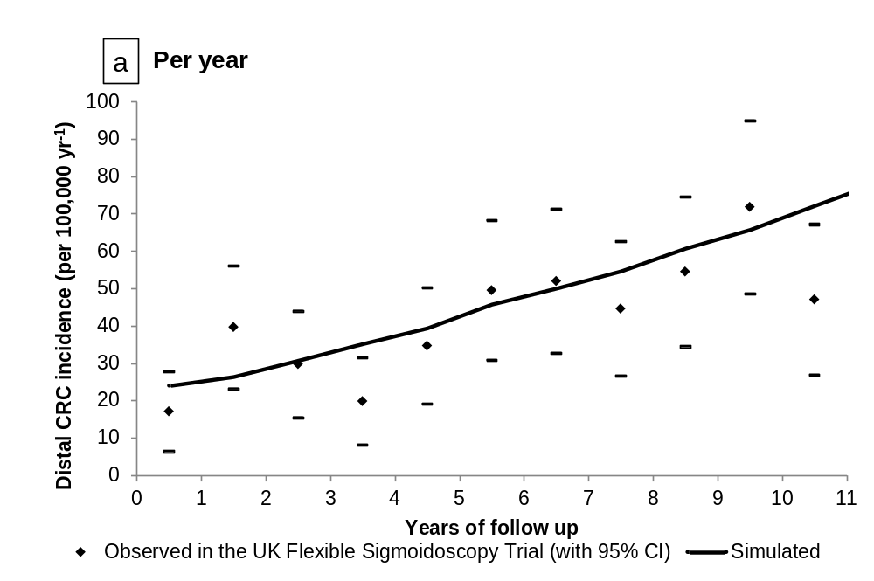
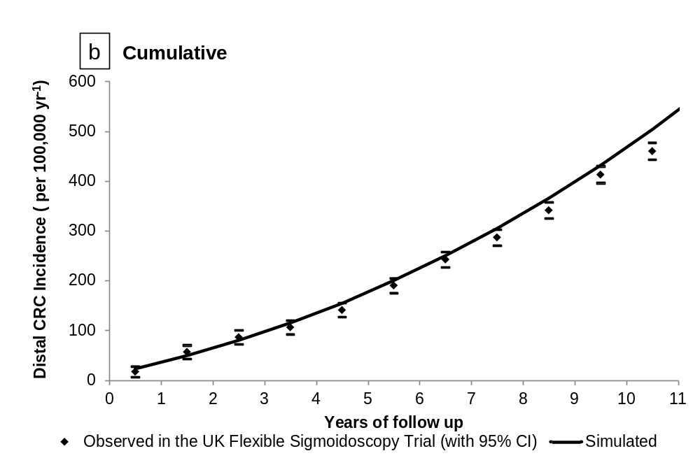
* Findings from the UK Flexible Sigmoidoscopy study were published in Lancet in 2010.(63) Simulations were performed using the base-case MISCAN-Colon model.

Supplementary Figure 4. Observed vs. simulated cancer incidence and mortality reductions for colonoscopy screening, from observational studies in a 2014 systematic review *
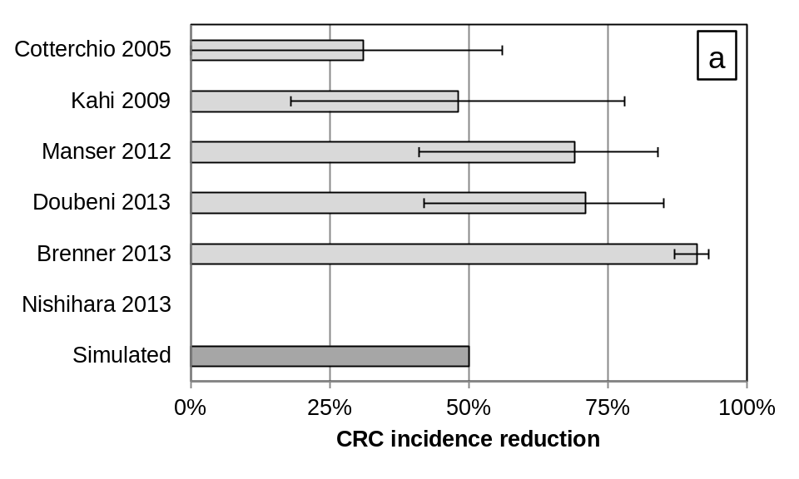
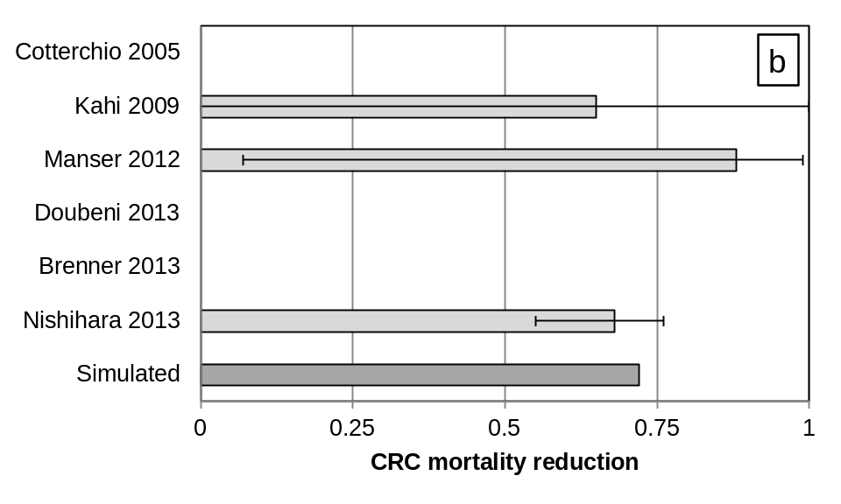
Abbreviation: CRC = colorectal cancer
* The systematic review was published in the British Medical Journal in 2014,(49) and included a total of 6 observational studies on colonoscopy screening effectiveness.(42-47) In the original studies, effectiveness was expressed in terms of odds ratios and incidence rate ratios, which both approximate the relative risk in case of rare events. Doubeni and colleagues assessed the impact of screening on advanced cancer stages. The risk period was 7-25 years in the included observational studies versus lifetime in the model. Simulations were performed using the base-case MISCAN-Colon model.

Supplementary Figure 5. Observed vs. simulated colorectal cancer mortality reductions for biennial FIT screening *
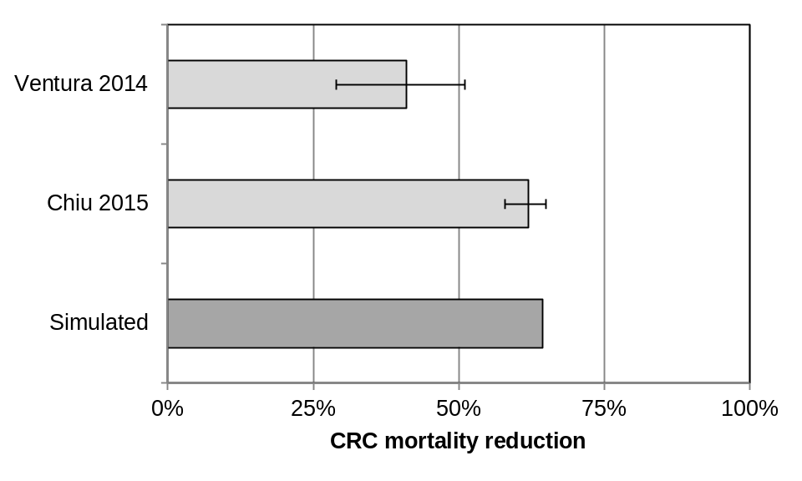
* Findings from the two observational studies were published in Digestive Liver Diseases in 2014 and Cancer in 2015, respectively.(48, 64) The risk period was 6-11 years in the observational studies versus lifetime in the model. The model analysis assumed 100% adherence with biennial screening over time, explaining the higher predicted than observed effectiveness. Simulations were performed using the base-case MISCAN-Colon model.

Supplementary Figure 6. Simulated vs. observed adenoma detection during surveillance of patients with removed low-risk and high-risk adenomas *
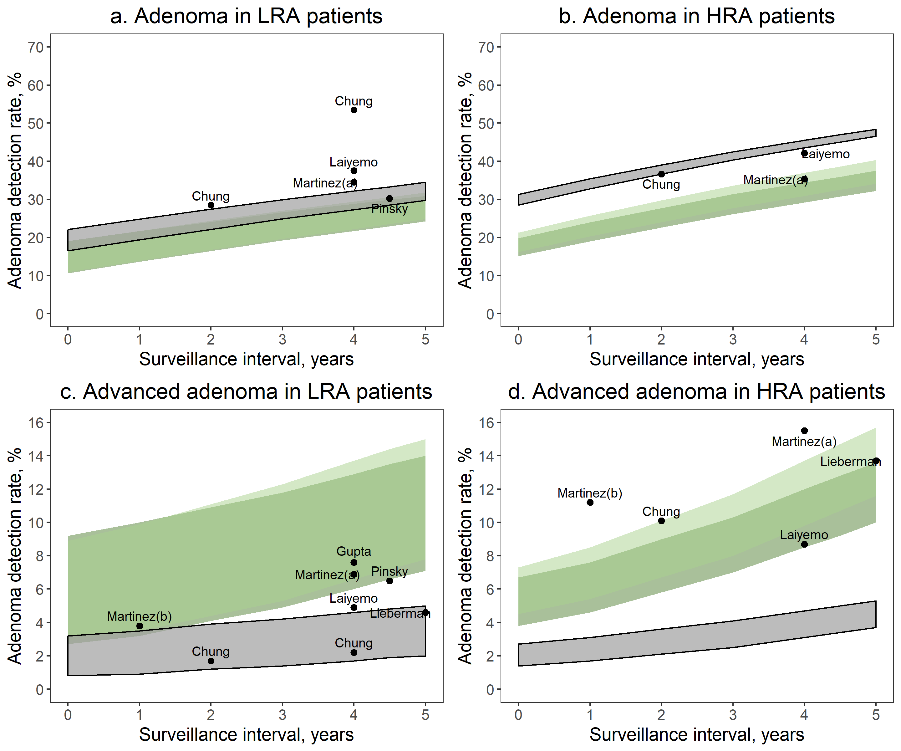
Abbreviations: LRA = low-risk adenoma; HRA = high-risk adenoma.
* Black dots represent observed data points from the literature.(50-56) More study details are provided in Supplementary Table 4. The grey area represents the model-predicted range across colonoscopy and FIT-detected adenoma patients aged 50-69 years. The light and darker green areas represent the model-predicted ranges for models with increased recurrence and risk of advanced adenomas or just increased rates of recurrence (more details in §3). These alternative models better matched observed advanced adenoma detection rates for HRA patients. Low-risk adenomas were defined as 1-2 tubular adenomas <10 mm in diameter; high-risk adenomas were defined as ≥3 tubular adenomas <10mm in diameter, and/or ≥1 advanced adenoma (tubular adenoma ≥10 mm in diameter, tubulovillous adenoma, or adenoma with high-grade dysplasia). In the model histology was not described, and an advanced small adenoma was considered an LRA.

Supplementary Figure 7. Observed vs. simulated colorectal cancer incidence for HRA patients in 17 UK Hospitals after baseline polypectomy, first surveillance, and multiple surveillance exams *
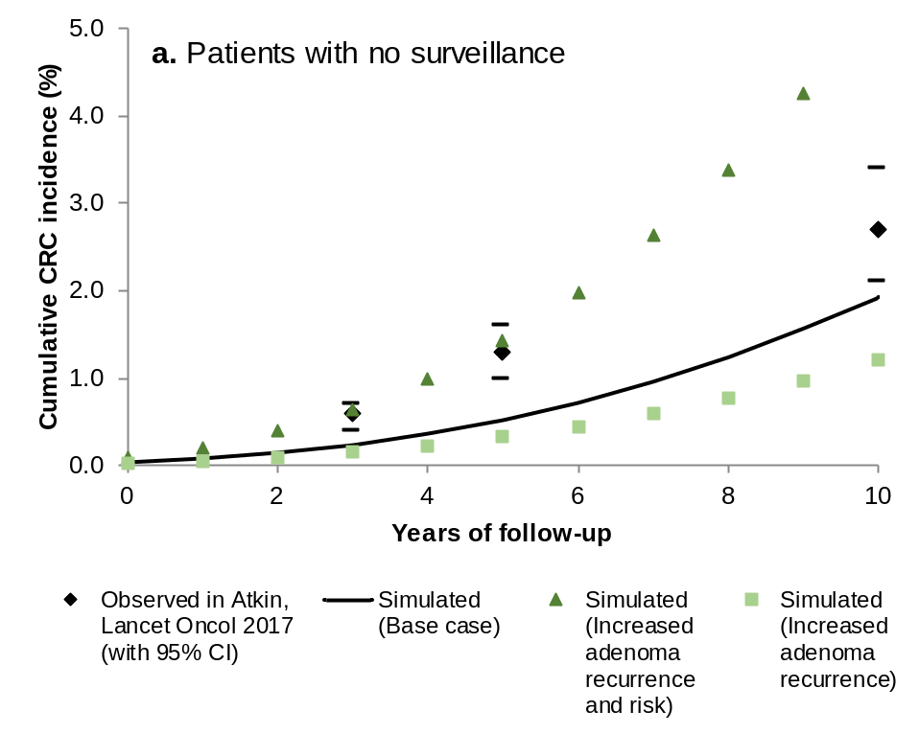 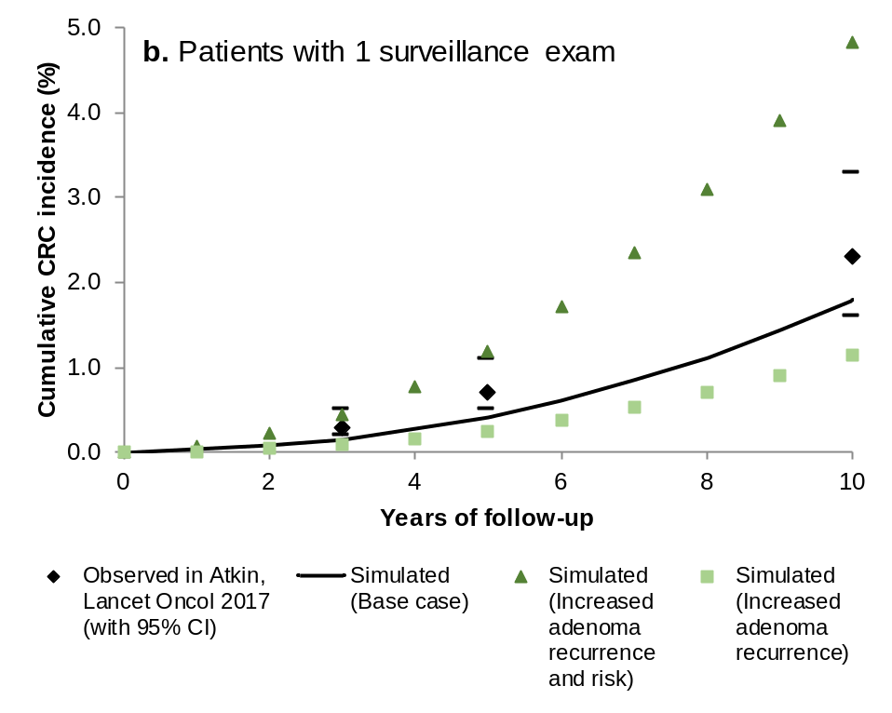 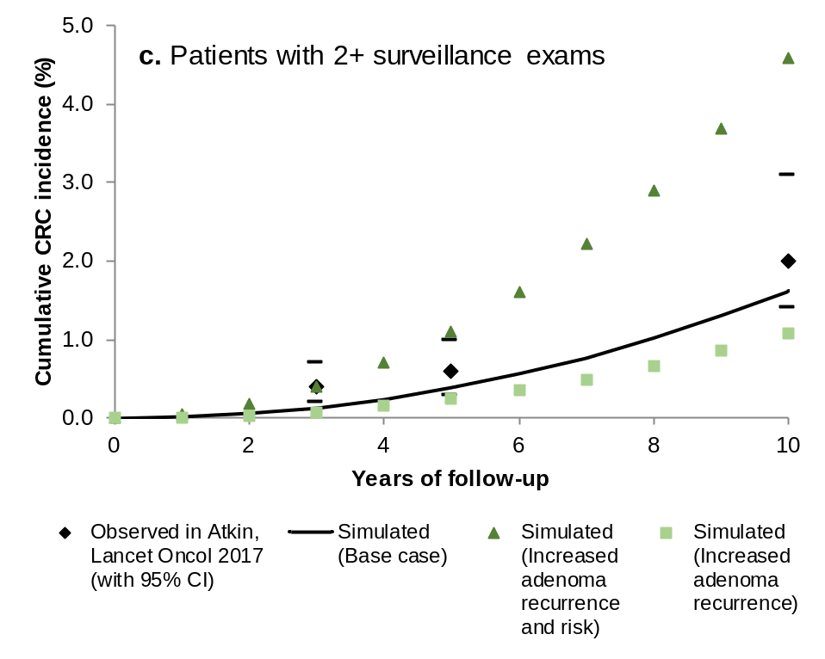
* Findings are from the UK study were published in Lancet Oncology in 2017.(58) Cumulative incidence was calculated as the complement of the Kaplan-Meier disease-free survival estimate. Atkin and colleagues included intermediate-risk patients, defined as patients with 3-4 small adenomas (0-9 mm diameter), or 1-2 large adenomas (≥10 mm diameter). In MISCAN-Colon, all patients with ≥3 small adenomas or ≥1 large adenoma were included, the majority of which would be classified intermediate-risk according to UK guidelines. In addition to predictions from the base-case model, predictions from models with alternative assumptions for the rates of recurrence and CRC risk of advanced adenoma are also shown (more details in §3).

Supplementary Figure 8. Observed vs. simulated colorectal cancer mortality for adenoma patients in the Norwegian cancer registry, with and without assumed colonoscopy use in the reference population *
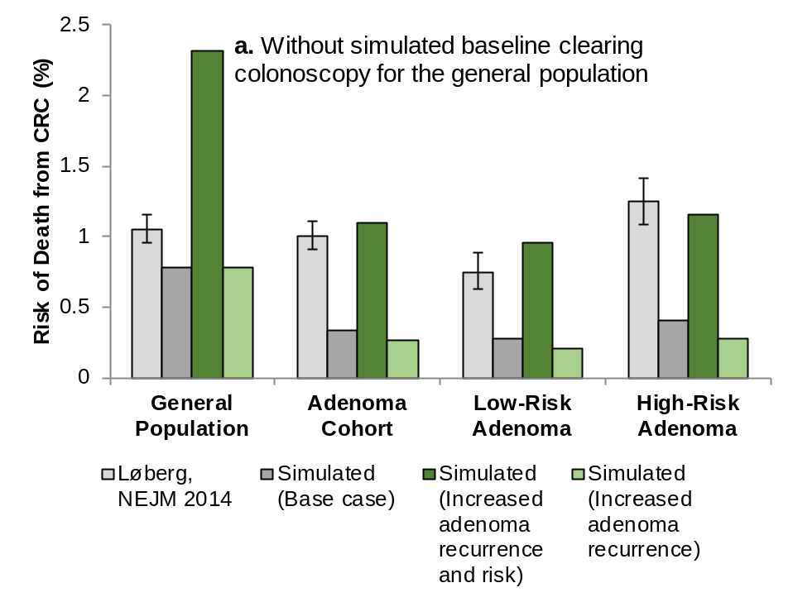 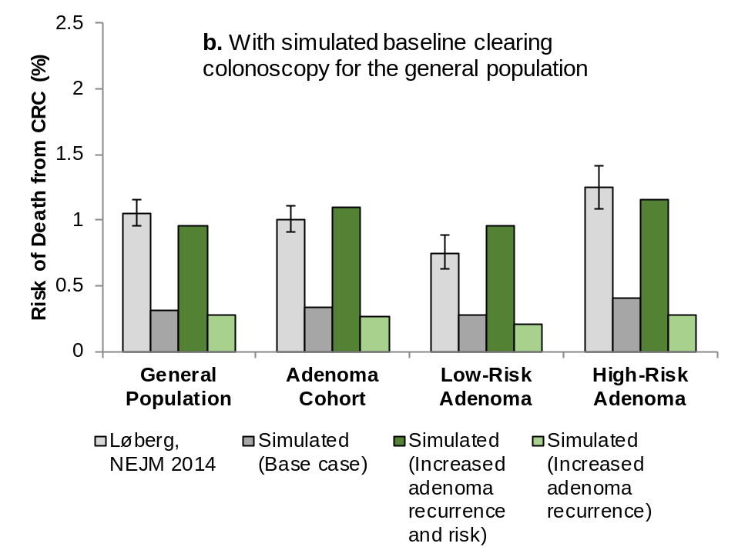
Abbreviations: CRC = Colorectal cancer; NEJM = New England Journal of Medicine.
* Findings from the Norwegian observational study were published in the New England Journal of Medicine in 2014.(59) Simulations were done using the MISCAN-Colon model. In addition to predictions from the base-case model, predictions from models with alternative assumptions for the rates of recurrence and CRC risk of advanced adenoma are also shown (more details in §3).

Supplementary Figure 9. Observed vs. simulated colorectal cancer mortality in the National Polyp Study *
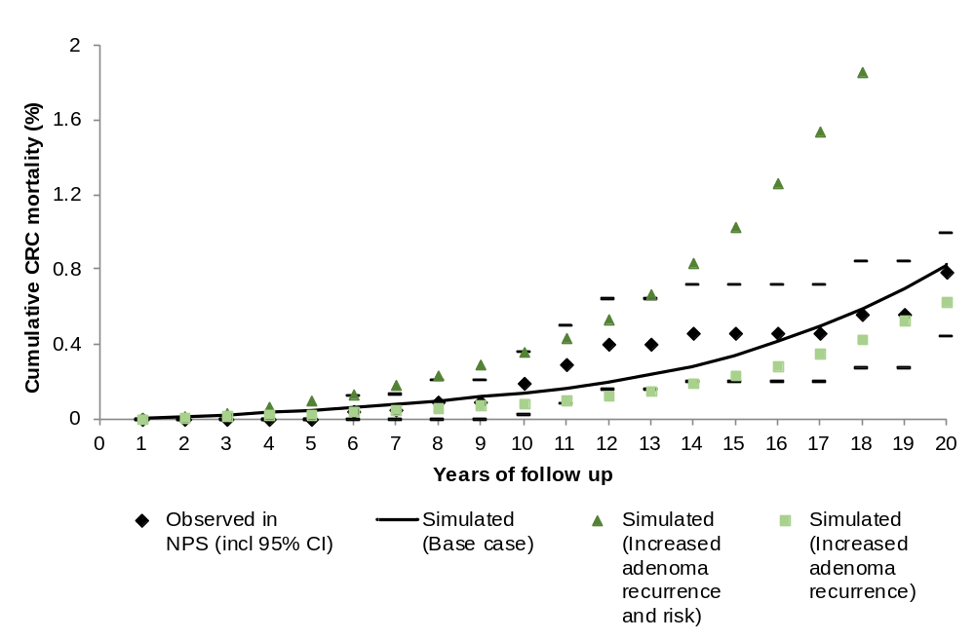
* Findings from the National Polyp Study were published in the New England Journal of Medicine in 2012.(62) Cumulative mortality was calculated as the complement of the Kaplan-Meier survival estimate. Simulations were performed using the MISCAN-Colon model. In addition to predictions from the base-case model, predictions from models with alternative assumptions for the rates of recurrence and CRC risk of advanced adenoma are also shown (more details in §3).

4. Outcomes of Surveillance in a Colonoscopy Screening Setting

Supplementary Table 5. Prediction cumulative lifetime surveillance benefit for patients with adenoma detected in colonoscopy screening, by age and finding
 |  | Follow-up (Fu)
 |  | After 10 years Fu |  |  |  | At age 80 y ‡ |  |  |  | Lifetime Fu
Risk  group * | Strategy  by age † | CRC  cases | CRC  deaths | QALY  gained  (disc.) |  | CRC  cases | CRC  deaths | QALY  gained  (disc.) |  | CRC  cases | CRC  deaths | QALY  gained  (disc.)
LRA | Patients aged 50 y
 | No surveillance/  No return to screening | 7 | 2 | - |  | 72 | 25 | - |  | 109 | 44 | -
 | Return to routine screening § | 13 | 2 | -5 |  | 43 | 10 | 55 |  | 65 | 19 | 114
 | Low-intensity surveillance | 13 | 2 | -5 |  | 46 | 9 | 55 |  | 59 | 16 | 121
 | High-intensity surveillance | 7 | 1 | -5 |  | 40 | 7 | 67 |  | 49 | 12 | 142
 | Patients aged 60 y
 | No surveillance/  No return to screening | 10 | 2 | - |  | 36 | 11 | - |  | 64 | 25 | -
 | Return to routine screening § | 18 | 2 | -5 |  | 27 | 6 | 11 |  | 46 | 14 | 46
 | Low-intensity surveillance | 18 | 2 | -5 |  | 30 | 6 | 10 |  | 42 | 11 | 52
 | High-intensity surveillance | 9 | 1 | -4 |  | 24 | 4 | 18 |  | 32 | 8 | 71
 | Patients aged 70 y
 | No surveillance/  No return to screening | 10 | 3 | - |  | 10 | 3 | - |  | 30 | 10 | -
 | Return to routine screening § | NA |  |  |  | NA |  |  |  | NA
 | Low-intensity surveillance | 18 | 3 | -4 |  | 18 | 3 | -4 |  | 22 | 5 | 13
 | High-intensity surveillance | 10 | 2 | -4 |  | 10 | 2 | -4 |  | 19 | 5 | 19
HRA | Patients aged 50 y
 | No surveillance/  No return to screening | 11 | 3 | - |  | 118 | 42 | - |  | 172 | 70 | -
 | Return to routine screening § | 22 | 3 | -5 |  | 71 | 16 | 94 |  | 105 | 31 | 188
 | Low-intensity surveillance | 10 | 1 | -3 |  | 71 | 14 | 110 |  | 89 | 23 | 222
 | High-intensity surveillance | 10 | 1 | -6 |  | 57 | 10 | 131 |  | 75 | 18 | 254
 | Patients aged 60 y
 | No surveillance/  No return to screening | 18 | 4 | - |  | 66 | 21 | - |  | 116 | 45 | -
 | Return to routine screening § | 34 | 4 | -6 |  | 50 | 11 | 24 |  | 84 | 26 | 87
 | Low-intensity surveillance | 16 | 2 | -2 |  | 47 | 9 | 39 |  | 66 | 17 | 128
 | High-intensity surveillance | 15 | 2 | -3 |  | 37 | 6 | 51 |  | 54 | 13 | 153
 | Patients aged 70 y
 | No surveillance/  No return to screening | 20 | 5 | - |  | 20 | 5 | - |  | 58 | 21 | -
 | Return to routine screening § | NA |  |  |  | NA |  |  |  | NA
 | Low-intensity surveillance | 19 | 3 | -2 |  | 19 | 3 | -2 |  | 40 | 11 | 38
 | High-intensity surveillance | 17 | 2 | -2 |  | 17 | 2 | -2 |  | 31 | 7 | 53
Abbreviations: CRC = colorectal cancer; disc. = discounted; HRA = high-risk adenoma; LRA = low-risk adenoma; NA = not applicable; QALY = quality-adjusted life year.
* Low-risk adenomas were defined as 1-2 tubular adenomas <10 mm in diameter; high-risk adenomas were defined as ≥3 tubular adenomas <10mm in diameter, and/or ≥1 advanced adenoma (tubular adenoma ≥10 mm in diameter, tubulovillous adenoma, or adenoma with high-grade dysplasia). In the model histology was not described, and an advanced adenoma was considered a large adenoma.
† There were four scenarios evaluated: No surveillance/No return to screening consisted of a baseline colonoscopy examination only; Return to routine screening consisted of resumed colonoscopy screening after 10 years through age 70 years; Low-intensity surveillance consisted of a colonoscopy after 5 years in case of HRA detection, and colonoscopy after 10 years after detection of LRA, and 10 years or return to screening in case of no detected adenoma (Supplementary Table 1), with a stopping age of 80 years; High-intensity surveillance consisted of a colonoscopy after 3 years in case of an HRA, colonoscopy after 5 years in case of an LRA; and colonoscopy after 10 years in case of no detected adenoma in surveillance (Supplementary Table 1), with a similar stopping age of 80 years.
‡ Results at age 80 years represent a variable follow-up period of 30 years for patients aged 50 years at baseline, 20 years for patients aged 60 years at baseline, and 10 years for patients aged 70 years at baseline. It approximates average life expectancy for these patients.
§ Patients returned to colonoscopy screening after 10 years. For patients aged 70 years at baseline, this scenario was identical to No surveillance/No return to screening, as in the U.S., screening is not generally recommended after a colonoscopy at age 70.

Supplementary Table 6. Health outcomes, costs, and incremental cost-effectiveness ratios of adenoma surveillance strategies for patients with adenomas detected at a screening colonoscopy, by age and finding *
 |  | Outcomes per 1000 adults
Risk  group † | Strategy  by age ‡ | CRC  cases | CRC  deaths | QALYs §  (disc.) | QALY ||  gained  (disc.) | Colono-  scopies | Cost (thousand $; disc.) ¶ |  |  | ∆Cost/  ∆QALY  (disc.) **
 |  |  |  |  |  |  | Colono-  scopy | Treat-  ment | Total
LRA | Patients aged 50 y
 | No surveillance/  No return to screening | 109 | 44 | 19,456 | - | 0 | 0 | 4,110 | 4,110 | Dom.
 | Return to routine screening †† | 65 | 19 | 19,570 | 114 | 1,736 | 1,199 | 2,671 | 3,870 | Ref.
 | Low-intensity surveillance | 59 | 16 | 19,577 | 121 | 2,013 | 1,341 | 2,557 | 3,898 | 4,000
 | High-intensity surveillance | 49 | 12 | 19,598 | 142 | 3,178 | 2,178 | 2,112 | 4,290 | 18,400
 | Patients aged 60 y
 | No surveillance/  No return to screening | 64 | 25 | 15,784 | - | 0 | 0 | 2,745 | 2,745 | Ref.
 | Return to routine screening †† | 46 | 14 | 15,830 | 46 | 866 | 681 | 2,105 | 2,786 | 900
 | Low-intensity surveillance | 42 | 11 | 15,835 | 52 | 1,111 | 838 | 2,010 | 2,848 | 10,500
 | High-intensity surveillance | 32 | 8 | 15,855 | 71 | 2,089 | 1,613 | 1,571 | 3,184 | 17,400
 | Patients aged 70 y
 | No surveillance/  No return to screening | 30 | 10 | 11,630 | - | 0 | 0 | 1,380 | 1,380 | Ref.
 | Return to routine screening †† | NA
 | Low-intensity surveillance | 22 | 5 | 11,643 | 13 | 705 | 574 | 1,175 | 1,749 | 27,400
 | High-intensity surveillance | 19 | 5 | 11,649 | 19 | 1,085 | 953 | 963 | 1,915 | 29,500
HRA | Patients aged 50 y
 | No surveillance/  No return to screening | 172 | 70 | 19,303 | - | 0 | 0 | 6,622 | 6,622 | Dom.
 | Return to routine screening †† | 105 | 31 | 19,491 | 188 | 1,720 | 1,231 | 4,402 | 5,633 | Ref.
 | Low-intensity surveillance | 89 | 23 | 19,525 | 222 | 2,712 | 1,960 | 3,824 | 5,784 | 4,500
 | High-intensity surveillance | 75 | 18 | 19,557 | 254 | 3,898 | 2,886 | 3,166 | 6,052 | 8,400
 | Patients aged 60 y
 | No surveillance/  No return to screening | 116 | 45 | 15,665 | - | 0 | 0 | 5,027 | 5,027 | Dom.
 | Return to routine screening †† | 84 | 26 | 15,752 | 87 | 860 | 709 | 3,902 | 4,611 | Ref.
 | Low-intensity surveillance | 66 | 17 | 15,793 | 128 | 1,808 | 1,486 | 3,138 | 4,623 | 300
 | High-intensity surveillance | 54 | 13 | 15,818 | 153 | 2,736 | 2,273 | 2,545 | 4,818 | 7,700
 | Patients aged 70 y
 | No surveillance/  No return to screening | 58 | 21 | 11,577 | - | 0 | 0 | 2,701 | 2,701 | Ref.
 | Return to routine screening †† | NA
 | Low-intensity surveillance | 40 | 11 | 11,615 | 38 | 942 | 886 | 1,981 | 2,866 | 4,300
 | High-intensity surveillance | 31 | 7 | 11,630 | 53 | 1,717 | 1,589 | 1,571 | 3,160 | 19,500
Abbreviations: CRC = colorectal cancer; disc. = discounted; Dom. = dominated; HRA = high-risk adenoma; ICER = incremental cost-effectiveness ratio; LRA = low-risk adenoma; QALY = quality-adjusted life-year; Ref. = reference scenario.
* Adenomas were detected through colonoscopy screening. Results for patients with adenomas detected through FIT screening are provided in Supplementary Table 9.
† Low-risk adenomas were defined as 1-2 tubular adenomas <10 mm in diameter; high-risk adenomas were defined as ≥3 tubular adenomas <10mm in diameter, and/or ≥1 advanced adenoma (tubular adenoma ≥10 mm in diameter, tubulovillous adenoma, or adenoma with high-grade dysplasia). In the model histology was not described, and an advanced adenoma was considered a large adenoma.
‡ There were four scenarios evaluated: No surveillance/No return to screening consisted of a baseline colonoscopy examination only; Return to routine screening consisted of resumed colonoscopy screening after 10 years through age 70 years; Low-intensity surveillance consisted of a colonoscopy after 5 years in case of HRA detection, and colonoscopy after 10 years after detection of LRA, and 10 years or return to screening in case of no detected adenoma (Supplementary Table 1), with a stopping age of 80 years; High-intensity surveillance consisted of a colonoscopy after 3 years in case of an HRA, colonoscopy after 5 years in case of an LRA; and colonoscopy after 10 years in case of no detected adenoma in surveillance (Supplementary Table 1), with a similar stopping age of 80 years.
§ QALYs were discounted by 3% per annum to baseline at age 50, 60, or 70 years, respectively. See Supplementary Table 7 for a specification of quality of life adjustments
|| QALY gained are presented compared to No screening/surveillance.
¶ Costs were discounted by 3% per annum to baseline at age 50, 60, or 70 years, respectively. Cost of colonoscopy complications were included as described elsewhere.(65) See Supplementary Table 7 for a specification of cost components.
** Additional cost per QALY gained for some surveillance strategy compared to the next less effective, non-dominated strategy.
†† Patients returned to colonoscopy screening after 10 years through age 70 years. For patients aged 70 years at baseline, this was equivalent to no further screening or surveillance.

Supplementary Table 7. Component-specific impact of surveillance on quality of life and costs for patients with adenomas detected in colonoscopy screening, by age and finding
Risk  group * | Strategy by age † | Outcomes per 1000 adults ‡
 |  |  | Quality of Life adjustments |  |  |  |  |  | Cost components (thousand US $)
 |  | Life years | Screen-  ing  tests | Surveil-  lance  tests | Compli-  cations | Treat-  ment | QALYs |  | Screen-  ing  tests | Surveil-  lance  tests | Compli-  cations | Treat-  ment | Total  costs
LRA | Patients aged 50 y
 | No surveillance/  No return to screening | 19510 | 0 | 0 | 0.0 | -55 | 19456 |  | 0 | 0 | 0 | 4110 | 4110
 | Return to routine screening § | 19610 | -6 | 0 | -0.2 | -34 | 19570 |  | 1169 | 0 | 30 | 2671 | 3870
 | Low-intensity surveillance | 19616 | -1 | -6 | -0.2 | -33 | 19577 |  | 265 | 1037 | 39 | 2557 | 3898
 | High-intensity surveillance | 19636 | 0 | -12 | -0.3 | -26 | 19598 |  | 0 | 2128 | 50 | 2112 | 4290
 | Patients aged 60 y
 | No surveillance/  No return to screening | 15816 | 0 | 0 | 0.0 | -33 | 15784 |  | 0 | 0 | 0 | 2745 | 2745
 | Return to routine screening § | 15858 | -4 | 0 | -0.1 | -25 | 15830 |  | 659 | 0 | 22 | 2105 | 2786
 | Low-intensity surveillance | 15864 | 0 | -4 | -0.2 | -24 | 15835 |  | 0 | 804 | 33 | 2010 | 2848
 | High-intensity surveillance | 15882 | 0 | -9 | -0.3 | -18 | 15855 |  | 0 | 1567 | 46 | 1571 | 3184
 | Patients aged 70 y
 | No surveillance/  No return to screening | 11645 | 0 | 0 | 0.0 | -15 | 11630 |  | 0 | 0 | 0 | 1380 | 1380
 | Return to routine screening § | NA |  |  |  |  |  |  | NA
 | Low-intensity surveillance | 11659 | 0 | -3 | -0.2 | -12 | 11643 |  | 0 | 538 | 36 | 1175 | 1749
 | High-intensity surveillance | 11664 | 0 | -5 | -0.2 | -10 | 11649 |  | 0 | 917 | 36 | 963 | 1915
HRA | Patients aged 50 y
 | No surveillance/  No return to screening | 19392 | 0 | 0 | 0.0 | -89 | 19303 |  | 0 | 0 | 0 | 6622 | 6622
 | Return to routine screening § | 19554 | -6 | 0 | -0.2 | -57 | 19491 |  | 1191 | 0 | 41 | 4402 | 5633
 | Low-intensity surveillance | 19583 | 0 | -10 | -0.4 | -48 | 19525 |  | 0 | 1900 | 61 | 3824 | 5784
 | High-intensity surveillance | 19610 | 0 | -15 | -0.4 | -38 | 19557 |  | 0 | 2816 | 71 | 3166 | 6052
 | Patients aged 60 y
 | No surveillance/  No return to screening | 15726 | 0 | 0 | 0.0 | -61 | 15665 |  | 0 | 0 | 0 | 5027 | 5027
 | Return to routine screening § | 15802 | -4 | 0 | -0.2 | -46 | 15752 |  | 676 | 0 | 33 | 3902 | 4611
 | Low-intensity surveillance | 15837 | 0 | -8 | -0.4 | -36 | 15793 |  | 0 | 1424 | 61 | 3138 | 4623
 | High-intensity surveillance | 15859 | 0 | -12 | -0.5 | -28 | 15818 |  | 0 | 2199 | 74 | 2545 | 4818
 | Patients aged 70 y
 | No surveillance/  No return to screening | 11606 | 0 | 0 | 0.0 | -29 | 11577 |  | 0 | 0 | 0 | 2701 | 2701
 | Return to routine screening § | NA |  |  |  |  |  |  | NA
 | Low-intensity surveillance | 11641 | 0 | -4 | -0.3 | -20 | 11615 |  | 0 | 837 | 49 | 1981 | 2866
 | High-intensity surveillance | 11655 | 0 | -8 | -0.5 | -16 | 11630 |  | 0 | 1514 | 75 | 1571 | 3160
Abbreviations: disc. = discounted; HRA = high-risk adenoma; LRA = low-risk adenoma; NA = not applicable; QALY = quality-adjusted life year.
* Adenomas were detected through colonoscopy screening. Results for patients with adenomas detected through FIT screening are provided in Supplementary Table 10. Low-risk adenomas were defined as 1-2 tubular adenomas <10 mm in diameter; high-risk adenomas were defined as ≥3 tubular adenomas <10mm in diameter, and/or ≥1 advanced adenoma (tubular adenoma ≥10 mm in diameter, tubulovillous adenoma, or adenoma with high-grade dysplasia). In the model histology was not described, and an advanced adenoma was considered a large adenoma.
† There were four scenarios evaluated: No surveillance/No return to screening consisted of a baseline colonoscopy examination only; Return to routine screening consisted of resumed colonoscopy screening after 10 years through age 70 years; Low-Intensity surveillance consisted of a colonoscopy after 5 years in case of HRA detection, and colonoscopy after 10 years after detection of LRA, and 10 years or return to screening in case of no detected adenoma (Supplementary Table 1), with a stopping age of 80 years; High-intensity surveillance consisted of a colonoscopy after 3 years in case of an HRA, colonoscopy after 5 years in case of an LRA; and colonoscopy after 10 years in case of no detected adenoma in surveillance (Supplementary Table 1), with a similar stopping age of 80 years.
‡ Outcomes were discounted by 3% per annum to baseline, i.e. patient age 50, 60, or 70, respectively.
§ Patients returned to colonoscopy screening after 10 years. For patients aged 70 years at baseline, this scenario was similar to No surveillance/No return to screening, as in the United States, screening is not generally recommended after a colonoscopy at age 70 years.

Supplementary Figure 10. Lifetime colorectal cancer incidence in patients with adenoma detected at a screening colonoscopy, by age and finding *
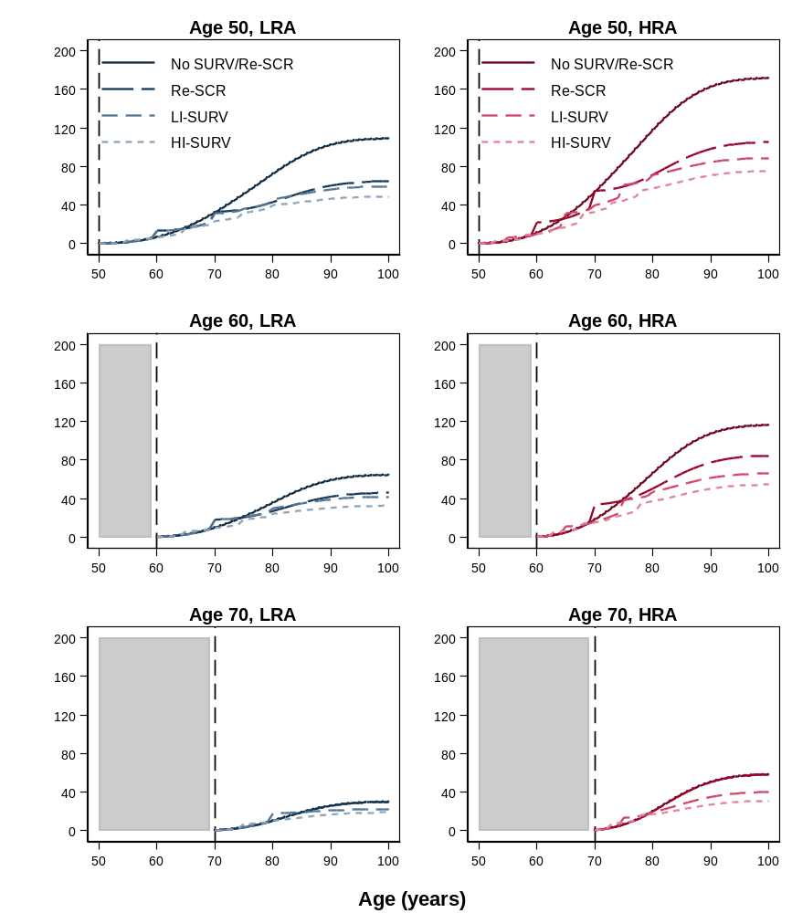
Abbreviations: COL = colonoscopy; Cont = continued; CRC = colorectal cancer; HI = High-intensity; HRA = high-risk adenoma; LI = Low-intensity; LRA = low-risk adenoma; Re = return; SCR = screening; SURV = surveillance.
* Low-risk adenomas were defined as 1-2 tubular adenomas <10 mm in diameter; high-risk adenomas were defined as ≥3 tubular adenomas <10mm in diameter, and/or ≥1 advanced adenoma (tubular adenoma ≥10 mm in diameter, tubulovillous adenoma, or adenoma with high-grade dysplasia). In the model histology was not described, and a small adenoma with advanced histology was considered an LRA. There were four scenarios evaluated: No surveillance/return to screening consisted of a baseline colonoscopy examination only; Return to routine screening in 10 years consisted of continued colonoscopy screening every 10 years through age 70 years (not applicable for patients with adenoma detected at age 70 years); Low-intensity surveillance consisted of a colonoscopy after 5 years in case of HRA detection, and colonoscopy after 10 years after detection of LRA, and 10 years or return to screening in case of no detected adenoma (Supplementary Table 1), with a stopping age of 80 years; High-intensity surveillance consisted of a colonoscopy after 3 years in case of an HRA, colonoscopy after 5 years in case of an LRA; and colonoscopy after 10 years in case of no detected adenoma in surveillance (Supplementary Table 1), with a similar stopping age of 80 years. Associated numbers with each of the scenarios are provided in Supplementary Table 5.

Supplementary Figure 11. Sensitivity analysis of incremental cost-effectiveness of surveillance in patients with adenoma at screening colonoscopy * 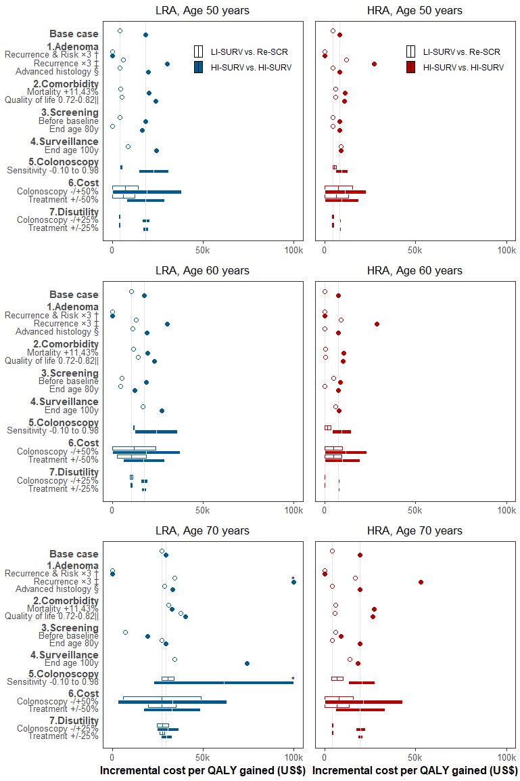
Abbreviations: COL = colonoscopy; CRC = colorectal cancer; HI = high-intensity; HRA = high-risk adenoma; ICER = incremental cost-effectiveness ratio; LI = low-intensity; LRA = low-risk adenoma; POL = polyp; QALY = quality-adjusted life year; Re = return; SCR = screening; SURV = surveillance.
* Incremental cost-effectiveness ratios for low-intensity surveillance scenarios were relative to the scenario of return to colonoscopy screening in 10 years; incremental cost-effectiveness for high-intensity surveillance were relative to low-intensity surveillance. Grey vertical lines represent the base-case ICERs. Values greater than US $100,000 (marked*) were censored for this figure but reported in the Results. Results for patients with adenomas detected by FIT screening are in Supplementary Figure 13.
† The recurrence of advanced adenoma at surveillance and the associated CRC risk were increased approximately three-fold to better match observed data (Supplementary Figure 6, Panel d; Supplementary Figure 8). This increase was accomplished by decreasing the assumed average time it takes for a new adenoma to develop into cancer.
‡ The recurrence of advanced adenoma was increased three-fold to better match observed data on advanced adenoma recurrence in HRA patients (Supplementary Figure 6, Panel d), but CRC risk was kept consistent with the Surveillance Epidemiology and End Results program data used for model calibration.
§ Results for LRA patients were corrected for misclassification of small adenoma with advanced histological features (villous histology or high-grade dysplasia) under the assumption that these lesions behave similar to HRA.
|| The quality of life for the population was decreased with age to reflect overall deteriorating health with age.(66)

5. Outcomes of Surveillance in a FIT Screening Setting

Supplementary Table 8. Prediction cumulative lifetime surveillance benefit for patients with adenoma detected in FIT screening, by age and finding at follow-up colonoscopy
 |  | After 10 years |  |  |  | At age 80y ‡ |  |  |  | Lifetime
Risk  group * | Strategy  by age † | CRC  cases | CRC  deaths | QALY  gained  (disc.) |  | CRC  cases | CRC  deaths | QALY  gained  (disc.) |  | CRC  cases | CRC  deaths | QALY  gained  (disc.)
LRA | Patients aged 50 y
 | No surveillance/  No return to screening | 11 | 3 | - |  | 81 | 29 | - |  | 119 | 48 | -
 | Return to routine screening § | 17 | 3 | -2 |  | 65 | 13 | 46 |  | 92 | 25 | 101
 | Low-intensity surveillance | 19 | 3 | -5 |  | 56 | 12 | 57 |  | 74 | 20 | 123
 | High-intensity surveillance | 12 | 2 | -5 |  | 46 | 9 | 77 |  | 55 | 14 | 158
 | Patients aged 60 y
 | No surveillance/  No return to screening | 19 | 6 | - |  | 48 | 17 | - |  | 79 | 31 | -
 | Return to routine screening § | 27 | 6 | -2 |  | 49 | 11 | 5 |  | 72 | 21 | 37
 | Low-intensity surveillance | 30 | 6 | -5 |  | 43 | 10 | 12 |  | 55 | 16 | 59
 | High-intensity surveillance | 20 | 4 | -5 |  | 36 | 8 | 25 |  | 44 | 12 | 87
 | Patients aged 70 y
 | No surveillance/  No return to screening | 25 | 8 | - |  | 25 | 8 | - |  | 49 | 19 | -
 | Return to routine screening § | NA |  |  |  | NA |  |  |  | NA
 | Low-intensity surveillance | 37 | 8 | -5 |  | 37 | 8 | -5 |  | 42 | 13 | 16
 | High-intensity surveillance | 28 | 6 | -5 |  | 28 | 6 | -5 |  | 37 | 11 | 28
HRA | Patients aged 50 y |  |  |  |  | 52
 | No surveillance/  No return to screening | 13 | 3 | - |  | 116 | 42 | - |  | 169 | 69 | -
 | Return to routine screening § | 21 | 3 | -2 |  | 93 | 18 | 76 |  | 131 | 34 | 157
 | Low-intensity surveillance | 12 | 2 | -3 |  | 71 | 14 | 109 |  | 88 | 23 | 218
 | High-intensity surveillance | 11 | 1 | -6 |  | 58 | 11 | 131 |  | 75 | 18 | 251
 | Patients aged 60 y
 | No surveillance/  No return to screening | 23 | 6 | - |  | 73 | 24 | - |  | 124 | 49 | -
 | Return to routine screening § | 35 | 6 | -3 |  | 72 | 15 | 14 |  | 111 | 32 | 68
 | Low-intensity surveillance | 22 | 4 | -2 |  | 54 | 10 | 43 |  | 72 | 19 | 137
 | High-intensity surveillance | 20 | 3 | -3 |  | 43 | 7 | 58 |  | 60 | 15 | 166
 | Patients aged 70 y
 | No surveillance/  No return to screening | 28 | 8 | - |  | 28 | 8 | - |  | 70 | 26 | -
 | Return to routine screening § | NA |  |  |  | NA |  |  |  | NA
 | Low-intensity surveillance | 29 | 6 | -2 |  | 29 | 6 | -2 |  | 51 | 14 | 46
 | High-intensity surveillance | 26 | 4 | -2 |  | 26 | 4 | -2 |  | 41 | 10 | 63
Abbreviations: CRC = colorectal cancer; disc. = discounted; HRA = high-risk adenoma; LRA = low-risk adenoma; NA = not applicable; QALY = quality-adjusted life year.
* Low-risk adenomas were defined as 1-2 tubular adenomas <10 mm in diameter; high-risk adenomas were defined as ≥3 tubular adenomas <10mm in diameter, and/or ≥1 advanced adenoma (tubular adenoma ≥10 mm in diameter, tubulovillous adenoma, or adenoma with high-grade dysplasia). In the model histology was not described, and an advanced adenoma was considered a large adenoma.
† There were four scenarios evaluated: No surveillance/No return to screening consisted of a baseline colonoscopy examination only; Return to routine screening consisted of resumed FIT screening after 10 years through age 75 years; Low-intensity surveillance consisted of a colonoscopy after 5 years in case of HRA detection, and colonoscopy after 10 years after detection of LRA, and 10 years or return to screening in case of no detected adenoma (Supplementary Table 1), with a stopping age of 80 years; High-intensity surveillance consisted of a colonoscopy after 3 years in case of an HRA, colonoscopy after 5 years in case of an LRA; and colonoscopy after 10 years in case of no detected adenoma in surveillance (Supplementary Table 1), with a similar stopping age of 80 years.
‡ Results at age 80 years represent a variable follow-up period of 30 years for patients aged 50 years at baseline, 20 years for patients aged 60 years at baseline, and 10 years for patients aged 70 years at baseline. It approximates average life expectancy for these patients.
§ Patients returned to colonoscopy screening after 10 years. For patients aged 70 years at baseline, this scenario was identical to No surveillance/No return to screening, as in the U.S., screening is not generally recommended after a colonoscopy at age 70.

Supplementary Table 9. Health outcomes, costs, and incremental cost-effectiveness ratios of surveillance strategies for patients with adenomas detected at FIT screening, by age and finding at follow-up colonoscopy *
 |  | Outcomes per 1000 adults in MISCAN-Colon; Base-case
Risk  group † | Strategy  by age ‡ | CRC  cases | CRC  deaths | QALYs §  (disc.) | QALY ||  gained  (disc.) | Colono-  scopies | Cost (thousand $; disc.) ¶ |  |  | ICER (Cost/  QALY, disc.) **
 |  |  |  |  |  |  | Endo-  scopy | Treat-  ment | Total
LRA | Patients aged 50 y
 | No surveillance/  No return to screening | 119 | 48 | 19407 | - | 0 | 0 | 4699 | 4699 | Dom.
 | Return to routine screening †† | 92 | 25 | 19510 | 103 | 551 | 542 | 3994 | 4536 | Dom.
 | Low-intensity surveillance | 74 | 20 | 19530 | 123 | 1591 | 1144 | 3310 | 4454 | Ref.
 | High-intensity surveillance | 55 | 14 | 19565 | 158 | 3207 | 2211 | 2630 | 4841 | 11100
 | Patients aged 60 y
 | No surveillance/  No return to screening | 79 | 31 | 15714 | - | 0 | 0 | 3712 | 3712 | Ref.
 | Return to routine screening †† | 72 | 21 | 15752 | 38 | 246 | 271 | 3617 | 3888 | Dom.
 | Low-intensity surveillance | 55 | 16 | 15773 | 59 | 1132 | 859 | 2989 | 3848 | 2300
 | High-intensity surveillance | 44 | 12 | 15801 | 87 | 2119 | 1651 | 2512 | 4163 | 11100
 | Patients aged 70 y
 | No surveillance/  No return to screening | 49 | 19 | 11561 | - | 0 | 0 | 2604 | 2604 | Ref.
 | Return to routine screening †† | NA
 | Low-intensity surveillance | 42 | 13 | 11577 | 16 | 694 | 574 | 2487 | 3061 | Dom.
 | High-intensity surveillance | 37 | 11 | 11590 | 28 | 1114 | 991 | 2292 | 3283 | 23800
HRA | Patients aged 50 y
 | No surveillance/  No return to screening | 169 | 69 | 19302 | - | 0 | 0 | 6608 | 6608 | Dom.
 | Return to routine screening †† | 131 | 34 | 19462 | 159 | 600 | 581 | 5532 | 6113 | Dom.
 | Low-intensity surveillance | 88 | 23 | 19520 | 218 | 2709 | 1955 | 3901 | 5856 | Ref.
 | High-intensity surveillance | 75 | 18 | 19553 | 251 | 3883 | 2872 | 3258 | 6131 | 8400
 | Patients aged 60 y
 | No surveillance/  No return to screening | 124 | 49 | 15631 | - | 0 | 0 | 5554 | 5554 | Dom.
 | Return to routine screening †† | 111 | 32 | 15700 | 69 | 278 | 302 | 5283 | 5585 | Dom.
 | Low-intensity surveillance | 72 | 19 | 15768 | 137 | 1816 | 1496 | 3646 | 5142 | Ref.
 | High-intensity surveillance | 60 | 15 | 15797 | 166 | 2741 | 2285 | 3029 | 5314 | 5900
 | Patients aged 70 y
 | No surveillance/  No return to screening | 70 | 26 | 11536 | - | 0 | 0 | 3443 | 3443 | Ref.
 | Return to routine screening †† | NA
 | Low-intensity surveillance | 51 | 14 | 11582 | 46 | 956 | 906 | 2734 | 3640 | 4300
 | High-intensity surveillance | 41 | 10 | 11600 | 63 | 1710 | 1596 | 2320 | 3916 | 15400
Abbrevations: CRC = colorectal cancer; disc. = discounted; Dom. = dominated; FIT = fecal immunochemical test; HRA = high-risk adenoma; ICER = incremental cost-effectiveness ratio; LRA = low-risk adenoma; LYG = life-years gained; QALY = quality-adjusted life year; Ref. = reference case.
* Adenomas were detected through FIT screening. Results for patients with adenomas detected through colonoscopy screening are provided in Supplementary Table 6.
† Low-risk adenomas were defined as 1-2 tubular adenomas <10 mm in diameter; high-risk adenomas were defined as ≥3 tubular adenomas <10mm in diameter, and/or ≥1 advanced adenoma (tubular adenoma ≥10 mm in diameter, tubulovillous adenoma, or adenoma with high-grade dysplasia). In the model histology was not described, and an advanced adenoma was considered a large adenoma.
‡ There were four scenarios evaluated: No surveillance/No return to screening consisted of a baseline colonoscopy examination only; Return to routine screening consisted of resumed FIT screening after 10 years through age 75 years; Low-intensity surveillance consisted of a colonoscopy after 5 years in case of HRA detection, and colonoscopy after 10 years after detection of LRA, and 10 years or return to screening in case of no detected adenoma (Supplementary Table 1), with a stopping age of 80 years; High-intensity surveillance consisted of a colonoscopy after 3 years in case of an HRA, colonoscopy after 5 years in case of an LRA; and colonoscopy after 10 years in case of no detected adenoma in surveillance (Supplementary Table 1), with a similar stopping age of 80 years.
§ QALYs were discounted by 3% per annum to baseline at age 50, 60, or 70 years, respectively. See Supplementary Table 10 for a specification of quality of life adjustments
|| QALY gained are presented compared to No screening/surveillance.
¶ Costs were discounted by 3% per annum to baseline at age 50, 60, or 70 years, respectively. Cost of colonoscopy complications were included as described elsewhere.(65) See Supplementary Table 10 for a specification of cost components.
** Additional cost per QALY gained for some surveillance strategy compared to the next less effective, non-dominated strategy.
†† Patients returned to FIT screening after 10 years through age 70 years. For patients aged 70 years at baseline, this was equivalent to no further screening or surveillance.

Supplementary Table 10. Component-specific impact of surveillance on quality of life and costs for patients with adenomas detected in FIT screening, by age and finding at follow-up colonoscopy
Risk  group * | Strategy  by age † | Outcomes per 1000 adults ‡
 |  |  | Quality of Life adjustments |  |  |  |  |  | Cost components (thousand US $)
 |  | Life years | Screen-  ing  tests | Surveil-  lance  tests | Compli-  cations | Treat-  ment | QALYs |  | Screen-  ing  tests | Surveil-  lance  tests | Compli-  cations | Treat-  ment | Total  costs
LRA | Patients aged 50 y
 | No surveillance/  No return to screening | 19472 | 0 | 0 | 0.0 | -65 | 19407 |  | 0 | 0 | 0 | 4699 | 4699
 | Return to routine screening § | 19571 | -10 | 0 | -0.1 | -51 | 19510 |  | 160 | 0 | 16 | 3994 | 4170
 | Low-intensity surveillance | 19582 | -2 | -5 | -0.2 | -45 | 19530 |  | 30 | 1022 | 33 | 3310 | 4396
 | High-intensity surveillance | 19612 | 0 | -12 | -0.3 | -35 | 19565 |  | 0 | 2159 | 52 | 2630 | 4841
 | Patients aged 60 y
 | No surveillance/  No return to screening | 15762 | 0 | 0 | 0.0 | -48 | 15714 |  | 0 | 0 | 0 | 3712 | 3712
 | Return to routine screening § | 15803 | -5 | 0 | -0.1 | -46 | 15752 |  | 76 | 0 | 11 | 3617 | 3704
 | Low-intensity surveillance | 15817 | 0 | -4 | -0.2 | -39 | 15773 |  | 0 | 823 | 37 | 2989 | 3848
 | High-intensity surveillance | 15843 | 0 | -9 | -0.3 | -33 | 15801 |  | 0 | 1601 | 50 | 2512 | 4163
 | Patients aged 70 y
 | No surveillance/  No return to screening | 11592 | 0 | 0 | 0.0 | -31 | 11561 |  | 0 | 0 | 0 | 2604 | 2604
 | Return to routine screening § | NA |  |  |  |  |  |  | NA
 | Low-intensity surveillance | 11610 | 0 | -3 | -0.2 | -30 | 11577 |  | 0 | 535 | 39 | 2487 | 3061
 | High-intensity surveillance | 11623 | 0 | -5 | -0.3 | -28 | 11590 |  | 0 | 949 | 43 | 2292 | 3283
HRA | Patients aged 50 y
 | No surveillance/  No return to screening | 19392 | 0 | 0 | 0.0 | -90 | 19302 |  | 0 | 0 | 0 | 6608 | 6608
 | Return to routine screening § | 19540 | -9 | 0 | -0.1 | -69 | 19462 |  | 154 | 0 | 20 | 5532 | 5706
 | Low-intensity surveillance | 19581 | 0 | -10 | -0.4 | -50 | 19520 |  | 0 | 1896 | 59 | 3901 | 5856
 | High-intensity surveillance | 19609 | 0 | -15 | -0.4 | -41 | 19553 |  | 0 | 2803 | 69 | 3258 | 6131
 | Patients aged 60 y
 | No surveillance/  No return to screening | 15699 | 0 | 0 | 0.0 | -69 | 15631 |  | 0 | 0 | 0 | 5554 | 5554
 | Return to routine screening § | 15768 | -5 | 0 | -0.1 | -63 | 15700 |  | 74 | 0 | 15 | 5283 | 5372
 | Low-intensity surveillance | 15820 | 0 | -8 | -0.4 | -44 | 15768 |  | 0 | 1433 | 63 | 3646 | 5142
 | High-intensity surveillance | 15845 | 0 | -12 | -0.5 | -36 | 15797 |  | 0 | 2209 | 76 | 3029 | 5314
 | Patients aged 70 y
 | No surveillance/  No return to screening | 11574 | 0 | 0 | 0.0 | -38 | 11536 |  | 0 | 0 | 0 | 3443 | 3443
 | Return to routine screening § | NA |  |  |  |  |  |  | NA
 | Low-intensity surveillance | 11617 | 0 | -4 | -0.3 | -30 | 11582 |  | 0 | 853 | 53 | 2734 | 3640
 | High-intensity surveillance | 11634 | 0 | -8 | -0.5 | -26 | 11600 |  | 0 | 1517 | 79 | 2320 | 3916
Abbreviations: disc. = discounted; FIT = fecal immunochemical test; HRA = high-risk adenoma; LRA = low-risk adenoma; NA = not applicable; QALY = quality-adjusted life year.
* Adenomas were detected through FIT screening. Results for patients with adenomas detected through FIT screening are provided in Supplementary Table 7. Low-risk adenomas were defined as 1-2 tubular adenomas <10 mm in diameter; high-risk adenomas were defined as ≥3 tubular adenomas <10mm in diameter, and/or ≥1 advanced adenoma (tubular adenoma ≥10 mm in diameter, tubulovillous adenoma, or adenoma with high-grade dysplasia). In the model histology was not described, and an advanced adenoma was considered a large adenoma.
† There were four scenarios evaluated: No surveillance/No return to screening consisted of a baseline colonoscopy examination only; Return to routine screening consisted of resumed FIT screening after 10 years through age 70 years; Low-intensity surveillance consisted of a colonoscopy after 5 years in case of HRA detection, and colonoscopy after 10 years after detection of LRA, and 10 years or return to screening in case of no detected adenoma (Supplementary Table 1), with a stopping age of 80 years; High-intensity surveillance consisted of a colonoscopy after 3 years in case of an HRA, colonoscopy after 5 years in case of an LRA; and colonoscopy after 10 years in case of no detected adenoma in surveillance (Supplementary Table 1), with a similar stopping age of 80 years.
‡ Outcomes were discounted by 3% per annum to baseline, i.e. patient age 50, 60, or 70, respectively.
§ Patients returned to FIT screening after 10 years. For patients aged 70 years at baseline, this scenario was similar to No surveillance/No return to screening, as in the United States, screening is not generally recommended after a colonoscopy at age 70 years.

Supplementary Figure 12. Lifetime colorectal cancer incidence in patients with adenoma detected at FIT screening, by age and finding at follow-up colonoscopy *
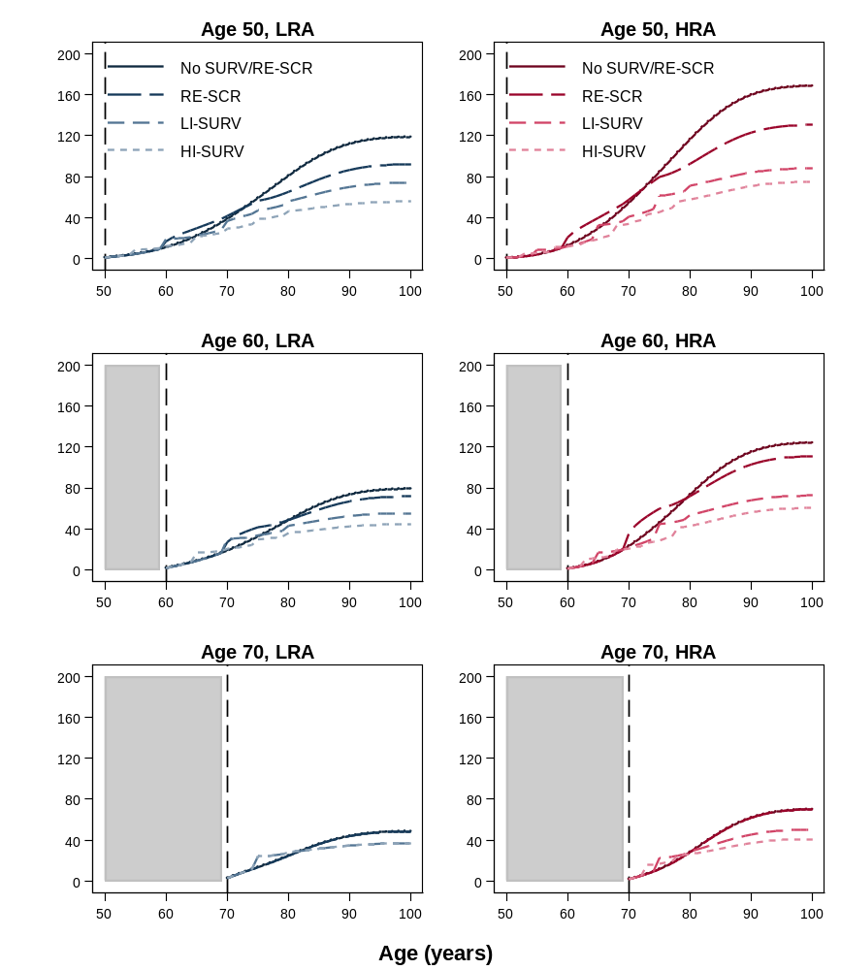
Abbreviations: COL = colonoscopy; Cont = continued; CRC = colorectal cancer; FIT = fecal immunochemical test; HI = High-intensity; HRA = high-risk adenoma; LI = Low-intensity; LRA = low-risk adenoma; Re = return; SCR = screening; SURV = surveillance.
* Low-risk adenomas were defined as 1-2 tubular adenomas <10 mm in diameter; high-risk adenomas were defined as ≥3 tubular adenomas <10mm in diameter, and/or ≥1 advanced adenoma (tubular adenoma ≥10 mm in diameter, tubulovillous adenoma, or adenoma with high-grade dysplasia). In the model histology was not described, and an advanced adenoma was considered a large adenoma. There were four scenarios evaluated: No surveillance/return to screening consisted of a baseline colonoscopy examination only; Return to screening in 10 years consisted of continued colonoscopy screening every 10 years through age 70 years (not applicable for patients with adenoma detected at age 70 years); Low-intensity surveillance consisted of a colonoscopy after 5 years in case of HRA detection, and colonoscopy after 10 years after detection of LRA, and 10 years or return to screening in case of no detected adenoma (Supplementary Table 1), with a stopping age of 80 years; High-intensity surveillance consisted of a colonoscopy after 3 years in case of an HRA, colonoscopy after 5 years in case of an LRA; and colonoscopy after 10 years in case of no detected adenoma in surveillance (Supplementary Table 1), with a similar stopping age of 80 years. The numbers associated with each of the scenarios are provided in Supplementary Table 8.

Supplementary Figure 13. Sensitivity analysis of incremental cost-effectiveness for surveillance in patients with adenoma detected by FIT *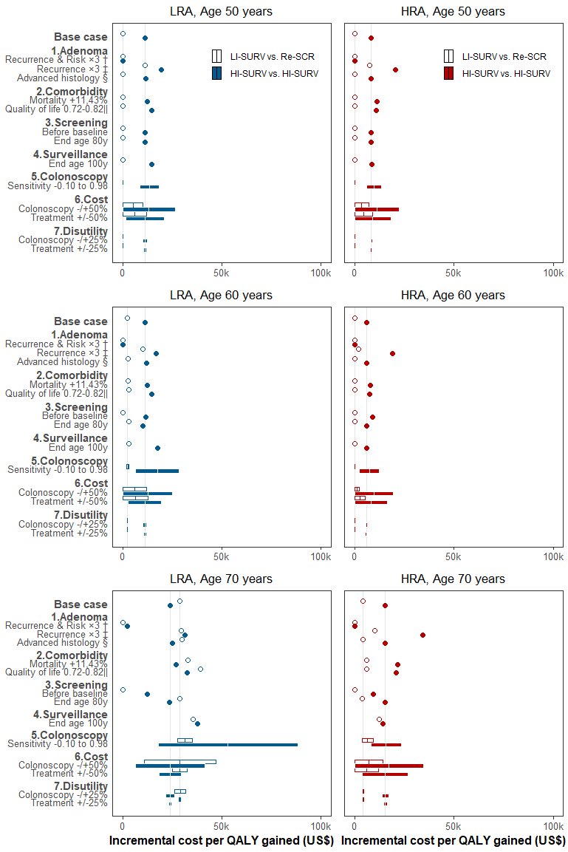
Abbreviations: COL = colonoscopy; CRC = colorectal cancer; HI = high-intensity; HRA = high-risk adenoma; LI = low-intensity; LRA = low-risk adenoma; POL = polyp; SCR = screening; SURV = surveillance.
* Incremental cost-effectiveness ratios for low-intensity surveillance scenarios were relative to the scenario of return to colonoscopy screening in 10 years; incremental cost-effectiveness for high-intensity surveillance were relative to low-intensity surveillance. Grey vertical lines represent the base-case ICERs. Results for adenomas detected at colonoscopy are in Supplementary Figure 11.
† The recurrence of advanced adenoma at surveillance and the associated CRC risk were increased approximately three-fold to better match observed data (Supplementary Figure 6, Panel d; Supplementary Figure 8). This increase was accomplished by decreasing the assumed average time it takes for a new adenoma to develop into cancer.
‡ The recurrence of advanced adenoma was increased three-fold to better match observed data on advanced adenoma recurrence in HRA patients (Supplementary Figure 6, Panel d), but CRC risk was kept consistent with the Surveillance Epidemiology and End Results program data used for model calibration.
§ Results for LRA patients were corrected for misclassification of small adenoma with advanced histological features (villous histology or high-grade dysplasia) under the assumption that these lesions behave similar to HRA.
|| The quality of life for the population was decreased with age to reflect overall deteriorating health with age.(66)

6. Supplementary References
1. Centers for Disease Control and Prevention 2011;Pages. Accessed at Centers for Disease Control and Prevention at http://www.cdc.gov/nchs/products/life_tables.htm on October 28 2013.
2. Rutter CM, Johnson EA, Feuer EJ, Knudsen AB, Kuntz KM, Schrag D. Secular trends in colon and rectal cancer relative survival. J Natl Cancer Inst. 2013;105(23):1806-13.
3. Surveillance, Epidemiology, and End Results (SEER) Program (www.seer.cancer.gov) SEER*Stat Database: Incidence - SEER 9 Regs Research Data, Nov 2013 Sub (1973-2011) <Katrina/Rita Population Adjustment> - Linked To County Attributes - Total U.S., 1969-2012 Counties, National Cancer Institute, DCCPS, Surveillance Research Program, Surveillance Systems Branch, released April 2014, based on the November 2013 submission.
4. Arminski TC, McLean DW. Incidence and Distribution of Adenomatous Polyps of the Colon and Rectum Based on 1,000 Autopsy Examinations. Dis Colon Rectum. 1964;7:249-61.
5. Blatt LJ. Polyps of the colon and rectum: incidence and distribution. Dis Colon Rectum. 1961;4:277-82.
6. Bombi JA. Polyps of the colon in Barcelona, Spain. An autopsy study. Cancer. 1988;61(7):1472-6.
7. Chapman I. Adenomatous polypi of large intestine: incidence and distribution. Ann Surg. 1963;157:223-6.
8. Clark JC, Collan Y, Eide TJ, Esteve J, Ewen S, Gibbs NM, et al. Prevalence of polyps in an autopsy series from areas with varying incidence of large-bowel cancer. Int J Cancer. 1985;36(2):179-86.
9. Jass JR, Young PJ, Robinson EM. Predictors of presence, multiplicity, size and dysplasia of colorectal adenomas. A necropsy study in New Zealand. Gut. 1992;33(11):1508-14.
10. Johannsen LG, Momsen O, Jacobsen NO. Polyps of the large intestine in Aarhus, Denmark. An autopsy study. Scand J Gastroenterol. 1989;24(7):799-806.
11. Rickert RR, Auerbach O, Garfinkel L, Hammond EC, Frasca JM. Adenomatous lesions of the large bowel: an autopsy survey. Cancer. 1979;43(5):1847-57.
12. Vatn MH, Stalsberg H. The prevalence of polyps of the large intestine in Oslo: an autopsy study. Cancer. 1982;49(4):819-25.
13. Williams AR, Balasooriya BA, Day DW. Polyps and cancer of the large bowel: a necropsy study in Liverpool. Gut. 1982;23(10):835-42.
14. Stoop EM, de Haan MC, de Wijkerslooth TR, Bossuyt PM, van Ballegooijen M, Nio CY, et al. Participation and yield of colonoscopy versus non-cathartic CT colonography in population-based screening for colorectal cancer: a randomised controlled trial. Lancet Oncol. 2012;13(1):55-64.
15. Mandel JS, Bond JH, Church TR, Snover DC, Bradley GM, Schuman LM, et al. Reducing mortality from colorectal cancer by screening for fecal occult blood. Minnesota Colon Cancer Control Study. N Engl J Med. 1993;328(19):1365-71.
16. Hardcastle JD, Chamberlain JO, Robinson MH, Moss SM, Amar SS, Balfour TW, et al. Randomised controlled trial of faecal-occult-blood screening for colorectal cancer. Lancet. 1996;348(9040):1472-7.
17. Jorgensen OD, Kronborg O, Fenger C. A randomised study of screening for colorectal cancer using faecal occult blood testing: results after 13 years and seven biennial screening rounds. Gut. 2002;50(1):29-32.
18. Lansdorp-Vogelaar I, van Ballegooijen M, Boer R, Zauber A, Habbema JD. A novel hypothesis on the sensitivity of the fecal occult blood test: Results of a joint analysis of 3 randomized controlled trials. Cancer. 2009;115(11):2410-9.
19. Mapp TJ, Hardcastle JD, Moss SM, Robinson MH. Survival of patients with colorectal cancer diagnosed in a randomized controlled trial of faecal occult blood screening. Br J Surg. 1999;86(10):1286-91.
20. American Joint Committee on Cancer. AJCC Cancer Staging Manual. 5th ed. Philadelphia: Lippincott - Raven Publishers; 1997.
21. van Rijn JC, Reitsma JB, Stoker J, Bossuyt PM, van Deventer SJ, Dekker E. Polyp miss rate determined by tandem colonoscopy: a systematic review. Am J Gastroenterol. 2006;101(2):343-50.
22. Imperiale TF, Ransohoff DF, Itzkowitz SH, Levin TR, Lavin P, Lidgard GP, et al. Multitarget stool DNA testing for colorectal-cancer screening. N Engl J Med. 2014;370(14):1287-97.
23. Warren JL, Klabunde CN, Mariotto AB, Meekins A, Topor M, Brown ML, et al. Adverse events after outpatient colonoscopy in the Medicare population. Ann Intern Med. 2009;150(12):849-57, W152.
24. Gatto NM, Frucht H, Sundararajan V, Jacobson JS, Grann VR, Neugut AI. Risk of perforation after colonoscopy and sigmoidoscopy: a population-based study. J Natl Cancer Inst. 2003;95(3):230-6.
25. Ness RM, Holmes AM, Klein R, Dittus R. Utility valuations for outcome states of colorectal cancer. Am J Gastroenterol. 1999;94(6):1650-7.
26. Swan JS, Kong CY, Hur C, Halpern EF, Itauma O, Williams O, et al. Comparing morbidities of testing with a new index: screening colonoscopy versus core-needle breast biopsy. J Am Coll Radiol. 2015;12(3):295-301.
27. Knudsen AB, Lansdorp-Vogelaar I, Rutter CM, Savarino JE, van Ballegooijen M, Kuntz KM, et al. Cost-effectiveness of computed tomographic colonography screening for colorectal cancer in the medicare population. J Natl Cancer Inst. 2010;102(16):1238-52.
28. Lansdorp-Vogelaar I, Kuntz KM, Knudsen AB, Wilschut JA, Zauber AG, van Ballegooijen M. Stool DNA testing to screen for colorectal cancer in the Medicare population: a cost-effectiveness analysis. Ann Intern Med. 2010;153(6):368-77.
29. Jonas DE, Russell LB, Sandler RS, Chou J, Pignone M. Patient time requirements for screening colonoscopy. Am J Gastroenterol. 2007;102(11):2401-10.
30. Leffler DA, Kheraj R, Garud S, Neeman N, Nathanson LA, Kelly CP, et al. The incidence and cost of unexpected hospital use after scheduled outpatient endoscopy. Arch Intern Med. 2010;170(19):1752-7.
31. Zauber AG, Knudsen AB, Rutter CM, Lansdorp-Vogelaar I, Savarino JE, van Ballegooijen M, et al. Cost-Effectiveness of CT Colonography to Screen for Colorectal Cancer. Rockville, MD: Agency for Healthcare Research and Quality; 2007.
32. U.S. Department of Labor 2014;Pages. Accessed at Bureau of Labor Statistics at http://www.bls.gov/ on January 22 2014.
33. Gini A, Zauber AG, Cenin DR, Omidvari AH, Hempstead SE, Fink AK, et al. Cost Effectiveness of Screening Individuals With Cystic Fibrosis for Colorectal Cancer. Gastroenterology. 2018;154(3):556-67 e18.
34. Yabroff KR, Lamont EB, Mariotto A, Warren JL, Topor M, Meekins A, et al. Cost of care for elderly cancer patients in the United States. J Natl Cancer Inst. 2008;100(9):630-41.
35. Chen AB, Li L, Cronin AM, Brooks GA, Kavanagh BD, Schrag D. Estimating Costs of Care Attributable to Cancer: Does the Choice of Comparison Group Matter? Health Serv Res. 2018;53 Suppl 1:3227-44.
36. Yabroff KR, Davis WW, Lamont EB, Fahey A, Topor M, Brown ML, et al. Patient time costs associated with cancer care. J Natl Cancer Inst. 2007;99(1):14-23.
37. Sanders GD, Neumann PJ, Basu A, Brock DW, Feeny D, Krahn M, et al. Recommendations for Conduct, Methodological Practices, and Reporting of Cost-effectiveness Analyses: Second Panel on Cost-Effectiveness in Health and Medicine. JAMA. 2016;316(10):1093-103.
38. Atkin W, P Rogers, R Edwards et al. Wide Variation in Adenoma Detection Rates at Screening Flexible Sigmoidoscopy. Gastroenterology. 2004;126:10.
39. Rutter CM, Knudsen AB, Marsh TL, Doria-Rose VP, Johnson E, Pabiniak C, et al. Validation of Models Used to Inform Colorectal Cancer Screening Guidelines: Accuracy and Implications. Med Decis Making. 2016;36(5):604-14.
40. Buskermolen M, Gini A, Naber SK, Toes-Zoutendijk E, de Koning HJ, Lansdorp-Vogelaar I. Modeling in Colorectal Cancer Screening: Assessing External and Predictive Validity of MISCAN-Colon Microsimulation Model Using NORCCAP Trial Results. Med Decis Making. 2018;38(8):917-29.
41. Holme O, Loberg M, Kalager M, Bretthauer M, Hernan MA, Aas E, et al. Effect of flexible sigmoidoscopy screening on colorectal cancer incidence and mortality: a randomized clinical trial. JAMA. 2014;312(6):606-15.
42. Cotterchio M, Manno M, Klar N, McLaughlin J, Gallinger S. Colorectal screening is associated with reduced colorectal cancer risk: a case-control study within the population-based Ontario Familial Colorectal Cancer Registry. Cancer Causes Control. 2005;16(7):865-75.
43. Kahi CJ, Imperiale TF, Juliar BE, Rex DK. Effect of screening colonoscopy on colorectal cancer incidence and mortality. Clin Gastroenterol Hepatol. 2009;7(7):770-5; quiz 11.
44. Manser CN, Bachmann LM, Brunner J, Hunold F, Bauerfeind P, Marbet UA. Colonoscopy screening markedly reduces the occurrence of colon carcinomas and carcinoma-related death: a closed cohort study. Gastrointest Endosc. 2012;76(1):110-7.
45. Doubeni CA, Weinmann S, Adams K, Kamineni A, Buist DS, Ash AS, et al. Screening colonoscopy and risk for incident late-stage colorectal cancer diagnosis in average-risk adults: a nested case-control study. Ann Intern Med. 2013;158(5 Pt 1):312-20.
46. Brenner H, Chang-Claude J, Jansen L, Knebel P, Stock C, Hoffmeister M. Reduced risk of colorectal cancer up to 10 years after screening, surveillance, or diagnostic colonoscopy. Gastroenterology. 2014;146(3):709-17.
47. Nishihara R, Wu K, Lochhead P, Morikawa T, Liao X, Qian ZR, et al. Long-term colorectal-cancer incidence and mortality after lower endoscopy. N Engl J Med. 2013;369(12):1095-105.
48. Chiu HM, Chen SL, Yen AM, Chiu SY, Fann JC, Lee YC, et al. Effectiveness of fecal immunochemical testing in reducing colorectal cancer mortality from the One Million Taiwanese Screening Program. Cancer. 2015;121(18):3221-9.
49. Brenner H, Stock C, Hoffmeister M. Effect of screening sigmoidoscopy and screening colonoscopy on colorectal cancer incidence and mortality: systematic review and meta-analysis of randomised controlled trials and observational studies. BMJ. 2014;348:g2467.
50. Chung SJ, Kim YS, Yang SY, Song JH, Kim D, Park MJ, et al. Five-year risk for advanced colorectal neoplasia after initial colonoscopy according to the baseline risk stratification: a prospective study in 2452 asymptomatic Koreans. Gut. 2011;60(11):1537-43.
51. Gupta S, Jacobs ET, Baron JA, Lieberman DA, Murphy G, Ladabaum U, et al. Risk stratification of individuals with low-risk colorectal adenomas using clinical characteristics: a pooled analysis. Gut. 2017;66(3):446-53.
52. Laiyemo AO, Murphy G, Albert PS, Sansbury LB, Wang Z, Cross AJ, et al. Postpolypectomy colonoscopy surveillance guidelines: predictive accuracy for advanced adenoma at 4 years. Ann Intern Med. 2008;148(6):419-26.
53. Martinez ME, Baron JA, Lieberman DA, Schatzkin A, Lanza E, Winawer SJ, et al. A pooled analysis of advanced colorectal neoplasia diagnoses after colonoscopic polypectomy. Gastroenterology. 2009;136(3):832-41.
54. Martinez ME, Thompson P, Messer K, Ashbeck EL, Lieberman DA, Baron JA, et al. One-year risk for advanced colorectal neoplasia: U.S. versus U.K. risk-stratification guidelines. Ann Intern Med. 2012;157(12):856-64.
55. Lieberman DA, Weiss DG, Harford WV, Ahnen DJ, Provenzale D, Sontag SJ, et al. Five-year colon surveillance after screening colonoscopy. Gastroenterology. 2007;133(4):1077-85.
56. Pinsky PF, Schoen RE, Weissfeld JL, Church T, Yokochi LA, Doria-Rose VP, et al. The yield of surveillance colonoscopy by adenoma history and time to examination. Clin Gastroenterol Hepatol. 2009;7(1):86-92.
57. Lieberman DA, Rex DK, Winawer SJ, Giardiello FM, Johnson DA, Levin TR, et al. Guidelines for colonoscopy surveillance after screening and polypectomy: a consensus update by the US Multi-Society Task Force on Colorectal Cancer. Gastroenterology. 2012;143(3):844-57.
58. Atkin W, Wooldrage K, Brenner A, Martin J, Shah U, Perera S, et al. Adenoma surveillance and colorectal cancer incidence: a retrospective, multicentre, cohort study. Lancet Oncol. 2017;18(6):823-34.
59. Loberg M, Kalager M, Holme O, Hoff G, Adami HO, Bretthauer M. Long-term colorectal-cancer mortality after adenoma removal. N Engl J Med. 2014;371(9):799-807.
60. Hoff G, Sauar J, Hofstad B, Vatn MH. The Norwegian guidelines for surveillance after polypectomy: 10-year intervals. Scand J Gastroenterol. 1996;31(9):834-6.
61. Colquhoun P, Chen HC, Kim JI, Efron J, Weiss EG, Nogueras JJ, et al. High compliance rates observed for follow up colonoscopy post polypectomy are achievable outside of clinical trials: efficacy of polypectomy is not reduced by low compliance for follow up. Colorectal Dis. 2004;6(3):158-61.
62. Zauber A, SJ Winawer, JD Waye et al. Colonoscopic Polypectomy and Long-Term Prevention of Colorectal-Cancer Deaths. New England Journal of Medicine. 2012;366(8):10.
63. Atkin WS, Edwards R, Kralj-Hans I, Wooldrage K, Hart AR, Northover JM, et al. Once-only flexible sigmoidoscopy screening in prevention of colorectal cancer: a multicentre randomised controlled trial. Lancet. 2010;375(9726):1624-33.
64. Ventura L, Mantellini P, Grazzini G, Castiglione G, Buzzoni C, Rubeca T, et al. The impact of immunochemical faecal occult blood testing on colorectal cancer incidence. Dig Liver Dis. 2014;46(1):82-6.
65. van Hees F, Habbema JD, Meester RG, Lansdorp-Vogelaar I, van Ballegooijen M, Zauber AG. Should colorectal cancer screening be considered in elderly persons without previous screening?: a cost-effectiveness analysis. Ann Intern Med. 2014;160(11):750-9.
66. Hanmer J, Hays RD, Fryback DG. Mode of administration is important in US national estimates of health-related quality of life. Med Care. 2007;45(12):1171-9.

