Chronic Exertional Compartment Syndrome in the Leg: Comparing Surgery to Conservative Therapy
S. Vogels, MD¹
E.D. Ritchie, MD¹
H.P.H. Hundscheid, MD²
K.V.M. van Someren, MD²
L. Janssen, MD PhD²
R. Hoencamp, MD PhD^{1, 3, 4, 5}
M.R.M. Scheltinga, MD PhD²
1. Department of Surgery, Alrijne Hospital, Leiderdorp, the Netherlands.
2. Department of Surgery, Máxima MC, Veldhoven, the Netherlands.
3. Defense Healthcare Organization, Ministry of Defense, Utrecht, the Netherlands
4. Department of Surgery, Leiden University Medical Center, Leiden, the Netherlands.
5. Trauma Research Unit, Department of Trauma Surgery, Erasmus MC, University Medical Center Rotterdam, Rotterdam, the Netherlands.

Corresponding author
Sanne Vogels
Simon Smitweg 1, 2353 GA Leiderdorp, The Netherlands
Tel: +31 (0)71-5828282 or email: svogels@alrijne.nl

Abstract
The aim of this nonrandomized cohort study was to compare the clinical effectiveness of an elective fasciotomy with conservative treatment for Chronic Exertional Compartment Syndrome of the leg. Patients diagnosed with Chronic Exertional Compartment Syndrome who opted for surgery (n=188) completed a preoperative questionnaire and a 12 month postoperative questionnaire. Patients who continued conservative treatments (n=23) served as controls. Gender, age, sports activity or affected compartments were comparable, but intensity of pain was higher in the surgical group (in rest: 2.5±0.1 vs 2.0±0.2, during exercise: 4.2±0.1 vs 3.8±0.2; both p<0.05). Following treatment, surgical patients demonstrated a larger drop in intensity levels of pain (surgery 1.6±0.1, conservative 0.9±0.2, p=0.01) and tightness (surgery 1.4±0.1, conservative 0.4±0.3, p=0.00) during exercise. Success (good or excellent treatment effect) was attained in 42% of the surgical group compared to only 17% in the conservatively treated group (p=0.02). However, previous activity level was achieved in a mere 26% in the surgical treatment group and 35% in the conservative treatment group (p=0.33). A fasciotomy for Chronic Exertional Compartment Syndrome in the leg results in significantly decreased levels of pain and tightness and better satisfaction compared to patients who continued a conservative treatment regimen.

Key Terms
Chronic Exertional Compartment Syndrome, Lower Extremity, Fasciotomy, Conservative treatment, cohort study.

Abbreviations
CECS = Chronic Exertional Compartment Syndrome
ICP = Intracompartmental Pressure
SD = Standard Deviation
RCT = Randomized Controlled Trial
VRS = Verbal Reporting Scale
Introduction
Chronic exertional compartment syndrome (CECS) is an exercise-induced pathology characterized by pain and tightness in affected extremities upon performing repetitive physical activity. The etiology of CECS is largely unknown but may be related to pathologically elevated intracompartmental pressures (ICP) following muscular expansion during exercise. Symptoms can be severely invalidating eventually forcing patients to avoid any provocative physical activity.[1-7]
The natural course of CECS is often not self-limiting and therefore requires active intervention.[8] The initial treatment entails a combination of conservative modalities including a period of rest, guidance by physiotherapist, shoe modifications, insoles, activity modification, gait retraining, and/or botulinum injections[9]. However, a generally applied treatment protocol or guideline is not available and their respective effectiveness is scarcely reported.[10, 11]
Surgery for CECS is considered once conservative treatments have failed or when symptoms are severely disabling. Opening of the fascia (fasciotomy) is thought to create more space for the expanding muscles.[7, 12] Literature suggests that a fasciotomy is the most optimal treatment method with reported success rates up to 90%. Yet, complications such as wound infections, hematomas, nerve damage or recurrence of symptoms may occur in up to 14% of the cases.[13-21]
The choice for either conservative or surgical treatment for CECS is largely based on clinical experience but not on sound evidence. However, current literature appears to favor a surgical intervention, even though recent studies have shown successful conservative treatment in specific patient groups..[6, 8, 18, 22-25] In addition, most studies are biased due to small sample sizes and a high variety in outcome measurements. Considering these limitations, determination of superiority of either type of treatment is not supported by the current body of data at this moment.
This cohort study evaluates the long-term outcomes of both conservative and surgical interventions, thereby contributing to an evidence based practice in the near future. Within this report, the effectiveness of conservative treatment is weighed against a fasciotomy. Results of this report may be used to direct the organization of a well-structured randomized controlled trial.
Materials and methods
Study design
This observational retrospective cohort study was conducted in a non-academic teaching hospital ([…]). The study protocol was reviewed by […]’s medical ethics committee, who concluded that the rules laid down in the Medical Research Involving Human Subjects Act do not apply to this study. The study protocol complied with the Declaration of Helsinki and IJSM’s ethical standards document[26].

Study population
All patients were referred to [...]’s department of Sports Medicine for analysis of exertional lower leg pain possibly associated with CECS, meaning they experienced lower leg tightness and/or pain during or following exercise. At physical examination, most patients reported tenderness upon palpation of the compartment. All patients underwent a dynamic ICP measurement between January 2013 and September 2018 for the first time. The diagnosis lower leg CECS was demonstrated if at least one ICP value was too high according to the Pedowitz criteria (≥15 mmHg at rest, ≥30 mmHg 1 minute post-exercise or ≥20 mmHg 5 minutes post-exercise).[27] If CECS was considered likely based on history, physical examination and ICP values, the patient was informed in a shared decision-making environment on the pros and cons of either conservative or surgical treatment.
Patients who completed the follow up analysis 12 months after initiation of treatment were included for the study. Exclusion criteria were a previous ICP measurement, recurrent CECS, CECS in compartments other than the lower leg, illiteracy, of insufficient knowledge of the Dutch language. Patients signed an informed consent form agreeing to the use of their encoded data.

Intracompartmental pressure measurement
The dynamic ICP manometry was performed by experienced sports medicine physicians in each compartment that was possibly harboring CECS. When symptoms presented bilaterally, the most symptomatic side was measured. A slit catheter was used (Indwelling Slit Catheter Set; Stryker) and introduced according to published protocols.[28] After establishing a resting ICP, symptoms were provoked using a treadmill test or patient specific exercises (eg. jumping or tiptoeing). Activity was ceased when patient experienced a maximum severity of symptoms. Pressures were recorded immediately after, and 1 and 5 minutes after exercise cessation.

Conservative treatment
If patients opted for a conservative treatment regimen, they were treated by their referring sports physicians without further involvement of surgeons. Frequent interventions were cessation or adaptation of provocative activity, orthotics, physiotherapy, compressive stockings or combinations thereof. No standardized protocol was used, as both the sports physician and patient were free to choose the type of intervention most suitable for patient’s profile.

Surgical treatment
If patients preferred surgery, characteristics of the surgical procedure were discussed as well as potential complications such as hematoma, wound infection or superficial peroneal nerve damage. Following informed consent, surgery was performed by two experienced surgeons (each >100 procedures). A minimally invasive two cm single incision approach was used for the anterior compartment, whereas the deep flexor compartment required an open procedure via an 8-10 cm incision. If a lateral CECS was present, the peroneal compartment was opened via a two-incision technique[16, 20, 21, 29, 30] All patients were operated under general or regional anesthesia in day care. Postoperatively, patients received compressive stockings for two weeks day and night. Normal daily activities were allowed after day 1 but vigorous exercise or movements were discouraged. Two weeks later, the wound was inspected, followed by gradually increasing exercise between weeks 3-6. They were allowed to normal activity levels from week 6 to 8 following surgery.

Questionnaire scoring and data collection
Each study patient was asked to complete questionnaires scoring the 5 cardinal symptoms associated with CECS (pain, tightness, cramps, muscle weakness and reduced skin sensibility) using a 5-item categorical verbal rating scale.[21] A questionnaire scored symptom intensity (minimal 1, symptom is absent - maximal 5, symptom is severely disabling) and symptom frequency (minimal 1, symptom is never present - maximal 5, symptom is always present), both during resting conditions and during exercise. Questionnaires were completed during the first outpatient visit prior to starting a conservative or surgical treatment. Twelve months after starting these interventions, all patients were again asked to complete this questionnaire via email. Surgical patients received an additional electronic questionnaire 3 months postoperatively aimed at determining possible onset of complications. In the 12 months post treatment questionnaire, additional questions were addressed regarding current physical activity after the intervention and satisfaction with the treatment. Based on this patient reported satisfaction, success was defined as an excellent or good clinical outcome. In contrast, failure was defined as a moderate, fair, or poor outcome. Questionnaires were adopted from previously published studies.[12, 20, 21, 28, 31] In addition, electronic patient records were analyzed for demographics, medical history and other patient characteristics.

Statistical analysis
Statistical analysis was performed using SPSS statistics (v24, IBM Corporation, Armonk, New York ). Differences between groups were analyzed using an unpaired T-test, Pearson Chi-square test, Fisher’s exact test, or a Mann-Whitney U-test where appropriate. Results are reported as means with corresponding Standard Error to the Mean. Differences within groups were analyzed by a Wilcoxon Signed Rank Test. Linear relations with a p-value (two-sided) ≤0.05 were considered significant.
Results
Patient demographics
During the almost 6 years of interest (January 2013 – October 2018), a total of 1125 patients were analyzed for exercise-related leg pain that was possibly related to the presence of CECS and underwent ICP manometry if indicated (figure 1). As 201 CECS patients either pursued further treatment in their referring hospital or did not respond to electronic invitations and reminders, a total of 211 patients met inclusion criteria and had complete follow up data sets. Patient demographics of the surgical (n=188) and conservative (n=23) groups are depicted in table 1. No significant differences were found regarding gender, age or comorbidities. Moreover, an equal distribution of duration of symptoms and sports activity was found. Three quarters of all patients had symptoms bilaterally, mainly involving the anterior compartment (conservative 79%; surgical 77%), followed by the deep posterior flexor compartment (conservative 31%; surgical 40%).

Intracompartmental pressure
Most measurements were not significantly different between groups (table 1). However, ICP values immediately after exercise were significantly higher in the anterior (p=0.02) and peroneus (p=0.04) compartment, as well as the 1 and 5 minutes after exercise in the deep posterior compartment (both p=0.04).

Conservative interventions
The majority of patients who rejected surgery decided to cease or modify their provoking sportive activity (87%), started treatment under the guidance of a physical therapist (43%), and/or used shoe orthotics (61%). Alternative treatment options were steroid injections (17%), shockwave (4%) or dry needling (4%). No uniformity in treatment protocols was found.

Postoperative complications
Reoperations for bleeding, hematoma or other immediate postoperative untoward events were not required in any of the 188 patients. Signs of an impending wound infection occurred in 20 of 338 legs (6% infection rate). To prevent wound sepsis, these patients received a 7 days course of oral antibiotics. Three patients (2%) reported a temporary sensory deficit in the area of the superficial peroneal nerve that had recovered completely after 3 months.

Patient Reported Outcome Measurements – Intensity of Symptoms due to CECS
Baseline pain and tightness intensity levels are depicted in figure 2. Before treatment, significantly more intense pain during rest and exercise were found in the surgical treatment group compared to the conservatively treated group (rest: 2.5±0.1 versus 2.0±0.2; exercise 4.2±0.1 versus 3.8±0.2; both p=0.04). In addition, more intense tightness was found in surgical patients during exercise (4.0±0.1 versus 3.2±0.3; p=0.001).
Changes in intensity of pain and tightness after treatment are illustrated in figure 3. The drop of pain intensity during rest (surgical 0.8±0.8; conservative 0.4±0.2; p=0.04), during exercise (surgical 1.6±0.1; conservative 0.9±0.2, p=0.01) as well as the drop of tightness during exercise (surgical 1.4±0.1; conservative 0.4±0.3, p=0.001) were all significantly higher in surgical patients.
Intensity of cramps, paresthesia, and experienced weakness were comparable before treatment and dropped significantly in a similar way in both groups (data not shown).

Patient Reported Outcome Measurements – Frequency of pain and tightness
Frequency of pain and tightness at baseline and after 12 months is represented by figure 4. Baseline frequency of tightness during exercise before treatment was significantly higher in the surgical group (4.3±0.1 versus 3.2±0.3; p=0.001). However, all other parameters were not different among the two groups.
Changes in frequency of pain and tightness after treatment are presented in figure 5. Decreases were essentially significant and not different between groups. However, the drop in frequency of tightness during exercise was significantly greater after a fasciotomy (1.5±0.1 versus 0.4±0.4; p=0.001).

Success was achieved in 42% of patients who received surgery (14% excellent, 28% good, table 2 & 3). On the contrary, only 17% of conservative interventions was considered successful by the patients (p=0.02). Return to previous level of physical activity was only 26% in the surgically treated group compared to 35% of patients in the conservative group (table 4), although this difference was not statistically significant (p=0.33).
Discussion
In the absence of any high level data for lower leg CECS such as randomized trials, superiority of any treatment modality remains under debate. The main finding of the current nonrandomized study is that a fasciotomy was more effective after one year in reducing intensity and frequency of cardinal symptoms such as pain and tightness compared to conservatively treated CECS patients. In addition, operated patients were more satisfied. However, these beneficial effects did not result in a difference in return rate to previous level of activity.
This cohort study compares treatment outcome as reflected by changes in cardinal symptoms, patient satisfaction as well as return to physical activity. Similar differences in satisfaction favoring surgery were already demonstrated in most small cohorts[6, 8, 22, 23]. However, an exact description of the methodology for determining satisfaction was often lacking. In addition, differential effects on the various cardinal symptoms were never considered in these other studies. The current study did provide a detailed evaluation of residual symptoms and clearly defined how satisfaction was assessed. These findings may contribute to a further understanding of CECS management.
No significant difference in return to physical activity after treatment was found in the current study population. In contrast, earlier studies revealed a higher return to activity rate after surgical treatment compared to conservative treatment.[23, 24] Interestingly, our results showed a trend towards a higher return rate amongst conservatively treated patients (conservative 83% versus surgery 74%). It may be that a portion of patients, once successfully operated on one leg, opted for surgery of the opposite leg as well, thereby lengthening the rehabilitation process. Moreover, one in nine operated patients chose to shift to an alternative physical activity whereas all conservatively treated patients stayed with their original type of exercise.
The present study has various limitations. The three different types of lower leg CECS including combinations were not separately evaluated. Our study design is different from previously published cohorts focusing on the anterior compartment only.[22-24] For instance, the study by Packer et al.[23] found higher satisfaction rates in patients just receiving a fasciotomy for the anterior compartment compared to patients undergoing surgery for multiple compartments. Our limited volume of patients however did not allow for a detailed analysis focusing on subgroups of patients with the various compartments and its combinations. Nevertheless, this type of selection bias likely did not influence study outcome as compartment distribution between our two study groups was not different.
Additional drawbacks of our study are the large difference in number of patients among the two study groups and the absence of a standardized treatment regimen. Both aspects are consequent to the retrospective nonrandomized study design. As patients had often experienced a protracted diagnostic delay and had tried all sorts of conservative interventions, the option of surgery may have been more attractive. These limitations clearly illustrate the urgent call of a prospective randomized controlled trial.
A limitation is also a difference in muscle compartment pressures as patients who were treated surgically demonstrated higher ICP pressures compared to the conservative controls. This difference may suggest that patients preferring conservative treatment were suffering from a milder form of CECS. However, recent literature questions the validity of ICP measurements whereas the use of Pedowitz’ criteria is seriously doubted.[32, 33] As a consequence, our belief is that an ICP should always be considered in the light of a suggestive history and physical examination. The patients in the current study population were all suspected having lower leg CECS based on these findings and were thought to have an indication for surgical treatment.
In conclusion, a fasciotomy was more effective in reducing intensity and frequency of cardinal symptoms such as pain and tightness compared to a conservatively treated CECS patients. Satisfaction with surgical treatment was also higher compared to patients who were treated conservatively. However, rates of return to previous activity level are disappointingly low and not significantly different between groups. These findings require confirmation in a prospective randomized controlled trial.
References

1. Bong MR, Polatsch DB, Jazrawi LM et al. Chronic exertional compartment syndrome: diagnosis and management. Bull Hosp Jt Dis 2005; 62: 77-84
2. Blackman PG. A review of chronic exertional compartment syndrome in the lower leg. Med Sci Sports Exerc 2000; 32: S4-10
3. Fraipont MJ, Adamson GJ. Chronic exertional compartment syndrome. J Am Acad Orthop Surg 2003; 11: 268-276
4. Wilder RP, Magrum E. Exertional compartment syndrome. Clin Sports Med 2010; 29: 429-435. doi:S0278-5919(10)00023-2 [pii];10.1016/j.csm.2010.03.008 [doi]
5. Wuellner JC, Nathe CD, Kreulen CD et al. Chronic Exertional Compartment Syndrome: The Athlete's Claudication. Operative Techniques in Sports Medicine 2017; 25: 52-58
6. Fronek J, Mubarak SJ, Hargens AR et al. Management of chronic exertional anterior compartment syndrome of the lower extremity. Clin Orthop Relat Res 1987. 217-227
7. Tucker AK. Chronic exertional compartment syndrome of the leg. Curr Rev Musculoskelet Med 2010; 3: 32-37. doi:10.1007/s12178-010-9065-4 [doi]
8. Van der Wal WA, Heesterbeek PJ, Van den Brand JG et al. The natural course of chronic exertional compartment syndrome of the lower leg. Knee Surg Sports Traumatol Arthrosc 2015; 23: 2136-2141. doi:10.1007/s00167-014-2847-2 [doi]
9. Isner-Horobeti ME, Dufour SP, Blaes C et al. Intramuscular pressure before and after botulinum toxin in chronic exertional compartment syndrome of the leg: a preliminary study. Am J Sports Med 2013; 41: 2558-2566. doi:0363546513499183 [pii];10.1177/0363546513499183 [doi]
10. Rajasekaran S, Hall MM. Nonoperative Management of Chronic Exertional Compartment Syndrome: A Systematic Review. Curr Sports Med Rep 2016; 15: 191-198. doi:10.1249/JSR.0000000000000261 [doi];00149619-201605000-00017 [pii]
11. Zimmermann WO, Helmhout PH, Beutler A. Prevention and treatment of exercise related leg pain in young soldiers; a review of the literature and current practice in the Dutch Armed Forces. J R Army Med Corps 2017; 163: 94-103. doi:jramc-2016-000635 [pii];10.1136/jramc-2016-000635 [doi]
12. de Bruijn JA, van Zantvoort AP, Winkes MB et al. Feasibility and Safety of an Operative Tool for Anterior Chronic Exertional Compartment Syndrome Treatment. Foot Ankle Int 2015; 36: 1475-1482. doi:1071100715596081 [pii];10.1177/1071100715596081 [doi]
13. Detmer DE, Sharpe K, Sufit RL et al. Chronic compartment syndrome: diagnosis, management, and outcomes. Am J Sports Med 1985; 13: 162-170. doi:10.1177/036354658501300304 [doi]
14. Beck JJ, Tepolt FA, Miller PE et al. Surgical Treatment of Chronic Exertional Compartment Syndrome in Pediatric Patients. Am J Sports Med 2016; 44: 2644-2650. doi:0363546516651830 [pii];10.1177/0363546516651830 [doi]
15. Islam J, Robbs JV. Management of chronic exertional compartment syndrome. South African Journal of Surgery 2015; 53: 59-61
16. Micheli LJ, Solomon R, Solomon J et al. Surgical treatment for chronic lower-leg compartment syndrome in young female athletes. Am J Sports Med 1999; 27: 197-201. doi:10.1177/03635465990270021401 [doi]
17. Turnipseed WD. Diagnosis and management of chronic compartment syndrome. Surgery 2002; 132: 613-617. doi:S0039606002001393 [pii]
18. Verleisdonk EJ, Schmitz RF, van der Werken C. Long-term results of fasciotomy of the anterior compartment in patients with exercise-induced pain in the lower leg. Int J Sports Med 2004; 25: 224-229. doi:10.1055/s-2003-45255 [doi]
19. Waterman BR, Laughlin M, Kilcoyne K et al. Surgical treatment of chronic exertional compartment syndrome of the leg: failure rates and postoperative disability in an active patient population. J Bone Joint Surg Am 2013; 95: 592-596. doi:1668921 [pii];10.2106/JBJS.L.00481 [doi]
20. Winkes MB, Hoogeveen AR, Scheltinga MR. Is surgery effective for deep posterior compartment syndrome of the leg? A systematic review. Br J Sports Med 2014; 48: 1592-1598. doi:bjsports-2013-092518 [pii];10.1136/bjsports-2013-092518 [doi]
21. Winkes MB, van Zantvoort AP, de Bruijn JA et al. Fasciotomy for Deep Posterior Compartment Syndrome in the Lower Leg: A Prospective Study. Am J Sports Med 2016; 44: 1309-1316. doi:0363546515626540 [pii];10.1177/0363546515626540 [doi]
22. Ali T, Mohammed F, Mencia M et al. Surgical management of exertional anterior compartment syndrome of the leg. West Indian Med J 2013; 62: 529-532. doi:1430 [pii];10.7727/wimj.2006.135 [doi]
23. Packer JD, Day MS, Nguyen JT et al. Functional outcomes and patient satisfaction after fasciotomy for chronic exertional compartment syndrome. Am J Sports Med 2013; 41: 430-436. doi:41/2/430 [pii];10.1177/0363546512471330 [doi]
24. Thein R, Tilbor I, Rom E et al. Return to sports after chronic anterior exertional compartment syndrome of the leg: Conservative treatment versus surgery. J Orthop Surg (Hong Kong) 2019; 27: 2309499019835651. doi:10.1177/2309499019835651 [doi]
25. van Zoest WJ, Hoogeveen AR, Scheltinga MR et al. Chronic deep posterior compartment syndrome of the leg in athletes: postoperative results of fasciotomy. Int J Sports Med 2008; 29: 419-423. doi:10.1055/s-2007-965365 [doi]
26. Harriss DJ, MacSween A, Atkinson G. Ethical Standards in Sport and Exercise Science Research: 2020 Update. Int J Sports Med 2019; 40: 813-817. doi:10.1055/a-1015-3123
27. Pedowitz RA, Hargens AR, Mubarak SJ et al. Modified criteria for the objective diagnosis of chronic compartment syndrome of the leg. Am J Sports Med 1990; 18: 35-40. doi:10.1177/036354659001800106 [doi]
28. van Zantvoort APM, de Bruijn JA, Winkes MB et al. Isolated Chronic Exertional Compartment Syndrome of the Lateral Lower Leg A Case Series. Orthopaedic Journal of Sports Medicine 2015; 3
29. Rorabeck CH, Bourne RB, Fowler PJ. The surgical treatment of exertional compartment syndrome in athletes. J Bone Joint Surg Am 1983; 65: 1245-1251
30. Rorabeck CH, Fowler PJ, Nott L. The results of fasciotomy in the management of chronic exertional compartment syndrome. Am J Sports Med 1988; 16: 224-227. doi:10.1177/036354658801600304 [doi]
31. Winkes MB, Hoogeveen AR, Houterman S et al. Compartment pressure curves predict surgical outcome in chronic deep posterior compartment syndrome. Am J Sports Med 2012; 40: 1899-1905. doi:0363546512449324 [pii];10.1177/0363546512449324 [doi]
32. Aweid O, Del BA, Malliaras P et al. Systematic review and recommendations for intracompartmental pressure monitoring in diagnosing chronic exertional compartment syndrome of the leg. Clin J Sport Med 2012; 22: 356-370. doi:10.1097/JSM.0b013e3182580e1d [doi]
33. Roberts A, Franklyn-Miller A. The validity of the diagnostic criteria used in chronic exertional compartment syndrome: a systematic review. Scand J Med Sci Sports 2012; 22: 585-595. doi:10.1111/j.1600-0838.2011.01386.x [doi]

Figure 1: Patient selection
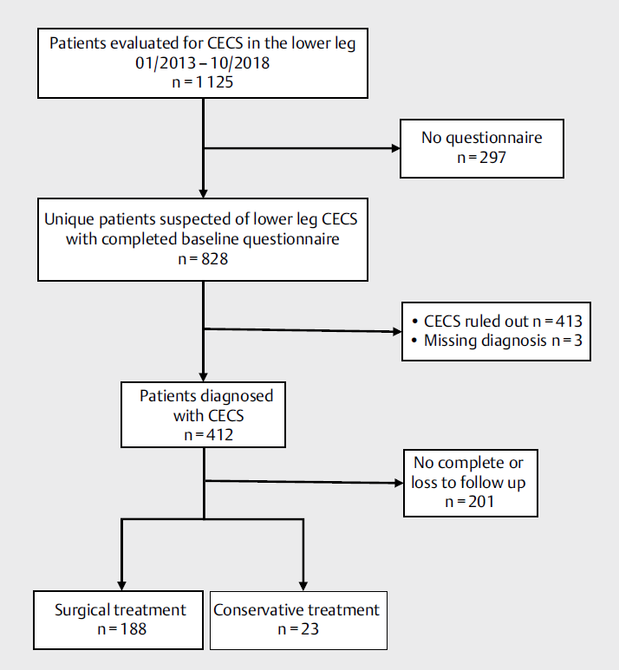

Figure 2:
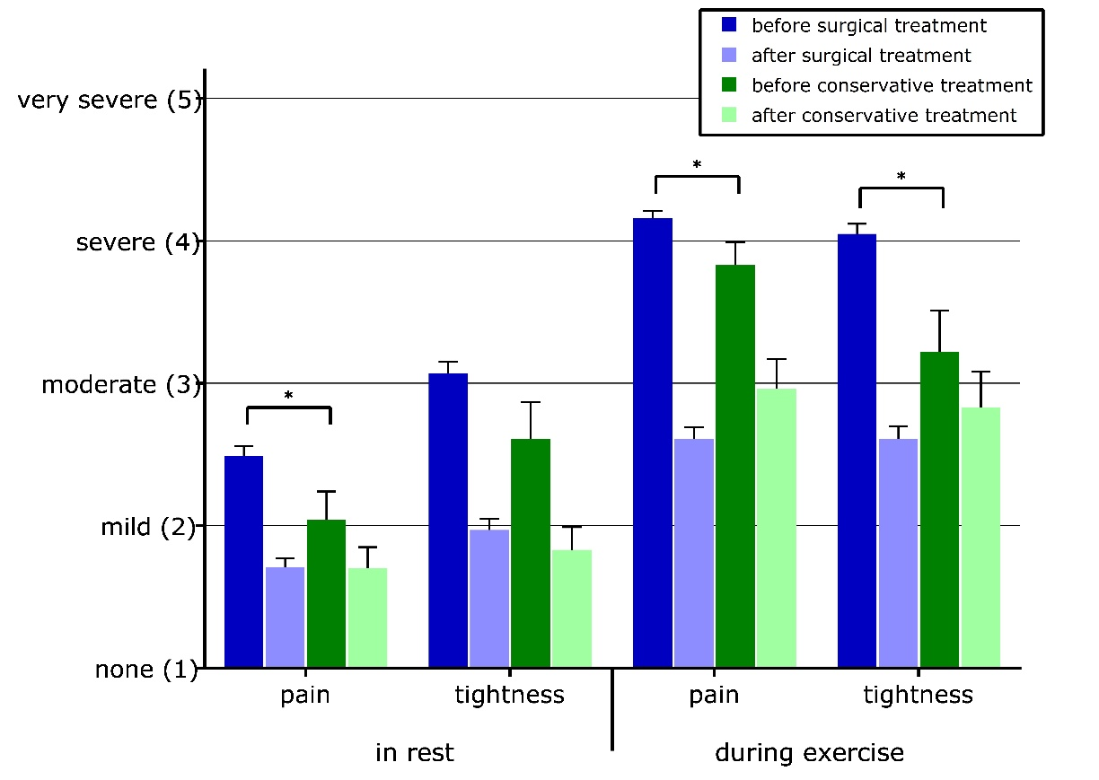
Intensity of pain and tightness in 211 patients with lower leg chronic exertional compartment syndrome before and 1 year after surgical (n=188) or conservative (n=23) treatment (mean ± SEM, *P<0.05).

Figure 3:
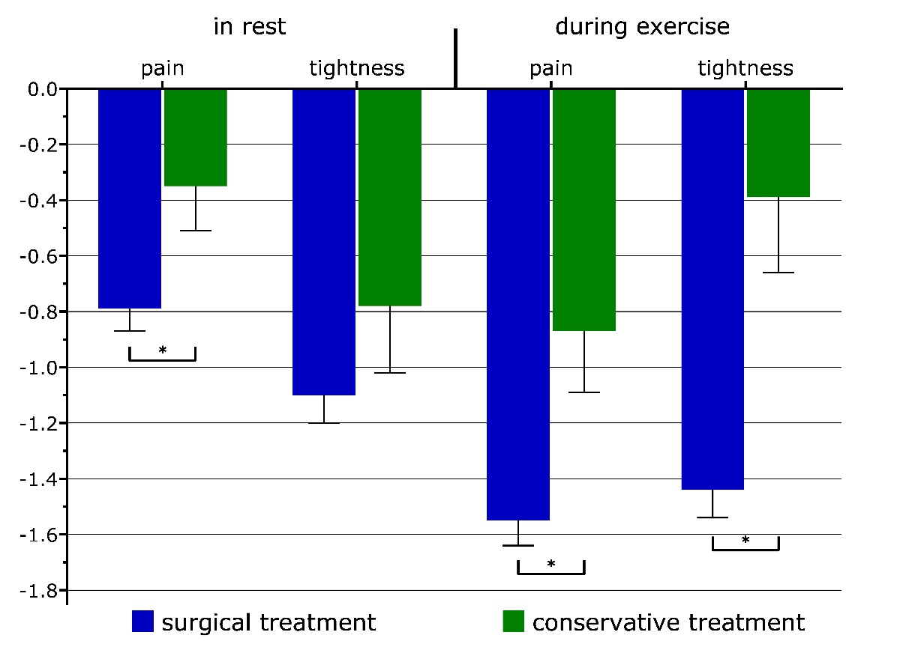
Change in patient reported intensity of pain and tightness following surgical (n=188) or conservative (n=23) treatment (mean ± SEM, *P<0.05).

Figure 4:
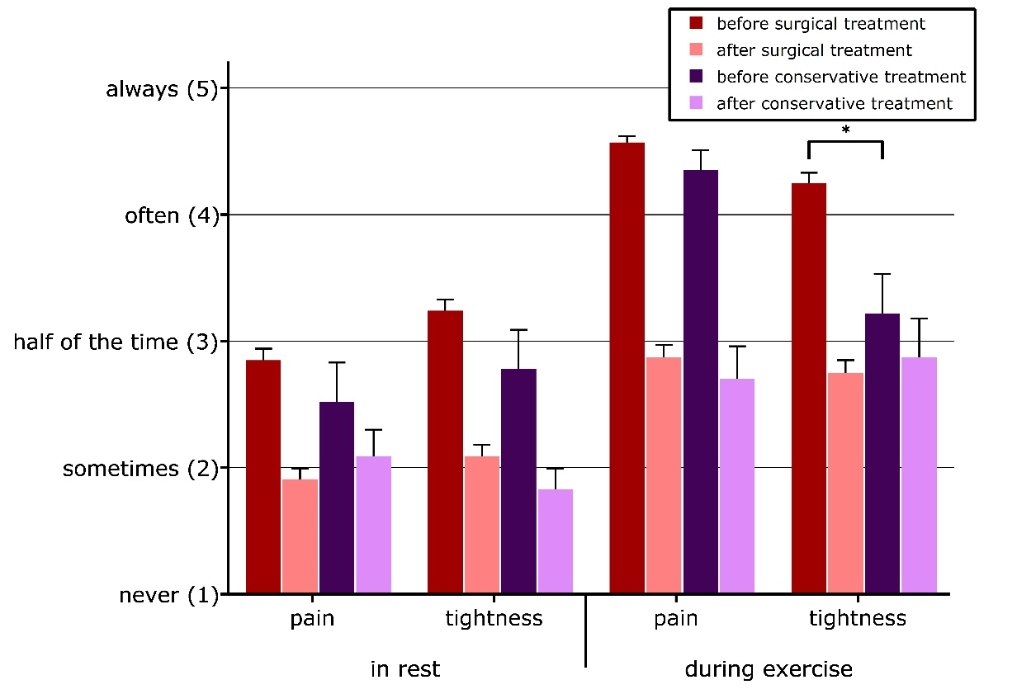
Frequency of pain and tightness symptoms in 211 patients with lower leg chronic exertional compartment syndrome before and 1 year after surgical (n=188) or conservative (n=23) treatment (mean ± SEM, *P<0.05)

Figure 5:
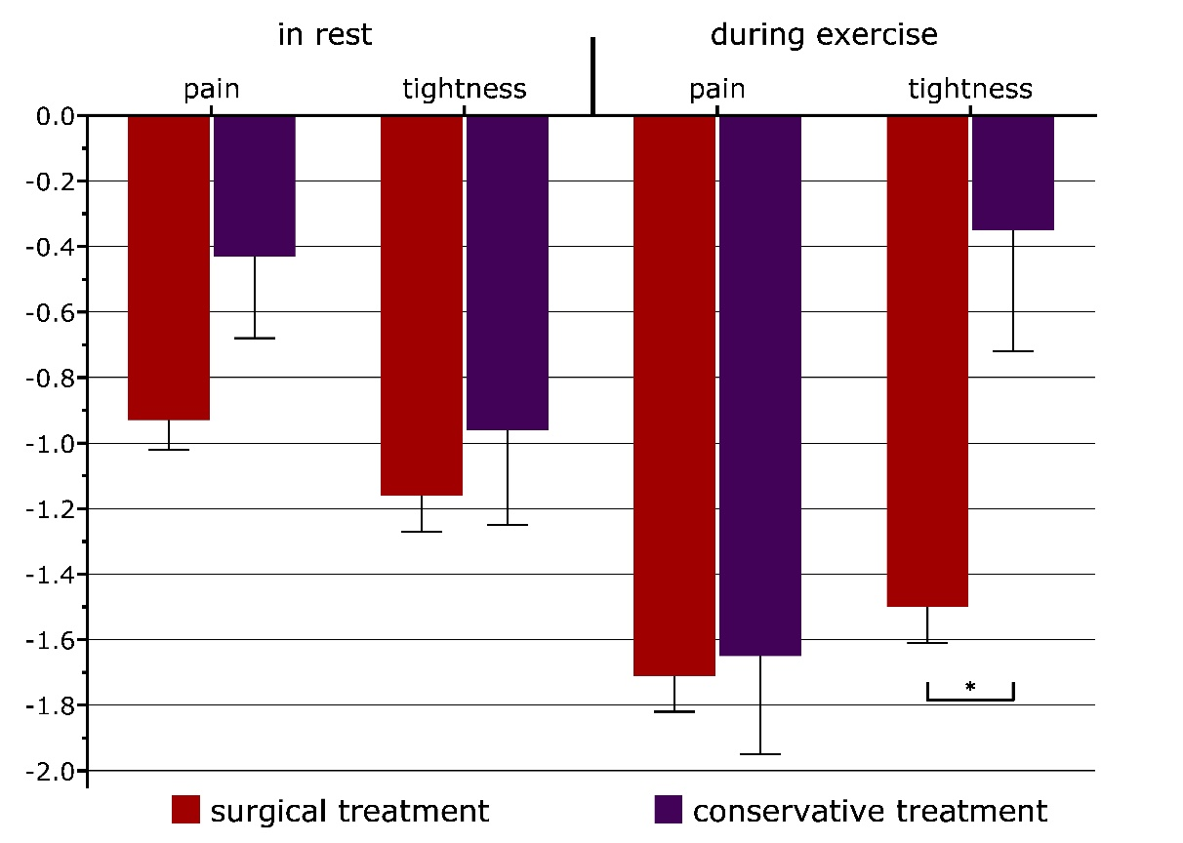
Change in patient reported frequency of pain and tightness following surgical (n=188) or conservative (n=23) treatment (mean± SEM, *P<0.05).

Table 1: Demographics and intracompartmental muscle pressures of 211 CECS patients undergoing surgical or conservative treatment.
 |  | Surgical  intervention  (n=188) | Conservative intervention  (n=23) | P-value
Age average, years (±SD) |  | 30 (±14) | 32 (±16) | 0.57ª
Sex, n (%) |  |  |  | 0.88^{b}
Male |  | 93 (49) | 11 (48)
Female |  | 95 (51) | 12 (52)
Comorbidities, n (%) |  |  |  | 1.00^{c}
Operation of the lower leg  (other than fasciotomy) |  | 2 (1) | 0 (0)
Trauma of the lower leg |  | 3 (2) | 0 (0)
Peripheral arterial disease |  | 1 (1) | 0 (0)
Peripheral venous disease |  | 3 (2) | 0 (0)
Sports, n (%) |  |  |  | 0.90^{c}
Running |  | 53 (28) | 7 (30)
Soccer |  | 35 (19) | 6 (26)
Other (e.g. ice skating or other ballgames) |  | 91 (48) | 9 (39)
None |  | 9 (5) | 1 (4)
Level of Sports, n (%) |  |  |  | 0.51^{c}
Not involved in sports |  | 10 (5) | 0 (0)
Non competitive |  | 63 (34) | 7 (30)
Competes regional |  | 83 (44) | 12 (52)
Competes national |  | 30 (16) | 3 (13)
Competes international |  | 2 (1) | 1 (4)
Duration of symptoms, months (±SD) |  | 47 (±62) | 41 (±46) | 0.62ª
Laterality, n (%) |  |  |  | 0.51^{c}
Left |  | 20 (11) | 2 (9)
Right |  | 18 (10) | 4 (17)
Bilateral |  | 150 (80) | 17 (74)
Total number of affected legs |  | 338 | 40
Compartments, n (%) |  |  |  | 0.16^{c}
Anterior |  | 74 (39) | 14 (61)
Posterior |  | 33 (18) | 5 (22)
Peroneus |  | 7 (4) | 0 (0)
Anterior + peroneus |  | 30 (16) | 2 (9)
Anterior + posterior |  | 34 (18) | 2 (9)
Posterior + peroneus |  | 2 (1) | 0 (0)
Anterior + posterior + peroneus |  | 8 (4) | 0 (0)
Total number of affected compartments |  | 489 | 47
Mean ICP, mmHg (±SD)
Resting | Anterior | 18 (±5) | 20 (±9) | 0.17ª
 | Deep Posterior | 15 (±4) | 17 (±5) | 0.28ª
 | Peroneus | 16 (±2) | 20 (±7) | 0.16ª
Direct after exercise | Anterior | 38 (±12) | 47 (±16) | 0.02ª
 | Deep Posterior | 29 (±8) | 34 (±13) | 0.17ª
 | Peroneus | 24 (±12) | 42 (±20) | 0.04ª
1 minute after exercise | Anterior | 34 (±10) | 42 (±15) | 0.08ª
 | Deep Posterior | 25 (±9) | 30 (±12) | 0.04ª
 | Peroneus | 19 (±14) | 37 (±17) | 0.05ª
5 minutes after exercise | Anterior | 31 (±9) | 36 (±13) | 0.10ª
 | Deep Posterior | 21 (±7) | 27 (±9) | 0.04ª
 | Peroneus | 36 (-) | 33 (±13) | 0.80ª
a. Independent Samples T-test
b. Chi-Square test
c. Fisher exact test

Table 2: Patient reported satisfaction after conservative or surgical interventions for CECS
 | Surgical  intervention  (n=188) | Conservative intervention  (n=23) | p-value
Outcome, n (%) |  |  | 0.01ª
Excellent | 26 (14) | 3 (13) | 0.01ª
Good | 53 (28) | 1 (4) | 0.01ª
Fair | 44 (23) | 5 (22) | 0.01ª
Poor | 41 (22) | 12 (52) | 0.01ª
Bad | 24 (13) | 2 (9) | 0.01ª
a. Fisher exact test

Table 3: Success or failure, based on patient reported satisfaction
 | Surgical  intervention  (n=188) | Conservative intervention  (n=23) | p-value
Success, n (%) | 79 (42) | 4 (17) | 0.02ª
Failure, n (%) | 109 (58) | 19 (83) | 0.02ª
a. Fisher exact test

Table 4: Return to activity after two different interventions for CECS
 | Surgical  intervention  (n=188) | Conservative intervention  (n=23) | p-value
Return to activity, n(%) |  |  | 0.33ª
Return to previous level of activity. | 48 (26) | 8 (35) | 0.33ª
Return to activity, yet lower level. | 90 (48) | 11 (48) | 0.33ª
No return to activity. | 29 (15) | 4 (17) | 0.33ª
Other | 21 (11) | 0 (0) | 0.33ª
a. Fisher exact test

