Disability-adjusted life years averted versus quality-adjusted life years gained: a model analysis for breast cancer screening
Maša Davidović^{1,2}, Nadine Zielonke¹, Iris Lansdorp-Vogelaar¹, Nereo Segnan³, Harry J. de Koning¹, Eveline AM Heijnsdijk¹
¹ Department of Public Health, Erasmus MC, University Medical Center Rotterdam, Rotterdam, the Netherlands
² Graduate School for Health Sciences, University of Bern, Bern, Switzerland
³ Department of Cancer Screening, Unit of Cancer Epidemiology, Center for Epidemiology and Prevention in Oncology, CPO Piedmont, University Hospital "Citta della Salute e della Scienza", Turin, Italy

Running title: DALY averted and QALY gained: model analysis [see full title above]
Correspondence to:
M. Davidović, MD MSc
Graduate School for Health Sciences
University of Bern
Mittelstrasse 43
3012 Bern
Switzerland
Phone: +41 76 589 08 16
Key words: MISCAN, quality of life, QALY, DALY, QoL
Summary: We assessed whether the use of DALYs averted or QALYs gained will lead to different cost-effective screening strategies for breast cancer in the Netherlands
Text pages: 11
Tables: 3
Figures: 2
Word count: 3,115

ABSTRACT
Objectives: To quantify the impact of mammography-based screening on the quality of life, disability-adjusted life years (DALYs) averted or quality-adjusted life years (QALYs) gained can be used. We aimed to assess whether the use of DALYs averted or QALYs gained will lead to different cost-effective screening strategies.
Methods: Using the microsimulation model MISCAN, we simulated different breast cancer screening strategies varying in starting age (starting at 45, 47, and 50 years), stopping age (stopping at 69, 72, and 74 years), and frequency (annual (A), biennial (B), combination of both (A+B) and triennial (T)). In total, we defined 24 different breast cancer screening strategies including no screening as a reference strategy. We calculated incremental cost-effectiveness ratios (ICERs) and compared which strategies were on the efficiency frontiers for DALYs and QALYs.
Results: Breast cancer screening averted between 46.00 and 105.58 DALYs and gained between 28.69 and 64.50 QALYs per 1000 women. For DALYs there were five strategies on the efficiency frontier (T50-69, T50-74, T45-74, B45-74 and A45-74). The same strategies plus one (B45-72) were on the efficiency frontier for QALYs.
Conclusion: Using DALYs averted instead of QALYs gained to assess the effects on quality of life from breast cancer screening in the Dutch population yields differences in ICERs, but almost the same strategies were on the efficiency frontiers. Whether the choice in outcome measure leads to a difference in optimal policy depends on the cost-effectiveness threshold.

INTRODUCTION
Mammography screening is strongly recommended for all asymptomatic women aged 50 to 69 years with an average risk for breast cancer and it leads to early detection and early treatment of breast cancer.^{1,2} Several randomized controlled trials have established its effectiveness demonstrating, on average, a 25% breast cancer mortality reduction from mammography screening among women 50 to 69 years old.³ However, randomized controlled trials are limited in follow-up time and only a limited number of screening strategies can be evaluated.
Cost-effectiveness analysis evaluates the life-time harms and benefits of mammography screening and the resulting cost-effectiveness of different screening strategies to determine the optimal screening program.⁴ Traditionally, cost-effectiveness analyses mostly considered life-years gained to calculate the ratio of costs per unit of effectiveness.^{4,5} To capture not only the effects on mortality and morbidity, but also to compare different burden of diseases and the impact of screening itself, two alternative measures of life-years gained have been proposed: disability adjusted life-years (DALYs) and quality-adjusted life-years (QALYs). These are summary measures of population health that allow the combined impact of death and morbidity to be considered simultaneously.⁶ DALYs are a measure of the burden of disease, and studies on cost-per-DALY mostly have been focusing on health interventions in lower income country contexts analyzing health effects in global health.^{7,8} QALYs are more dominantly used in economic evaluations, but mostly in higher income countries.^{7,8} The number of cost-effectiveness studies, which included costs per DALY averted or QALY gained has grown globally in recent years, with more than 600 and 7,000 reported studies by 2017 respectively, to measure health benefits.^{8–11} Still, information on the impact of using DALYs versus QALYs on outcomes of cost-effectiveness analyses and optimal screening strategies is lacking.
The aim of this research was to determine whether using DALY averted or QALY gained in cost-effectiveness analyses of 24 screening strategies leads to differences in estimates of optimal strategies for breast cancer screening in the Netherlands.

METHODS
Using the microsimulation model MISCAN, we simulated different breast cancer screening strategies varying in starting age, stopping age, and frequency. To determine the optimal screening strategy, we evaluated the costs and effects of different screening strategies, using both DALY averted and QALY gained.
DALYs and QALYs
DALY is “a measure of the gap between the ideal health and the current health status”.⁶ It focuses on the burden of a disease and health loss in the quality of life, due to combined effects of disability and premature mortality as a consequence of the disease. DALYs are based on the sum of years of life lost from premature death (YLLs) and years of life lived with disability (YLDs) (Figure 1).⁶ In contrast, QALY measures the quality of life in health gain. It assesses the health state of a person in which the benefits, in terms of length of life, are adjusted to reflect the quality of life.⁶ If a person lives in perfect health, QALYs will be equal to life-years lived. However, due to a disease, quality of life can be affected, and a reduction of quality needs to be subtracted from the life-years depending on the severity of the disease. QALYs are calculated by multiplying the health-related quality of life (HRQoL) utilities of a specific health state, with the duration of that health state (Figure 1).⁶ In this study, the impact of a screening strategy on DALYs and QALYs (i.e. how many DALYs can be averted or QALYs gained by the intervention) is measured as the difference between a situation with and without screening (Appendix 1, Figure 1).¹²

Literature review
We performed a literature review to identify studies estimating disability weights or health-related quality of life (HRQoL) utilities related to screening, breast cancer and its consequences. Since 2010, the Global Burden of Disease Project (GBD)¹³ has developed a new standardized approach and composed a list of disability weights to allow overall comparisons across regions and countries. In short, they defined cancer-specific health states, and calculated the values based on household surveys and a web-based survey. Salomon et al.¹⁴ re-estimated disability weights from the GBD Study 2010, and have expanded and improved the description of health states with participants from four European countries, including the Netherlands. Therefore, we decided to use disability weights from this study.^{14,15} The disability weights range from 0.036 for mastectomy to 0.54 for the terminal phase of breast cancer. To calculate QALYs, HRQoL utilities were extracted from three carefully selected papers that describe health states most comparable to the set defined by the GBD Study.^{16–18} The utilities varied from 0.99 for mammography screening to 0.288 for the last month in the terminal phase of breast cancer (Table 1). Appendix 2 Table 1 presents the full list of HRQoL utilities and disability weights extracted from literature.
MISCAN model
The MISCAN model is a well-established microsimulation model. It was designed to evaluate the effect of breast cancer screening. MISCAN simulates individual life histories and assesses the consequences of introducing a screening program on these life histories.¹⁹ The model estimates the effect of cancer screening in a population and can explain results of cancer screening trials and predict and compare the cost-effectiveness of different screening strategies.¹⁹ Our model has been calibrated on Dutch data, and the standard life expectancy of Dutch women was incorporated.²⁰ We used the MISCAN model to quantify the effects of mammography-based screening, comparing screened to non-screened life histories and to estimate DALYs, QALYs, DALYs averted and QALYs gained and costs for each screening strategy.
Screening strategies
We simulated different breast cancer screening strategies varying in starting age (starting at 45, 47, and 50 years), stopping age (stopping at 69, 72, and 74 years), and frequency (annual, biennial, triennial and combination of annual and biennial). In total, we defined 24 different breast cancer screening strategies including no screening as a reference strategy. Overall, we assumed an attendance of 80% to all screening invitations²¹, which means that there is an independent probability of 80% to attend each screen. We assumed 100% diagnostic follow-up for women with a positive test.
Model parameters and assumptions
In our modeling analysis, one birth cohort of 10 million Dutch women, born in 1965, was simulated for every screening strategy and women were followed from age 40 to death. For each strategy, the total number of screens, the numbers of breast cancers diagnosed, breast cancers deaths, life-years from diagnosis to death, and age of death were predicted. We defined the possible life histories a woman might pass through from screening to death of breast cancer or other causes (Appendix 3). For women who had or have been diagnosed with breast cancer, two clinical stages were assumed: controlled breast cancer (Stage 0 (ductal carcinoma in citu), Stage 1-3) and metastatic breast cancer (Stage 4) based by TNM staging system. Stage distribution is based on Dutch Cancer Registry data²², and the proportion of controlled breast cancer cases, which progressed to metastatic stage was assumed by model. In the model, we also assumed that all women with breast cancer (controlled of metastatic) received lumpectomy or mastectomy with or without radiation. In order to investigate the impact of screening on a woman’s quality of life for each life history we assigned the utility and disability-values for each health state obtained from the literature review. The model includes overdiagnosed cases; therefore, the impact of overdiagnosis in terms of disability and morbidity is included as well.
Additionally, to analyze the costs of each screening strategy, the number of events was calculated and multiplied with their respective costs. The costs were based on Sankatsing et al. (2015)¹, and were €65 for screening, €160 for biopsy, €9,000 for lumpectomy/mastectomy²³, €6,000 for controlled breast cancer, €16,000 for metastatic breast cancer and €18,000 for death from breast cancer (including palliative care). Women who went to several stages had the sum of the costs in those stages.
Outcomes
To estimate DALYs for each screening strategy, YLLs were calculated by multiplying the number of estimated breast cancer deaths in 5–year age groups with the respective remaining life-expectancy at that age.²⁰ The YLDs for each health state were calculated by multiplying the time spent in that health state with the number of women who went through that health state – provided by the MISCAN model – and with the specific disability weight. The sum of all health state-specific YLDs represents the total YLDs of one screening strategy. The sum of the total YLDs and YLLs produced the DALYs for that specific screening strategy
QALYs were calculated by following all life histories and multiplying the time spent in a specific health state with its score of 1 – HRQoL utility (disutility) and the number of women who went through that health state. Finally, these calculation methods were implemented for each screening strategy and the results were compared to the reference strategy (no screening) to calculate DALYs averted and QALYs gained (Appendix 4 presents an example of the calculation of DALYs and QALYs).
Cost-effectiveness analysis
The net costs for each strategy were defined as the difference between the total costs of the strategy and the costs of the reference strategy. We conducted analyses with 3% annual discount for costs and effects as recommended by WHO²⁴, which means that costs and effects in the future will count less than current costs and effects. Undiscounted results are presented in the Supplement (Appendix 5). Finally, we identified the efficient frontier of non-dominated strategies and calculated incremental cost-effectiveness ratio (ICERs) among these strategies. We assumed the ICER threshold of €20,000 per QALY gained, recommended by the Health Council of the Netherlands.²⁵ For the purpose of our study and simplification of comparison between these two measures, we assumed an equal threshold for both QALY gained and DALY averted analysis.

RESULTS
The least intensive screening strategy considered (T50-69) led to additional 46.00 DALYs averted and 28.69 QALYs gained per 1,000 women (Table 2). The most expensive strategy is annual screening from age 45 to 74 years, which averted 105.58 DALYs and gained 64.50 QALYs per 1,000 women.
Figure 2 depicts the relation between DALY averted or QALY gained and the net costs for each screening strategy. For DALYs there were five strategies on the efficiency frontier (T50-69, T50-74, T45-74, BB45-74 and A45-74). The same strategies plus one (B45-72) were on the efficiency frontier for QALYs. The ICERs ranged between €1,222 and €9,883 per each DALY averted, and between €1,960 and €15,899 per each QALY gained (Table 3). Therefore, assuming an ICER threshold of €20,000 per DALY averted or QALY gained, all evaluated screening strategies can be considered cost-effective and the most intensive scenario, screening annually from 45 to 74 years old, can be considered as optimal.

DISCUSSION
Both DALYs averted and QALYs gained increased with expanding age limits for screening. The lowest results, in both DALYs averted and QALYs gained, were in the strategy with the shortest period of screening (T50 to 69). The screening strategy with the biggest age interval and the highest screening frequency (A45-74) had the highest impact on life-years gained, regardless of measure used. However, by increasing the age range or frequency of screening, the costs increased as well, consequently making this the most expensive strategy. All ICERs were below the cost-effectiveness threshold of €20,000 per additional QALY gained or DALY averted. In our analyses, the most cost-effective strategy in both DALY and QALY analyses, is annual screening from 45 to 74 (A45-74), with an ICER of €9,883 per DALY averted and €15,899 per QALY gained. Although almost the same strategies were on the efficiency frontier for DALYs and QALYs, the ICERs were different. Therefore, when choosing another threshold or simulating more intensive protocols, the cost-effective strategy might differ between DALYs and QALYs.
The costs per QALY are lower from results published elsewhere.^{4,26,27} However, these discrepancies in cost-effectiveness estimates between our results and results reported by others can be explained by variations in screening and treatment costs (the Dutch costs are comparably low), annual discount rate, geographical settings and simulated screening strategies. In comparison with a previous cost-effectiveness study performed with the same model¹, we used less detailed costs. The outcomes however, are comparable.
Interpreting and comparing our results using DALYs in cost-effectiveness analysis is challenging, because the DALY approach is used dominantly in evaluating the intervention costs in low- and middle-income countries, where population based mammography is not implemented. Additionally, our results show that the order of screening strategies remained almost the same regardless using DALY or QALY approach. However, there were differences between absolute estimates of DALYs averted and QALYs gained, because of differences in used utilities. DALY for example does not incorporate disabilities from the mammography and biopsy, whereas QALY do incorporate disutility from diagnosis and primary therapy. Also disability weights for having cancer were generally higher than the disutilities from having cancer. In order to test the effect of disutilities for each health state, we conducted a sensitivity analysis by replacing 1 – HRQoL disutilities with values used as disability weights for health states that overlapped (mastectomy; controlled breast cancer; metastatic breast cancer and terminal disease) or 0 (screening and biopsy). Utilities were replaced one at a time, in both the reference strategy (no screening) and an exemplary strategy (B50-69), while other utilities remained the same (respective 1 – HRQoL disutility). The QALYs gained were sensitive to varying disutilities for controlled and metastatic breast cancer, whereas changing the disutilities for screening, biopsy and mastectomy hardly had any effect.
Additionally, we tested the effect of varying all disutilities together by replacing the health disutilities (1 – HRQoL) for mastectomy; controlled breast cancer; metastatic breast cancer; and terminal disease with corresponding disability weights in all screening strategies, including the no screening strategy, at the same time. Thus, we re-calculated the ICERs and identified the non-dominated strategies. Again, the same strategies, except one were on the efficiency frontier (Supplement Appendix 6).
Therefore, in this breast cancer screening example, the difference between DALYs averted and QALYs gained was mainly caused by the difference in disability weights and disutilities for the controlled breast cancer state. The impact of utility used in such an analysis is previously reported as a major driver of differences between DALY and QALY measures.¹¹
When interpreting the results of our study, some limitations are noteworthy. Firstly, we only considered two stages of breast cancer: metastatic stage and controlled breast cancer (all stages except metastatic stage). To provide a more sophisticated analysis, additional research should investigate a more precise estimate for disability by cancer stage. Secondly, to estimate DALYs and YLLs in our analysis, we followed the same method as used in the GBD study¹⁵, except the remaining life expectancy. We used country-specific remaining life expectancy for each age provided by the World Health Organization (WHO)²⁰ which are slightly lower than the life expectancy used in the GBD study. Therefore, when we compared the DALYs and DALYs averted from our analysis with the GBD study results, there were slight differences. We believe the country-specific life expectancy provided by the WHO reflects our cohort more precisely. Thirdly, co-morbidity was not considered in our model analysis. A remaining challenge for disability and disutility weighting is adjusting for co-morbidities and co-disabilities.²⁸ Finally, since data sources including stage distribution and treatment approaches were not available, the simplifying assumptions of a constant duration of diagnosis and treatment, mammography screening, biopsy, metastatic breast cancer and terminal breast cancer was made. Although these limitations influence our ability to precisely estimate absolute values of DALYs averted and QALYs gained, both measures are expected to be influenced similarly. Thus, the impact of these limitations on the comparison between the outcomes is expected to be modest. However, these limitations can significantly affect a comparison between results of our study and results published in other CE analyses.
Comparing DALY and QALY outcomes in cost-effectiveness analyses is challenging. In theory, DALYs averted and QALYs gained could be equivalent if disutility of specific health state is equal to disability weight of the same health state. DALYs averted and QALYs gained are both used as outcome in cost-effectiveness analyses, providing a basis for extensive comparisons of the health effects of various policies and interventions.²⁹ Yet, they are not interchangeable, and the differences need to be considered.^{30–32}
The utilities are derived from different studies, using different methods, techniques and groups of subjects. The disability weights are more based on expert valuations and reflect on specific disease, while disutility is based on population or individual opinion and reflect on health states.^{30,32} Additionally, age of disease onset and discounting procedures are important factors that can lead to variations in DALY averted and QALY gained results when the same intervention is evaluated.³²
The major advantage of using QALYs in cost-effectiveness analyses is that - besides accounting for an improving life expectancy, it also takes the health effects on the quality of life into account. In general, cost-effectiveness thresholds have been based on QALYs gained. However, using QALYs is associated with many challenges due to the complexity and diversity of health related utilities used in the calculation; and lack of capturing years lost due to the disease, which is relevant when evaluating fatal diseases as cancer.^{29–32} DALYs provide a much more general overview of the burden of disease, for its universal set of disability weights used around the globe. Hence, DALYs averted can be used interchangeably across Europe, not only to evaluate the quality of life among breast cancer patients, but also for other cancer types, because disability weights have the same value for different types of cancer, and there are only two cancer-specific health states: stoma and mastectomy.¹⁵ Although differences in DALYs averted and QALYs gained were observed, conclusions of this cost-effectiveness analysis for breast cancer screening in the Netherlands is not likely to change based on the measure used (DALY averted versus QALY gained) when measuring health gain, as long as the recommended threshold for cost-effectiveness in the Netherlands is applied.^{11,25}
Nonetheless, depending on the researcher’s preferences, the aim of the study and the country-specific context using DALYs averted or QALYs gained as a part of a cost-effectiveness analysis, should be carefully identified.¹¹ In general, results should be expected to be very similar when using DALYs or QALYs, except when the disutilities and disabilities are considerably different in important health states. When there are substantial differences, the reasons behind this should be evaluated. Future research should evaluate a wider range of life histories, including co-morbidities, health states duration and the effects of treatment.
In conclusion, our study demonstrates that using DALYs averted instead of QALYs gained to assess the effects on quality of life from breast cancer screening in the Netherlands yields differences in results. Nevertheless, the relation between these two tools remained constant through all analyses. To align with literature and accommodate comparison across studies, we therefore recommend using DALYs for burden of disease studies and QALYs in cost-effectiveness analyses.

REFERENCES
1. Sankatsing VD V, Heijnsdijk EAM, van Luijt PA, et al. Cost-effectiveness of digital mammography screening before the age of 50 in The Netherlands. Int J cancer. 2015;137(8):1990-1999. doi:10.1002/ijc.29572
2. Schunemann HJ, Lerda D, Quinn C, et al. Breast Cancer Screening and Diagnosis: A Synopsis of the European Breast Guidelines. Ann Intern Med. November 2019. doi:10.7326/M19-2125
3. Lauby-Secretan B, Scoccianti C, Loomis D, et al. Breast-cancer screening-viewpoint of the IARC Working Group. N Engl J Med. 2015;372(24):2353-2358. doi:10.1056/NEJMsr1504363
4. van Luijt PA, Heijnsdijk EAM, de Koning HJ. Cost-effectiveness of the Norwegian breast cancer screening program. Int J cancer. 2017;140(4):833-840. doi:10.1002/ijc.30513
5. van Luijt P. Overdiagnosis in the Dutch and Norwegian breast cancer screening program. 2016. http://hdl.handle.net/1765/94339.
6. Gold MR, Stevenson D, Fryback DG. HALYs and QALYs and DALYs, Oh My: similarities and differences in summary measures of population Health. Annu Rev Public Health. 2002;23:115-134. doi:10.1146/annurev.publhealth.23.100901.140513
7. Leech AA, Kim DD, Cohen JT, Neumann PJ. Use and Misuse of Cost-Effectiveness Analysis Thresholds in Low- and Middle-Income Countries: Trends in Cost-per-DALY Studies. Value Heal. 2018;21(7):759-761. doi:10.1016/j.jval.2017.12.016
8. Neumann PJ, Thorat T, Zhong Y, et al. A Systematic Review of Cost-Effectiveness Studies Reporting Cost-per-DALY Averted. PLoS One. 2016;11(12):e0168512. doi:10.1371/journal.pone.0168512
9. Thorat T, Cangelosi M, Neumann P. Skills of the trade: The Tufts Cost-Effectiveness Analysis (CEA) Registry. J Benefit-Cost Anal. 2012;3:5. doi:10.1515/2152-2812.1114
10. Center for the Evaluation of Value and Risk in Health. The Cost-Effectiveness Analysis Registry. Institute for Clinical Research and Health Policy Studies, Tufts Medical Center. www.cearegistry.org. [Accessed August 28, 2020].
11. Feng X, Kim DD, Cohen JT, Neumann PJ, Ollendorf DA. Using QALYs versus DALYs to measure cost-effectiveness: How much does it matter? Int J Technol Assess Health Care. 2020;36(2):96–103. doi:10.1017/S0266462320000124
12. Fox-Rushby JA, Hanson K. Calculating and presenting disability adjusted life years (DALYs) in cost-effectiveness analysis. Health Policy Plan. 2001;16(3):326-331. doi:10.1093/heapol/16.3.326
13. Salomon JA, Vos T, Hogan DR, et al. Common values in assessing health outcomes from disease and injury: disability weights measurement study for the Global Burden of Disease Study 2010. Lancet (London, England). 2012;380(9859):2129-2143. doi:10.1016/S0140-6736(12)61680-8
14. Salomon JA, Haagsma JA, Davis A, et al. Disability weights for the Global Burden of Disease 2013 study. Lancet Glob Heal. 2015;3(11):e712-23. doi:10.1016/S2214-109X(15)00069-8
15. Institute for Health Metrics and Evaluation. Global Burden of Disease Study 2016 (GBD 2016) Results. Glob Burd Dis Collab Netw. 2017.
16. de Haes JC, de Koning HJ, van Oortmarssen GJ, van Agt HM, de Bruyn AE, van Der Maas PJ. The impact of a breast cancer screening programme on quality-adjusted life-years. Int J cancer. 1991;49(4):538-544. doi:10.1002/ijc.2910490411
17. de Koning HJ, van Ineveld BM, van Oortmarssen GJ, et al. Breast cancer screening and cost-effectiveness; policy alternatives, quality of life considerations and the possible impact of uncertain factors. Int J cancer. 1991;49(4):531-537. doi:10.1002/ijc.2910490410
18. Lloyd A, Nafees B, Narewska J, Dewilde S, Watkins J. Health state utilities for metastatic breast cancer. Br J Cancer. 2006;95(6):683-690. doi:10.1038/sj.bjc.6603326
19. Habbema JD, van Oortmarssen GJ, Lubbe JT, van der Maas PJ. The MISCAN simulation program for the evaluation of screening for disease. Comput Methods Programs Biomed. 1985;20(1):79-93. doi:10.1016/0169-2607(85)90048-3
20. World Health Organization. Global Health Observatory (GHO): the data repository. World Health Organization. http://apps.who.int/gho/data/?theme=main&vid=61160. Published 2014. [Accessed August 19, 2020].
21. National Evaluation Team for Breast Cancer Screening (NETB). National Evaluation of Breast Cancer Screening in the Netherlands 1990-2011/2012. Rotterdam, The Netherlands; 2014.
22. IKCnet. Cijfersoverkanker.nl. Netherlands. www.cijfersoverkanker.nl. [Accessed August 10, 2020].
23. Saadatmand S, Tilanus-Linthorst MMA, Rutgers EJT, et al. Cost-effectiveness of screening women with familial risk for breast cancer with magnetic resonance imaging. J Natl Cancer Inst. 2013;105(17):1314-1321. doi:10.1093/jnci/djt203
24. Baltussen RMPM, Adam T, Tan-Torres Edejer T, et al. Making Choices in Health : WHO Guide to Cost-Effectiveness Analysis / Edited by T. Tan-Torres Edejer ... [et Al]. World Health Organization; 2003.
25. Zorginstituut Nederland. Cost-Effectiveness in Practice.; 2015.
26. Rashidian A, Barfar E, Hosseini H, Nosratnejad S, Barooti E. Cost effectiveness of breast cancer screening using mammography; a systematic review. Iran J Public Health. 2013;42(4):347-357.
27. Mittmann N, Stout NK, Tosteson ANA, Trentham-Dietz A, Alagoz O, Yaffe MJ. Cost-effectiveness of mammography from a publicly funded health care system perspective. C open. 2018;6(1):E77-E86. doi:10.9778/cmajo.20170106
28. Mittmann N, Stout NK, Lee P, et al. Total cost-effectiveness of mammography screening strategies. Heal reports. 2015;26(12):16-25.
29. Sanders GD, Neumann PJ, Basu A, et al. Recommendations for Conduct, Methodological Practices, and Reporting of Cost-effectiveness Analyses: Second Panel on Cost-Effectiveness in Health and Medicine. JAMA. 2016;316(10):1093-1103. doi:10.1001/jama.2016.12195
30. Gold MR, Muennig P. Measure-dependent variation in burden of disease estimates: implications for policy. Med Care. 2002;40(3):260-266. doi:10.1097/00005650-200203000-00009
31. Schleinitz MD, DePalo D, Blume J, Stein M. Can differences in breast cancer utilities explain disparities in breast cancer care? J Gen Intern Med. 2006;21(12):1253-1260. doi:10.1111/j.1525-1497.2006.00609.x
32. Sassi F. Calculating QALYs, comparing QALY and DALY calculations. Health Policy Plan. 2006;21(5):402-408. doi:10.1093/heapol/czl018

ABBREVIATIONS

QoL – Quality of life
DALYs – Disability-adjusted life years
QALYs – Quality-adjusted life years
CEA - Cost-effectiveness analyses
YLLs – The sum of years of life lost from premature death
YLDs – Years of life lived with disability
HRQoL – The health-related quality of life
ICERs – Incremental cost-effectiveness ratios
WHO – The World Health Organization

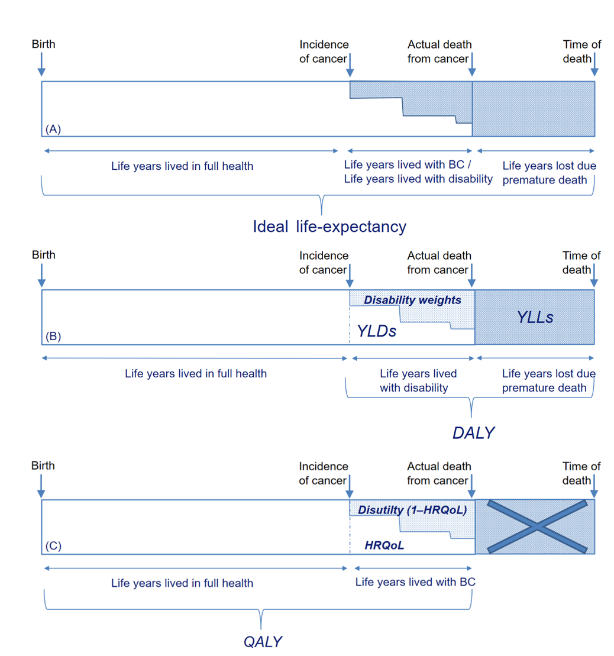
Figure 1. DALYs and QALYs. Each box represents the lifespan from birth to death. A person can live the whole life in full health (ideal life-expectancy) (A). When the person is diagnosed with cancer, QoL is reduced. The effects on QoL can be measured on two ways. Firstly, we can estimate how long a person lived with disability due to disease (YLDs) and how many years the person lost due to disease (YLLs) (B). YLLs are calculated as a number of deaths and life expectancy at that age. To calculate YLDs, prevalence of a given health state is multiplied by a DW. DW are anchored between 0 and 1, where 0 represents full health and 1 is equivalent to death. The sum of these two measures represents DALY for a specific person and specific disease. One DALY can be thought of as one year of “healthy” life lost. Secondly, we can estimate the loss of QoL during life years lived with disease (C). QALYs are calculated as a time spent in specific health state with HRQoL utility for that health state. One QALY is equal to 1 year of life in perfect health. As it is shown (B and C), disability weights and disutility are two parts of the same equation and could result in the same outcomes. However, disability weights and disutility are currently measured very differently and therefore are not necessarily complementary.

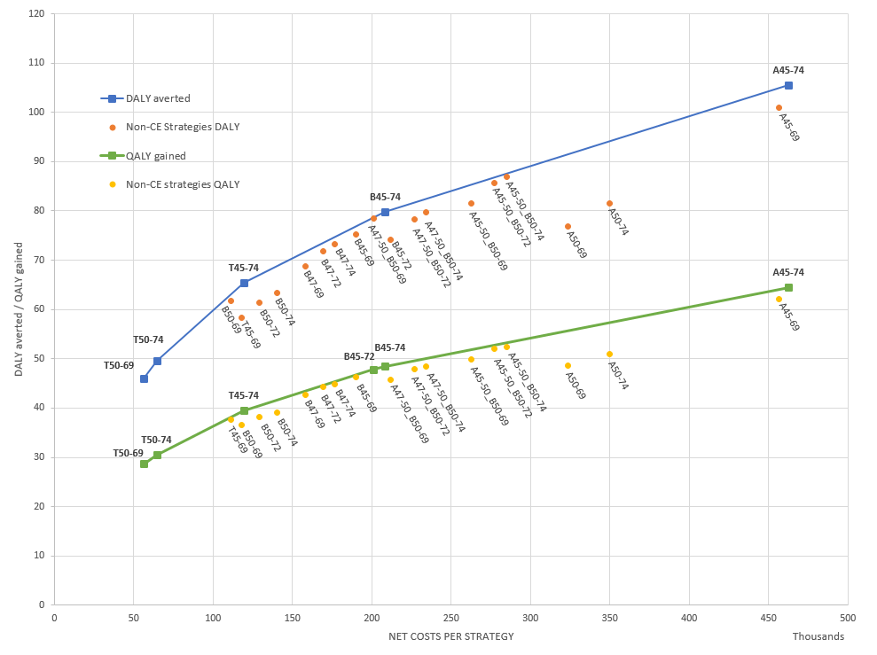
Figure 2. Efficiency frontier of screening strategies. Each screening strategy is represented by a point. Both DALYs averted or QALYs gained and costs for each strategy are relative to a situation without screening and are presented per 1,000 women. Strategies consist of annual (A), biennial (B), triennial (T) screening and combination of annual and biennial (A+B). Strategies on the green (QALY gained) and blue line (DALY averted) represent cost-effective strategies. Dominated strategies are represented by dots only.

Table 1. Disability weights and health-related quality of life utilities and disutilities for breast cancer related health states
Health State | Disability weight (95% CI) |  | Reference
Diagnosis and primary therapy | 0.288 (0.193-0.399) |  | Global Burden Disease Study 2015 [15]
Controlled phase of breast cancer | 0.049 (0.031-0.072) |  | Global Burden Disease Study 2015 [15]
Metastatic phase of breast cancer | 0.451 (0.307-0.600) |  | Global Burden Disease Study 2015 [15]
Terminal phase of breast cancer | 0.540 (0.377-0.687) |  | Global Burden Disease Study 2015 [15]
Mastectomy due to breast cancer | 0.036 (0.020-0.057) |  | Global Burden Disease Study 2015 [15]
Health State | HRQoL utility | Disutilityª | Reference
Mammographic screening – 1 week | 0.99 | 0.01 | De Koning et al. (1991) [17]
Biopsy with benign results / due to false positive | 0.89 | 0.11 | De Haes et al. (1991) [16]
3 months – 1 year after mastectomy | 0.84 | 0.16 | De Haes et al. (1991) [16]
Breast cancer^{b} | 0.83 (0.40-0.90)^{c} | 0.17 | Schleinitz et al. (2006) [31]
Base state – stable metastatic disease with no toxicity | 0.71 | 0.29 | Lloyd et al. (2006) [18]
Terminal illness – 1 month | 0.29 | 0.71 | De Haes et al. (1991) [16]
Abbreviations: CI – Confidence Interval; HRQoL utilities – Health Related Quality of Life Utilities;
ª Disutility is calculated as 1 – HRQoL
^{b}The value is the mean of utilities for stage 1 and stage 2 by TNM classification (for more, see Schleinitz et al. 2006) [31].
^{c} Utility and standard error

Table 2. The discounted net costs in Euros, LYG, DALYs averted and QALYs gained per 1000 women per strategy
Screening strategyª | Net costs per strategy^{b} | LYG | DALYs averted | QALYs gained
No screening | Ref. (Total cost: 1,201,486) | Ref. | Ref. | Ref.
T50-69 | 56,217 | 36.70 | 46.00 | 28.69
T50-74 | 64,326 | 40.10 | 49.68 | 30.48
T45-69 | 111,203 | 46.90 | 61.79 | 37.69
B50-69 | 118,112 | 46.90 | 58.30 | 36.60
T45-74 | 119,276 | 50.30 | 65.45 | 39.50
B50-72 | 129,089 | 49.80 | 61.40 | 38.19
B50-74^{c} | 140,301 | 51.70 | 63.44 | 39.00
B47-69 | 158,257 | 53.80 | 68.77 | 42.68
B47-72 | 169,153 | 56.70 | 71.84 | 44.24
B47-74 | 176,803 | 58.10 | 73.28 | 44.91
B45-69 | 190,112 | 57.80 | 75.32 | 46.20
B45-72 | 200,995 | 60.80 | 78.40 | 47.87
B45-74 | 208,447 | 62.20 | 79.88 | 48.52
A47-50_B50-69 | 212,050 | 57.30 | 74.23 | 45.79
A47-50_B50-72 | 226,701 | 61.20 | 78.34 | 47.91
A47-50_B50-74 | 234,261 | 62.40 | 79.69 | 48.39
A45-50_B50-69 | 262,407 | 62.00 | 81.53 | 49.84
A45-50_B50-72 | 277,127 | 65.90 | 85.63 | 51.98
A45-50_B50-74 | 284,729 | 67.10 | 86.97 | 52.46
A50-69 | 323,346 | 63.00 | 76.92 | 48.59
A50-74 | 349,540 | 67.50 | 81.58 | 50.92
A45-69 | 456,493 | 78.40 | 100.94 | 62.02
A45-74 | 462,471 | 83.00 | 105.58 | 64.50
Abbreviations: LYG – Life Years Gain, DALY – Disability Adjusted Life Years, QALY – Quality Adjusted Life Years
a Screening strategies consist of annual (A), biennial (B) and triennial (T) screening or combination of annual and biennial (A + B)
b Result is presented in Euros
c Current screening strategy in the Netherlands

Table 3. Additional discounted costs; DALYs averted; and QALYs gained, and Incremental Cost-Effectiveness Ratio for cost-effective screening strategies
Cost-effective strategies – ICER
DALY analyses |  |  |  | QALY analyses
Screening strategy | Additional costsª | Additional DALY averted | ICER^{b} | Screening strategy | Additional costsª | Additional QALY gained | ICER^{b}
No screening | Ref. | Ref. | Ref. | No screening | Ref. | Ref. | Ref.
T50-69 | 56,217 | 46.00 | 1,222 | T50-69 | 56,217 | 28.69 | 1,960
T50-74 | 8,109 | 3.67 | 2,207 | T50-74 | 8,109 | 1.80 | 4,512
T45-74 | 54,950 | 15.77 | 3,484 | T45-74 | 54,950 | 9.01 | 6,096
/ | / | / | / | B45-72 | 81,720 | 8.37 | 9,776
B45-74 | 89,171 | 14.43 | 6,180 | B45-74 | 7,452 | 0.66 | 11,364
A45-74 | 254,024 | 25.70 | 9,883 | A45-74 | 254,024 | 15.98 | 15,899
Abbreviations: DALY – disability adjusted life years; ICER – incremental cost-effectiveness ratio; QALY – quality adjusted life years
ª The results are presented in Euros, and reflect the additional costs relative to the less effective strategy in the ranking
^{b} The results are presented in Euros per one DALY averted or QALY gained, and are calculated as the difference in costs divided by the difference in DALY averted or QALY gained between a strategy and the previous, less effective strategy in the ranking

