Inequalities in alcohol-related mortality in 17 European countries: register-based study
Johan P. Mackenbach [a]
Ivana Kulhánová [a]
Matthias Bopp [b]
Carme Borrell [c]
Patrick Deboosere [d]
Katalin Kovács [e]
Caspar W.N. Looman [a]
Mall Leinsalu [f,g]
Pia Mäkelä [h]
Pekka Martikainen [i]
Gwenn Menvielle [j,k]
Maica Rodríguez-Sanz [c]
Jitka Rychtaříková [l]
Rianne de Gelder [a]

for the DEMETRIQ consortium [m]

a. Department of Public Health, Erasmus MC, Erasmus University Medical Center, Rotterdam, The Netherlands
b. Epidemiology, Biostatistics and Prevention Institute, University of Zürich, Switzerland
c. Agència de Salut Pública de Barcelona, Barcelona, Spain
d. Department of Sociology, Vrije Universiteit Brussel, Belgium
e. Demographic Research Institute of the Central Statistical Office, Budapest, Hungary
f. Stockholm Centre for Health and Social Change, Södertörn University, Huddinge, Sweden
g. Department of Epidemiology and Biostatistics, National Institute for Health Development, Tallinn, Estonia
h. National Institute for Health and Welfare, Helsinki, Finland
i. Department of Sociology, University of Helsinki, Finland
j. Centre for research in Epidemiology and Population Health (CESP), U1018, INSERM, Villejuif, France
k. University of Versailles Saint Quentin, Versailles, France
l. Department of Demography, Charles University, Prague, Czech Republic
m. For other members, see acknowledgments

Correspondence:
Prof. Dr Johan P. Mackenbach
Department of Public Health
Erasmus MC
P.O. Box 2040
3000 CA Rotterdam
Netherlands
j.mackenbach@erasmusmc.nl

This is the second revision d.d. 210815. A slightly different version has been published in PLoS Medicine.

Abstract

Background
Socioeconomic inequalities in alcohol-related mortality have been documented in several European countries, but it is unknown whether the magnitude of these inequalities differs between countries and whether these inequalities increase or decrease over time.

Methods and findings
We collected and harmonized data on mortality from four alcohol-related causes (alcoholic psychosis, dependence and abuse; alcoholic cardiomyopathy; alcoholic liver cirrhosis; and accidental poisoning by alcohol) by age, sex, educational level and occupational class in 20 European populations from 17 different countries, both for a recent period and for previous points in time, using data from mortality registers. Mortality was age-standardized using the European Standard Population, and measures for both relative and absolute inequalities between low and high socioeconomic groups were calculated.
Rates of alcohol-related mortality are higher in lower socioeconomic groups in all countries. Both relative and absolute inequalities are largest in Eastern Europe, and Finland and Denmark also have very large absolute inequalities in alcohol-related mortality. Over time, relative inequalities in alcohol-related mortality have increased in many countries, but the main change is a strong rise of absolute inequalities in several countries in the East (Hungary, Lithuania, Estonia) and North (Finland, Denmark) due to a rapid rise in alcohol-related mortality in lower socioeconomic groups. In some of these countries alcohol-related causes now account for 10 percent or more of inequalities in total mortality.
Because our study relies on routinely collected underlying causes of death, it is likely that our results underestimate the true extent of the problem.

Conclusions
Alcohol-related conditions play an increasingly important role in generating inequalities in total mortality in many European countries. Countering increases in alcohol-related mortality in lower socioeconomic groups is essential for reducing inequalities in mortality. Studies of why such increases have not occurred in countries like France, Switzerland, Spain and Italy can help to develop evidence-based policies in other European countries.

Introduction

Alcohol consumption, particularly in higher doses, is a risk factor for many fatal and non-fatal health problems. Acute intoxication is a risk factor for injuries, both accidental and non-accidental, and for cardiovascular disease, whereas chronic heavy drinking is a risk factor for liver cirrhosis, various forms of cancer and cardiovascular disease (1, 2).

Liver cirrhosis mortality is high in Europe, particularly in Central & Eastern European countries (3). These rates used to be high in Southern Europe too, but since the 1970s and 1980s mortality from liver cirrhosis has declined substantially in France, Italy, Spain, Greece, and other Mediterranean countries. By contrast, mortality from liver cirrhosis has increased in Central & Eastern Europe, in Finland and in the United Kingdom (3-6).

Patterns and trends of mortality from other alcohol-related conditions have been studied less often. Within Europe, mortality from alcoholic psychosis, alcohol poisoning and alcohol dependence appears to have a different geographical pattern as compared to mortality from liver cirrhosis, with relatively high rates of the former in the Nordic countries (7, 8). This has been attributed to the Northern style of drinking, characterized by non-daily drinking and frequent intoxication, which is also common in Eastern Europe (9). Mortality from these conditions has been rising in many European countries (8).

Like many other health-related behaviours, alcohol consumption is strongly patterned by socioeconomic status, as indicated by level of education, occupational class and income. In many European countries, the frequency of drinking and sometimes also the levels of consumption are higher in higher socioeconomic groups, whereas problematic forms of consumption, like binge drinking, and alcohol-related health and social problems are more frequent in lower socioeconomic groups (7, 10).

Recent literature reviews have shown that mortality from alcohol-related conditions is higher in lower socioeconomic groups in most of the available studies (11, 12), including studies from Finland (13), Sweden (14, 15), the United Kingdom (16, 17) and Estonia (18). Comparative studies are, however, lacking and it is therefore unknown whether there are important differences between countries in the magnitude of inequalities in alcohol-related mortality. Investigating these differences is important because this may provide useful insights into the explanation of these inequalities, and into the potential for reducing them.

Studies of trends in inequalities in alcohol-related mortality are even scarcer. Finland is the only country for which detailed studies have been made. Over the past decades absolute inequalities in alcohol-related mortality have strongly increased in Finland (19), which has contributed importantly to rising inequalities in total mortality and life expectancy (20, 21). These changes were partly fuelled by changes in the affordability of alcohol (22, 23). In Finland, the rise of inequalities in alcohol-related mortality has partly un-done the effect of declining inequalities in smoking-related mortality, suggesting that one risk factor has been replaced by another (21). Studies from other countries are very scarce (18, 24), and it is therefore unknown whether the Finnish experience can be generalized to other countries.

To fill these gaps, we set out to study whether European countries differ in the magnitude of socioeconomic inequalities in alcohol-related mortality, and what the trends of these inequalities over the past decades have been. More specifically, we studied inequalities in alcohol-related mortality in all European countries with available data, and assessed whether their magnitude and contribution to inequalities in total mortality varies between countries and has changed over time.

Methods

Data
We extracted data from national or regional mortality registers which allow a classification of deaths and population numbers by socioeconomic position, such as the national longitudinal mortality registers in Finland, Sweden, Norway and Denmark, the Office of National Statistics Longitudinal Mortality Study in England & Wales, and the Echantillon Démographique Permanent created by the National Institute of Statistics (INSEE) in France. We included all European countries in which data on cause-specific mortality covering complete national or regional populations were available that allowed a distinction by the most commonly used indicator of socioeconomic position, level of education (see below). Unfortunately, not all European countries have data collection systems in place from which such data could be extracted, e.g. because of privacy restrictions or lack of information on education in their population census, but our study includes 17 countries which together represent all parts of the European subcontinent. Table 1 gives an overview of the main characteristics of our data sources; web appendix table A1 provides additional detail. To facilitate inspection of tables and graphs, we have loosely grouped countries into four geographical regions (North, West, South and East).

Most data stemmed from a longitudinal mortality follow-up after a census, in which socioeconomic information of the population-at-risk and of the deceased had been recorded in the census; some countries only had unlinked cross-sectional data in which socioeconomic information on the population-at-risk came from the census, and socioeconomic information on the deceased came from the death certificate. In most countries linkage between the population and death registries was more than 95% complete; for countries where linkage failure exceeded 5% (Madrid, Barcelona and the Basque Country) mortality rates were multiplied by the inverse of the proportion of deaths that were successfully linked in order to adjust for the linkage failure. Data for Spain and Italy came from regional populations, but previous studies have shown that patterns observed in these regional populations correspond well to those seen at the national level (25-27).

- Table 1 here –

We used two indicators of socioeconomic position: level of education and occupational class. For education, we used the ISCED 1997 classification, and combined categories 0-2 (pre-primary, primary and lower secondary education) into a group labelled ‘low’, categories 3-4 (upper secondary and post-secondary non-tertiary education) into ‘mid’, and categories 5-6 (first and second stage of tertiary education) into ‘high’ (28). For occupation, we used the Erikson-Goldthorpe-Portocarero scheme of occupational classes, and distinguished non-manual, manual, farmers, and self-employed workers (29). As the groups of farmers and self-employed are heterogeneous in terms of their social position (e.g., because some farmers or self-employed have employees working for them while others lead a precarious existence), which is also reflected in highly variable mortality rates in different European countries (30), we only report on differences in mortality between manual and non-manual workers. Because occupational class was not available for all populations, and information on occupational class is less reliable among women, we present results on male mortality by occupational class in the web appendix. Persons with missing education or occupational class were excluded from the analysis. Proportion of population aged 35-79 years with unknown educational level varied between 0 and 11%; percentage of male population aged 35-64 years with unknown occupational class varied between 3 and 36% (web appendix table A1).

For our outcome variable, mortality due to alcohol-related causes, we selected four underlying causes of death: alcoholic psychosis, dependence and abuse; alcoholic cardiomyopathy; alcoholic diseases of the liver; and accidental poisoning by alcohol. In the most recent time-period, most countries used ICD-10 for classifying causes of death. ICD-code numbers selected in ICD-10 and previous editions are given in web appendix table A2. All countries were able to provide data on all four alcohol-related causes in the latest period, but some were not for earlier periods in time.

Analysis
Our analysis consisted of two parts: a cross-country comparison of inequalities in alcohol-related mortality for the most recent point in time for which data were available in these countries, and a cross-country comparison of trends in inequalities in alcohol-related mortality over time. Mortality rates by educational level and occupational class were age-standardized using the European Standard Population (31). Because education gradually loses its discriminatory power at higher ages, and because registration of causes of death becomes increasingly unreliable at higher ages, all analyses for education are restricted to the age-range 35-79 years (for exceptions see table 1); because registration of (former) occupation was incomplete for pensioners, analyses for occupational class were restricted to the age-range 35-64 years. All analyses were stratified by sex, because alcohol consumption patterns and inequalities in these patterns are known to differ between men and women (32).

We systematically studied the magnitude of both relative and absolute inequalities because both are important (33, 34), and operationalized inequalities in terms of both a ratio and a difference measure of the excess mortality in lower as compared to higher socioeconomic groups. All measures were adjusted for age. For education, we used the Relative Index of Inequality (RII) and the Slope Index of Inequality (SII)(35, 36). Both measures take into account all education groups (i.e., not just the lowest and highest groups), and derive from a linear regression analysis of mortality on education. The RII was calculated using Poisson regression with the observed number of deaths as the dependent variable, person-years as offset variable, and educational rank and dummy variables for age (in 5-year age-groups) as independent variables. Educational rank was calculated for each education group (by country, sex and period) as the mean proportion of the population having a higher level of education. The RII is the ratio between mortality at rank 1 (the lowest educational level) and rank 0 (the highest educational level), and can thus be interpreted as the rate ratio of mortality between those with the very lowest and those with the very highest educational position in the population (35). The SII represents the absolute version of the RII and was calculated as follows: SII = 2*ASMR*(RII-1)/(RII+1), in which ASMR is the age-standardized mortality in the whole population (37). The SII can be interpreted as the rate difference (in deaths per 100,000 person-years) between those with the very lowest and those with the very highest educational position in the population. The RII and SII take into account the size of educational groups, and adjust the relative position of each group to its share in the population, which increases comparability over time and between countries if there are substantial differences in distribution of the population over educational groups (35). 95% CI were calculated using bootstrapping of 1000 replicas (38). The per cent contribution of inequalities in alcohol-related mortality to inequalities in total mortality was calculated from the SIIs for alcohol-related mortality (numerator) and total mortality (denominator), respectively. As our comparison for occupational class only involved two classes (manual and non-manual), we used simple Rate Ratios and Rate Differences with the non-manual class as the reference group for this socioeconomic indicator.

Results

Levels of mortality from alcohol-related causes in the latest available period are presented in table 2. Mortality from all alcohol-related causes together was highest in Hungary, both among men and women, mainly due to extremely high mortality from alcoholic liver disease. Alcoholic psychosis, dependence and abuse mortality was highest in Denmark, and alcohol poisoning mortality in Estonia.

- Table 2 here –

Educational inequalities in mortality from alcohol-related causes were found in all countries, with mortality being higher among the mid- than the high-educated and among the low- than the mid-educated, almost without exception (figure 1). However, it can immediately be seen that the absolute gap in death rates varied substantially between countries, being very small in the four populations in the South and very large in most countries in the East. The gap in death rates was also relatively large in Finland and Denmark. Remarkably, alcohol-related mortality among the high-educated was also highly variable between countries.

- Figure 1 here

Table 3 shows relative and absolute educational inequalities in mortality from alcohol-related causes in the latest observed period. The Relative Index of Inequality (RII) almost always exceeded 1.00, indicating higher mortality among the lower educated. As could already be seen in figure 1, absolute inequalities as measured by the Slope Index of Inequality (SII) were largest in Hungary, both among men and among women, with the two Baltic countries coming second and third. Absolute inequalities in alcohol-related mortality were also very large in Slovenia, Finland and Denmark.

- Table 3 here

Table 3 also shows the contribution of alcohol-related mortality to inequalities in total mortality. That contribution was equal to or higher than 10% in Finland, Denmark (men only), Slovenia and Hungary. Data on occupational class inequalities in alcohol-related mortality among men were available for 11 out of 16 countries, and show a pattern of consistently higher mortality among manual than non-manual workers. The contribution of alcohol-related mortality to occupational class inequalities in total mortality was often even larger than that seen for educational inequalities in total mortality, due to the restriction to a younger age-group (web appendix table A3).

We now turn to the analysis of trends in inequalities in alcohol-related mortality, which are illustrated in table 4. Relative inequalities in alcohol-related mortality, as measured by the Relative Index of Inequality (RII), have gone up in some countries, including Finland and Norway. The main change in inequalities, however, is a strong rise in absolute inequalities, as measured by the Slope Index of Inequality (SII), in several countries in the East (Hungary, Lithuania, Estonia) and North (Finland, Denmark). On the other hand, absolute inequalities in alcohol-related mortality have been stable in several other countries, and declining among men in France.

- Table 4 here

Web appendix table A4 shows trends in relative and absolute inequalities in alcohol-related mortality by occupational class. Here again, we observe a strong rise of absolute inequalities among men in several countries, including Finland, England & Wales, and Lithuania.

The rise of absolute inequalities in alcohol-related mortality in several countries was due to a remarkable increase in mortality from alcohol-related conditions among the lower educated, with stable or only moderately increasing mortality among the higher educated, as shown in figure 2. However, trends are far from uniform. For example, while mortality among low educated men has risen enormously in Finland and Denmark, it has been relatively stable in Sweden and Norway. The stability, or even tendency towards decline, of mortality from alcohol-related causes among lower educated men in France, Switzerland, Spain and Italy is also noteworthy.

- Figure 2 here

Similar results are seen for women (figure 2) and for men by occupational class (web appendix figure A1).

Discussion

Summary of main findings
Rates of alcohol-related mortality are higher in lower socioeconomic groups in all countries. Both relative and absolute inequalities are largest in Eastern Europe, and Finland and Denmark also have very large absolute inequalities in alcohol-related mortality. Over time, relative inequalities in alcohol-related mortality have increased in many countries, but the main change is a strong rise of absolute inequalities in several countries in the East (Hungary, Lithuania, Estonia) and North (Finland, Denmark) due to a rapid rise in alcohol-related mortality in lower socioeconomic groups. In some of these countries alcohol-related causes now account for 10 percent or more of inequalities in total mortality in the age-group 35–79 years.

Strengths and limitations
This study is unique in its population-wide coverage of a wide range of European countries and a long period of time, using two indicators of socioeconomic position. The main limitation is that we had to rely on routinely registered data, and that cause-of-death data are a far-from-perfect source of information on alcohol-related mortality.

It has been suggested that differences between European countries in the levels of mortality from alcohol-related conditions are likely to be at least partly due to different recording practices (8). Between-country differences in mortality levels as observed in the present study – which also strongly influence absolute inequalities in mortality from alcohol-related conditions – should therefore be regarded with caution. For example, the quality and coverage of alcohol-related cause-of-death data have been characterized as particularly good in Finland (19), which may partly be due to better recognition or a relative absence of social stigma in this country. By contrast, recording whether excessive alcohol consumption is the cause of liver cirrhosis may be far from complete in other countries (39, 40).

Although under-recording is probably the most prevalent source of bias, over-recording has been reported in Hungary, where liver cirrhosis was often assigned as a cause of death in cases of diagnostic uncertainty (41). To redress this problem a change in coding rules was implemented in 1996, after which mortality from alcoholic liver cirrhosis suddenly dropped by 20% (Kovács, Demographic Research Institute of the Central Statistical Office, Budapest, Hungary; personal communication 27 March 2015). This implies that mortality rates from alcohol-related causes in Hungary in the early 1980s and early 1990s, as presented in table 2 and figure 2, have been overestimated, and that the real increase was even larger than suggested by our data.

Over- and under-recording may also differ between socio-economic groups or change over time. For example, the lower mortality rate from alcohol-related causes among those with a higher socioeconomic position could be partly due to social stigma, and to medical doctors being more hesitant to attach social stigma to people of similar social standing (13). Yet, it is likely that the risk of bias is less for between-country comparisons of relative inequalities in alcohol-related mortality, and for within-country comparisons of relative and absolute inequalities over time, than for between-country comparisons of absolute inequalities in alcohol-related mortality.

The second limitation with the cause-of-death data is that we have studied directly alcohol-attributable causes of death only, and these cover only a part of all alcohol-attributable deaths. The Global Burden of Disease study has estimated that alcohol accounts for around 11% of deaths among men in European populations, many of which are from cardiovascular disease and cancer (42). In our data the alcohol-related causes generally account for a few percentage points only, partly because we have not taken into account such more indirect effects (table 2). In Finnish studies, this problem has to some extent been reduced by using data on contributory causes of death (13, 19) but in international comparisons these data are not available and even if they were may present even greater problems of comparability.

Another limitation is that, although we have used the most recent data available when we undertook this study (2012-2014), some of the data are already quite old, particularly in the East. Also, whereas data on level of education were relatively complete, data on occupational class were more often missing, particularly in Lithuania (36% missing) and Estonia (35% missing) (web appendix table A1). Despite the greater risk of bias that this creates, the fact that occupational class data produce similar findings as educational data increases confidence in our findings.

Interpretation
Excessive alcohol consumption is one of the greatest challenges for public health in Europe – in no other world region is the alcohol-attributable burden of disease higher than in Europe (43). As our study shows, alcohol-related health problems have also become an important driver of socioeconomic inequalities in mortality in many parts of the region, particularly in Central & Eastern Europe and in the Nordic countries. Our previous study of cause-specific inequalities in mortality in Europe in the 1990s already pointed in this direction (37) but our present study shows that this is also a rapidly growing problem.

The omnipresence of socioeconomic inequalities in alcohol-related mortality suggests that these are linked to structural characteristics of societies, but their specific explanation is likely to be complex. First, it is important to recognize that part of the association may be due to selection factors: alcohol-related physical, mental and social problems may lead to a lower socioeconomic position, but this is likely to affect income more than education and occupational class (13). Furthermore, certain personality traits or psychological problems in childhood and adolescence may predispose both to a higher risk of problematic drinking and to lower educational level (13, 14).

It is highly plausible, however, that the association between low socioeconomic status and alcohol-related health problems also partly reflects an indirect, causal effect of low socioeconomic position on the risk of dying from alcohol-related conditions, both through a higher prevalence of harmful consumption levels or patterns, and through a higher vulnerability to the effects of alcohol. The first may be due to a higher exposure to material and psychosocial stressors, with alcohol being used for tension reduction (44, 45). It has also been suggested that drinkers from lower socioeconomic groups, e.g. in Hungary (46) and other Central & Eastern European countries, are more exposed to lower quality alcoholic drinks, such as home-brewed and non-beverage alcohol that may contain toxic compounds (47-49).

A higher vulnerability to the effects of alcohol is suggested by a Finnish longitudinal study, which found that, with consumption level and drinking patterns controlled, alcohol-related hospitalizations and mortality were much more frequent in the lower socioeconomic groups (50), perhaps due to an interaction with dietary habits, safety of the drinking environment, or support from work and family to address emerging alcohol problems.

We found that inequalities in alcohol-related mortality are much larger in some countries in the North and East of Europe than they are in the West and South. Part of the explanation may lie in different drinking cultures (51). Binge drinking is common in the North and East, and strongly socially stratified, whereas in the South a Mediterranean style of drinking still predominates, particularly in older generations including lower socioeconomic groups, which is characterized by almost daily drinking of alcohol, mostly in the form of wine with meals, and less acceptance of public drunkenness (4, 32). Nevertheless, daily drinking of moderate amounts of alcohol does increase the risk of cirrhosis (52), and may be the main factor behind inequalities in alcohol-related mortality in the South, which is indeed dominated by cirrhosis mortality (table 2). We also found remarkable differences between men and women: whereas relative inequalities in alcohol-related mortality are sometimes larger among women than among men, absolute inequalities are almost always larger among men (Table 3).

Inequalities in alcohol-related mortality have been very dynamic, as shown by this study, which at the very least suggests that they are not immutable. To what extent do changes in inequalities in alcohol-related mortality reflect policy impacts?

Trends in alcohol control policies in Western Europe have been analysed in the European Comparative Alcohol Study (ECAS) (53). Between 1950 and 2000, alcohol control has become less strict in Northern Europe, partly as a result of harmonization of national laws and regulations following membership of the European Union, but more strict in Southern Europe, including France. Although this may help to explain the relatively favourable trends in countries like France, Spain, and Italy, as has been reported before (54-56), it does not explain our findings for the Nordic countries. Loosening of alcohol control policies coincided with a rise of mortality from alcohol-related causes among lower educated men in Finland, but not in Sweden or Norway, whereas the rise of mortality from alcohol-related causes among lower educated men in Denmark coincided with a slight tightening of alcohol control policies (figure 2) (57).

Increasing affordability of alcohol, due to a combination of rising incomes and stable or sometimes even declining price levels of alcoholic drinks, may also have played a role in the rise of alcohol-related mortality seen in many European countries. Because lower socioeconomic groups are likely to be more responsive to price changes (as shown, for example, in the case of tobacco (58)), increased affordability of alcohol may have led to relatively larger increases in consumption in lower socioeconomic groups. Between 1996 and 2004 affordability of alcohol has increased strongly in many European countries, including Lithuania, United Kingdom and Finland (59). Finnish studies have shown that the impact of these changes has been largest in the lowest socioeconomic groups (19, 22, 23). Our data suggest that inequalities in alcohol-related mortality have indeed increased most in countries like Lithuania and Finland in which affordability has increased most (figure 3).

- Figure 3 here

Trends in alcohol policy in Central & Eastern Europe since 1990 have not been systematically characterized (57). In many of these countries excessive alcohol consumption surged around 1990 when cheap alcohol flooded the market (60). The strong increases of alcohol-related mortality seen in these countries are also likely to be a reflection of the economic crisis following the collapse of the Soviet Union and the resulting stress in the population, and of the extreme liberalization of alcohol markets with a breakdown of control measures in the chaotic first years after the political changes (61-64). More recently, rising income and increased affordability of alcohol may also have played a role (65).

What can be done to reduce inequalities in alcohol-related mortality? The WHO Commission on Social Determinants of Health has emphasized the importance of tackling the underlying or “upstream” causes of inequalities in health, i.e. the unequal distribution of socioeconomic resources in society (66). Some argue that if one would focus efforts to tackle health inequalities on “downstream” causes instead, such as health-related behaviours, the “gap” left by one downstream cause would soon be filled by another, and health inequalities would persist with little change (67). Although there is some evidence for the exchangeability of downstream causes, such as between smoking and alcohol (21), our between-country comparison shows that it is possible to have small inequalities in alcohol-related mortality with large inequalities in socioeconomic resources, as in Southern Europe, as well as the reverse, as in Northern Europe.

This implies that policies and interventions redressing the higher prevalence of harmful alcohol consumption patterns in lower socioeconomic groups could help to reduce inequalities in mortality, even without tackling the “upstream” causes of health inequalities. The evidence base shows that a range of alcohol control measures are (cost-)effective (68). Although little is known about differential effectiveness by socioeconomic position (69), an informed guess is that a combination of different approaches will be necessary. Making alcohol more expensive has been shown to be the most cost-effective way to reduce alcohol-related harm, and will probably also work to reduce inequalities. Whatever the policies and interventions chosen, they should take into account cultural preferences of drinking, and include measures to control illegal trade and production.

Conclusions
Alcohol-related conditions play an increasingly important role in generating inequalities in total mortality in many European countries. Countering increases in alcohol-related mortality in lower socioeconomic groups is essential for reducing inequalities in mortality. Studies of why such increases have not occurred in other countries, such as France, Switzerland, Spain and Italy, can help to develop evidence-based policies in other European countries.

Acknowledgements

Supported by a grant (FP7-CP-FP grant no. 278511) from the European Commission Research and Innovation Directorate General, as part of the “Developing methodologies to reduce inequalities in the determinants of health” (DEMETRIQ) project. We thank the members of the DEMETRIQ consortium for their valuable comments and suggestions on a previous version of the manuscript.

In addition to the authors, the following members of the DEMETRIQ consortium contributed to this study (in alphabetical order by country):
- Austria: Johannes Klotz, Statistics Austria, Vienna
- Denmark: Jorn Korsbo Petersen, Statistics Denmark, Copenhagen
- England and Wales: Office for National Statistics, Newport, Wales
- Italy (Turin): Giuseppe Costa, Department of Clinical Medicine and Biology, University of Turin, Turin
- Lithuania: Ramune Kalediene and Remigijus Prochorskas, Lithuanian University of Health Sciences, Kaunas
- Norway: Bjørn Heine Strand, Division of Epidemiology, Norwegian Institute of Public Health, Oslo
- Poland: Bogdan Wojtyniak, Department of Monitoring and Analyses of Population Health, National Institute of Public Health-National Institute of Hygiene, Warsaw
- Scotland: Tom Clement, Scottish Longitudinal Study Development and Support Unit, Edinburgh
- Slovenia: Barbara Artnik, Department of Public Health, Faculty of Medicine, Ljubljana
- Spain (Basque Country): Santiago Esnaola, Department of Public Health, Basque Government, Vitoria, Spain
- Spain (Madrid): Enrique Regidor, Department of Preventive Medicine and Public Health, Universidad Complutense de Madrid, Madrid
- Sweden: Olle Lundberg, Center for Health Equity Studies, Stockholm

References

1. Rehm J. The risks associated with alcohol use and alcoholism. Alcohol research & health: the journal of the National Institute on Alcohol Abuse and Alcoholism. 2010;34(2):135-43.
2. Rehm J, Baliunas D, Borges GL, Graham K, Irving H, Kehoe T, et al. The relation between different dimensions of alcohol consumption and burden of disease: an overview. Addiction. 2010;105(5):817-43.
3. Bosetti C, Levi F, Lucchini F, Zatonski WA, Negri E, La Vecchia C. Worldwide mortality from cirrhosis: an update to 2002. J Hepatol. 2007;46(5):827-39. Epub 2007/03/06.
4. Zatonski WA, Sulkowska U, Manczuk M, Rehm J, Boffetta P, Lowenfels AB, et al. Liver cirrhosis mortality in Europe, with special attention to Central and Eastern Europe. European addiction research. 2010;16(4):193-201. Epub 2010/07/08.
5. Leon DA, McCambridge J. Liver cirrhosis mortality rates in Britain from 1950 to 2002: an analysis of routine data. Lancet. 2006;367(9504):52-6. Epub 2006/01/10.
6. Munoz-Prez F, Nizard A. Alcohol consumption and cirrhosis mortality in the industrialised countries since 1950. European Journal of Population/Revue européenne de Démographie. 1999;14(4):367-86.
7. Bloomfield K, Grittner U, Kramer S, Gmel G. Social inequalities in alcohol consumption and alcohol-related problems in the study countries of the EU concerted action 'Gender, Culture and Alcohol Problems: a Multi-national Study'. Alcohol Alcohol Suppl. 2006;41(1):i26-36. Epub 2006/10/13.
8. Ramstedt M. Alcohol-related mortality in 15 European countries in the postwar period. In: Norstrom T, editor. Alcohol in Postwar Europe Consumption, drinking patterns, consequences and policy responses in 15 European countries. Stockholm: National Institute of Public Health; 2002.
9. Stickley A, Leinsalu M, Andreev E, Razvodovsky Y, Vagero D, McKee M. Alcohol poisoning in Russia and the countries in the European part of the former Soviet Union, 1970 2002. European journal of public health. 2007;17(5):444-9. Epub 2007/03/01.
10. Kuntsche E, Rehm J, Gmel G. Characteristics of binge drinkers in Europe. Social science & medicine. 2004;59(1):113-27. Epub 2004/04/17.
11. Probst C, Roerecke M, Behrendt S, Rehm J. Gender differences in socioeconomic inequality of alcohol-attributable mortality: A systematic review and meta-analysis. Drug and alcohol review. 2014. Epub 2014/08/12.
12. Probst C, Roerecke M, Behrendt S, Rehm J. Socioeconomic differences in alcohol-attributable mortality compared with all-cause mortality: a systematic review and meta-analysis. International journal of epidemiology. 2014;43(4):1314-27. Epub 2014/03/13.
13. Mäkelä P. Alcohol-related mortality as a function of socio-economic status. Addiction. 1999;94(6):867-86. Epub 2000/02/09.
14. Hemström O. Alcohol-related deaths contribute to socioeconomic differentials in mortality in Sweden. European journal of public health. 2002;12(4):254-62. Epub 2003/01/01.
15. Norström T, Romelsjo A. Social class, drinking and alcohol-related mortality. Journal of substance abuse. 1998;10(4):385-95. Epub 2000/07/18.
16. Metcalfe C, Davey Smith G, Sterne JA, Heslop P, Macleod J, Hart CL. Cause-specific hospital admission and mortality among working men: association with socioeconomic circumstances in childhood and adult life, and the mediating role of daily stress. European journal of public health. 2005;15(3):238-44. Epub 2005/06/01.
17. Harrison L, Gardiner E. Do the rich really die young? Alcohol-related mortality and social class in Great Britain, 1988-94. Addiction. 1999;94(12):1871-80. Epub 2000/03/16.
18. Leinsalu M, Vågerö D, Kunst AE. Estonia 1989-2000: enormous increase in mortality differences by education. International journal of epidemiology. 2003;32(6):1081-7. Epub 2003/12/19.
19. Herttua K, Mäkelä P, Martikainen P. Differential trends in alcohol-related mortality: a register-based follow-up study in Finland in 1987-2003. Alcohol and alcoholism. 2007;42(5):456-64. Epub 2007/02/06.
20. Martikainen P, Valkonen T, Martelin T. Change in male and female life expectancy by social class: decomposition by age and cause of death in Finland 1971-95. Journal of epidemiology and community health. 2001;55(7):494-9. Epub 2001/06/20.
21. Martikainen P, Mäkelä P, Peltonen R, Myrskyla M. Income differences in life expectancy: the changing contribution of harmful consumption of alcohol and smoking. Epidemiology. 2014;25(2):182-90. Epub 2014/02/04.
22. Herttua K, Mäkelä P, Martikainen P. Changes in alcohol-related mortality and its socioeconomic differences after a large reduction in alcohol prices: a natural experiment based on register data. American journal of epidemiology. 2008;168(10):1110-8; discussion 26-31. Epub 2008/08/23.
23. Herttua K, Mäkelä P, Martikainen P. Minimum prices of alcohol and educational disparities in alcohol-related mortality: a time-series analysis. European Public Health Conference Abstracts. 2013.
24. Najman JM, Williams GM, Room R. Increasing socioeconomic inequalities in male cirrhosis of the liver mortality: Australia 1981-2002. Drug and alcohol review. 2007;26(3):273-8. Epub 2007/04/25.
25. Federico B, Mackenbach JP, Eikemo TA, Sebastiani G, Marinacci C, Costa G, et al. Educational inequalities in mortality in northern, mid and southern Italy and the contribution of smoking. Journal of epidemiology and community health. 2013;67(7):603-9. Epub 2013/04/19.
26. Marinacci C, Grippo F, Pappagallo M, Sebastiani G, Demaria M, Vittori P, et al. Social inequalities in total and cause-specific mortality of a sample of the Italian population, from 1999 to 2007. European journal of public health. 2013;23(4):582-7. Epub 2013/01/11.
27. Regidor E, Kunst AE, Rodriguez-Artalejo F, Mackenbach JP. Small socio-economic differences in mortality in Spanish older people. European journal of public health. 2012;22(1):80-5. Epub 2011/05/03.
28. Unesco. International Standard Classification of Education-ISCED 1997: November 1997: Unesco; 1997.
29. Erikson E, Goldthorpe JH. The Constant Flux. Oxford: Clarendon Press; 1992.
30. Kunst AE, Groenhof F, Mackenbach JP. Mortality by occupational class among men 30-64 years in 11 European countries. EU Working Group on Socioeconomic Inequalities in Health. Social science & medicine. 1998;46(11):1459-76. Epub 1998/07/17.
31. Ahmad O, Boschi-Pinto C, Lopez A, Murray C, Lozano R, et al. Age Standardization of Rates: A New WHO Standard. GPE Discussion Paper Series: No 31: World Health Organization; 2001.
32. Mäkelä P, Gmel G, Grittner U, Kuendig H, Kuntsche S, Bloomfield K, et al. Drinking patterns and their gender differences in Europe. Alcohol Alcohol Suppl. 2006;41(1):i8-18. Epub 2006/10/13.
33. Harper S, King NB, Meersman SC, Reichman ME, Breen N, Lynch J. Implicit value judgments in the measurement of health inequalities. The Milbank quarterly. 2010;88(1):4-29. Epub 2010/04/10.
34. Mackenbach JP. Should we aim to reduce relative or absolute inequalities in mortality? European journal of public health. 2015;25(2):185. Epub 2015/03/31.
35. Mackenbach JP, Kunst AE. Measuring the magnitude of socio-economic inequalities in health: an overview of available measures illustrated with two examples from Europe. Social science & medicine. 1997;44(6):757-71. Epub 1997/03/01.
36. Regidor E. Measures of health inequalities: part 2. Journal of epidemiology and community health. 2004;58(11):900-3.
37. Mackenbach JP, Stirbu I, Roskam AJ, Schaap MM, Menvielle G, Leinsalu M, et al. Socioeconomic inequalities in health in 22 European countries. The New England journal of medicine. 2008;358(23):2468-81. Epub 2008/06/06.
38. Sergeant JC, Firth D. Relative index of inequality: definition, estimation, and inference. Biostatistics. 2006;7(2):213-24.
39. Bell G, Cremona A. Alcohol and death certification: a survey of current practice and attitudes. British medical journal. 1987;295(6590):95. Epub 1987/07/11.
40. Ramstedt M. Alcohol consumption and liver cirrhosis mortality with and without mention of alcohol--the case of Canada. Addiction. 2003;98(9):1267-76. Epub 2003/08/22.
41. Jozan P. Some features of mortality in Hungary in the post-war period: the third stage of epidemiologic transition in promoting health in Hungary. Report of a group established by the Council of Ministers of the Hungarian People’s Republic. . Budapest: Central Statistical Office, 1987.
42. Lim SS, Vos T, Flaxman AD, Danaei G, Shibuya K, Adair-Rohani H, et al. A comparative risk assessment of burden of disease and injury attributable to 67 risk factors and risk factor clusters in 21 regions, 1990-2010: a systematic analysis for the Global Burden of Disease Study 2010. Lancet. 2012;380(9859):2224-60. Epub 2012/12/19.
43. Rehm J, Mathers C, Popova S, Thavorncharoensap M, Teerawattananon Y, Patra J. Global burden of disease and injury and economic cost attributable to alcohol use and alcohol-use disorders. The Lancet. 2009;373(9682):2223-33.
44. Droomers M, Schrijvers C, Stronks K, van de Mheen D, Mackenbach JP. Educational differences in excessive alcohol consumption: the role of psychosocial and material stressors. Preventive medicine. 1999;29(1):1-10.
45. de Goeij MC, Suhrcke M, Toffolutti V, van de Mheen D, Schoenmakers TM, Kunst AE. How economic crises affect alcohol consumption and alcohol-related health problems: a realist systematic review. Social science & medicine. 2015;131:131-46. Epub 2015/03/17.
46. Petrovski BE, Szeles G, Melles M, Pataki V, Kardos L, Jenei T, et al. Behaviour does not fully explain the high risk of chronic liver disease in less educated men in Hungary. European journal of public health. 2011;21(5):662-6. Epub 2010/06/17.
47. Popova S, Rehm J, Patra J, Zatonski W. Comparing alcohol consumption in central and eastern Europe to other European countries. Alcohol and alcoholism. 2007;42(5):465-73. Epub 2007/02/09.
48. Szucs S, Sarvary A, McKee M, Adany R. Could the high level of cirrhosis in central and eastern Europe be due partly to the quality of alcohol consumed? An exploratory investigation. Addiction. 2005;100(4):536-42. Epub 2005/03/24.
49. Lang K, Vali M, Szucs S, Adany R, McKee M. The composition of surrogate and illegal alcohol products in Estonia. Alcohol and alcoholism. 2006;41(4):446-50. Epub 2006/05/12.
50. Mäkelä P, Paljärvi T. Do consequences of a given pattern of drinking vary by socioeconomic status? A mortality and hospitalisation follow-up for alcohol-related causes of the Finnish Drinking Habits Surveys. Journal of epidemiology and community health. 2008;62(8):728-33. Epub 2008/07/16.
51. Organization WH. Global Information System on Alcohol and Health. Geneva [cited 2015 16 July]; Available from: http://apps.who.int/gho/data/node.main.GISAH?lang=en.
52. Thun MJ, Peto R, Lopez AD, Monaco JH, Henley SJ, Heath CW, Jr., et al. Alcohol consumption and mortality among middle-aged and elderly U.S. adults. The New England journal of medicine. 1997;337(24):1705-14. Epub 1997/12/11.
53. Norström T, editor. Alcohol in Postwar Europe. Consumption, drinking patterns, consequences and policy responses in 15 European countries. Stockholm: National Institute of Public Health; 2002.
54. Simpura J. Mediterranean mysteries: mechanisms of declining alcohol consumption. Addiction. 1998;93(9):1301-4. Epub 1999/02/02.
55. Gual A, Colom J. Why has alcohol consumption declined in countries of southern Europe? Addiction. 1997;92 Suppl 1:S21-31. Epub 1997/03/01.
56. Sulkunen P. Drinking in France 1965-1979. An analysis of household consumption data. British journal of addiction. 1989;84(1):61-72. Epub 1989/01/01.
57. Karlsson K, Österberg E. Scaling alcohol control policies across Europe. Eurocare Bridging the Gap Project. 2007.
58. Townsend J, Roderick P, Cooper J. Cigarette smoking by socioeconomic group, sex, and age: effects of price, income, and health publicity. Bmj. 1994;309(6959):923-7.
59. Rabinovich L, Brutscher P-B, de Vries H, Tiessen J, Clift J, Reding A. The affordability of alcoholic beverages in the European Union: understanding the link between alcohol affordability, consumption and harms. Santa Monica etc.: RAND Europe; 2009.
60. Zatonski W. Democracy is healthier. A health miracle on the Vistula. Warsaw: Cancer Center and Institute of Oncology, 2002.
61. Leon DA, Chenet L, Shkolnikov VM, Zakharov S, Shapiro J, Rakhmanova G, et al. Huge variation in Russian mortality rates 1984–94: artefact, alcohol, or what? The Lancet. 1997;350(9075):383-8.
62. Stuckler D, King L, McKee M. Mass privatisation and the post-communist mortality crisis: a cross-national analysis. The Lancet. 2009;373(9661):399-407.
63. Moskalewicz J, Simpura J. The supply of alcoholic beverages in transitional conditions: the case of Central and Eastern Europe. Addiction. 2000;95 Suppl 4:S505-22. Epub 2001/02/24.
64. Reitan TC. Does Alcohol Matter-Public Health in Russia and the Baltic Countries before, during, and after the Transition. Contemporary Drug Problems. 2000;27:511-60.
65. Lai T, Habicht J. Decline in alcohol consumption in Estonia: combined effects of strengthened alcohol policy and economic downturn. Alcohol and alcoholism. 2011;46(2):200-3.
66. Commission on Social Determinants of Health. Closing the gap in a generation. Health equity through the social determinants of health. Geneva: World Health Organization; 2008.
67. Link BG, Phelan J. Social conditions as fundamental causes of disease. Journal of health and social behavior. 1995;Spec No:80-94. Epub 1995/01/01.
68. Anderson P, Chisholm D, Fuhr DC. Effectiveness and cost-effectiveness of policies and programmes to reduce the harm caused by alcohol. Lancet. 2009;373(9682):2234-46. Epub 2009/06/30.
69. Jepson RG, Harris FM, Platt S, Tannahill C. The effectiveness of interventions to change six health behaviours: a review of reviews. BMC Public Health. 2010;10:538. Epub 2010/09/10.

Tables and graphs

Table 1. Overview of data sources

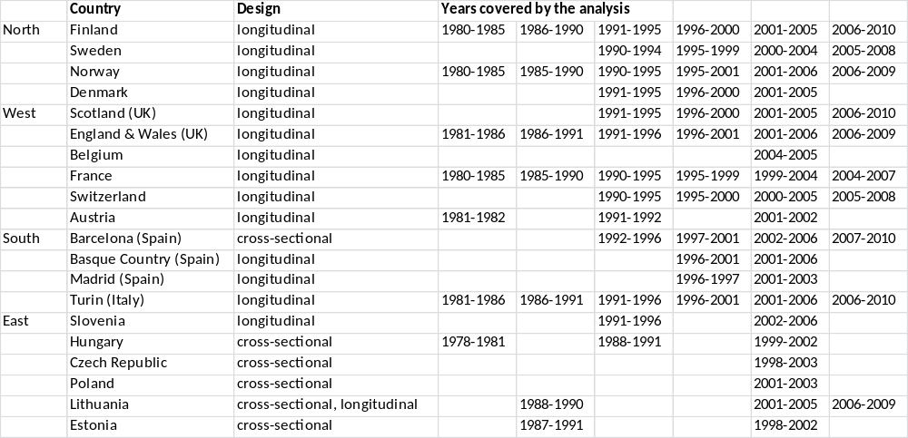
Notes: All data cover complete national or regional populations with the exceptions of England & Wales (1% representative sample), France (1% sample French born living in mainland France), and Switzerland (Swiss nationals only). Age range is 35-79 years in all populations, with the exceptions of Norway (40–79 years); Poland (35–64 years); Lithuania (35–69 years). Longitudinal design: population census linked to mortality during a follow-up period. Cross-sectional design: deaths by education from death certificates, person-years by education from population census. Lithuania had a cross-sectional design in 1988-90 and 2000-02, and a longitudinal design in 2001-05 and 2006-09; to remove design effects, longitudinal data were used for 2001-05, and 1988-90 data were adjusted using the differences between the two designs seen in 2000-02 and 2001-05.
Table 2. Latest observed mortality from alcohol-related causes, by country and sex (35-79 years, deaths per 100,000 person-years, age-standardized, with 95% confidence intervals)

- Men

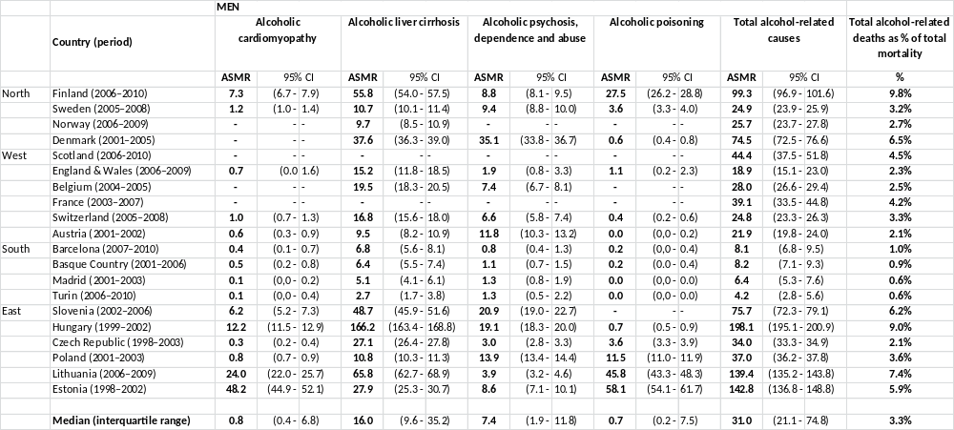

- Women
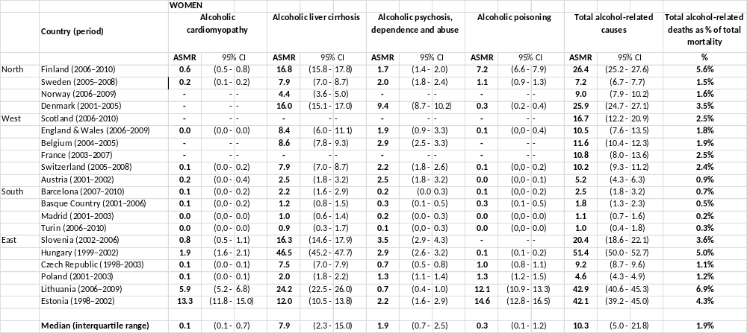
Notes: ASMR = Age-standardized mortality rate. Due to confidentiality restrictions, some countries did not supply information on causes of death which involved very small numbers of deaths (indicated by “-“) .
Figure 1. Latest observed mortality from alcohol-related causes, with 95% confidence intervals, by country, sex and level of education (35-79 years, deaths per 100,000 person-years, age-standardized)
a. Men
b. Women
Note: Among mid educated Scottish women the number of deaths was smaller than 10, and because of confidentiality regulations data could not be supplied for this group.
Table 3. Educational inequalities in mortality from alcohol-related causes, latest observed period, by country and sex (35-79 years, Relative Index of Inequality and Slope Index of Inequality, adjusted for age, with 95% Confidence Intervals)

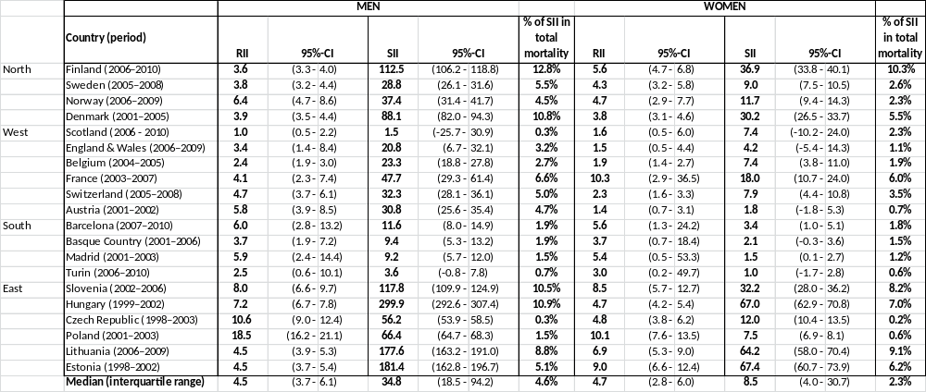

Notes: RII = Relative Index of Inequality. SII = Slope Index of Inequality.

Table 4. Trends in educational inequalities in mortality from alcohol-related causes, ca. 1980-2010, by country and sex (35-79 years, Relative Index of Inequality and Slope Index of Inequality, with 95% Confidence Intervals)

a. Men, Relative Index of Inequality

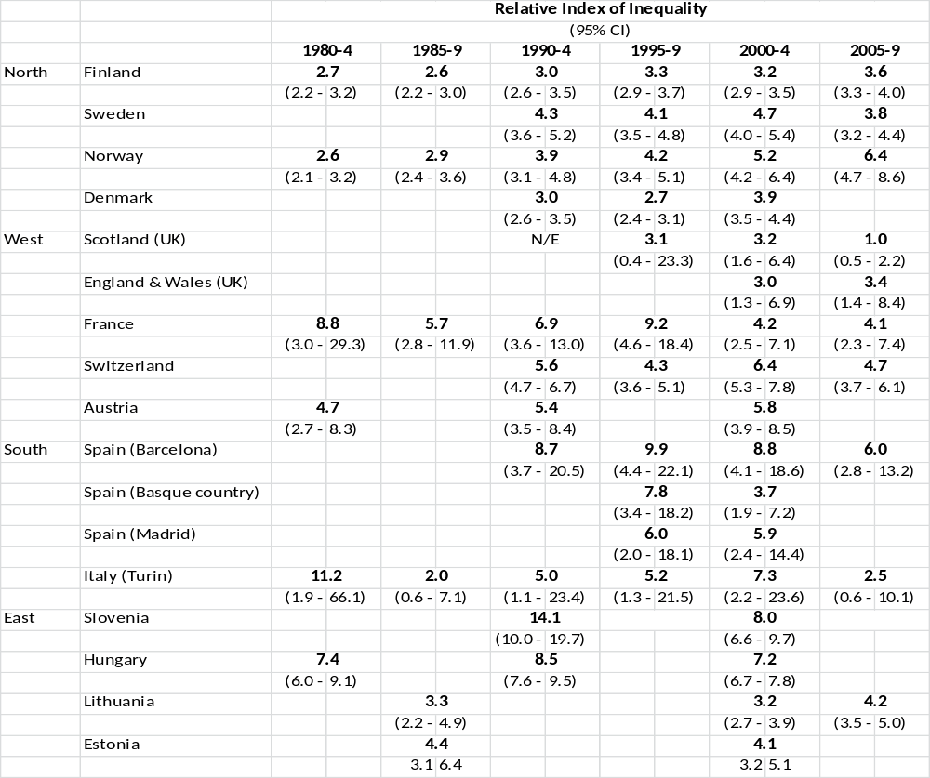

b. Men, Slope Index of Inequality

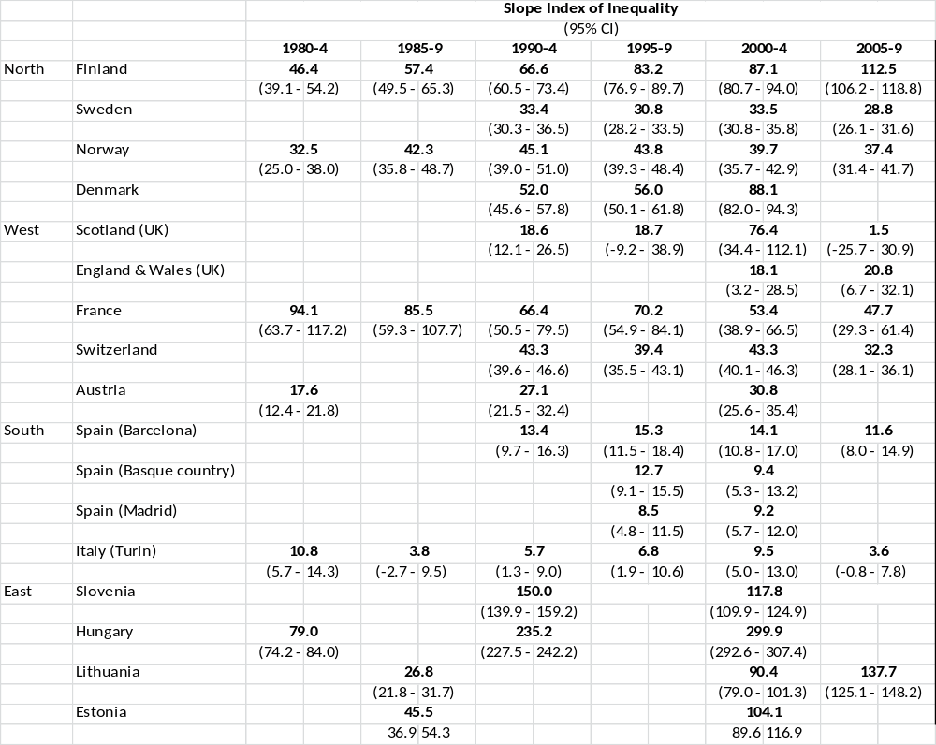

c. Women, Relative Index of Inequality

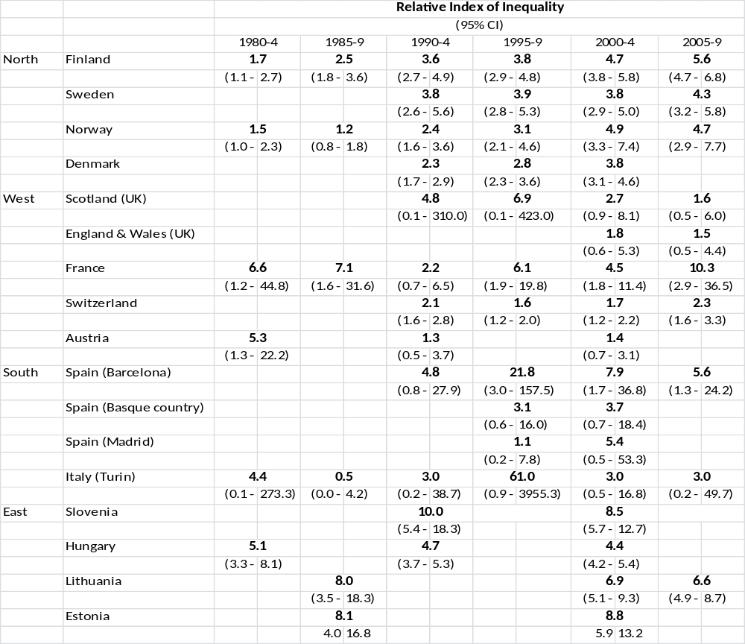

d. Women, Slope Index of Inequality
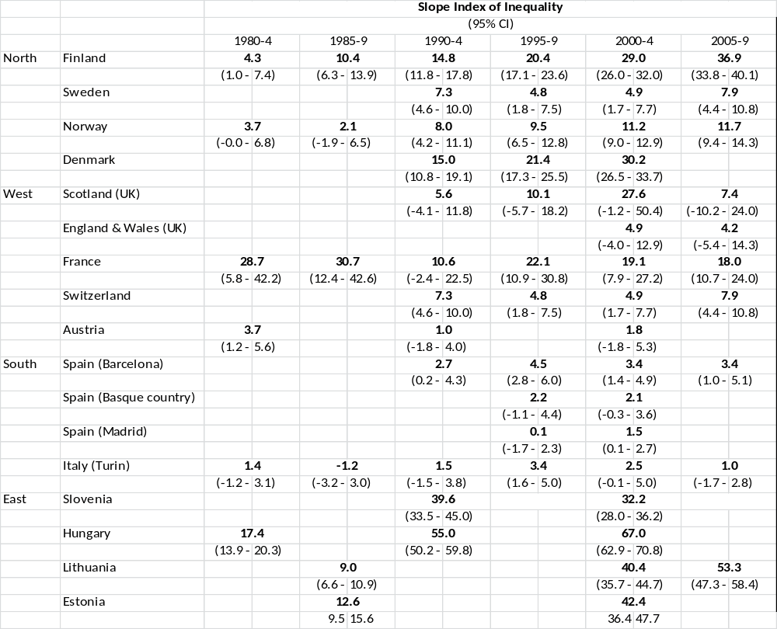
Notes: N/E: not estimable. Trend data for England & Wales only available for 2000s, because only two levels of education were available for 1980s and 1990s. Trend data for Belgium, Czech Republic and Poland not available because data on alcoholic liver cirrhosis were missing in earlier periods. In Lithuania and Estonia, only mortality due to alcoholic liver cirrhosis and alcohol poisoning were included in this trend table, because comparable data on other alcohol-related causes were not available for earlier time points.

Figure 2. Trends in age-adjusted mortality from alcohol-related causes among the low- and high-educated, 35-79 years, ca. 1980-2010, by sex and country

a. Men

b. Women
Note: In England & Wales, low and mid educated could not be distinguished before 2000, and therefore both groups have been combined in all study-periods (and labelled “low”).

Figure 3. Change in alcohol affordability between 1996 and 2004 vs. changes in absolute inequalities in alcohol-related mortality between ca. 1990-94 and ca. 2005-09
a. Men

b. Women
Notes: Data on affordability from Rabinovich (59). Only countries with both data on affordability and data on SII for ca. 1990-94 and ca. 2005-2009 included in this graph. A change in affordability >100 indicates that, as a result of increasing income and/or decreasing price, alcohol has become more affordable. Spain (B) = Barcelona.

Supporting information

Web appendix table A1. Data sources: quantitative characteristics for latest observed period
a. Men, education

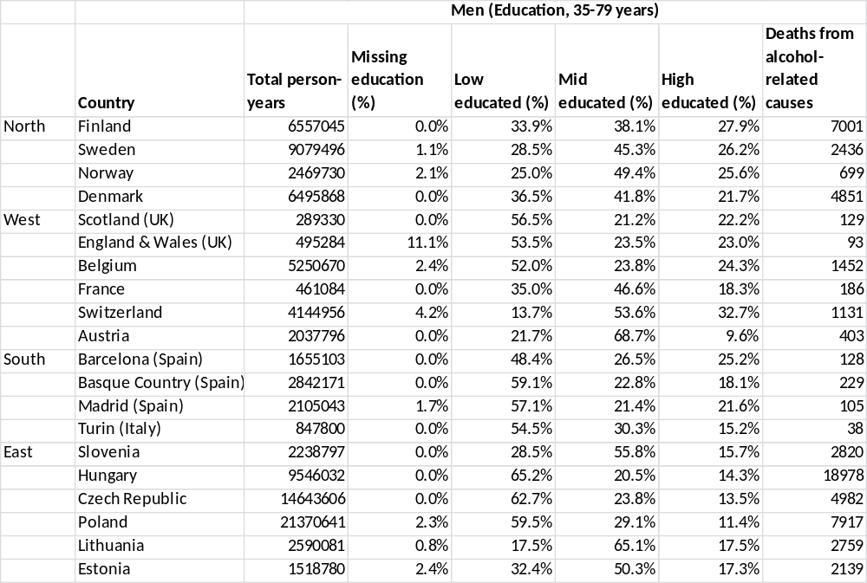

b. Men, occupation

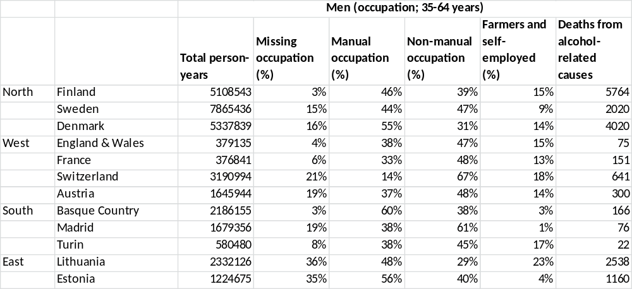

c. Women, education

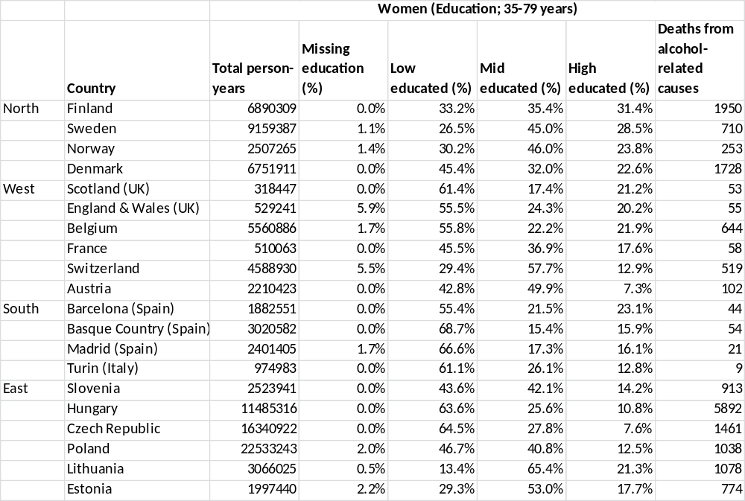
Note: For time-periods to which these data apply, see table 2. Percentage population by education or occupational class calculated among those with known education and occupational class, respectively.

Web appendix table A2. ICD-code numbers.

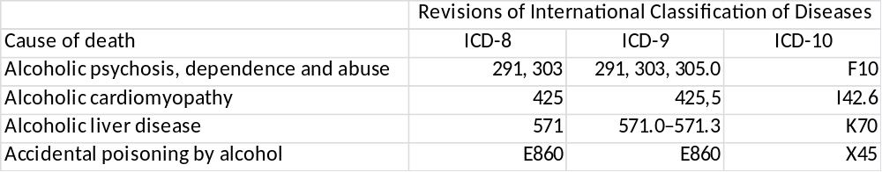

Web appendix table A2. Occupational class inequalities in mortality from alcohol-related causes, latest observed period, by country, men 35-64 years (Rate Ratio and Rate Difference, age-adjusted, with 95% Confidence Intervals)

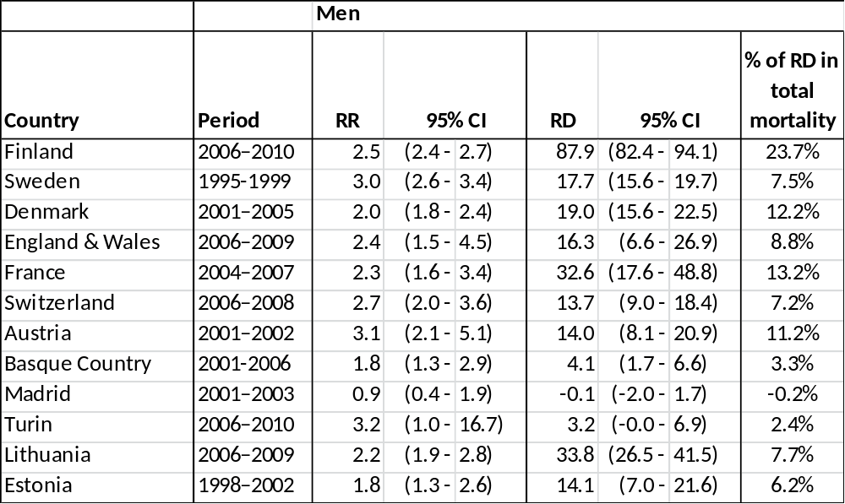

Notes: RR = Rate Ratio. RD = Rate Difference.

Web appendix table A3. Trends in relative and absolute occupational class inequalities in mortality from alcohol-related causes, by country, men 35-64 years (with 95% Confidence Intervals)

a. Rate Ratio (manual versus non-manual)

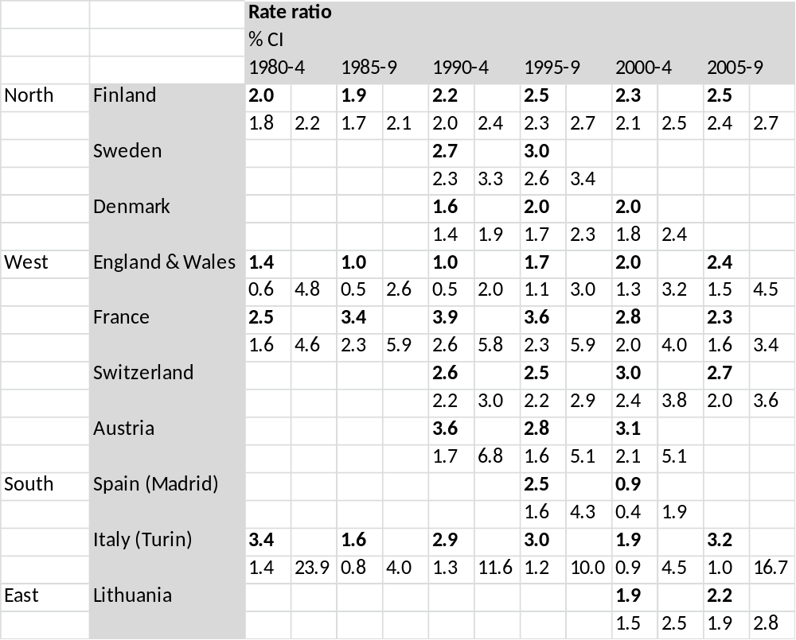

b. Rate Difference (Manual versus non-manual)

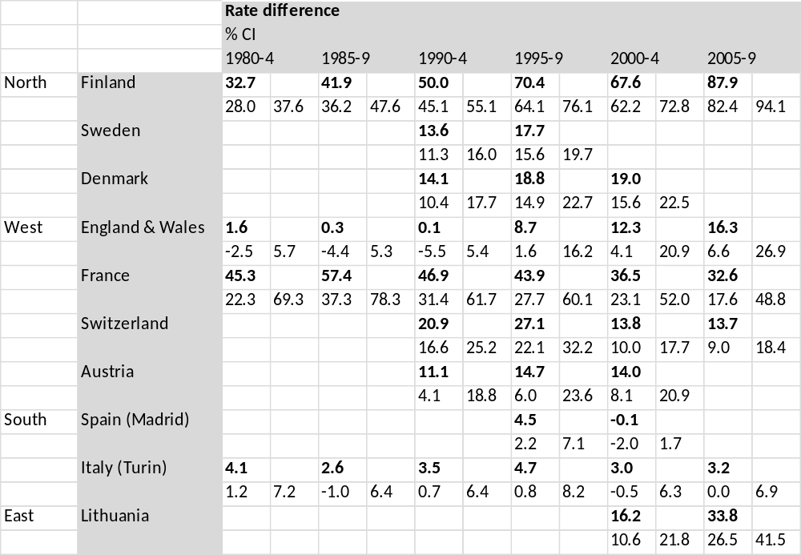

Note: For Basque Country and Estonia, no data on occupational class inequalities in mortality from alcohol-related causes were available for earlier periods than those presented in web appendix table A2.

Web appendix figure A1. Trends in age-adjusted mortality from alcohol-related causes among manual and non-manual men 35-64 years, ca. 1980-2010, by country

